Camp 252 Abergwili Hospital, Carmarthen, Carmarthenshire

1947 Camp List
252(Hospital) | P.W.Military Hospital, Abergwili, Carmarthen | W | Priswar, Abergwili | Carmarthen 7433 | Carmarthen | Major V.G.Matthews | v/1395/2

Prisoner of War Camps (1939 – 1948) - Project report by Roger J.C. Thomas - English Heritage 2003
OS NGR | Sheet | No. | Name & Location | County | Cond’n | Type 1945 | Comments
 |  | 252 | Abergwili Hospital, Abergwili, Carmarthen | Carmarthenshire |  |  | Wales

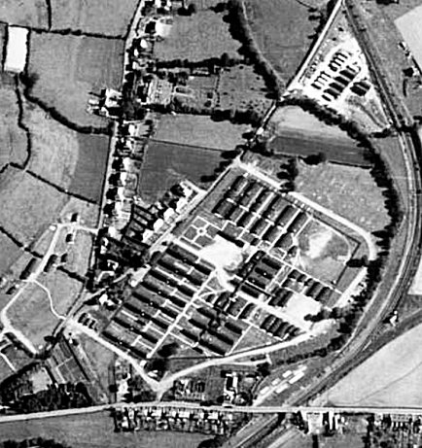  Location: NGR SN 4286 2130  Before the camp: Temporary hospital site for the US Army up to Spring 1945 in the grounds of the main hospital.  Pow Camp:  The site had a British Commanding Officer for the hospital, and a Commandant for the camp.  13 November 1945 - The camp was inspected by the International Red Cross – report below. | 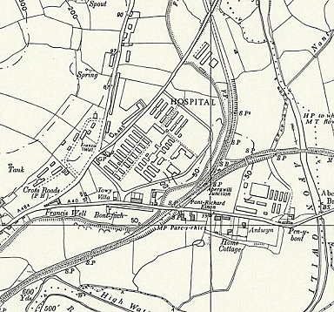
  Oversight and development of re-education activities and English teaching for German pows was carried out by PID (Political Intelligence Department of the Foreign Office) / COGA (Control Office for Germany and Austria – UK). Visits and reports were made. The standard of the reports varied greatly. The visitors took little interest, if any, in activities other than re-education. They rarely mentioned welfare, sports, games, pastimes, crafts, etc of the pows. If there were still Italian pows in hostels, they were usually ignored by PID.
 | Ordnance Survey 1964

21 October, 1946 - The camp was visited by Paul Bondy to give a lecture as part of the re-education programme for pows. It was recorded that 450 pows attended.

18/19 November 1946 – Short PID visit. Strength; not given. This was not the first visit, but previous reports are not included in the National Archive file.

Commandant: Major V G Matthews.
Interpreter: S/Sgt Spencer.

Only 49 pows had been politically screened. 8 were found to be ‘C’ grade / Black (Nazis) who expressed the opinion that, “no way can Germany be held responsible for the war – the blame is at all times thrown on the shoulders of the ‘Fuehrung.’” [Leadership]. There was no evidence of communism, and there was a general fear of anything connected with Russia.

Morale was very low for 2 main reasons. 1, all the pow staff on site were categorised as ‘Protected Personnel.’ Protected personnel were not included in the repatriation lists, and though the medical pows understood this, it was hard to accept by the others which included cooks, clerks, drivers etc. This anomaly was not sorted out until sping 1947. 2, many pows were shocked when told their political grades, and those with low grades B- / C generally protested; the better the grade the sooner repatriated, in theory.

April 1947 – Camp Magazine, No.1; Sprechstunde : Lagerzeitschrift des 252 Mil. PW. Hosp. Carmarthen - The Wiener Holocaust Library. The Hospital’s Commanding Officer, Colonel V L Fitzgerald-Powell provided a short introduction as well as the Commandant and camp leader.

May 1947 – recorded that the theatre group from nearby Llanddarog Camp 102 gave performances here.

11/12 June 1947 – Re-educational survey. Strength: Staff: 19 officers 187 Other Ranks
Patients: 28 “ 395 “

Commandant: Major V G Matthews Camp leader: Generalarzt Dr Thomann (B-)
Interpreter: S/Sgt W Wortsmann [or Wartsmann] Deputy C/L: O/Feldarzt Dr Arnold (A)

The Commandant was cooperative with the aims of re-education. He was popular, provided many recreational facilities and took a personal interest in the pows.

The interpreter was described as, “a youngster, new to the camp and keen to assist re-education…”

Camp Leader Thomann was also the Chief Physician. He had served in a German Division on the side of Franco in the Spanish Civil War and was decorated there. “Attitude correct to the extreme… Full of self importance, and given position of Camp Leader because of seniority.”

Deputy C/L Arnold, aged 55, “Pleasant type, but very much taken up with administrative duties.”

There was a camp Sgt/Major, Feldw Kurt Herde (B) who acted as liaison between the Camp Leader and the pows. “Plenty of drive, good organiser and pleasant personality.”

Political screening: | A+ | A | B+ | B | B- | C | C+ | Unscreened
Staff | 1 | 8 | 30 | 121 | 46 | - | - | -
Patients | - | 5 | 69 | 240 | 96 | 6 | 4 | 3

18 staff were appealing against their political grades. 109 staff had been repatriated to date.

The listing of all staff on site as Protected Personnel was lifted and morale was then recorded as good. There were rumours that a previous group transferred from this camp were still being held in the UK.

The patients often had no money to buy items from the canteen. An appeal had been made to German Officers’ camps to assist.

The officers on the staff were reluctant to take part in discussions or political activities. The standard list of re-education activities was given:

Wochenpost and Ausblick – separate Appendix.

Newspapers – Adequate British papers. A request was made for illustrated journals. Few German papers were received.

Lectures – Infrequent, but welcomed.

Discussion group – The Commandant organised small meetings to give non-political talks on subjects such as the English way of life.

Films – “Adequate.”

Wireless – Very good. Every ward had a loudspeaker. Keen interest in news direct from Germany.

Camp magazine – monthly, good standard. Supplies of paper and stencils were needed.

Press review – None.

Wall newspaper – Exhibited in the canteen.

Information room – None.

Great Britain  Military Hospital for Prisoners of War 252  Visited on 13 November, 1945 by M.Chavan  Address : Military 252 P.W. Hospital  Commander : Major HUBER  Camp leader : ARNOLD Fritz "Oberfeldarzt"  British officer doctor : Lt. Col, J.D, Cruickshank  German doctor : Prof. RODENWALDT. Ernst "Generalarzt"  Capacity : 750 men  Actual strength : 400 German prisoners, made up from; 18 officer doctors, 207 assistants, 175 patients.  No change has occurred since the arrival in this hospital of "Generalarzt" Prof. E. RODENWALDT and the increase in the number of the patients (175 instead of 93 on our preceding visit) come mainly from collecting sick prisoners from other work camps, (84 of them will be repatriated soon). The camp leader had no complaints. Food is sufficient and of good quality.  Money and pay : All of the medical personnel are recognized and thus receive wages.  Canteen : The canteen is well organized. The prisoners are entitled to 40 cigarettes per week.  Religious services :  Currently, a protestant chaplain from camp 199 [Haverfordwest] comes to read a service each week, and a civil catholic priest comes each week.  Correspondence : One hundred cards have arrived from the British zone, but at this time none from the American and French zones.  Two deaths have occurred during the last few months.  Conclusion  This hospital provides an excellent impression. The moral of the patients is good and each one is happy to think that he will be repatriated soon.  (Translated by M Sanders 2010)  Lieutenant Colonel J D Cruickshank was from the Royal Army Medical Corps. |  | English instruction – separate appendix.  Other camp activities –  Religion – Well looked after by a resident Protestant padre and a RC padre from Llanddarog Camp 102. Pows were also able to attend services in local churches.  Entertainments – An excellent theatre with stage and lighting. The theatre group and orchestra from camp 102 made regular visits. There was a classical trio at Abergwili and concerts had been given to local civilians. Lack of transport hindered inter-camp sports.  Outside contacts – The YMCA in Carmarthen provided a couple of rooms in their building which pows could use on Tuesday evenings and Sunday afternoons. The Commandant arranged for refreshments to be made available.  10-12 September 1947 – Re-educational survey. Strength;  No change to senior personnel.  137 pows repatriated to date.  The situation over pay for patients had not been resolved. Changes to activities –  Library – 1700 books.  Information room – held exhibitions of text and pictures on a theme, the last being ‘Political Caricatures.’  Entertainments – an orchestra from Llanmartin Camp 184 gave concerts.  Outside contacts – YMCA social evenings. Visits of small groups to the Magistrate’s Court and to St David’s. Some pows attended discussions in Carmarthen. The BBC recorded patients’ messages for the programme ‘Gruss aus England.’  The camp was expected to close in the near future.  Known Camp Commandants  1945 Major Huber  1947 Major V G Matthews, (possibly from the Leicestershire Regiment).  After the camp: Hospital
   | Officers | OR
  Staff: | 17 | 220 (of which 5 were Ukrainian)
  Patients: | 24 | 186 ( “ 25 “ “ )
  Political screening: | A | B | C
  Staff: | 4 | 233 | -
  Patients: | 2 | 206 | 2

Further Information:

National Archives FO 1120/237 – Re-educational survey visit reports for camps 252 to 256. Dated 1 January 1946 – 31 December 1948. 3 reports used above.

The Imperial War Museum have a copy of the journal dated September 1947.

Catalogue entry - 22 - Church Records of the Evangelical congregation at camps 199, 102, 252 and 70, all in South Wales - 1946-1948

