Camp 250 Thorpe Hall, Rudston, Yorkshire

Prisoner of War Camps (1939 – 1948) - Project report by Roger J.C. Thomas - English Heritage 2003
OS NGR | Sheet | No. | Name & Location | County | Cond’n | Type 1945 | Comments
TA 1051 6787 | 101 | 250 | Thorpe Hall, Rudston | Yorkshire | 4 |  | Former Army Divisional HQ re-occupied as a PoW Camp. Foot footings remain extant

Location: Memory of camp stated that the camp was “in the wood opposite the main entrance.”  Before the camp: Country estate and house.  Pow Camp:  1946 – recorded that the RC padre from this camp (Muenstermann) visited Eden Camp 83 once a month for confession and communion.  Pentecost (9 June) 1946 – Camp magazine, Die Pflugschar : Lagerzeitung Camp 250 - The Wiener Holocaust Library [The Ploughshare].  Article - “Sports and games. In recent months, all the hostels have seen a pleasing enthusiasm for sports, primarily thanks to the acquisition of various sports equipment. While football is the dominant sport, the handball teams from Thorpe Hall East and the combined team from Dawsons-Plantation and CRS have also achieved remarkable results. Fistball games have also been enthusiastically received. Even boxing teams are forming at Thorpe Hall East and Bathhouse after the recent purchase of boxing gloves.  During Pentecost, football fans are particularly focused on the final match between the two best teams, who were determined through qualifying rounds over the Pentecost weekend. Based on the current course of play, it appears that this match will be between Thorpe Hall East and Nafferton, with Nafferton likely to emerge victorious.  Prize tournaments for skat and chess are being held in all hostels, thus also catering to the interests of these members.”  2nd half 1946 – Thorpe Hall (and hostels) became a satellite camp to Eden Camp. Eden changed its number from 83 to 250. | 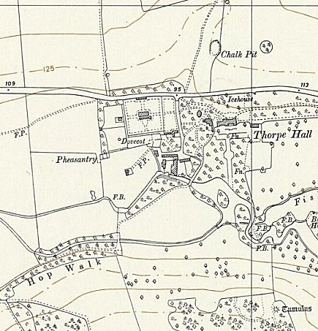
 | Ordnance Survey 1956

25 June 1947 – Command of Thorpe Hall Satellite Camp was handed over to Capt H C Holmes.

When Thorpe Hall became a satellite camp, it continued to administer some hostels, these were called the ‘Rudston Group’ in a couple of reports: HQ Thorpe Hall – Hostels; Bath House, Dawson’s Plantation, North Burton, and Rudston CRS. (This was set out in the October 1947 ICRC report for Eden Camp).

17 September 1947 – For details of the lorry collision with a train at Burton Agnes Level Crossing – see Eden Camp 83/250.

After the camp: Working estate.

Further Information:

The German Federal Archives have copies of the camp magazine.

Hostels

Bath House

Dawson’s Plantation

June 1946 - Mentioned in camp magazine article; “Activity report of the political working group of the Plantation Hostel.”

Nafferton. NOT confirmed as a hostel, but was mentioned in the camp magazine above.

North Burton

Rudston CRS. (CRS was a camp medical centre). Aka Thorpe Hall CRS.

