Camp 132 - Kimberley Park, Kimberley, Norfolk

Included in the 1945 ICRC camp list – Labour Camp. 132. Kimberley Park Camp, Wymondham, Norfolk.

Prisoner of War Camps (1939 – 1948) - Project report by Roger J.C. Thomas - English Heritage 2003
OS NGR | Sheet | No. | Name & Location | County | Cond’n | Type 1945 | Comments
TG 0935 0479 | 144 | 132 | Kimberley Park, Kimberley | Norfolk | 4 |  | Huts located under trees by the drive

Location: About 4 km NW of Wymondham  Before the camp: Parkland attached to Kimberley Hall.  Pow Camp: Italian non-collaborator Pows listed from 1944 until at least September 1945, then a German Working Camp.  November 1944 - The camp was listed as an Italian Working camp, (WO 32/10737).  “Evidence of World War Two military activity, including a Prisoner of War camp, is visible as extant structures and earthworks on aerial photographs taken in 1946. All the features lie within the eastern portion of Kimberley Park (NHER 30466), which was presumably requisitioned during the war. The Prisoner of War camp, sited under trees along the drive approaching Kimberley House, comprised various huts, gardens and sports fields, presumably for the use of the prisoners as well as the guards. To its north, and more widely spread across the park, is evidence of military training activity, in the form of recently excavated weapons pits and areas of disturbed ground. These were presumably created by troops stationed at the camp, although use of the area by other groups, such as the Home Guard, cannot be ruled out. A number of other World War Two sites in the area – a spigot mortar emplacement north of Kimberley village (NHER 54654) and a firing range just outside the southern boundary of the park (NHER 54655) – may have been in use by the same groups.” (Extracted details from Heritage.Norfolk). | 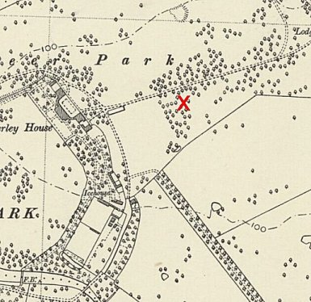
 | Ordnance Survey 1953
1 August 1945 - an urgent memorandum was sent to this camp, and others, about maintaining records of Italians who were classed as ‘co-operators’. At this point many, sometimes all, of the Italian pows were in hostels / billets.

15 September 1945 - Hostels listed for pows from this camp, (WO 32/10737): East Bilney, Dereham, Norfolk / Kimberley Park, Wymondham, Norfolk / Rookery Farm (Road), Walcott, Norfolk.

August 1946 – Recorded as a hostel for Victoria Camp in Suffolk with 332 pows.

Late 1946 - Incidental information from a German theatre group journal held by the Deutsches Historisches Museum. The group toured pow camps around England during 1946. It recorded its visit to Kimberley Park Camp, 253[sic]. 253 = Mousehold Heath.

Late 1946 – Listed as a hostel for Mousehold Heath Camp 253. Closed late 1947.

After the camp: Woodland.

Further Information:

Aerial photographs by RAF 1946 – RAF 3G/TUD/UK/52 5240-2 31-JAN-1946, and RAF 106G/UK/1429 3128-30 16-APR-1946.

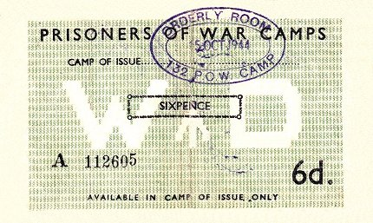 | 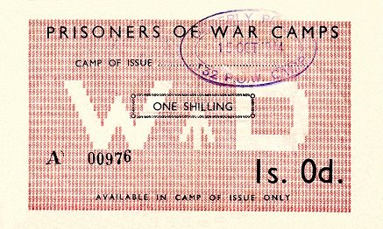 | 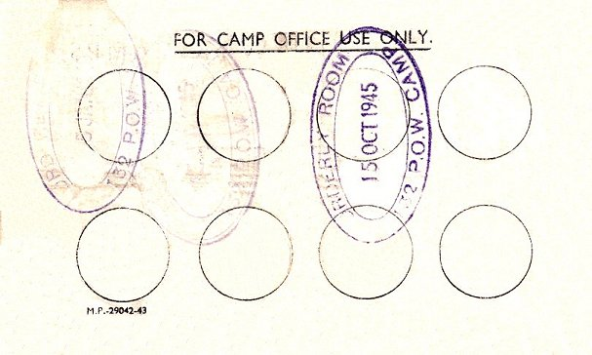 | Money Vouchers for Camp 132 – Could only be used within the camp and were stamped on the back when used.

Hostels

East Bilney, Dereham, Norfolk

Kimberley Park, Wymondham, Norfolk.

Rookery Farm (Road), Walcott, Norfolk. Just N of Walcott NGR TG 354 320.

September 1945 – Hostel with Camp 132.

August 1946 – With Hempton Green Camp 82.

