Camp 248 New Drill Hall, Clay Cross, Derbyshire

Prisoner of War Camps (1939 – 1948) - Project report by Roger J.C. Thomas - English Heritage 2003
OS NGR | Sheet | No. | Name & Location | County | Cond’n | Type 1945 | Comments
SK 390 640 | 119 | 248 | New Drill Hall, Clay Cross | Derbyshire | 4 |  | Site Occupied by industrial estate.

Location: Just to the N of Clay Cross.  Before the camp: Farmland.  Pow Camp:  “During the war labour was very short, most of the young men were in the forces or worked in the mines. It was difficult at busy harvest times to get help, but then a prisoner of war cap was built at Clay Cross and you could hire the POW’s to work on the farms. You had to let the camp head know how many and when you wanted them and they arrived with a warden in an army lorry. They brought with them tin bowls of potatoes and turnips and chunks of dry bread — this was their dinner. After the war when their movements weren’t so restricted, two of them used to come to the farm on Sundays for a bit of tea. They were very friendly boys and grateful for the hospitality. I remember two of their names Hienz Vahlenkamp and Ernst ? They carved me toys and boxes to show their gratitude.” Hienz Vahlenkamp returned to visit the site in 2005.  https://www.bbc.co.uk/history/ww2peopleswar/stories/36/a4477836.shtml  July 1945 – Clay Cross pow hostel listed in ICRC report administered by The Hayes Camp 5. | 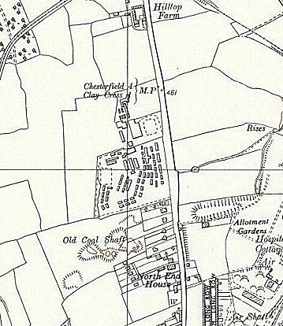
  Oversight and development of re-education activities and English teaching for German pows was carried out by PID (Political Intelligence Department of the Foreign Office) / COGA (Control Office for Germany and Austria – UK). Visits and reports were made. The standard of the reports varied greatly. The visitors took little interest, if any, in activities other than re-education. They rarely mentioned welfare, sports, games, pastimes, crafts, etc of the pows. If there were still Italian pows in hostels, they were usually ignored by PID.
 | Ordnance Survey 1955

1946 – Additional intake of many pows from camps in the USA. Most had very low morale as they had been misinformed in the US that they were being repatriated. Instead, they found themselves in working camps in the UK.

13 July 1946 – Report on Re-education. Strength; 2 officers (Medical Officers), 1905 Other Ranks at HQ, 6 hostels and billets. This was the 5th report, but the only 1 included in the National Archive file.

HQ and hostels were all hutted.

 | HQ | Dove Holes | Lismore Road | Stoney Middleton | Bakewell | Nether Langwith | Clowne | Billets
 | 1 officer + 887 OR | 389 | 1 officer + 317 OR | 82 | 35 | 61 | 101 | 31
Miles from HQ: | - | 30 | 25 | 15 | 15 | 12 | 15 | -

Commandant: Lt Col V C Holland, R.S. Camp Leader: O/Fw Frink (C).
Interpreters: Lt A G Blondeel and S/Sgt Gossels. Deputy C/L: Fw Neugebauer (B)
German M.O.: O/Arzt Grommes (B)
The Commandant was new to pow work, but promised to support re-education.

The Interpreter Officer was Belgian and only spoke a little German, the assistant S/Sgt was a German refugee. They were both efficient and co-operated with COGA.

Partial screening figures given: | A+ | A | B | B- | C | Unscreened
 | 1 | 12 | 341 | 1 | 291 | 1261

Although many of the hostel leaders were graded ‘C’ (Nazis), the visitor believed that most, and many of the others, would be regraded as ‘B’ when they were re-screened.

Most of the pows worked in quarries and iron-foundries.

Morale had fallen in the camp with the arrival of pows from the US. Other adverse factors were:

- Bad news from Germany, and infrequent news from the French, Polish and Russian Zones. 204 pows had received no news at all.
- Dense barbed wire around the camp. [In most camps this was drastically reduced once greater freedoms were allowed at end 1946/start 1947].
- Lack of repatriation.
- Hard working conditions – pows often referred to it as ‘slave labour.’ Some pows worked night shifts.

‘Youth’ pows (under-25) were not considered to be a problem.

Re-education was at a very basic level. There was a lack of accommodation for some activities and many pows did not wish to participate after working long and difficult hours. The standard list of activities was given:

Wochenpost & Ausblick – 470/70 copies respectively.

Newspapers – A small range of British newspapers was purchased using the Welfare Fund (money raised mainly through sales in the canteen). Hostels made their own arrangements through local newsagents. A limited number of German papers were received infrequently.

Library – totally inadequate. Just over half of the books were English friction which few could read. 106 were just pamphlets and magazines. 106 were in languages other than German or English. There were 77 Bibles. Only 74 of the books were German fiction.

Lectures at HQ were monthly. It was hoped they would soon be able to visit the hostels as transport was being organised.

Discussion groups – A ‘brains trust’ was attended by about 50 pows on Saturdays. None at the hostels.

Films – YMCA every three weeks at HQ, less so at Bakewell, Clowne and Nether Langwith. The other 3 hostels had received no visits.

Wireless – 3 sets at HQ, 1 at each hostel.

Camp magazine – ‘Hilf Mit.’ Fortnightly with 16 pages. Popular.

Press review – Hoped to start.

English instruction – separate appendix.

Other camp activities –

Religion – little interest, especially amongst those from camps in the US. Protestant padre San/Uffz Sieber (A) held services twice a week and every Sunday; about 20% attended. RC Pfarrer Wahler from Norton Park Camp 174 paid weekly visits for two services; about 30% attended.

At this time pows from this camp were not able to visit local churches unescorted – they would soon be allowed to do so.

Education – although re-education was poor, general education classes at HQ were extensive with about 150/200 attending. Classes included; German, French, Russian, maths (elementary and higher), chemistry, physics, shorthand, book-keeping, applied electricity and tailoring. There were also groups studying agriculture and building. The lack of space limited the number of classes. There were however, very few classes at the hostels.

Theatre – 10 members performing light entertainment shows at six weekly intervals. They were able to visit the hostels.

Orchestra – 12 members; 1 piano, 5 violins, 1 saxophone, 2 trumpets, 1 guitar, 1 cello and 1 accordion. Classical, light music and jazz. Unable to perform at the hostels due to lack of transport. They needed sheet music and paper.

Choir – 30 members. Good.

November 1946 – [Possibly earlier, see notes for Norton Camp 248]. The New Drill site became a hostel for Camp 248 at Cinderfield Lane, Norton (13 miles to the N). The Commandant, several other staff and hostels were transferred to the new camp. It was later administered by Nether Heage Camp 248 (58).

Known Commandants:
1946 – V C Holland, Royal Corps of Signals.
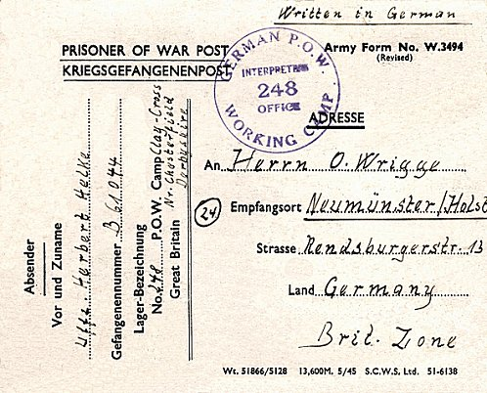
Pow postcard dated September, 1946 to Germany.

After the camp:

Further Information:

National Archives FO 1120/236 – Re-educational survey visit reports for camps 247 to 251. Dated 1 January 1946 – 31 December 1948. Just 1 report, used above.
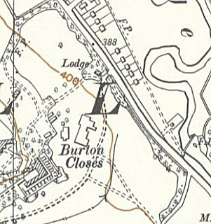

Hostels – [November 1946; ALL hostels were administered by Norton Camp 248].

Bakewell. (SK 220 677, Burton Closes, off Haddon Road, Bakewell – not confirmed that this was the site of this hostel or of the HQ).

7/1946 – 35 pows. Hostel leader; St/Fw Hansen (C).
Ordnance Survey 1955 >

Clowne. Nissen huts in grounds of Southgate House.

Italian pows recorded – administered by a different camp.

27 October 1944 – Death of Italian pow Caporale Guiseppe Rasconi at the Victoria Hospital in Worksop, aged 38, form natural causes (mainly asthma). He was buried in Worksop and later reinterred at Brookwood Military Cemetery.

7/1946 – 101 German pows. Hostel leader; O/Masch Brand (B).

Dove Holes. Photos show wooden huts.

Italian pows recorded – administered by a different camp.

7/1946 – 389 German pows. Hostel leader; O/Fw Stieler (C). Considered to be a ‘black’ hostel (C grade – Nazis).

Photos of pows clearing snow in Winter 46/7 - https://buxtonmuseumandartgallery.wordpress.com/2022/11/05/derbyshires-prisoners-of-war/

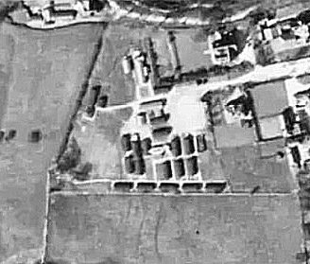  Lismore Road (Buxton).  Aerial photo 1948 - raf_cpe_uk_2598_rp_3117 - Aerial Photo | Historic England  7/1946 – 1 officer + 317 OR. Hostel leader; O/Fw Otto (C). Considered to be a ‘black’ hostel (C grade – Nazis). | 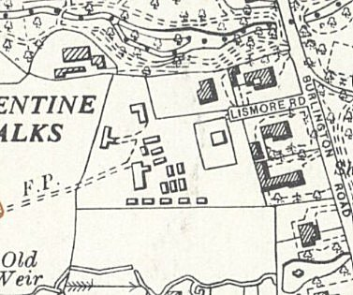
 | Ordnance Survey 1954
Nether Langwith. NGR SK 526 701

1943 / 44 – Administered by Nether Headon Camp 52 with Italian pows.

7/1946 – 61 pows. Hostel leader; O/Wm Weise (C)

Stoney Middleton. NGR SK 235 751.

1943 - listed as hostel for Lodge Moor Camp 17 with Italian pows.

7/1946 – 82 pows. Hostel leader; St/O/m Wegmann (B). Considered to be a ‘black’ hostel (C grade – Nazis).

Excellent local history website with further memories - http://smhccg.org/village-history/prisoner-of-war-camp/

