Camp 246 (& 586, 599) North Camp, Nettlebed, Henley-on-Thames, Oxfordshire

Prisoner of War Camps (1939 – 1948) - Project report by Roger J.C. Thomas - English Heritage 2003
OS NGR | Sheet | No. | Name & Location | County | Cond’n | Type 1945 | Comments
SU 7046 8675 | 175 | 246 | North Camp, Nettlebed, Henley-on-Thames | Oxfordshire | 4 | German Working Camp

Location: Just to the E of Nettlebed.  Before the camp: North camp site was farmland. US troops built the N and S camps. The United States Corps of Engineers built sewerage and water treatment plants, one of which remains and is used by Nettlebed village today (2022).  1944 aerial photo - Aerial Photo Explorer – Over 400,000 aerial photos in Historic England's digitised collections | Historic England  Pow Camp: Only the North camp was listed as a pow camp.  Likely to have closed as a pow camp in 1945 as the number was re-allocated to Basildon House Camp 246.  After the camp: Both camps were used by the Polish Resettlement Corps - confirmed by entry in Hansard, House of Commons, 25 February 1947, Vol 433.  “Squadron-Leader Sir Gifford Fox asked the Secretary of State for War when he anticipates removing the Army huts which disfigure Nettlebed Common, Oxfordshire, and which interfere with the amenities; and for what purpose the camp is being used at present.  The Financial Secretary to the War Office (Mr. John Freeman) - The two camps at Nettlebed Common, Oxfordshire, are both occupied by units of the Polish Resettlement Corps. I regret, therefore, that I cannot yet state when the huts will be available for dismantling and removal.”  Further Information: | 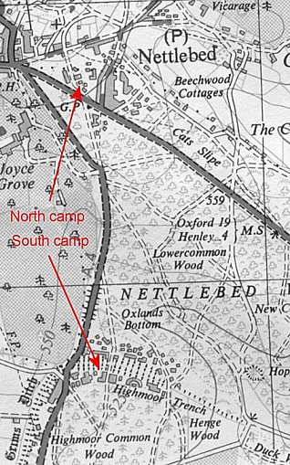
 | Ordnance Survey 1948

