Camp 233 Summer House, Ravensbourne, Kent (aka Ravensbourne)

Prisoner of War Camps (1939 – 1948) - Project report by Roger J.C. Thomas - English Heritage 2003
OS NGR | Sheet | No. | Name & Location | County | Cond’n | Type 1945 | Comments
TQ 407 691 | 177 | 233 | Summer House, Ravensbourne, Bromley | Kent | 5 |  | Site currently a college

Location: The NGR above places the camp in the grounds around what was Stockwell Teacher Training College.  This is contradicted by various other sites, placing it in Beckenham Place Park – Summer House Hill which seems a lot more likely! TQ 383 703.  1946 - View map: Ordnance Survey, OS Air Photo, 50 inch to the mile (1:1,250), Sheet 51/3870 S.W. - Ordnance Survey Air Photo Mosaics, 1944-1950  Before the camp:  Pow Camp: Italian and then German pows. Tented accommodation until it became a satellite camp.  11 May 1946 – Camp magazine number 1; Spiegel der Zeit : Lagerzeitung des PoW Camp 233 Bromley/Kent - The Wiener Holocaust Library . Stopped soon after, when the camp merged with 237.  Summer 1946 – the camp became a satellite camp for Co-ed Bel Camp 237 with c460 pows, (camp number 233 was re-allocated to Findo Gask in July 1946).  October 1947 – Ravensbourne hostel was administered by Shirley Church Road Camp 239  After the camp: The teacher training college returned to the site. 2020 Civic buildings.  Further Information: | 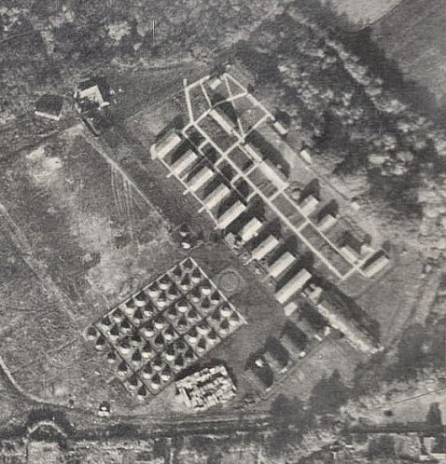
 | Aerial photo 1946

