Camp 125 - Newlands House, Tooting Bec Road, London SW17

Included in the 1945 ICRC camp list – Labour Camp. 125. Newlands House, Tooting Bec Rd. Tooting Bec Common, London SW 17.

1947 Camp list
125(G.W.C.) | Newlands House. Tooting Bec Road, Tooting Bec Common, London, S.W.17 | L.D. | Priswar, Toot, London | Balham 1051 Ext2 & 3 | Balham (S.R.) | Lt.Col.A.M.G.Evans | v/1453/2

Prisoner of War Camps (1939 – 1948) - Project report by Roger J.C. Thomas - English Heritage 2003
OS NGR | Sheet | No. | Name & Location | County | Cond’n | Type 1945 | Comments
TQ 43 81 | 177 | 125 | Newlands House, Tooting Bec Road, London SW17 | London | 5 | German Working Camp

Location: NGR above is incorrect. Newlands House was TQ 284 720.  Before the camp: Part of the Tooting Bec Mental Hospital.  Pow Camp: Italian pows to at least 1945, then a German Working Camp.  Considering its size and location the HQ was probably used mainly as an administrative centre for servicing its hostels.  November 1944 - The camp was listed as an Italian Labour Battalion, (WO 32/10737).  1 August 1945 - an urgent memorandum was sent to this camp, and others, about maintaining records of Italians who were classed as ‘co-operators’. At this point many, sometimes all, of the Italian pows were in hostels / billets.  Camp newspaper - Die Sanduhr Monatsblatt (The Hourglass, monthly paper) – No.7 – 15 February, 1947;  Die Sanduhr : Monatsblatt Camp 125 England - The Wiener Holocaust Library  Known Camp Commandants  1947 Lieutenant Colonel A M G Evans. I think he was with the Royal Welch Fusiliers.  After the camp: House demolished. Now blocks of flats.  Further Information:  IWM and The German Federal Archives have a copy of the camp newspaper – (IWM - Ref. LBY E.78946-9). | 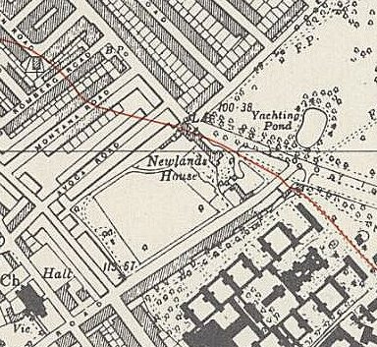
 | Ordnance Survey 1949

Hostels

A lecturer’s report on his visit to this camp (undated and mis-filed under National Archives FO939/307) recorded that he visited HQ and Coulsdon / Hadden Way / Peckham / West Dulwich.

Addington

Addington within the London Borough of Croydon. A hostel was located there at Shirley Church Road, Addington, Croydon, which became independent Camp 239 in 1947.

9 January 1947 - memorial page for POW Arno Paul Richard Langbein, aged 29, of Addington Hostel who died at the Royal Herbert Hospital. Cause of death not stated. The burial took place on 14/1 at Aldershot POW cemetery. He was later reinterred at the Cannock Chase German Military Cemetery.
Coulsdon

Reported to be located at; “top of Marlpit Lane (opposite the village pond)” – not confirmed.

Croydon

When this hostel was taken over by Camp 239 in 1947, it was stated it was previously administered by camp 125.

Hadden Way - New Malden

Reported to be located at; “both sides of the railway, (behind the houses opposite the plough pub on what was Stroud field, and also the other side of the bridge where the flats now are)” – not confirmed.

Peckham  “In 1944 four new huts built of concrete sections were erected on Peckham Rye Common to house POWs. The occupants raised pigs and chickens and also harvested | 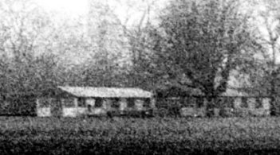 | 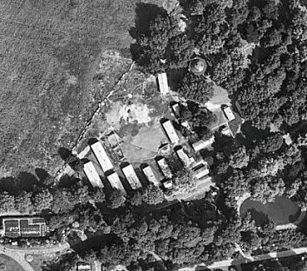 | 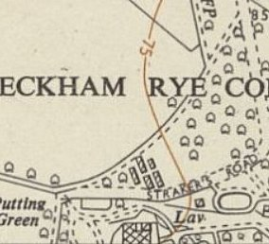
produce grown on the Common. The initial occupants were Italian prisoners, but these were soon replaced by German POWs and displaced people from Europe.”

https://www.peckhamsociety.org.uk/?p=2165
 |  | 1945 - raf_106g_uk_720_rvp2_6174 - Aerial Photo | Historic England | Ordnance Survey 1954

Ravensbourne

Previously independent ‘Summer House’ Camp 233. Then attached to Co-ed Bel Camp 237. When this hostel was taken over by Camp 239 in 1947, it was stated it was previously administered by camp 125.

West Dulwich

