Camp 236 White House, Church Hill, Loughton, Essex

Included in the 1945 ICRC Camp List – Labour Camp. 236. White House, Church Hill, Loughton, Essex.

Prisoner of War Camps (1939 – 1948) - Project report by Roger J.C. Thomas - English Heritage 2003
OS NGR | Sheet | No. | Name & Location | County | Cond’n | Type 1945 | Comments
TQ 441 963 | 167 | 236 | White House, Church Hill, Loughton | Essex | 4 |  | Site occupied by housing

Location: Grid reference above is shown on the map at position Y. However, the area known as ‘White House’ as shown on the 1896 OS map, was at location X.  Before the camp:  Pow Camp:  “I was born in 1936 in Loughton, Essex. the bottom of our road were fields in which the military had dug trenches. Just across the fields was the River Roding. On the other side of the river was a balloon barrage, which I think may have been a target for German bombers. We used to play on the fields (which we seemed to regard as our very own private playground)… On the other side of the river was a POW camp with (mostly) German and Italian prisoners. Security there didn’t seem to be that tight and the prisoners used to come across and speak to us children. They seemed nice enough young men.”  https://www.bbc.co.uk/history/ww2peopleswar/stories/97/a4366497.shtml  After the camp:  Further Information:  Camp magazine without date or location Ninewells or Whitehouse Camp 236? –  236 Erzahlt - The Wiener Holocaust Library | 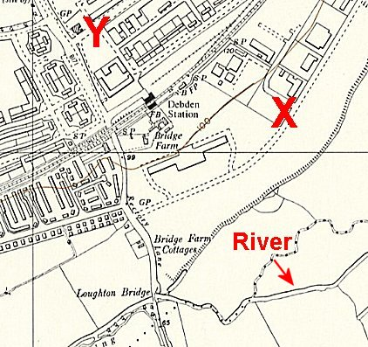
 | Ordnance Survey 1960

