Camp 234 Talgarth Military Hospital, Talgarth, Breconshire

1947 Camp List
Hospital | Talgarth Military Hospital, Talgarth, Mon | W |  | Military Registrar, Talgarth 79780 |  |  | Administered by No.99

Prisoner of War Camps (1939 – 1948) - Project report by Roger J.C. Thomas - English Heritage 2003
OS NGR | Sheet | No. | Name & Location | County | Cond’n | Type 1945 | Comments
 |  | 234 | Talgarth Hospital, Talgarth | Breconshire |  |  | Wales

Location: NGR SO 163 331 about 19 km north of Crickhowell.  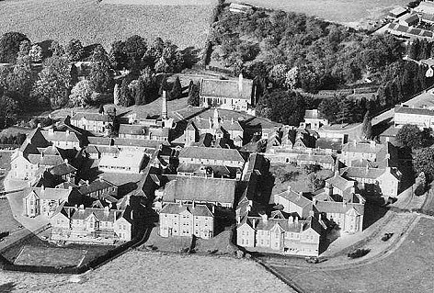  Before the camp: The ‘lunatic asylum’ was opened on 18 March 1903. In April 1940, 315 beds were made available for military use.  The book ‘Up Top’ by Hugh Purcell states that Rudolf Hess was held and treated secretly at Talgarth Asylum before it became a pow camp.  Pow Camp: Psychotic / Psychoneurotic pows were treated here. (Recorded in ‘Psychiatry in the British Army in the Second World War – Robert H Ahrenfeldt – 2018 – Routledge).  1941 – 1945 – The War Diaries have many gaps in the filed records.  21 December 1941 – The first mention of a pow in the War Diary for Talgarth Military Hospital – an unnamed Italian pow died at the hospital. | 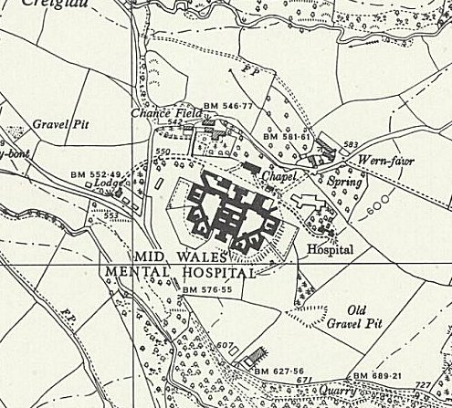
 | Ordnance Survey 1958
[2 Italian army soldiers recorded by the Commonwealth War Graves Commission: Salvatore Stradella, died 3 December, buried at Stratford-Upon-Avon Cemetery, and most likely; Antonino La Grassa, died 27 December, later reinterred at Brookwood Military Cemetery].

Commanding officer – Lt Col P Drummond, RAMC.

January 1942 – 54 patients were admitted including 3 Italian and 2 German pows. From this time on, small numbers of pows were admitted monthly into the hospital, mainly Italian. Fewer were discharged back to pow camps.

27 February 1942 – Major General E C Gepp, CB, DSC, Director, Prisoners of War, with 2 staff officers, toured and inspected the hospital regarding arrangements for pows. He visited again in February 1943.

28 February 1942 – A ‘Mixed Medical Commission’ headed by Col H H Blake, OBE, examined several pows with regard to repatriation. The commissions comprised one doctor appointed by the detaining power, and two doctors appointed by the ICRC.

10 April 1943 – 55 Italians were discharged to be repatriated to Italy. This was part of wounded prisoner exchanges carried out from 19 April 1943.

May 1943 – an unnamed Italian pow died in the hospital. [8 Italian pows recorded by the CWGC as having died in May / June 1943, so unable to identify].

June 1943 – an unnamed Italian pow died in the hospital.

2 September 1943 – the junior NCOs and staff, including attached Pioneer Corps (Guards) were moved into Nissen huts in the hospital grounds. Previous to this they had been accommodated inside the hospital, most occupying Ward E2.

September 1943 – 146 Italian pows repatriated.

October 1943 – 16 German pows repatriated. Medical repatriations had first been proposed in 1941, but were repeatedly delayed. In September 1943, a repatriation exchange was at last accepted by the Germans. The arrangements were detailed to Cabinet on 18 October:

“The exchange was being carried out in three separate movements: First, German prisoners of war from camps in the United Kingdom and North America, and British prisoners (nearly all belonging to this country) would be exchanged at Gothenberg.

Secondly, German prisoners from a North-West African port would be sent to a port in France. Thirdly, other prisoners from the Middle East, and prisoners from the forces of Australia, New Zealand, South Africa, India and other parts of the British Commonwealth, would be exchange at Barcelona.” (War Cabinet conclusions, 18 October 1943, 142(43).

Approximately 5,000 sick and injured pows held by the Allies were exchanged for a similar number of Germans for the first exchange at Gothenburg.

23 November 1943 – Italian pow Vito Marano died in hospital. He was buried at Talgarth Church yard on 26 November after a Post Mortem examination. He was later reinterred at the Brookwood Military Cemetery.

20 January 1944 – An Inspector of Prisoners of War visited the hospital. Again July 1944, 25 March 1945, 30 September 1945.

January to March 1944 – 171 Italian pows repatriated, 4 returned to camps, 1 sent to a different hospital

21 April 1944 – Pow Leoni escaped from a working party at 1045 hours. Search parties instituted and prisoner re-captured at approximately 1420 hours same day.

7 June 1944 – “Mass change over of Guard Coy personnel (Pioneer Corps).”

19 August 1944 – a further 10 Italian Protected Personnel posted from Lodge Moor Camp 17. Staff in the wards for pows, were mainly other pows. A further 25 arrived the following month.

July to September 1944 - 157 Italians (1 officer and 156 O.R.) repatriated. 12 were stretcher cases and joined the Ambulance Train at Hereford.

24 October 1944 – a representative of the International Red Cross, (IRC) visited. Again 3 February 1945, 10 April 1945.

November 1944 – a shortage of beds resulted in British patients being sent to other hospitals.

23 November 1944 – As a temporary measure it was decided that the hospital would not accommodate British psychotic cases, but only receive and treat Allied and pow cases.

October to December 1944 - 131 Italians repatriated. Most by Ambulance Train from Talgarth.

19 February 1945 – “Capt Owen (of J.A.G. Branch S.W.D.) visited this unit to take summary of evidence against P/W Effenhauser.” There were no details of this case, but during January a Pioneer Corps guard (Pte Kiley) was injured while on night duty – possibly related?

7 March 1945 – Pow Attilio Ghidoni died in hospital. Post mortem held on 8 March. He was buried at Bronllys Cemetery and later re-interred at Brookwood Military Cemetery.
January to March 1945 - 118 Italians repatriated. 1 German repatriated joining the Hospital train at Chepstow.

6 April 1945 – Pow O/Gefr Kurt Roediger died in hospital. He was buried at Hay Cemetery.

April to June 1945 - 205 Italians repatriated – entrained at Hereford.

July to September 1945 - 290 Italians and 98 Germans repatriated.

October 1945 - A Spanish Republican held as a pow was sent to Talgarth. A question was raised about him in the House of Commons:

“Lieutenant W. Griffiths asked the Secretary of State for War for what reasons Ceferino Medero, a Spanish Republican, was removed from Hall o' th' Hill Camp, Chorley, on or about 10th December. [sic – presumably this should be October]

Mr. Lawson - This Spaniard was evacuated to Talgarth Mental Hospital on 6th October, 1945, on account of his mental condition. His fellow Spaniards had previously requested his removal, but at that time his mental state was not considered such as to necessitate transfer to a mental hospital.” (House of Commons written answers - 30 October 1945
Vol 415).

October to November 1945 – 96 Italians repatriated, most travelled via Hereford and Liverpool. 112 Germans repatriated, mostly by road transport to Southampton.

22 November 1945 – “Capt Jesman and 1 Russian officer (Russian Mil.Repat Commission) visited this hospital.” Lieutenant Czeslaw Jesman is recorded several times in the book ‘Victims of Yalta.’ It was not stated how many Russians were held at the hospital – or what happened to them. It is likely that they were repatriated and executed or imprisoned.

November is the last War Diary entry in the file, however there is a further record for 1946:

9 July 1946 – Quarterly Historical Report for quarter ending 1 July 1946. British strength; 5 officers, and 95 O.R. (79 RAMC and 16 Pioneer Corps).

Duties with respect to pows – “Treatment of German and Italian Officers and Other Ranks – P/W suffering from mental illness.”

Administrative difficulties – Deficient number of staff which; “curtail treatment, supervision, recreation and therapeutic occupation of patients… slow up the discharge of patients.” It was recorded that this had been reported several times.

Further notes – “Owing to deficiencies in establishment, personnel work excessive hours, particularly, Nursing Orderlies and Clerical staff. Complaints are heard on the score of these long hours which are bound to affect adversely the contentment of the men. The work in this unit has increased since the cessation of hostilities.”

1947 – Possibly administered by Shugworth Military Hospital Camp 99 – not confirmed.

After the camp: The war department released most of their beds on 31 December 1946. The mid-Wales Mental Hospital closed in 1999. 2019 the site is derelict.

Further Information:

WO 177/1046 Talgarth records by the War office. Dated April 1941 to August 1944; October – November 1945. Used above.

There are other records relating to the asylum during the war years at the National Archives.

