Camp 233 Findo Gask Camp, Dunning, Perthshire

Location: NGR NO 011 212  Before the camp: The site became RAF Findo Gask in 1941 – a Flying Training Airfield. The airfield was abandoned by the RAF in 1944 and the area used by the Polish Army.  Pow Camp: (Camp number 233 previously used by Summer House camp).  July 1946 – camp opened, “with a nucleus of 18 P/W staff brought from the London area.” (from September report).  31 July 1946 - Raised in Parliament;  “THE EARL OF MANSFIELD asked His Majesty's Government, if they are now in a position to state the future of the aerodrome at Findo-Gask, Perthshire, both as regards the buildings, and the arable land.  LORD WESTWOOD - This airfield is no longer required by the Royal Air Force. The final disposal of the land has not yet been decided, but meanwhile it has been made available for unrestricted agricultural use. The buildings will be needed for some time for housing German prisoners who will be working on the land.” (House of Lords Deb 31 July 1946 Vol 142)  August 1946 – a further 60 pows transferred from Calvine Camp 66, 162 from Johnstone Castle Camp 188, 158 from Comrie Camp 21, and the officer dentist from Lodge Moor Camp 17. | 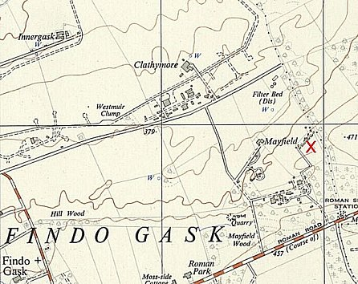
 | Ordnance Survey 1955

Most of the pows had been transferred from Camps in Belgium where they had experienced extremely poor conditions. Others were from camps in the UK + pows from camps in the USA and Canada. Ex-US pows often had a very low morale as they had been misinformed in the US that they were being repatriated. Instead, they found themselves in working camps in the UK. Pows from Canada were often C grade. They had been captured early in the war and had retained their Nazi ideology.

Oversight and development of re-education activities and English teaching for German pows was carried out by PID (Political Intelligence Department of the Foreign Office) / COGA (Control Office for Germany and Austria – UK). Visits and reports were made. The standard of the reports varied greatly. The visitors took little interest, if any, in activities other than re-education. They rarely mentioned welfare, sports, games, pastimes, crafts, etc of the pows. If there were still Italian pows in hostels, they were usually ignored by PID.

20/21 September 1946 – PID 1st visit to Organise re-education / Ascertain screening position. Strength; 1 officer, 398 Other Ranks.

Commandant: Major J E [?] White Camp leader: Ob.Fw Rudolf Hoffmann (A)
Interpreter: S/Sgt H P Auerbach Deputy C/L: Uffz Theo Schlaaf (B)
German M.O.: None. Dentist; Ass.Arzt Dr Franz-Josef Sina (A+)

The Commandant showed “some interest” in re-education, that is not to say he was actively involved.

The Interpreter was aged 19; “inexperienced but willing.”

Morale was generally low due to; Conditions experienced in Belgium; Unemployment; No welfare fund (monies raised mainly through sales in the canteen).

30 pows were ‘youth’ (under-25). They were not seen as a problem.

Political screening: | A+ | A | B+ | B | B- | C | Total
Previously screened: | 1 | 17 | 6 | 143 | 5 | 33 | 205
Provisional grades | 6 |  | 108 |  |  | 80 | 194
Totals | 24 |  | 262 |  |  | 113 | 399

28% C grade (Nazis) was higher than in many camps. Most pows were politically apathetic. There were some who retained their Nazi ideas, and some communists.

All activities were in a very poor state in the camp. The standard list of re-education activities was given –

Wochenpost and Ausblick – 100 / 0 copies respectively.

Newspapers – just 3 British newspapers received daily, paid for from the ‘meagre’ welfare fund. British staff passed on some periodicals. A small number of German papers were received.

Library – Poor. 304 books, of which 70 were English text books, and 164 on unwanted technical subjects.

Lectures – None.

Discussion groups – None. Hoped to start.

Films – YMCA entertainment films had been shown.

Wireless – 1 set in the Camp Leader’s office with 5 loudspeakers in the canteen, recreation room, medical centre and barracks.

Camp magazine – None. Hoped to start.

Press review – Given verbally on Sunday evenings.

English instruction – 54 students with 3 teachers.

Other camp activities –

Religion – there was a camp chapel, but no regular services. 255 Lutherans and 148 RC. It was hoped that visiting padres would come to the camp.

Education – No classes.

Theatre – Being formed.

Orchestra – No instruments.

After the camp: The site was derequisitioned in 1948. 2020 Farming land and a small residential area.

Further Information:

National Archives FO 1120/233 – Re-educational survey visit reports for camps 230 to 235. Dated 1 January 1946 to 31 December 1948. Just 1 report, used above.

