Camp 200 Llanover Park, Llanover, Abergavenny, Monmouthshire

Included in the 1945 ICRC Camp List – Base Camp. 200. Llanover Park Camp, Abergavenny, Mon.

1947 Camp List
200(B.C.) | Llanover Park Camp, Llanover, Abergavenny, Mon. | W. | Priswar, Llanover | Abergavenny 560/1/2 | Nantyderry | Lt.Col.P.L.Crimwood, M.C. T.D. | v/202/4

Prisoner of War Camps (1939 – 1948) - Project report by Roger J.C. Thomas - English Heritage 2003
OS NGR | Sheet | No. | Name & Location | County | Cond’n | Type 1945 | Comments
 |  | 200 | Llanover Park Camp, Llanover, Abergavenny | Monmouthshire (Gwent) | Base Camp | Wales

Location: The buildings beside Llanover House were located at NGR SO 312 086  Before the camp: Country house and estate. US troops stationed at the site prior to D-day.  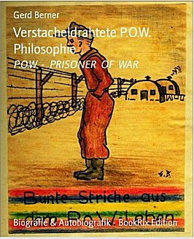  Pow Camp:  1943 - Mardy Camp 118 listed Llanover as a hostel.  Italian and later German pows. One history records that Italians were held here, the site was taken over by US troops, and then it reverted to being a pow camp, but this time for Germans. (Abergavenny’s War – Tim Butters – 2017 – Amberley Books).  Llanover Village Hall was built by Italian POWs, then later relocated to its current location and added to over the years.  < Book of pictures and poems (in German) by Karl-Gerhard Berner based on his time as a pow at Kempton Park and Llanover (Winter 1946 / 1947).  1946 - Pows from camps in Canada, who expected to be returned to Germany, were held at this camp. This included some officers. One officer was Gerhard Stamer from the U-35. Initially he was held at Grizedale before being sent to Canada – on his return he was held at Sheffield, Lllanover Park and Lllanmartin. | 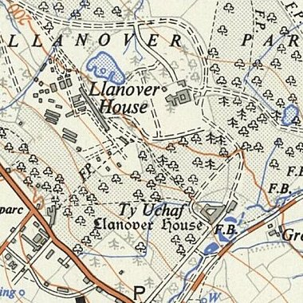
Ordnance Survey 1956.
(Buildings at side of Llanover House are not there 1964)

15 December 1946 – Camp magazine; Llanover Park Echo : Politik Wirtschaft Kultur aus dem Lager : Camp 200 - The Wiener Holocaust Library

25 February 1947 - There was a brief comment about officers in a House of Commons debate:

“Major Bramall asked the Secretary of State for War how many officer prisoners of war at No. 20 [sic] Prisoner-of-War Camp, Llanover Park, have volunteered for work outside the camp; how many are actually working; and how many of those who have volunteered, but are not working, are graded C.

Mr. Bellenger - Between 60 and 70 officer prisoners of war at this camp have volunteered for work outside the camp, and they are all working.” (Hansard - 25 February 1947,
Vol 433).

After the camp: Used for emergency housing – based on comments from forum about memories of being a child born at the camp in 1949. 2020 park and farm land.

Further Information:

Verstacheldrahtete P.O.W. Philosophie (Barbed Wire POW Philosophy) – produced by Gerd Berner, based on his father’s work – 2012 – BookRix

IWM has a copy of the magazine, dated January 1947. Ref LBY E.J.391.

Catalogue entry - 30 - Artist file with 9 drawings/prints done by prisoners in camp 200, Hanover Park, Wales - 1946

