Camp 199 Haverfordwest, Pembrokeshire (aka Portfield)

Prisoner of War Camps (1939 – 1948) - Project report by Roger J.C. Thomas - English Heritage 2003
OS NGR | Sheet | No. | Name & Location | County | Cond’n | Type 1945 | Comments
 |  | 199 | Haverfordwest | Pembrokeshire |  |  | Wales

Location: SM 9338 1544  Before the camp:  Pow Camp: HER DESCRIPTION – “Complex consisting of 32 rectangular plan gable roofed huts with a number of minor structures all of which have been demolished apart from a gatepost and retaining wall of the main gate. Chiefly used to house Italian POW's. Some German POW's also present.”  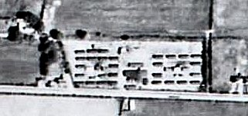  Small, enhanced section of Aerial photograph RAF 106G UK1625 2406  This camp may have been taken over as a hostel by Henllan Bridge camp 70 in 1945 (separate details). Called Portfield Hostel – Portfield Street runs directly in to Haven Road.  After the camp:  Further Information:  http://www.dyfedarchaeology.org.uk/projects/campsandrangespreseli.pdf | 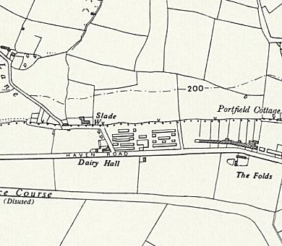
 | Ordnance Survey 1964

