Camp 193 Hampton Park, London

Prisoner of War Camps (1939 – 1948) - Project report by Roger J.C. Thomas - English Heritage 2003
OS NGR | Sheet | No. | Name & Location | County | Cond’n | Type 1945 | Comments
 |  | 193 | Hampton Park, London | London | 5

Location: Approximate centre of Park NGR TQ 167 685.  Before the camp:  Pow Camp:  A reference to the camp by a German pow who was held here for just a few days:  “8-03-1945 Transportation to England - Embarkation in many small boats began on 8-3-1945. After arrival in England, we were transported over three days in railway goods wagons and lorries to Hampton Park, London. We were accommodated in tents. Polish officers questioned us several times. Here I was given my prisoner’s number — No. 659302 together with my release number No. 26 which predicted a longer stay on the Island.”  On 14 March 1945, he was transported to another camp. (Submitted by Patrick Barrett, regarding pow Willy Reuter to the BBC People’s War website, Article ID A8080102).  After the camp:  Further Information: | 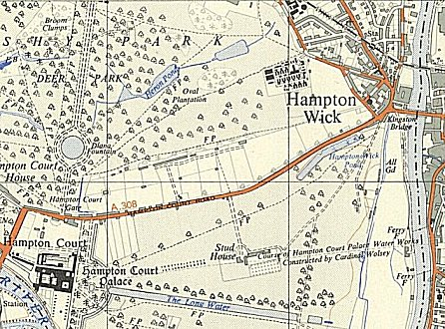
 | Ordnance Survey 1956

Beginning to have doubts over this site!

1 – note it is not called Hampton Court Park, the correct name.

2. Just the one BBC reference above and another which mentioned “Hampton Park Racecourse” – beginning to wonder if this was really the nearby Kempton Park site.

US Camp Griffiss was in Bushy Park – did this hold pows after D-day?

