Camp 190 Lissanoure Camp, Loughgiel, Cloughmills, Co Antrim

Prisoner of War Camps (1939 – 1948) - Project report by Roger J.C. Thomas - English Heritage 2003
OS NGR | Sheet | No. | Name & Location | County | Cond’n | Type 1945 | Comments
 |  | 190 | Lisanoure Camp, Loughgiel, Cloughmills | County Antrim |  | Base Camp | Northern Ireland

Location: Within the Lissanoure Castle Estate.  Before the camp: Country estate. Estate requisitioned at the start of the war. Part of the site was used by the British Army for oil storage. 1943 the US Army 41st Group was based here prior to D-day.  Pow Camp: Pow camp from 1944 to 1945. Noted that many of the pows were submariners.  Camp derequisitioned 1945. (FO939/383).  After the camp: The Mackie family retook possession in 1945, they had bought the estate in 1943. 2020 country estate – popular for weddings at the castle.  Further Information: | 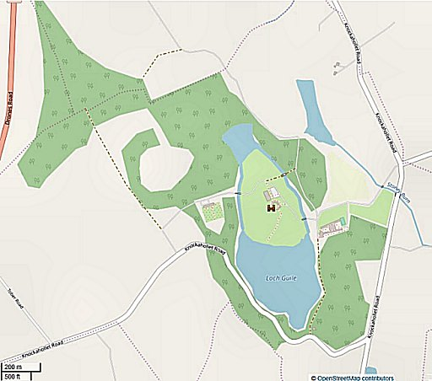
 | © OpenStreetMap contributors

