**Camp 18****9 Dunham Park Camp, Altrincham, Cheshire**

|  |  |  |  |  |  |  |  |
| --- | --- | --- | --- | --- | --- | --- | --- |
| **Prisoner of War Camps (1939 – 1948) - Project report by Roger J.C. Thomas - English Heritage 2003** | | | | | | | |
| OS NGR | Sheet | No. | Name & Location | County | Cond’n | Type 1945 | Comments |
| SJ 751 878 | 109 | 189 | Dunham Park Camp, Dunham New Park, Altringham | Cheshire | 4 | Base Camp | Restored parkland |

|  |  |
| --- | --- |
| **Location:** On the W edge of Altrincham. Note Dunham NEW Park, not the main Dunham Park nearby.  Aerial photo 1945 –  [raf_106g_uk_622_rp_3303 - Aerial Photo | Historic England](https://historicengland.org.uk/images-books/archive/collections/aerial-photos/record/raf_106g_uk_622_rp_3303)  **Before the camp:** Part of the Dunham Massey Estate. US troops used the site from October 1943 to just before D-day. There were two sections to the camp; north and south.  **Pow Camp:**  **October 1944** - it was decided to use the site as a pow camp with a maximum capacity of 3,500. The camp was surrounded by barbed wire fencing. There were huts for accommodation, ablutions, water storage, offices, and a theatre. |  |
| Ordnance Survey 1954 |

**November 1944** - Italian pows were remembered as the first prisoners, with Germans soon after. It seems likely that the Italians were not here in large numbers, but as a working party to ready the camp for receiving German pows. As the Germans arrived, the Italians were moved to a hostel in Bowdon prior to repatriation.

**23 November 1944** - the Commandant and land owner, Lord Stamford, toured the site. It had already expanded to 4,000 pows. The capacity was expanded to 6,000 by the end of 1945.

Polish guards (No.1 PGC) were used for a while at the camp. British troops ran the administration offices.

*“German POWs arrived and two German Jews assisted with interpretation. Initially there was hostility between the prisoners and their guards until both realised that there were advantages from co-operation, and a black-market in cigarettes developed.*

*The POWs were guarded by Free Polish Army soldiers who patrolled the perimeter fence. There were two watchtowers equipped with searchlights. British troops were only concerned with administrative duties. Later more SS prisoners arrived, ranging in rank from lance-corporal to sergeant-major. There were regular random searches of the huts and POWs were counted two or three times a day which took about an hour each time. POWs called it an Appel. No-one ever escaped.*

*If a POW needed to be transferred to another camp this would be by train with the POW handcuffed to his kitbag. An orderly room sergeant received the following after one delivery to Northumberland: “Received, one live body of one prisoner of war.” POWs had a strict code of conduct and dealt with theft themselves. At the end of the war security was relaxed and POWs used to lock themselves up at night.*

*At its height in 1945 there were about 220 buildings in the camp, housing 6,000 POWs, well above average. The POWs had closely-shaven heads and highly-polished boots. The many SS troops could be identified by tattoos of their blood group on their arms. A former orderly-room sergeant said “they were Rommel’s men.” The British camp adjutant was called Fisher and the commander was Lieutenant-Colonel George W Kilby. POWs said that they were well treated by him and the other British officers.*

*Reliable POWs were given the opportunity to work on farms, in market gardens, at Dunham Hall, and in other occupations and were said to be very efficient. Most usually volunteered to ease the boredom. Local builder Alan Gibbons used to drive POWs to nearby farms. Some worked behind the bar in the British Officers’ mess.”* Extracts from – ‘Communigate – This is Cheshire.’

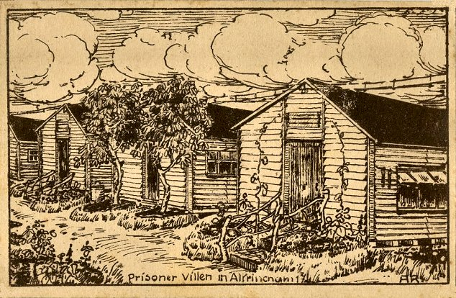

< Postcard showing Dunham, with thanks to Altrincham Area Image Archive. The artist ‘AR’ has not been identified.

*“Alfred Paeserack, a POW at Dunham between 1945 and 1948 left the area but kept links with several families for over 50 years. He wrote his memoirs in 1995, which are held in Trafford Local Studies and include sketches of POW camps in Cheshire produced by a Dunham prisoner, and several photographs of himself and a Dunham girl he befriended.*

*Alfred said rations were small. Breakfast consisted of one slice of bread and one third of a bowl of porridge. In the afternoon soup was served on a flat tin plate with a thin slice of bread. For the first few months only cabbage soup was available. Supper was a cup of tea and two slices of bread with a very thin layer of spread. Showers were allowed on Friday or Saturday when clothes were washed as part of the process. There were 50 men in a hut which had tables and chairs in the middle. The blanket, kitbag and towel had to be kept folded on the mattress with plates etc on top. Rooms were checked constantly. No photographs were allowed and sleeping was forbidden in the daytime. There were three roll-calls per day with the POWs in columns of five.*

*Eventually prisoners built flower beds and grass areas around the huts, the paths were improved and the huts painted white. The POWs offered courses in languages, business studies, engineering, history, etc. A theatre group was formed and there were performances with proper sets and costumes. One was of the operetta Gluckliche Reise, with a railway station set, wagons and good costumes. A pastor and a priest were given rooms for church activities and were soon allowed to go to local churches without a guard. Later prisoners were also allowed to attend churches. In 1946 ten Germans went out of the camp to work as a trial and soon POWs were working for farmers, companies, road builders, market gardeners such as Clibrans and Caldwells, and for Cheshire County Council. Before long all POWs were working. Alfred's job was as a pipe layer with nine other POWs and ten locals.”*

From “The Bowdon Sheaf;” Bowdon History Society, No 48, February 2010 – by David Miller.

**13 April 1945 -** when Vienna was liberated, Austrian pows at Dunham made an Austrian flag and threw it over the branches of a tree to celebrate, (reported in ‘*Prisoners of England’* by Mirian Kochan). Austrian and German pows would have been kept separate within the camp.

Children in the area recall various impressive models in the grounds which could be seen by passers-by. These included a model railway, *“with stations, tunnels and real steam engines, landscaped to produce a most striking effect. When they saw us approaching, they would throw us toffees over the barbed-wire fence. I can only guess that these were received in Red Cross parcels.”* There was also a six feet high model of a Bavarian castle.

**End April 1945** – 600 Austrian pows moved from this camp to Meesden camp 128.

**23-26 June 1945** – Approximately 800 Austrian pows moved from this camp to Bickham Camp 20.

**September 1946** - Dunham was wound down and listed as a hostel for Marbury Hall camp which took the number 189.

The last record of the site as a hostel attached to Marbury was in October 1946. Some billeted pows stayed on to work in the area. The Manchester Regiment moved to the camp in early 1947.

Known Camp Commandants:

1944 - ? Lieutenant Colonel Buisseret – I think this may have been Edmund Joseph Buisseret of the Royal Artillery / Pioneer Corps.

1945 Lieutenant Colonel George W Kilby

**After the camp:** 2020 Dunham Forest Golf and Country Club.

**Further Information:**

Trafford Local Studies Centre Collection. Archive reference TRA773. Handwritten version of 'Prisoner of War Camp Dunham Park, Great Britain: an eyewitness report 1945-1948' by Alfred Paeserack