Camp 188 Johnstone Castle Camp, Johnstone, Renfrewshire

Prisoner of War Camps (1939 – 1948) - Project report by Roger J.C. Thomas - English Heritage 2003
OS NGR | Sheet | No. | Name & Location | County | Cond’n | Type 1945 | Comments
 |  | 188 | Johnstone Castle Camp, Johnstone | Renfrewshire |  | Base Camp | Scotland

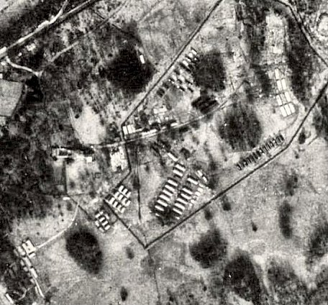  Location: NGR NS 433 624.  1950 aerial photo - View map: Ordnance Survey, OS Air Photo, 6 inch to the mile  Before the camp: Housed various troops including Polish. A Polish soldier who died at the castle is buried in the nearby woods.  Pow Camp: “The camp, built within the former estate grounds, forms an irregular rectangle between the Castle and the Kings Road to the E. It is bounded by a single perimeter fence and visible on the photographs are at least 155 huts of different types. There are a further 26 huts outside the perimeter fence, presumably for staff accommodation. Entrance to the camp was from the Beith Road.”  (Information from RCAHMS (DE), July 2005)  Memories - “…at the very end of the war it was fortified to hold captured troops, not German, but from some European ally of Germany. | 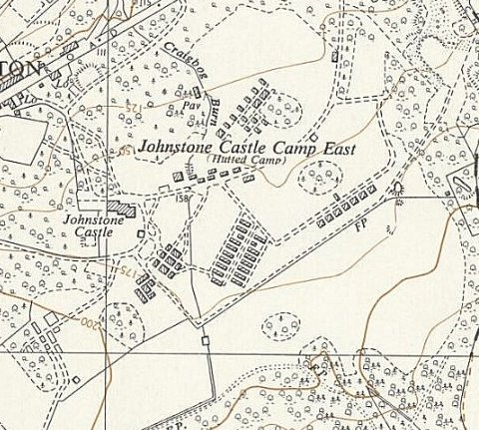
 | Ordnance Survey 1954
These soldiers were badly treated for the first week of captivity in this camp. At the time I thought they were being starved as punishment for the exposure of Belson, but on recollection I guess it was only impossible organisation at the war’s end. They received no supplies whatever for the first week in the camp. The school kids of Johnstone bartered loaves over the high barbed wire for all the petty possessions these pathetic creatures had, though when supplies did arrive, I remember a great side of beef being carved al fresco.
When they departed, the camp had a barrack block beautifully decorated as a chapel and an almost Olympic sized pool dug in the castle lawn.” (From BBC People’s War website – Memories of Harry Collins – Article A1989228 – 7 November 2003).

From this it would seem the camp held mixed nationalities for a while. However, this arrangement was not liked as it often led to troubles and later it was a German camp.

Pows worked at local farms and at the Bridge of Weir Tanneries.

1 June 1946 - Camp magazine; Camp-Echo : Camp 188 - The Wiener Holocaust Library

Oversight and development of re-education activities and English teaching for German pows was carried out by PID (Political Intelligence Department of the Foreign Office) / COGA (Control Office for Germany and Austria – UK). Visits and reports were made. The standard of the reports varied greatly. The visitors took little interest, if any, in activities other than re-education. They rarely mentioned welfare, sports, games, pastimes, crafts, etc of the pows. If there were still Italian pows in hostels, they were usually ignored by PID.

11 October 1946 – English Inspector’s Report. German Working Camp. Strength; 700, including 130 billetees. No hostels. Hutted camp.

Commandant: Lt Col Larcombe Camp leader: Műller.

26 pow pupils in 4 classes. Lessons were disrupted by frequent long working hours gathering the harvest.

6-7 November 1946 - As part of the re-education programme administered by the Control Office for Germany and Austria (COGA), Paul Bondy, a German-speaking refugee gave lectures at the camp. He recorded a camp complement of 700.

17 to 20 November 1946 – Report by the Segregation Section of PID on political screening. Strength; 2 officers (probably the M.O.s), 524 Other Ranks. 125 billeted.

Commandant: Lt Col A J B Larcombe Camp leader: Not listed.
Interpreter: S/Sgt Bruder

Political screening: | A+ | A | A- | B+ | B | B- | C | C+ | Unscreened
 | 60 |  |  | 477 |  |  | 88 |  | 1 in hospital

Other pows from several other camps were brought to Johnstone to be screened. The British staff were fully co-operative with the screening process. Many of the C grade pows had been held for a few years and had been in camps in Canada. Many retained their Nazi ideology. Evidence given at the Nürnberg trials was the most frequently referred to influence in changing their minds.

April 1947 – noted that all library books had been transferred to Camp 182, so Camp 188 likely to have closed.

Unknown date - A story in the Paisley Daily Express stated that a German pow (unnamed) died violently at the camp and was buried in the woods. Two totally conflicting stories about this – he was shot in an escape attempt / he was murdered as an informer. Although there is not a burial site now, this may mean that the body was reburied at the German Military Cemetery.

One of the German parachutists who rescued Mussolini in 1943 was held at Johnstone Castle. He later married and settled in Scotland.

Known Commandants:
Lt Col AJB Larcombe, Pioneer Corps. Later Commandant at White Cross Camp 115.

After the camp: Recorded as a Polish Resettlement Corps camp with the first Polish troops arriving on 11 January, 1947. Used as emergency housing. 2020 residential area, including the castle.

Further Information:

Two reports used above mis-filed in National Archives FO 939/177 and FO 1120/242

canmore.org.uk/site/273038/johnstone-castle-johnstone-castle-camp-german-working-camp-no-188

Vertical air photograph (106G/Scot/UK 140 [Pt.II], 5167-5168, flown 3 July 1946).

