Camp 187 Dungannon, County Tyrone

Prisoner of War Camps (1939 – 1948) - Project report by Roger J.C. Thomas - English Heritage 2003
OS NGR | Sheet | No. | Name & Location | County | Cond’n | Type 1945 | Comments
 |  | 187 | Dungannon | County Tyrone |  |  | Northern Ireland

Location: There are photos showing a small row of buildings which remain of what was once the Ballynorthland Prisoner Of War Camp in Dungannon.  Local memories place it in ‘The Park’ – shown on the map. Corroborated by; “…my Grandfather was a guard in the camp. It was situated inside the now Dungannon Park which is situated on the Moy Road as you drive into Dungannon” and other memories.  Before the camp: The 3d Field Artillery Observation Battalion of the United States Army were based at Ballynorthland for a short time. Ballynorthland Manor (A) is alongside the lake at the top of the park.  Pow Camp:  1944 – a small castle was built by pows on a large rock by Dungannon Rugby Club Pavilion (B). It stood 4 feet high. One memory stated that German Officers were held in the Pavilion.  18 July 1945 – Notes from the Segregation Section of PID – ‘Progress Report 126’ (FO 939/383) –  Provisional political screening: Whites (A) Greys (B) Blacks (C) Total  76 616 310 1002  No date - News article in The Irish News – unfortunately it did not have a date: | 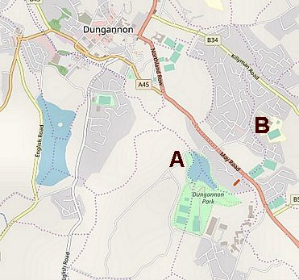
 | © OpenStreetMap contributors

“While attempting to escape from a prisoner of war camp near Dungannon, Co Tyrone on Monday night, a German prisoner of war, aged 21, was fired on by the military guard and received five bullet wounds.

He was attended by two German doctors and by Dr J G Bell of Dungannon and was later removed to a military hospital in Belfast in a serious condition. It is stated that the German had got clear of the heavy barbed wire entanglements when spotted, and as he refused to halt, the sentry opened fire. He received four bullet wounds in the right arm and the fifth in the chest. The right arm was badly shattered and Dr Bell had to give a blood transfusion.”

1945 – Camp closed (FO939/383).

After the camp:

Further Information:

