Camp 186 Fornham Park Camp, Bury St Edmunds, Suffolk

1947 Camp List
186(B.C.) | Berechurch Hill Camp, Colchester, Essex | E. | Priswar, Colchester | Colchester 4275/6/7 | Colchester | Lt.Col.R.F.Squibb M.C. | v/202/4
The entry above has been crossed out in blue crayon and the following details handwritten on.
 | Fornham Park, Bury St Edmunds, Suffolk |  | Priscamp, Bury St. Edmunds | Bury St Edmunds 2322 | Bury St. Edmunds | J.F.Ashton | v/202/5

Location: NGR for Fornham Hall TL 841 684. A large number of huts can be seen dotted about all over Fornham Park on the map.  Before the camp: Country Hall and Estate. In late 1939, Fornham Park and Hall were requisitioned by the War Department for troops.  Early 1947 - the military camp had been empty for well over a year and was in bad repair. The waste of space and money was raised in the House of Commons by Geoffrey Clifton-Brown, MP for Bury St. Edmunds. (Hansard Commons - 13 March 1947, Vol 434).  Two months later he raised the site again;  “Lieut.-Colonel Geoffrey Clifton-Brown asked the Secretary of State for War why it has become necessary to recondition and re-equip Fornham Park Camp, Bury St. Edmund's, which has stood derelict for 18 months; what will be the cost of this work; and if there is no barrack or permanent camp more suitable for peace-time military occupation.  Mr. Bellenger - Fornham Park Camp, Bury St. Edmunds is being reconditioned and re-equipped to accommodate a regiment returning from overseas. The camp was evacuated approximately six months ago by Polish Forces when it was certainly not in a derelict condition. The cost of the work being carried out is estimated at £700, and there is no more suitable barrack or permanent camp available at present for the purpose for which it is required.” (Hansard - 6 May 1947 - Vol 437).  This response was challenged as there was no knowledge of Polish troops at this site, the site was empty and was certainly in a bad state up until the time of reconditioning. There was then a change for the purpose of the camp as it became a camp to hold pows being repatriated through Harwich. | 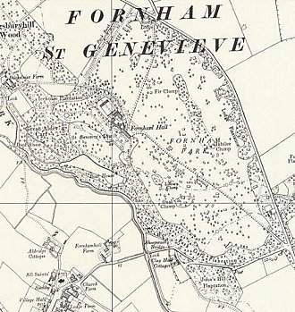
 | Ordnance Survey 1957
Pow Camp: The camp was open from summer 1947 to late spring 1948. It was allocated number 186 as Berechurch Hall Camp was closed down. Some pows and British staff were transferred from Berechurch to Fornham.

Oversight and development of re-education activities and English teaching for German pows was carried out by PID (Political Intelligence Department of the Foreign Office) / COGA (Control Office for Germany and Austria – UK). Visits and reports were made. The standard of the reports varied greatly. The visitors took little interest, if any, in activities other than re-education. They rarely mentioned welfare, sports, games, pastimes, crafts, etc of the pows. If there were still Italian pows in hostels, they were usually ignored by PID.

7-9 and 13-14 January 1948 – 186 German Base Camp; Progress Report [on re-education]. This was the 3rd PID visit, the previous reports are not in the NA file.

Strength; Pow staff: 0 Officers; 443 Other Ranks. Total 443.
Repatriates: 25 Officers; 916 OR. Total 941.

It was estimated that 24,000 pows had passed through this camp as repatriates from July 1947 to January 1948. There were 3 to 4 new intakes each week as repatriations were speeded up.
Commandant: Lt Col J F Ashton * Camp leader: O/Fw Hans Heibach (A) *
Interpreter: Capt H Lambert (R.P.C) * Deputy C/L: Uffz Karl Ferk (B)
Adjutant: Capt J F G Smith (R.A.) German M.O.: U/Arzt Adolf Dahmen (B)

* Known to have transferred from Berechurch.

Lt Col Ashton was reported as being unpopular with the British officers, (as at Berechurch), however he was regraded as “scrupulously fair” by the pows.

Interpreter Officer Lambert was very highly regarded.

The camp leader was recorded as an “outstanding personality” and extremely popular. He had deferred his repatriation.

M.O. Dahmen was, “of reticent temperament,” who did not take part in any cultural activities.

Simplified political screening figures were given for the pow staff only; A 3 / B 440. The 3 As had deferred their repatriation. 160 staff members repatriated since July 1947.

Due to the nature of the camp with large numbers of pows passing through, military discipline was maintained more so than in working camps. Pows in transit were only allowed to leave the camp twice per week. Despite this, morale was good for pows returning to ‘western’ zones of Germany, less so for those returning to the Russian zone. Most pows were politically apathetic and down-hearted over the future of Germany.

It was difficult to organise re-education activities in this type of camp. The standard list applied mainly to the staff:

Lectures – regular, but declining in popularity. Appreciation depended on the speaker and the subject.

Discussion groups – a small group discussed political matters.

Camp magazine – imported from Berechurch camp; “Querschnitt.” Monthly, with an intention to increase production to 350 copies.

Press review – popular daily news-sheet issued, “Lagerkurier.” The Interpreter selected items from Hansard regarding pows and Germany, and displayed them in the Information Room with humorous cartoons.

Newspapers – 40 British newspapers and some illustrated magazines. COGA supplied 6-8 German papers per week and some pows were sent copies from relatives in Germany. 2 Swiss papers received.

Library – 3000 books, about 1000 in English. There were strict controls to ensure books did not leave with pows being repatriated.

Information room – displayed text and pictures on a theme, often concerning Germany and repatriation.

Wireless – there were 9 sets in the camp with extension speakers. German stations could be received, though ‘faded’ on some sets.

Films – very frequent, up to every 2 days. However, the projector was temporarily out of action.

English instruction – no formal classes. Some pows studied privately.

Other camp activities –

Education – no classes.

Religion – Little interest. Protestant padre, Ludwig Pongartz (B). RC padre, Hans Glassner (A).

Entertainment – an active theatre-Variety group of 10 men, but suffering from repatriation of its own members. Put on 3 or 4 shows a week for the repatriates.

Formal outside contacts – some pow staff had attended Bury St.Edmunds Town council meetings. Bury Quaker Society invited pows to their cultural meetings. Sports matches were held with some local sports groups.

11/14 May 1948 – Outlook / Re-education report. Recorded as the 11th visit – other reports are not in the NA file.
Strength; Pow staff: 2 Officers; 283 Other Ranks. Total 285.
Repatriates: Approximately 2500 on arrival, increasing to 4500 during the visit.

Some of these last pows to be repatriated included very high ranking officers from Island Farm Camp – called “the Bridgend Generals.”

Two changes noted for senior personnel - Interpreter, Capt H Lambert had been joined by S/Sgt Levy. The German M.O. was O/Arzt Franke.

A survey was conducted in camps still open at this time concerning pow attitudes to the British. It was pointless, carried out far too late and in totally random ways. Some visitors simply gathered whoever was around and asked them to give a show of hands to the questions, some only asked a ‘selected’ group – most did not state how the data was gathered or the numbers involved. At Fornham 180 pows were asked for their views, who they were, how they were asked was not recorded. For what it is worth (nothing?) the results were:

Hatred | Dislike and distrust | Indifference | Benefit of the doubt / Liking
0% | 45% | 20% | 35%

Re-education activities had all but ceased. An Information Room continued, but it was noted that some pows had applied disgruntled comments to the displays. The Lagerkurier daily news-sheet continued. There were no visiting lecturers.

Outside contacts – the people of Colchester had mostly lost interest and talked of “the PW plague” as they saw so many. There were no formal organised contacts. Some ex-pows who had settled in the UK visited the camp, or invited old friends to visit them before they left – there were 30-40 applications for this per day.

The theatre group performed to “overflowing houses” and charged 1d entrance.

An appendix to the report concerned visits by ‘Resettlement teams.’ This camp had six visits since February – most camps had none. The teams were mainly German lecturers giving advice on conditions in Germany. Although some of the speakers were very eloquent, the pows found little of any constructive value.

Fornham Park was recorded as the last pow camp to close.

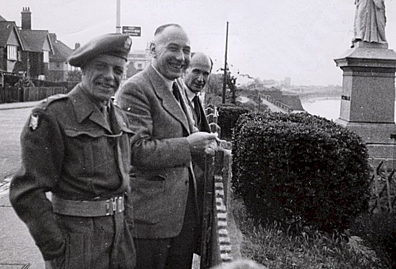 | 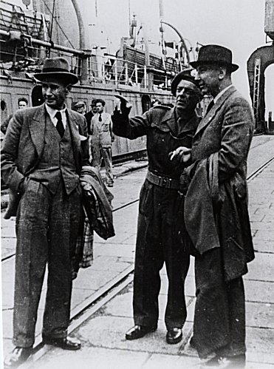 | 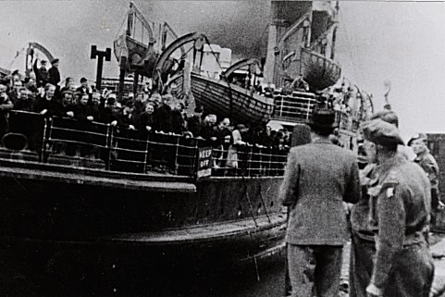
1948 Caption for Photographs – ‘Dernier rapatriement de prisonniers de guerre allemands’ – The last repatriation of German Prisoners of War – ICRC Archive

The pictures above were taken in Harwich, dated 12 July 1948.

In picture 1, from left to right; Lt Col J F Ashton, camp commandant; Frédérick Bieri, ICRC delegate; and Jean Muller, ICRC delegate. Frédérick Bieri was the lead delegate and wrote many pow camp reports for the ICRC. Pictures 2 and 3, the same men at the port. The ship was the SS Biarritz.

Unknown date / name - One German pow committed suicide by hanging in the woods at the camp. It was believed that he feared going home to the Russian sector of Germany.

Camp Commandant: Lt Colonel John Forbes Ashton, from the Border Regiment. He was previously at Ellough Airfield Camp 258, then at Berechurch Hall Camp 186.

After the camp: The Hall was demolished in 1951

Further Information:

National Archive file - FO 1120/231, 2 reports used above.

History of Fornham Park - stedmundsburychronicle.co.uk/fornhampark/fornhampark.htm

