Camp 173 (& 681) - Rockport Camp, Belfast, County Down

1947 Camp list
682(G.W.Coy) | N.I.D. | Rockport, Craigavad, Co.Down, N.Ireland | Holywood 2309 & 3090 | (Blank) | V/1270/4

Prisoner of War Camps (1939 – 1948) - Project report by Roger J.C. Thomas - English Heritage 2003
OS NGR | Sheet | No. | Name & Location | County | Cond’n | Type 1945 | Comments
 |  | 173 | Rockport, Belfast | County Down |  | Base Camp | Northern Ireland. See Camp 173 / 681
 |  | 681/682 | Rockport, Craigavon |  | 5 | German Working Company

Location: Seahill, Co. Down. Contemporary newspaper reports suggest the camp was on the other side of the village where concrete bases of Nissen huts remain standing in woodland near the sewage treatment works at the coast.  Before the camp:  Pow Camp:  Italian pows recorded here from end 1944 to early 1945. Germans later.  Various memories – “Evelyn Aickin told of an escape attempt in Rockport, when the local policeman had been out on his bicycle looking for the prisoner; Mary Strahan herself observed a policeman with his hand on the shoulder of a POW bringing him in to the former Helen’s Bay police station. Alfie Beaney and Betty Lowry remember local houses being searched, following an escape. Jim McClements remembers the high fences and barbed wire surrounding the camp. Nikko Duffin also recalls passing the camp one day, back from a swim below Craigdarragh, when he and his companions’ eyes were stung, which came from tear gas which must have been used at the camp, perhaps to restrain the prisoners. Lionel Carew, whose family was then living at Fairholme (with a flock of chickens which he recalls had a particular propensity to roam across the Craigdarragh Road), remembers parties of prisoners on their way to work on local farms singing Deutschland uber Alles. Margot McClements has evidence of the friendship between her uncle and another German prisoner – Karl Schouau, POW No. 20317. The photograph of Karl in his uniform is dated 27 April 1947, at Rockport camp though was no doubt taken a good deal earlier, as may be seen from the accompanying photograph of Karl in his POW dress with Anne McBride. It was given ‘in | 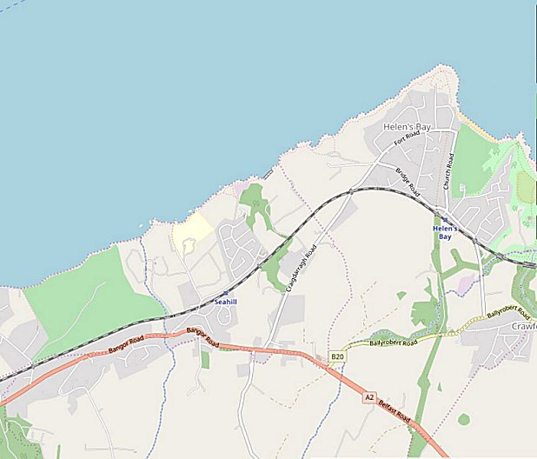
 | © OpenStreetMap contributors
thankfulness for received hospitality’. It is understood that he had been allowed out to help those working with the horses at Enfield House at the top of Craigdarragh Road, and this was where he met Dickie McBride, with whom he then kept in touch for many years after his return to Germany. Their friendship is the more remarkable given that Dickie had been a staunch member of the Home Guard.“ (from; ‘Twixt Bay & Burn’ A History of Helen’s Bay & Crawfordsburn by the Bayburn Historical Society. Compiled and edited by Robin Masefield, 2011).

18 July 1945 – Notes from the Segregation Section of PID – ‘Progress Report 126’ (FO 939/383) –

Provisional political screening: | Whites (A) | Greys (B) | Blacks (C) | Total
 | 84 | 884 | 273 | 1241

29 April 1946 - Belfast Telegraph; “Football is the favourite pastime of the Rockport Camp. Most of the prisoners are newcomers to the game but it is extraordinary how quickly they have mastered it. There is one youngster who is considered to be the equal of Davy Cochrane, and another who has the technique of a Joe Bambrick. Some of them, it is said, can almost make the ball talk.” Not sure why most prisoners would be “newcomers” to the game.

26 May 1946 – Camp magazine; No.6; Die Sendung : Wochen Zeitschrift des Camp 682 Rockport - The Wiener Holocaust Library

An article entitled “Austrian Corner” shows that Austrians were also held here – they were holding press reviews with newspapers from Austria.

18 December 1946 – A ‘Special Report’ was issued about Victoria Camp 85. It refers to the arrival [why?] at Camp 85 of 600 pows from 681 POW Company (listed as Rockport Camp). They only stayed for a short time and comments made were that they had: “first shed some of their rather clannish feelings of superiority, and having contributed a good deal to the cultural life of the camp during their stay.”

1947 – Closed.

After the camp:

On 23 and 24 June 1948, an auction took place of the camp contents:

Item | Quantity | Information
Standard Nissen Huts | 91 | 36' x 16' (22 with Dormer Windows)
Nissen Hut | 1 | 96' x 16' (8 Dormer Windows)
Nissen Hut | 1 | 90' x 16' (8 Dormer Windows)
Nissen Hut | 1 | 72' x 16' (4 Dormer Windows)
Nissen Huts | 5 | 54' x 16'
Nissen Huts | 3 | 48' x 16'
Nissen Hut | 1 | 42' x 16'
Nissen Huts | 2 | 30' x 16'
Nissen Hut | 1 | 24' x 16'
Nissen Hut | 2 | 18' x 16'
Nissen Hut | 1 | 12' x 16'
Brick Buildings | 5 | Covered with Asbestos and Corrugated Iron with Wood Purlins.
Heating and Water Plant | 1
Pumping Plant | 1 | With Lister 3.5 HP single-cylinder Diesel Engine. Wrought iron piping and fittings.
Pumping Plant | 1 | With Lister 7 HP Petrol Engine. Wrought iron piping and fittings.
Lumby Solar Domestic Hot Water Boilers | 2
Beeston OX Domestic Hot Water Boilers | 2
Hot Water Storage Cylinders |  | 260 Gallon, 150 Gallon, and 48 Gallon.
Sectional Steel Tanks | 2 | Approximately 5,500 Gallons Each.
Sectional Steel Tanks | 2 | Approximately 3,000 Gallons Each.
Sinks | 11
Other items - Galvanised Iron Storage Tanks / Iron Piping / Rotary Pumps / Ranges / Farm Boilers / Soyer Stoves / Ablution Benches / Spar Shelving / Duck Boards / Steel Cupboards / Wooden Cupboards / Concrete Flags

Further Information:

https://archives.wartimeni.com/location/co-down/seahill/rockport-prisoner-of-war-camp/

