Camp 170 (& 292) - Weelsby Camp, Grimsby, Lincolnshire

Prisoner of War Camps (1939 – 1948) - Project report by Roger J.C. Thomas - English Heritage 2003
OS NGR | Sheet | No. | Name & Location | County | Cond’n | Type 1945 | Comments
TA 285 077 | 113 | 170 | Weelsby Camp, Grimsby | Lincolnshire | 4 | Base Camp | Camp occupied a circular plan within an irregular perimeter fence guarded by nine watchtowers. Site restored parkland. See Camp no.292
 |  | 292

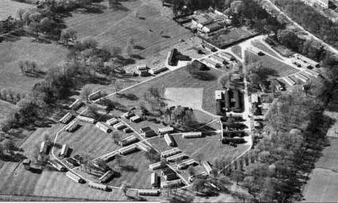  Location: In Weelsby Woods park.  Before the camp: Area used during WW1 for training and transit of soldiers.  1946 – a different aerial view ;  raf_3g_tud_uk_203_v_5059 - Aerial Photo | Historic England  Pow Camp: Italian, and then German pows.  9 March 1945 - Progress Report 51 - FO 939/383 (by PID - Political Intelligence Department of the Foreign Office) – “By arrangement with D.P.W. No.170 Camp… will be opened in the near future as a dumping ground for members of the Barred Units (e.g. G.A.F., G.N., S.S., R.A.D., O.T.) who have been certified by PID as anti-Nazi – total capacity:- 1,200.” | 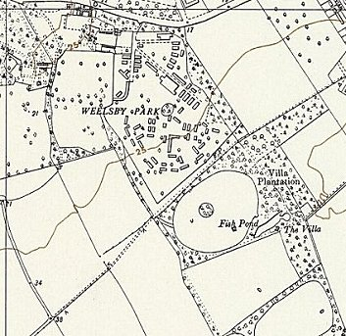
 | Ordnance Survey 1956

GAF = usually German Air Force; G.N. = German Navy; SS = Schutzstaffel (interesting that any members would be considered anti-Nazi in 1945); RAD = Reich Labour Service, Reichsarbeitsdienst; O.T. = Organisation Todt, a mixed volunteer and forced labour force, regarded as paramilitary.

7 June 1945 – Progress Report 92; “We have been informed by D.P.W. that Camp 170; which contains a total of 926 Ps/W, is being dissolved. 840 Ps/W are being transferred to form a new Camp no.39. The remainder (less 43 Nazis who are being moved to 17 Camp) will go to another new Camp no.60. This Camp has a capacity of 677 and D.P.W. have agreed at our request to draw the bulk of the prisoners for this Camp from Camp no.169. where the general trend is reported by the Camp authorities to be grey/white.

Camp 70 will now contain Poles. Signed – G Sinclair, Lt col.”

Camp 39 was Maxstoke Castle – the camp had been open to Italian pows – it was ‘new’ to German pows having held Italians. Camp 17 = Lodge Moor. Camp 60 = Overdale, again, only ‘new’ as a German camp. Camp 169 = Tollerton Hall.

Scartho Road Cemetry, Grimsby contains burials from the First and Second World Wars. Survey states – “There are also 17 war burials of other nationalities many of them German prisoners of war from the camp at nearby Weelsby.” See below.

After the camp: Used as displacement camp for 900 Polish troops from the Polish Independent Carpathian Brigade, (Pulk Utanow Karpackich). Resettlement Camp. From 1951 reverted to parkland.

Further Information:

National Archives DEFE 51/65 – Grimsby: Weelsby Park former PoW camp; disputed compensation claims, and settlement thereof. Dated 1953-1956.

Scartho Road Cemetery.

17 burials = 16 Axis forces + 1 Norwegian, during / after WW2.

Of the Axis forces, 7 were from 1940 to 1943, all German Air Force casualties, and before the camp.

9 were possibly pows from Weelsby Camp. This is a very high number if they all came from the one camp – Unless, there was a hospital associated with the camp.

GUISEPPE TEDESCO – Soldato - Service Number: B/245626 - Italian Army - Died 24 December 1944 - 45 years old (recorded as 35 on CWGC).

LUDWIG BLASZCZOK - German Army - Died 04 September 1945 - 39 years old

FRANZ SCHMIDT - German Army - Died 01 August 1946

FRANZ KAPRON - German Navy - Died 07 September 1946

WALDEMAR BRONNY - German Army - Died 20 March 1947 - 39 years old

BRUNO KLUCK - German Army - Died 12 June 1947

VIKTOR KOCZY - German Army - Died 31 August 1947

ERICH SCHOPPA - German Army - Died 05 October 1947

HEINRICH KREBS - German Army - Died 04 November 1947

