Camp 169 (& 613 / 698) - Tollerton Hall Camp, Tollerton, Nottinghamshire

Prisoner of War Camps (1939 – 1948) - Project report by Roger J.C. Thomas - English Heritage 2003
OS NGR | Sheet | No. | Name & Location | County | Cond’n | Type 1945 | Comments
SK 6153 3349 | 129 | 169 | Tollerton Hall Camp, Tollerton | Nottinghamshire | 5 |  | Restored parkland. Evidence of hut  footings also visible at SK 6136 3457. See Camp no.613
 |  | 613

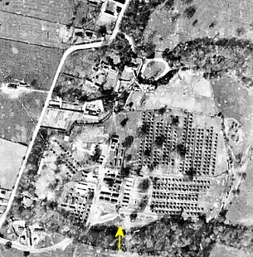  Location: About 8 km SE of central Nottingham.  Before the camp: Country estate. After 1929, it ceased to be a private house and the owners turned it into a residential sports club and hotel. At the start of WW2 it was requisitioned and used by the Army, RAF, and the US 507th Parachute Infantry Regiment up until May 1944. The 507th arrived in March 1944 and the camp was then described as a tent city – with officers using the Hall.  1944 – huts and tents - us_7ph_gp_loc282_v_5035 - Aerial Photo | Historic England  Pow Camp: Reports state that Italian and then German pows were held here and guarded initially by Polish soldiers.  8 June 1945 - PID Progress Report 101, from Segregation Section – “In view of great demand for labour in recent weeks, we have had to ask D.P.W. to provide the 550 Ps/W required as additional labour for [Camp 86]. This camp was opened by the War Office and has not been screened by us…. D.P.W. agreed at our request to draw the Ps/W from Camp No.169.” | 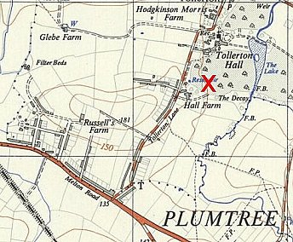
 | Ordnance Survey 1952
30 October 1946 - Incidental information from a German theatre group journal held by the Deutsches Historisches Museum. The group toured pow camps around England during 1946. It recorded its visit to Tollerton Hall Camp, 698 on this date. (Note use of 698 at this time).

1 January 1947 – Camp magazine No.9; Lagerspiegel : 698 Tollerton Hall Camp - The Wiener Holocaust Library

A review of recent Christmas events was given:

December 8; the Heinz Priester band gave a concert – “The program featured mostly good German music.”

December 21; weekly press review was restarted after a break. An information board was also set up with pictures, German and foreign articles, and news.

December 22; (Sunday) a small group of pows gathered in the ‘study’ (reading/information room) for a part of Bach's Christmas Oratorio. It did not say if this was a gramophone or choir performance.

December 24 – “At 8 o'clock in the evening, we gathered in the dining hall, which had been festively decorated for Christmas. On tables covered in white and decorated with greenery, each person had a plate of pastries, apples, nuts, and cigarettes, alongside platters laden with pies and cakes. The Christmas tree, with its large and small white and silver stars and tinsel, shone with lights, and candles burned on the tables. All of this put us in the perfect Christmas spirit.” There was a short speech by the camp leader, and performances by the orchestra and choir. “At 10 p.m., almost the entire camp was out for a short stroll in the park; the brass band played "Silent Night" and "Oh, how joyful" by torchlight on the castle's highest battlement. The ancient melodies swung like a fairytale through the starry night, filling the hearts of the strollers with solemnity.”
December 25 – an English Catholic priest celebrated Holy Mass in the morning. The choir sang two hymns during the service. In the evening, the Heinz Preister band gave a concert.

105 pows (10%) were invited to spend Christmas with local families.

December 26 - Pastor Karl Kessler held a service in the Protestant church, with the choir again participating. This was followed by Holy Communion. The Catholic German chaplain of Camp 52 held another service in the Catholic Chapel. A prize ‘skat’ game was held with the first prize being 30 cigarettes.

“On both days, many of us hiked into the surrounding area to get to know the country and its people. The main destination was the city, as many barely knew what a big city was really like in peacetime.”

(At some time, the magazine was called - Die Posaune – (The Trombone)).

After the camp: The Hall was converted to a junior seminary for the Roman catholic Church. 1987 the Hall was converted to offices.

Further Information:

The German Federal Archives has a copy of the camp magazine.

