Camp 161 - Belfast Military Hospital, Belfast, County Down (aka Orangefield)

Prisoner of War Camps (1939 – 1948) - Project report by Roger J.C. Thomas - English Heritage 2003
OS NGR | Sheet | No. | Name & Location | County | Cond’n | Type 1945 | Comments
 |  | 161 | Belfast Military Hospital, Belfast | Down

Location: © OpenStreetMap contributors >  Before the camp: Originally part of the Orangefield Estate. Sold in 1938 for a residential estate, but building work was halted during the war. The US Army had a base at Orangefield Hall and estate from 1942 to 1944.  Pow Camp: Annex to Holywood Pow and Military Hospital (Camp 14). Working as a pow hospital for just 11 months according to the ICRC report - from January 1945 to November 1945 for German pow patients.  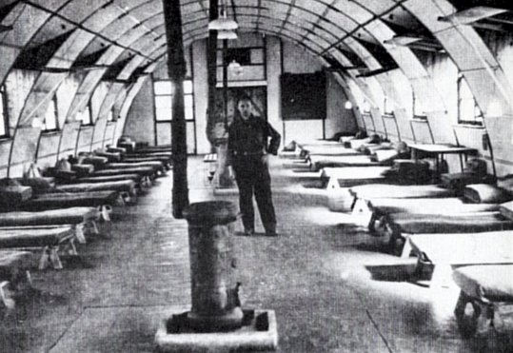  8 November 1945 - Camp 161 was inspected by the International Red Cross – see below.  <ICRC photograph of infirmary accommodation.  Five deaths were recorded at this hospital, 1 was suicide – see report below. All were later reinterred at Cannock Chase German Military Cemetery. (LISSER Herbert, was recorded as LISSEN).  Camp Commandant 1945 Major Silver  After the camp: 2019 part park, part residential.  Further Information: |  | 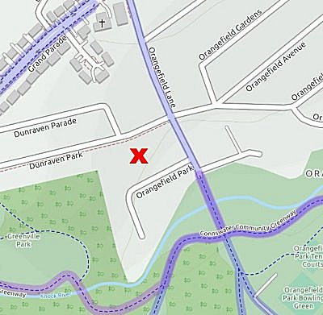
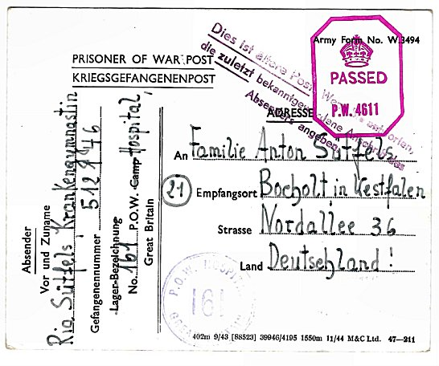
 | < POW Postcard dated 28 April 1945. From Ria Sűtfels, Krankengymnastin (Physiotherapist). POW Hospital cachet. (Ria = Maria). Note, she was Protected Personnel, not a pow.

HOSPITAL 161.  Visited on November 8, 1945 by Mr.Bieri.  Address; German POW Hospital 161, Great Britain.  Commandant; Major SILVER  Camp Leader; SEMPER Robert, "Hauptfeldwebel" B 366557 (he has a copy of the Convention)  Chief doctor; STEUER Adolf, "Oberstabsarzt", No A. 841048  Capacity; 360 men  Actual numbers; 195 German prisoners  personnel  9 officer doctors  79 other ranks  12 German nurses  95 patients.  General information;  German personnel arrived at the hospital on 28 January 1945; the first patients arrived on February 8, 1945. Since then, and up to the day of our visit, there have been 1066 patients.  A number of camps in the vicinity have been closed and the number of patients has regularly decreased. Several rooms are now empty and it is possible that the hospital will soon be closed.  Currently, 95 cases are being treated, - 39 requiring surgery and 56 cases of internal medicine.  Medical Officers: SCHEMANN Paul, "Oberarzt" A 954 473  HAUSMANN Paul, "Stabsarzt" A 854 905  SCHMIDT Fritz, "Oberarzt" B 29 656  KROHN Herbert, "Stabsarzt" 29 796  ROSENDAHL Adolf, "Oberarzt" 523 435  GELLENBECK Rudolf, "Assis. Arzt" 446 806  SPIESS Egon, “Assist.Arzt" B 29 675 |  | German Quartier-maître: GRENZDOERFER Alfred, "Stabsintendant", A 831104  Dental technician: HAEFELE Josef, "Ob.Gefr.", B 36 707.  Sister: LEPPER Gertrude, "Oberschwester", 606310.  Each of the patients has 4 blankets, sheets and a pillow.  Medical personnel receive 4 blankets each.  Food  No complaint was raised on this subject. The patients receive 2800 to 2900 calories each day, and the German head doctor regards this sufficient. Medical supplies are also sufficient.  Deceased  THOENE Wilhelm, "Gefr." B 24299, deceased on March 7, 1945  (suicide)  LISSER Herbert, "Ob.Gefr.", A 8170, deceased on March 22, 1945  (bullet wounds in the lung and the upper part of the abdomen)  GEIER Gerhard, "Uffz.", B 19042, deceased on March 24, 1945 (fracture  of the base of the cranium, serious concussion)  SCHWARZ Rudolf, "ob. Maat.", A 939273, deceased on May 29, 1945  (brain haemorrhage).  SELBACH Friedrich, "Ob.Gefr.", A 934355, deceased on July 26 1945,  (rupture of the spleen).  These five prisoners (also three others from other camps) were buried in a local cemetery. The German head doctor, a British officer and ourselves, visited the graves. Four German graves were located beside the graves of the British army, the others formed a separate group, at a small distance from there. The crosses were similar to those used for British soldiers and the graves were well maintained. German prisoners came there to leave flowers on the 1st November, All Saints' Day.  Clothing  Patients and medical personnel do not need anything more. The officers could obtain underwear (shirts, pyjamas, etc). About 60% of other ranks belonging to the permanent personnel are equipped with complete German uniforms.

Pay  Officers receive normal pay. All the members of the protected personnel (recognized or not) receive the correct amounts, and all the men belonging to the permanent personnel are also paid.  The nursing sister receives £ 1.10. -, the other nurses have £ 1.6.- each month.  Canteen  The camp has a small canteen and the funds raised amount to £ 75. –  Religious Services  One of the empty rooms was transformed into a chapel.  The protestant chaplain, RICHTER Aribert, "ob.Gefr.", 809597 has been with the hospital since June 28, 1945 and leads the Sunday worship which is attended by 18 to 20 prisoners.  The catholic priest, MULLER Hermann, "San.Ob.Gefr.", 602422, has been with the hospital since June 28, 1945 and celebrates mass on Sundays with forty prisoners and leads mass each evening.  Before the arrival of these two chaplains, the hospital was served by the camp chaplains.  Leisure  The prisoners have the use of a football pitch.  Members of the protected personnel, the permanent personnel, and the patients who are well enough, are allowed to go for short walks under escort.  The library has approximately 100 novels.  The director of educational courses, HIEMANN Richard, "Fw.", A 808588, has organised the following courses:  Pupils  English 25  Spanish 5  French 5  accountancy 12  shorthand 8  No film shows take place and the prisoners have not made a theatrical troop or orchestra. They do however have a radio receiver.  Their choir is composed of 12 members and they have two violins, a violin-cello and a viola has been ordered. |  | Correspondence  On October 5, 1945, approximately 65 brown cards [location postcards] were dispatched to the three zones. So far, 28 replies have arrived from the British zone.  Discipline  The responsible authorities consider that all is well and no attempt to escape has been made. No complaint was recorded.  Requests  The camp leader requests:  cigarettes for the patients  books  table tennis balls  collections of popular songs music for the violin (traditional and popular).  The dental technician would like to obtain the following works: "Röntgentherapie und Röntgentechnik", by Zanker or Schöninger.  Conclusion  This hospital seems well organized and the collaboration between the British administration and German personnel is excellent. The British Commandant is very satisfied with the discipline and conduct of the prisoners. The wards, rooms, kitchen, etc. are very well maintained. The nurses are delighted with the idea of being repatriated as soon as the hospital closes its doors.  -------  We have since learned that this hospital was closed in the middle of November.  [Translated by M Sanders, 2010]

