Camp 155 - Hornby Hall Camp, High Street, Brougham, Cumberland (and Greystoke)

Included in the 1945 ICRC camp list – Labour Camp. 155. Hornby Hall Camp, Penrith, Cumberland.

Prisoner of War Camps (1939 – 1948) - Project report by Roger J.C. Thomas - English Heritage 2003
OS NGR | Sheet | No. | Name & Location | County | Cond’n | Type 1945 | Comments
NY 573 293 | 90 | 155 | Hornby Hall Camp, Hornby Hall, High Street, Brougham | Cumberland | 3 | German  Working Camp | Camp consisted of 25 huts, chiefly 18'6" Nissen huts. Some features still appear to survive in woodland

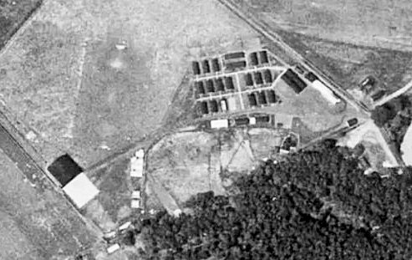  Location: About 5.5 km E of Penrith.  Before the camp: “Hornby Hall was Satellite Landing Ground No:9, and was ready for use by March 1941. It was parented by RAF 12 MU (Maintenance Unit), Kirkbride, but used initially by 22 MU (RAF Silloth), with the landing of two Vickers Wellington bombers... The landing-ground closed - officially - in July 1945, after which the site was used to house German Prisoners-of-War.” (Information from –  www.users.globalnet.co.uk/~rwbarnes/defence/hornby.htm)  1948 aerial photo –  raf_541_61_rs_4158 - Aerial Photo | Historic England  Pow Camp: | 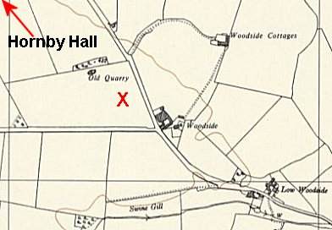
 | Ordnance Survey 1957

Spring/Summer 1945 – listed as opened for German pows with capacity of 474. (Progress report 152 – FO 939/383). From the report below, it was a tented site at this time.

March 1946 – Camp Magazine No.6; Lager-Zeitung : Camp 155 - The Wiener Holocaust Library. Address given as Greystokes, see below.

May 1946 - The camp was raised in parliament;

“Mr. Vane asked the Secretary of State for War for what reason the German prisoners recently quartered at Greystoke were moved to Hornby Hall, Westmorland; what was the cost of construction of the new camp at Hornby Hall; and why public money was spent for this purpose when nearby military camps at Lowther and Carleton were unoccupied.

Mr. Lawson – These prisoners of war were held in temporary accommodation at Greystoke, while their original tented camp at Hornby Hall was being adapted for use during the winter months. The cost of this work was £1,200. I am informed that the camps at Lowther and Carleton were occupied at the time; they are required for further military commitments.” (House of Commons, 30 May 1946 – Vol 423). This response indicates that Greystoke was just a temporary site.

June 1946 - Large group of pows transferred from Warth Mills Camp. No electric supply.

28 June 1946 – became satellite camp for Merry Thought Camp 76 with c.476 pows.

After the camp:

Further Information:

Werner W. Schlupmann published his memories of the time he spent as a pow, mainly at Hornby Hall Camp - ‘Three Years and a Day, the long road to a new and better freedom,’ 2010. (Drei Jahre Und Ein Tag. Der Lange Weg In Eine Neue Und Bessere Freiheit). German and English editions were sent to Joan Raine, chairman of Eden District Council who decided the best place for both books would be in the Penrith and Eden Museum.

The German Federal Archives have a copy of the magazine for camp 155.

