Camp 152 - Old Liberal Club, Charnwood Road, Shepshed, Leicestershire

Included in the 1945 ICRC camp list – Labour Camp. 152. Old Liberal Club, Charnwood Rd, Shepshed, Loughborough, Leics.

Prisoner of War Camps (1939 – 1948) - Project report by Roger J.C. Thomas - English Heritage 2003
OS NGR | Sheet | No. | Name & Location | County | Cond’n | Type 1945 | Comments
SK 47 19 | 129 | 152 | Old Liberal Club, Charnwood Road, Shepshed | Leicestershire | 5 | German Working Camp

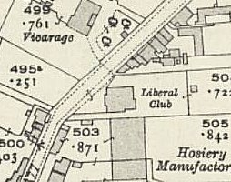  Location: Marked as ‘Club’ on map. (Liberal Club on 1921 OS insert). NGR SK 478 194  Before the camp: Liberal Club. Building from about 1902 / 6.  Pow Camp: Italian pows, then a German Working Camp.  Considering the size and location of the Liberal Club, I think this would have been used as an administrative centre, perhaps with a few pows accommodated there – and with other pows accommodated in hostels.  1 August 1945 - an urgent memorandum was sent to this camp, and others, about maintaining records of Italians who were classed as ‘co-operators’. At this point many, sometimes all, of the Italian pows were in hostels / billets.  Postal items seen: POW postcard January 1946 in Italian to Italy.  After the camp: 2019 Nursing home.  Further Information: | 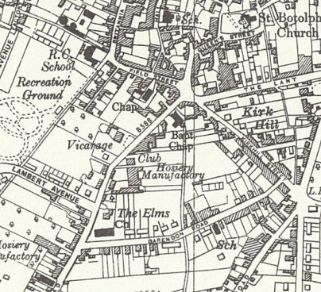
 | Ordnance Survey 1955
Hostels

Shellbrook. Huts.

1943 - listed for Italian pows with Garenden Camp 28.

Transferred to Camp 152 with Sutton Cheney hostel.

July 1946 – listed as transferred back to Garenden Camp with 69 pows.

Sutton Chenney. Huts.

1943 - listed for Italian pows with Garenden Camp 28.

Transferred to Camp 152 with Sutton Cheney hostel.

July 1946 – listed as transferred back to Garenden Camp with 62 pows.

