Camp 151 - Pendeford Hall, Codsall, Wolverhampton, Staffordshire

Included in the 1945 ICRC camp list – Labour Camp. 151. Pendeford Hall, Codsall, Wolverhampton, Staffs.

Prisoner of War Camps (1939 – 1948) - Project report by Roger J.C. Thomas - English Heritage 2003
OS NGR | Sheet | No. | Name & Location | County | Cond’n | Type 1945 | Comments
SJ 895 039 | 127 | 151 | Pendeford Hall, Codsall, Wolverhampton | Staffordshire | 4 | German Working Camp | Precise location not identified, NGR given junction of Coven Lane and Pendeford Hall Lane

Location: Pendeford Hall Estate. NNW edge of Wolverhampton. Possible site listed as being at the junction of Coven Lane and Pendeford Hall Lane – marked x.  There is also a large site on the OS map shown next to Pendeford Farm (SJ 898 034) at the bottom of the map. This was not there before the war and the area was considerably changed by the 1966 map – I think this was connected to the Boulton Paul Aircraft factory.  Before the camp: Estate lands.  Pow Camp: Italian pows and later a German Working camp.  “Ex-prisoners describe the proximity of AA Batteries to the camp. From the descriptions of two anti-aircraft sites - although both are listed as Coven Heath one should not assume that they relate to the current village of Coven Heath as the whole area north and west was known as that - the original AA site appears to be on the hill protecting the BPA factory in the field of upper Pendeford Farm. The other final H1 appears to be approximately in Lawn Lane just north of the current M54.” ( www.brewoodandcovenparish.org.uk/decoy-factory-in-coven/ )  1946 – Camp 151 is listed as Coven Lawn camp – less than 2 km away. I believe the HQ simply moved site from Pendeford to Coven Lawn. The Coven site may have been a hostel before the move.  After the camp: 2019 - Pendeford Hall estate is a mobile home park / the site by Pendeford Farm is Pendeford Business Park.  Further Information: | 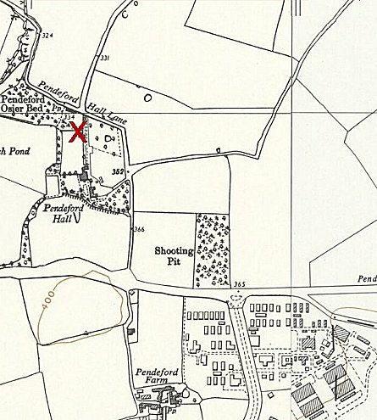
 | Ordnance Survey 1955 + 1958

