Camp 645 / 669 Cruwys Camp, Tiverton, Devonshire

ICRC – Labour Camp. 645. Cruwis Morchard, Tiverton, Devon.

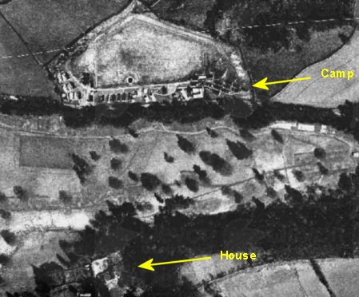  Location: About 8km W of Tiverton. Cruwys Morchard House is at NGR SS 874 122. The camp was located just to the N, on the other side of ‘Deerpark Plantation’ at SS 874 125.  Before the camp: Fields.  A transport camp built by US troops. Water was pumped from the river at Wood Farm. Sewage works, Nissen huts and roadways built.  Pow Camp: Italian labour camp to 1945, then a German Working Camp.  Late 1940’s aerial photo –  https://map.devon.gov.uk/portal/apps/webappviewer/index.html  After D-day; “the perimeter fence was strengthened and more barbed wire put in place. Soon after a unit of the Pioneer Corp. arrived, made the living quarters suitable for the housing of POW's, these were Italian and were picked up each day in lorries and along with armed guards would do gang work on local farms i.e. potato digging and drainage schemes etc. When the war finished German POW's were in camp, but these men were not guarded so heavily and many were billeted with the people they worked for. Many of them did not wish to be repatriated and are still in the area.”  ‘Pennymoor then and now,’ by John Greenslade, p34 – see: INTRODUCTION | 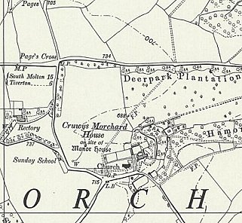
 | Ordnance Survey 1961
September 1945 – Appendix to HQ Southern Command War Diary: 669 Cruwys Morchard camp, Tiverton – German working company – capacity 430 – 128/343310

11 July 1946 - This camp became a hostel to Bampton Road Camp 92 near Tiverton. Note from inspection report for that camp – “Cruwys Morchard, formed on 11th July 1946, with Ps/W ex-USA, is a hutted camp, having its own power plant. There is ample accommodation at present for all purposes.”

Most pows arriving from the USA had very low morale as they had been misinformed in the US that they were being repatriated. Instead, they found themselves in working camps in the UK.

After the camp: Fields.

Further Information:

Many thanks to Wilf Whitty who identified the location of the camp.

