Camp 148 - Castlethorpe (Hall) Camp, Castlethorpe, Lincolnshire (+Sawcliffe)

The 1944/45 ICRC listing for camp 148 is – ‘Labour Camp, 148. Sawcliffe, Lincolnshire.’ Sawcliffe is about 10 miles north-west of Brigg.

Prisoner of War Camps (1939 – 1948) - Project report by Roger J.C. Thomas - English Heritage 2003
OS NGR | Sheet | No. | Name & Location | County | Cond’n | Type 1945 | Comments
SE 986 078 | 112 | 148 | Castlethorpe Camp, Brigg | Lincolnshire | 3 | German  Working Camp | Consisted of 39 huts arranged on the west & north boundaries of Castlethorpe Covert and adjacent to a hardstanding north of Castlethorpe Hall. See Hostel list.

Apart from the ICRC listing, all other lists refer to Castlethorpe Camp 148. It is probable that the camp was located at Sawcliffe and then moved to Castlethorpe, or the ICRC list was an error.  Nissen huts were located at Sawcliffe next to an AA site, and memories recall this as a pow camp.  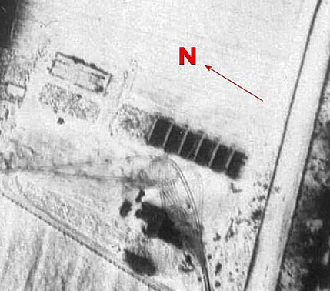  < 1956 - raf_58_1934_v_0087 - Aerial Photo | Historic England  Before the camp: Fields  Pow Camp: (Castlethorpe from at least 1945) Italian then German pows.  1 August 1945 - an urgent memorandum was sent to this camp and others, about maintaining records of Italians who were classed as ‘co-operators’. At this point many, sometimes all, of the Italian pows were in hostels / billets.  15 September 1945 - Hostels listed for pows from this camp, (WO 32/10737): Crowle / Elsham / Keadby South and North / Northholt.  During 1946 - Castlethorpe became a hostel for Camp 81 Pingley Farm together with the hostels at Crowle, Elsham and Keadby. | 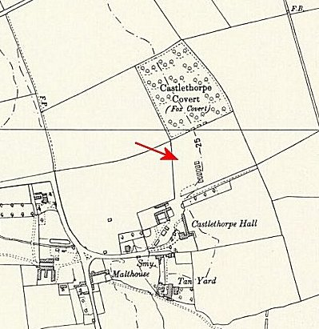
 | Castlethorpe – Ordnance Survey 1958
After the camp: The main building is shown as Castlethorpe Nursing Home.

Further Information:

Hostels

Crowle, Scunthorpe, Lincolnshire. NGR SE 777 131. Huts.

Administration transferred to Pingley Camp 81 – see for map.

Elsham, Brigg, Lincolnshire. Hall TA 031 120

Administration transferred to Pingley Camp 81 – see for map. Elsham Hall hostel later transferred to Donna Nook Camp 292.

Keadby South and North, Scunthorpe, Lincolnshire. Huts. 2 sites about 100m apart. Memories place it next to the tidal Trent Bridge, SE 839 107.

Administration transferred to Pingley Camp 81 – see for map.

North Holt. TF 278 446. Very bleak!

