Camp 147 - Boar's Head Camp, Walgherton, nr Nantwich, Cheshire (aka Walgherton)

Included in the 1945 ICRC camp list – Labour Camp. 147. Boars Head Camp, Walgherton, Nantwich, Cheshire.

Prisoner of War Camps (1939 – 1948) - Project report by Roger J.C. Thomas - English Heritage 2003
OS NGR | Sheet | No. | Name & Location | County | Cond’n | Type 1945 | Comments
SJ 701 485 | 118 | 147 | Boar's Head Camp, Walgherton, Nantwich | Cheshire | 4 | German Working Camp | Former Heavy Anti-aircraft battery (HAA Bty)

Location: In the centre of the map off the A51 London Road. The Boar’s Head Public House is seen to the N. NGR SJ 701 485.  Before the camp: Fields. HAA Battery (Crewe H4) was there 1941-1942.  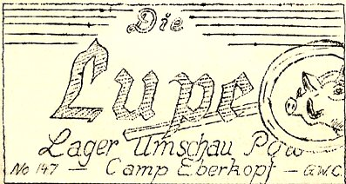  Pow Camp: Italian and then German pows.  1 August 1945 - an urgent memorandum was sent to this camp, and others, about maintaining records of Italians who were classed as ‘co-operators’. At this point many, sometimes all, of the Italian pows were in hostels / billets.  15 September 1945 - hostels listed, (WO 32/10737):  Marbury, Whitchurch, Salop / Sandbach, Cheshire / Warmingham, Sandbach, Cheshire.  27 July 1946 - Die Lupe : Lager Unschau POW Camp Eberkopf - G.W.C. - The Wiener Holocaust Library | 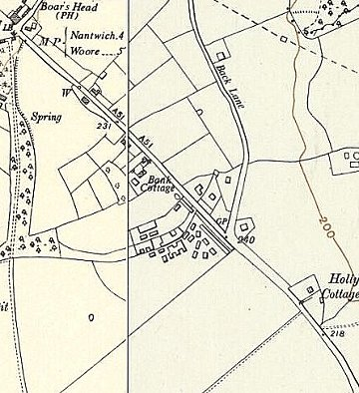
 | Ordnance Survey 1953

Camp magazine No.4 – The magnifying glass – Camp review, Pow Camp Boar’s head – German Working Company.

Mentions that the Commandant is Major Thornville. Refers to football matches against Tarporley Camp 74 and other hostels.

Summer 1946 - Boar’s Head Camp became a hostel for Tarporley Camp 74. After this it was usually called Walgherton hostel. Later with Marbury Camp.

No. of pows | As Camp 147 | With Tarporley Racecourse Camp 74 |  |  |  | With Marbury Camp 189 (cf180)
 |  | 7/46 | 10/46 | 1/47 | 3/47 | 5/47 | 8/47 | 10/47 | 2/48
Walgherton (Boar’s Head) | ? | 280 | 186 | 156 | 123 | 103 | 92 | 152 | 55

After the camp: A later OS map marks the site as a hostel. 2019 fields.

Hostels

Hankelow Court;

Mid 1946 – Recorded in the camp magazine. Administered by Boar’s Head Camp 147. Later, administered by Tarporley Camp 74 and then Marbury Camp 180.

Marbury, Whitchurch, Salop (Was this what became the main Marbury Camp 180 – or a smaller site?).

15 September 1945 – With Camp 147

Mobberley;

Mid 1946 – Recorded in the camp magazine. Administered by Boar’s Head Camp 147. Later, administered by Tarporley Camp 74 and then Marbury Camp 180.

Sandbach, Cheshire. NGR SJ 772 609.

Previously listed with Racecourse Camp 74

15 September 1945 – With Camp 147

 | 1942  Italians | 1943  Italians | >1946 | 4/46 no. of Germans | 7/46 | 10/46 | 1/47 | 3/47 | 5/47 | 8/47 | 10/47 | 2/48
Sandbach | - | With 74 | With 147 |  | 82 | 62 | 54 | 51 | With 189
 |  |  |  |  | With 74

Warmingham, Sandbach, Cheshire –

15 September 1945 – With Camp 147

Was with Crewe Hall Camp 191 - Boar’s Head Camp 147 – then Tarporley Camp 74 – then Marbury Hall Camp 189. Details with Marbury Hall Camp 180 / 189.

 | 1942  Italians | 1943  Italians | >1946 | 4/46 no. of Germans | 7/46 | 10/46 | 1/47 | 3/47 | 5/47 | 8/47 | 10/47 | 2/48
Warmingham |  |  | With 191 & 147 |  | 57 | 44 | 38 | 34 | With Camp 189
 |  |  |  |  | With 74

Weston;

Mid 1946 – Recorded in the camp magazine. Administered by Boar’s Head Camp 147. Later, administered by Tarporley Camp 74 and then Marbury Camp 180.

Wrenbury

Mid 1946 – Recorded in the camp magazine. May have been administered by Boar’s Head Camp 147. Later, administered by Tarporley Camp 74.

