Camp 146 - Newton Camp, Newton-with-Scales, Kirkham, Lancashire

Included in the 1945 ICRC camp list – Labour Camp. 146. Newton Camp, Kirkham, Preston, Lancashire.

Prisoner of War Camps (1939 – 1948) - Project report by Roger J.C. Thomas - English Heritage 2003
OS NGR | Sheet | No. | Name & Location | County | Cond’n | Type 1945 | Comments
SD 448 310 | 102 | 146 | Newton Camp, Newton-with-Scales, Kirkham | Lancashire | 4 | German Working Camp | Hostel

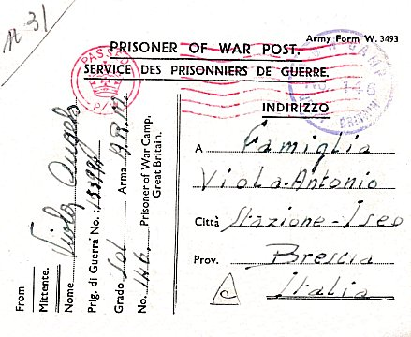  Location: On the A583, opposite where the map says MS. Another camp 168 Brookmill, Kirkham nearby.  Before the camp: Field.  Pow Camp: Italian pows, then a German working camp.  1 August 1945 - an urgent memorandum was sent to this camp, and others, about maintaining records of Italians who were classed as ‘co-operators’. At this point many, sometimes all, of the Italian pows were in hostels / billets.  < Italian pow postcard August 1945  September 1946 – this camp and the Stanhill hostel, became hostels administered by Warth Mills Camp 177 (cf 8).  After the camp:  Further Information:  Hostels  Stanhill. NGR SD 719 280. Aka Knuzden pow camp.  Site began as anti-aircraft gun battery. Became a pow camp with Italian pows. Wooden huts. | 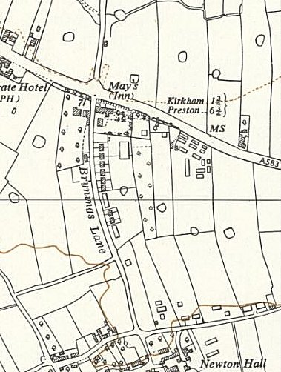
 | Ordnance Survey 1954

