Camp 144 - Ruskin Avenue, Kew, Surrey

Included in the 1945 ICRC camp list – Labour Camp. 144. Ruskin Avenue, Kew, Richmond, Surrey.

Prisoner of War Camps (1939 – 1948) - Project report by Roger J.C. Thomas - English Heritage 2003
OS NGR | Sheet | No. | Name & Location | County | Cond’n | Type 1945 | Comments
TQ 196 771 | 176 | 144 | Ruskin Avenue, Kew | Surrey | 4

Location: In what was the Ministry of Labour Offices at the end of Ruskin Avenue.  Before the camp: Ministry of Labour Office from the First World War. Single storey buildings. Civil servants left in 1940. During the war the offices were used to accommodate US troops and American cartographers involved in mapping the D-day landings.  Pow Camp: Italian pows only.  “The land The National Archives stands on once housed a complex of buildings known as camp 144. In July 1945, about 2,300 Italian prisoners of war were held in the camp.  Italy had surrendered in 1943 and many Italian POWs were then categorised as ‘co-operators’ and put to work outside their camps and granted some freedoms. When not working they could travel up to 5 miles away, but weren’t allowed to visit shops, cinemas or pubs. If invited, they could visit local people in their homes.  The ‘co-operators’ living at camp 144 worked on properties across London that had been damaged by V1 and V2 rockets. The final POWs from camp 144 left Kew in July 1946.”  https://www.nationalarchives.gov.uk/about/visit-us/whats-on/exhibitions/past-exhibitions-and-displays/camp-144-at-kew/ | 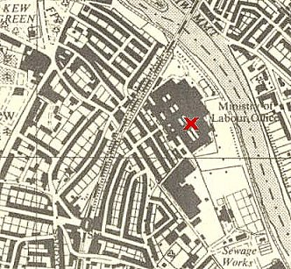
 | Ordnance Survey 1957

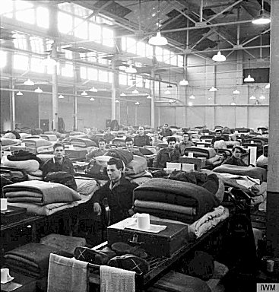 | < IWM – Italian pows next to their bunks at Camp 144. https://www.iwm.org.uk/collections/item/object/205202294  Other pics of c144 - link1 – link 2 – link 3 - link 4  "The camp is sub-divided into 5 large dormitories in which are found 2-tiered bunks. These dormitories have central heating. Every bunk is further provided with a mattress and 4 blankets in the winter (in the summer they have only 3)…. there is a single refectory in which the 2000 collaborators eat in two relays. Here they eat their breakfast in the morning, before going to work, and the evening meal. At midday the workers squadrons take the uncooked food with them and prepare it at the place of work". IWM as above.  The pows cleared sites over a very wide range around London. Several other ‘outposts’ were used – 1 located at Occupation Road, Hanwell, W7 [Post Office stores].  July 1945 – c2300 pows, with 23 British guards. Commandant Lt Col Hobby.  1 July 1945 – Metropolitan Police Report, Richmond Station, to the Camp Commandant: “Fracas between Italian POWs and civilians.  At 9.17pm. on 1st July, 1945, information was received by police that a fracas was taking place in the vicinity of Kew Green, Kew, between Italian Prisoners of War and civilians. Police were despatched to the scene
immediately and on their arrival the situation was quiet. A few minutes later, however, a body of Italians, numbering between 150 and 200, some armed with sticks and pieces of iron, and adopting a threatening attitude, were see to be approaching Kew Bridge from the direction of their camp ostensibly bent on following and attacking a gang of youths who had been dispersed and had proceeded across Kew Bridge to the Brentford side of River Thames. Police formed a cordon and prevented the Italians from doing so, but despite requests to the mob from Police, a few unarmed guards and Italian pickets wearing yellow armbands, to return to the Camp, they remained hostile and an iron [belt?] measuring 12” x ¾” was thrown. In view of this police were compelled to draw truncheons and succeeded to marshal them away from the bridge back to the camp where they were ordered to their huts. This was achieved without causing any personal injury and there was no need for further police action.

It would appear, according to the Italian version, that the disturbance was caused by a sailor and a gang of youths discharging fireworks near some Italians, which they at the time presumed to be a pistol shot.”

There were further incidents between Italians and local youths. At least one complaint was made by the Kew Ratepayers Association about, “these uninvited and extremely ill-behaved men” who were “molesting women and girls.” Follow-up police reports found the allegations to have been exaggerated, and if anything, the problem arose because local girls were trying to associate with the pows. An Italian Corporal was remanded for being overly familiar with an Ilford woman.

26 July 1945 – 2 Italian pows killed in a lorry accident; Soldato Felice Di Fabio and Caporale Lorenzo Parmigiani. Both were later reinterred at Brookwood Military Cemetery.

19 November 1945 – Suicide of Soldato Carlo Trincia. He was later reinterred at Brookwood Military Cemetery.

July 1946 – the pow camp closed.

After the camp: National Archives and residential area.

Further Information:

Excellent history lecture - https://cdn.nationalarchives.gov.uk/documents/gis-and-pows.mp3

