Camp 143 - Serlby Hall Camp, Serlby, Blyth, Nottinghamshire

Prisoner of War Camps (1939 – 1948) - Project report by Roger J.C. Thomas - English Heritage 2003
OS NGR | Sheet | No. | Name & Location | County | Cond’n | Type 1945 | Comments
SK 634 893 | 111 | 143 | Serlby Hall Camp, Serlby, Blyth | Nottinghamshire | 5

Location: About 2.5 km NNE of Blyth..  Before the camp: Country mansion and estate. The house was an auxiliary military hospital during the First World War.  Carlton In Lindrick was also recorded as Camp 143 – dates for both locations and their relationship as HQ, satellite or hostel has not yet been discovered.  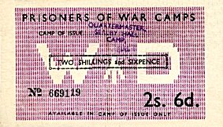  Pow Camp:  1944 to at least November 1945 - Italian collaborator pows recorded at this site.  June 1946 – this camp and three hostels were transferred to Nether Headon Camp 52.  After the camp: Hall is Grade 1 listed. Believed to be in private ownership.  Further Information: | 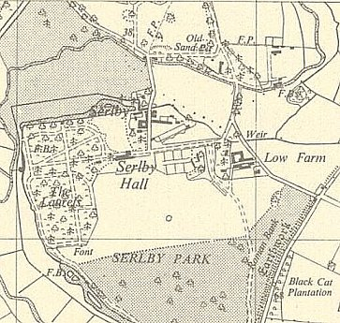
 | Ordnance Survey 1958
Hostels

Carlton In Lindrick

June 1946 – satellite camp, transferred to Nether Headon Camp 52. A report for camp 52 stated this was a satellite camp attached to Camp 143. It then become a hostel, rather than having satellite status.

Lea Hall. NGR SK 828 864 – possible. [‘Lea Hall’ attached to Maxstoke Camp 39 was a different location.]

June 1946 – transferred to Nether Headon Camp 52, (and later to Pingley Camp 81).

Misson. Bawtry, Nottinghamshire. At site of present Misson Mill – NGR SK 685 949. Huts.

1943 / 1944 - listed at Nether Headon Camp 52.

June 1946 – transferred back to Nether Headon Camp 52 with 75 German pows.

