Camp 143 - Carlton Hall, Carlton, Nottinghamshire

Included in the 1945 ICRC camp list – Labour Camp. 143. Carlton Hall, Carlton, Worksop, Notts.

Prisoner of War Camps (1939 – 1948) - Project report by Roger J.C. Thomas - English Heritage 2003
OS NGR | Sheet | No. | Name & Location | County | Cond’n | Type 1945 | Comments
SK 590 842 | 111 | 143 | Carlton Hall, Carlton in Lindrick, Worksop | Nottinghamshire | 5 | German  Working Camp | Precise location not identified, NGR given for Hall, there is cropmark evidence for some structures at SK 5894 8433

Location: The NGR is for a location at the side of the A60 on the E edge of the estate, about where the ‘schs’ (Ramsden Primary School) is on the map. However, the school was there well before the war, it shows on an 1890 OS map. 2 Nissan hut bases were found at SK 588 839.  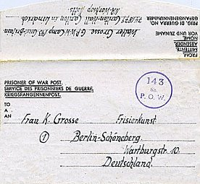  Before the camp: Country hall and estate.  Pow Camp:  Serlby Hall was also recorded as Camp 143 – dates for both locations and their relationship as HQ, satellite or hostel has not yet been discovered.  November 1944 - The camp was listed as an Italian Labour Battalion, (WO 32/10737).  < POW letter-sheet dated 16.6.1946  Carlton became a satellite Camp to Serlby Camp 143. (Info from Camp 52 report)  June 1946 - Serlby and 3 hostels, including Carlton were transferred to Nether Headon Camp 52.  After the camp:  Further Information: | 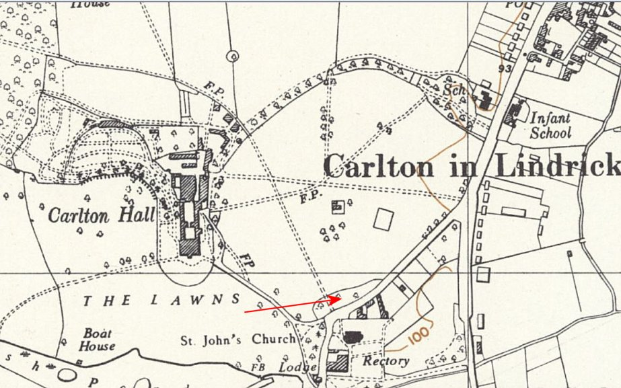
 | Ordnance Survey 1958

