Camp 140 - Racecourse Camp, Warwick, Warwickshire

Included in the 1945 ICRC camp list – Labour Camp. Racecourse Camp, Warwick.

Prisoner of War Camps (1939 – 1948) - Project report by Roger J.C. Thomas - English Heritage 2003
OS NGR | Sheet | No. | Name & Location | County | Cond’n | Type 1945 | Comments
SP 27 64 | 151 | 140 | Racecourse Camp, Warwick | Warwickshire | 5 | German Working Camp | Precise location not identified, there was a large camp at SP 257 648

Location: The NGR above is a general location.  A brief reference; “There was an Italian prisoner of war camp on the racecourse, they wore a yellow circle on the back of their brown jackets. There was a German PoW camp at the corner of Myton Road with Banbury Road, where the prep school is today.”  (By Tony Talliss - ourwarwickshire.org.uk/content/article/wartime-warwick)  2 sites marked A and B on map. Possibly another site at nearby Budbrooke Barracks.  Before the camp: Horse racecourse  Pow Camp: Italian collaborator Pows listed from 1944 until at least September 1945, then a German Working Camp.  November 1944 - The camp was listed as an Italian Labour Battalion, (WO 32/10737).  1 August 1945 - an urgent memorandum was sent to this camp, and others, about maintaining records of Italians who were classed as ‘co-operators’. At this point many, sometimes all, of the Italian pows were in hostels / billets.  November 1946 – Record for Maxstoke Camp 39 – “met…by Major Lynch, Asst Cmdt., (Formerly | 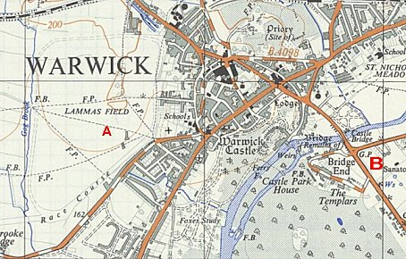
 | Ordnance Survey 1952
Cmdt of Warwick Racecourse)… Major Lynch has brought most of his officers with him from Warwick to Coleshill. ”

1946 – Camp closed (before November)

After the camp: Racecourse back in use 1947.

Further Information:

