Camp 138 - The Rectory Camp, Bassingham, Lincolnshire

Included in the 1945 ICRC camp list – Labour Camp. The Rectory, Bassingham, Lincoln.

Prisoner of War Camps (1939 – 1948) - Project report by Roger J.C. Thomas - English Heritage 2003
OS NGR | Sheet | No. | Name & Location | County | Cond’n | Type 1945 | Comments
SK 912 598 | 121 | 138 | The Rectory Camp, Bassingham | Lincolnshire | 5 | German Working Camp | Hostel

Location: The Rectory is shown to the W of the site marked.  Before the camp:  Pow Camp: Italian collaborator Pows listed from 1944 until at least September 1945, then a German Working Camp.  November 1944 - The camp was listed as an Italian Labour Battalion, (WO 32/10737).  1945 – possible – Commandant Major J E Burman, not confirmed.  1 August 1945 - an urgent memorandum was sent to this camp, and others, about maintaining records of Italians who were classed as ‘co-operators’. At this point many, sometimes all, of the Italian pows were in hostels / billets.  15 September 1945 - Hostels listed for pows from this camp, (WO 32/10737): Skellingthorpe / Thorney.  The site may have become a hostel administered by a different camp.  After the camp: A school and hall are shown on the site.  Further Information: | 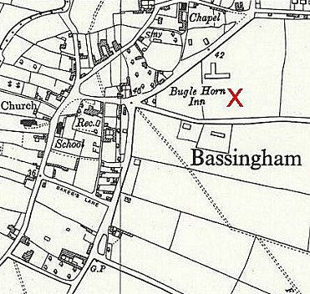
 | Ordnance Survey 1960
Hostels

North Kyme A building rather than hutted.

1945 – with Camp 138.

14 July 1946 – hostel taken over by Horbling Camp 80 with 68 German pows..

Skellingthorpe. Huts.

A ‘bakery unit’ that supplied bread for all the camps in the district.

1945 – with Camp 138.

1948 - with Moorby Camp 79.

Thorney, Peterborough, Cambridgeshire. Reported to be at Thorney Manor – NGR SK 860 728.

1945 – with Camp 138.

1946 – recorded with Nether Headon camp 52.

Walcot

14 July 1946 – hostel taken over by Horbling Camp 80 and then Moorby camp 79.

