Camp 131 - Uplands Camp, Diss, Norfolk

Included in the 1945 ICRC camp list – Labour Camp. 131. Uplands Camp, Diss, Norfolk.

Prisoner of War Camps (1939 – 1948) - Project report by Roger J.C. Thomas - English Heritage 2003
OS NGR | Sheet | No. | Name & Location | County | Cond’n | Type 1945 | Comments
TM 11 80 | 144 | 131 | Uplands Camp, Diss | Norfolk | 5 |  | It is possible that this site was nearer Eye, Suffolk

Location: NGR TM 121 804. On the N edge of Diss – roughly where the map shows ‘Sports Ground.’  Before the camp: Uplands was a large Victorian house and grounds. Used as an army training base at the start of the war.  Pow Camp: Italian non-collaborator Pows listed from 1944 until at least September 1945, then a German Working Camp.  November 1944 - The camp was listed as an Italian Working camp, (WO 32/10737).  1944 - Memories passed on (unable to verify) - “My father, Captain Robert Varville Ledden, was posted to 131 in 1944. He was still there when the Germans arrived so I suspect he was there for a couple of years.  During his time there was a riot which made the national press. Quelled by my father with a revolver and a sergeant and two soldiers with rifles (there was only one strand of barbed wire to keep the prisoners in) against a few hundred P.O.W.s. Actually, he brought my one year old brother out with him which defused the situation. The Italians, being family minded and, no doubt, missing their own families.  There was a murder and the murderer who was Italian was guarded by the Italians themselves. My father went to the cinema in the evening and when the lights went up at the interval the murderer was seated a few seats away but was back under lock and key by the time my father got back to camp.  My father issued the order that P.O.W.s weren't allowed bikes. That evening there was a knock on the door from his Italian batman, Scheppes from Sicily, asking if he could hide his bike in his flat as they weren't allowed them any | 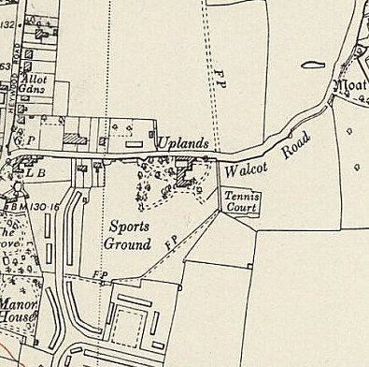
 | Ordnance Survey 1953
more, which my father did. They were a very friendly. They made him a cigarette case in aluminium which we still have.
After the war an ex-incarcerated Italian doctor from Sicily wrote to my father asking for medical supplies as they had nothing, he sent supplies.
Then the Germans came and everything changed.

https://ww2talk.com/index.php?threads/camp-131-uplands-house-camp-diss-norfolk.78576/

1 August 1945 - an urgent memorandum was sent to this camp, and others, about maintaining records of Italians who were classed as ‘co-operators’. At this point many, sometimes all, of the Italian pows were in hostels / billets.

3 September 1945 – Progress Report 153 recorded a new Italian hostel at St Margaret’s Avenue, Lowestoft with a capacity of 100. (FO 939/383).

15 September 1945 - Hostels listed for pows from this camp on, (WO 32/10737): Bungay, Suffolk / Mere Manor (Court), Diss, Norfolk.

After the camp: 2019 Diss High School.

Further Information:

Hostels

Bungay, Suffolk. NGR TM 346 893. (Nearby there was also Bungay Base Camp 171, and Flixton Airfield Camp 273).

1943 and 1944 – listed for Italian pows with Botesdale Camp 56.

1945 – listed with Uplands Camp 131.

Mere Manor (Court), Diss, Norfolk. NGR TM 120 796. Formerly listed as ‘Rectory.’ | 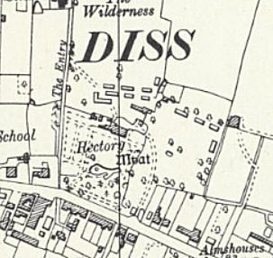
 | Ordnance Survey 1958

St Margaret’s Avenue, Lowestoft.

Can only find St Margeret’s Road.

