Camp 130 - West Fen Militia Camp, Ely, Cambridgeshire

Included in the 1945 ICRC camp list – Labour Camp. 130. West Fen Militia Camp, Ely, Cambridgeshire.

Prisoner of War Camps (1939 – 1948) - Project report by Roger J.C. Thomas - English Heritage 2003
OS NGR | Sheet | No. | Name & Location | County | Cond’n | Type 1945 | Comments
TL 533 809 | 154 | 130 | West Fen Militia Camp, Ely | Cambridgeshire | 4 |  | STANDARD type.

Location: NW Ely  Before the camp: Farmland  Pow Camp: Italian collaborator Pows listed from 1944 until at least September 1945, then a German Working Camp.  The site had a standard layout with a main pow compound, with guards’ huts and offices at the front. Buildings included a water tower, offices, officer's mess, a canteen, guard rooms, barrack huts, ablution blocks, cell blocks, a camp reception station (medical facility/hospital), a cookhouse, dining rooms, recreation rooms and living huts or tents.  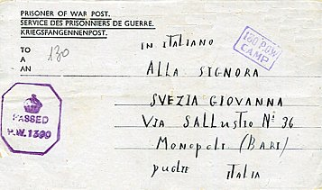  November 1944 - The camp was listed as an Italian Labour Battalion, (WO 32/10737) with a capacity of 600.  1 August 1945 - an urgent memorandum was sent to this camp, and others, about maintaining records of Italians who were classed as ‘co-operators’. At this point many, sometimes all, of the Italian pows were in hostels / billets.  < Letter-sheet 1945 to Italy.  July 1946 – recorded as a satellite camp for Barton Field Camp 26.  After the camp: Residential area.  Further Information: | 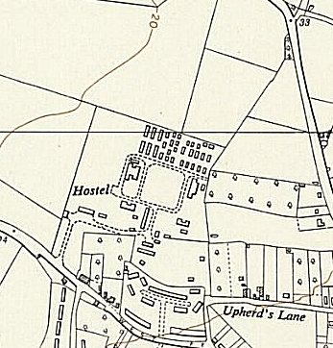
 | Ordnance Survey 1958

