**Camp 126** **- Melland Camp, Sandfold Lane, Gorton, Lancashire**

Included in the 1945 ICRC camp list – Labour Camp. 126. Mellands Camp, Gorton, Manchester 18.

|  |  |  |  |  |  |  |  |
| --- | --- | --- | --- | --- | --- | --- | --- |
| **Prisoner of War Camps (1939 – 1948) - Project report by Roger J.C. Thomas - English Heritage 2003** | | | | | | | |
| OS NGR | Sheet | No. | Name & Location | County | Cond’n | Type 1945 | Comments |
| SJ 886 949 | 109 | 126 | Melland Camp, Sandfold Lane, Gorton, Manchester | Lancashire | 4 | German Working Camp | Former Heavy Anti-aircraft battery (HAA Bty) |

|  |  |  |
| --- | --- | --- |
| **Location:** Sandfold Lane is just at the S edge of the school site marked.  **Before the camp:** Playing Field. HAA placements can be seen in photo.  **Pow Camp:** Listed as Italian collaborator working camp / labour battalion to at least 1945, then a German Working Camp.  **November 1944** - The camp was listed as an Italian Labour Battalion, (WO 32/10737).  **1 August 1945** - an urgent memorandum was sent to this camp, and others, about maintaining records of Italians who were classed as ‘co-operators’. At this point many, sometimes all, of the Italian pows were in hostels / billets.  **Autumn 1946** - **closed** and pows (+ hostels) transferred to Camp 189 Marbury Hall (FO 939/177). |  |  |
| 1946 - [raf_3g_tud_uk_185_vp3_5242 - Aerial Photo | Historic England](https://historicengland.org.uk/images-books/archive/collections/aerial-photos/record/raf_3g_tud_uk_185_vp3_5242) | Ordnance Survey 1955 |

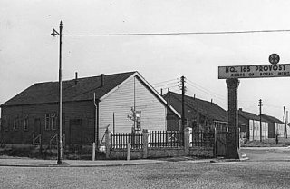**After the camp:** The site was used as a camp for the Military Police. 2019 School and grounds. At the end of Sandfold Lane is a factory.

The camp as it was when used by the Military police.

**Further Information:**

**Hostels** –

**Audenshaw** SJ 925 964

Up to September / October 1946 then transferred to Marbury Hall Camp 180/189.