**POW Accommodation in the UK during WW2.**

POW Accommodation was covered under two articles of the Geneva Convention:

|  |
| --- |
| **Art. 9.** Prisoners of war may be interned in a town, fortress or other place, and may be required not to go beyond certain fixed limits. They may also be interned in fenced camps….  **Art. 10**. Prisoners of war shall be lodged in buildings or huts which afford all possible safeguards as regards hygiene and salubrity.  The premises must be entirely free from damp, and adequately heated and lighted. All precautions shall be taken against the danger of fire.  As regards dormitories, their total area, minimum cubic air space, fittings and bedding material, the conditions shall be the same as for the depot troops of the detaining Power. |

Two articles set further rules: Art.13 stated that camps must be clean and healthy, they must have toilet facilities, baths / showers, and spaces for outdoor activities. Art.14 stated camps must have an infirmary.

- - - - - - - - - - - - - - - -

**Demand for pow camps in the UK.**

* 1939 ‘phoney war’ – Mid 1940: Only two sites: Grizedale for officers - remote, fairly comfortable;and Glen Mill, Oldham for other ranks – large, cheap. By March 1940, there were still only 257 pows in the UK(1).
* Mid 1940 – Late 1940: German offensive. The plan was to ship pows to other countries(2). By the end of 1940 there were just 12 camps and 1 pow hospital(3).
* Early 1941 Africa campaigns – 1943 Italian armistice: A major shortage of manpower led to the Minister of Agriculture suggesting; “*2,000 to 3,000 North Italian peasants from among the prisoners of war taken in Libya should be brought to this country at once to be formed into gangs to work…”* (4)

In June 1941, it was agreed to bring a further 25,000 Italian pows to work on the land.(5) Further sites were located and the ‘Standard Camp’ was developed in order to speed up construction of sites.

At the end of 1941, the Ministry of Agriculture requested that new camps be built rather than existing ones expanded to distribute pows to areas of need. 21 new sites were identified.(6)

Smaller ‘hostels’ started January 1942 with an experimental site at Whissendine administered by Camp 28.

* Late 1943 - 1944 D-Day: By mid-1944 there were 153,779 Italians held in the UK – 78,763 in camps, 54,214 in hostels and 20,802 in billets. Germans were shipped to other countries.(7)
* Mid-1944 - 1945 Victory: Military bases, airfields, warehouses… built prior to D-Day were supplemented by US forces supplying and building their own bases in the UK to accommodate millions of US military personnel, (Operation Bolero). After D-Day many of these sites were used as pow camps. For a while the numbers of pows arriving in the UK outstripped what was available and tented camps were used.
* 1945 - 1948: Italian repatriations started while ‘Germans’ were shipped to the UK, (including Austrian and other nationals). The peak was reached in September 1946 at 402,000. More ex-military camps, especially air bases, were utilised, hostels were increasingly built. Tented camps were gradually replaced by huts.

German repatriations began September 1946, up to July 1948.(8)

(1) Financial Secretary to the War Office answering a question in the House of Commons, 11 March 1940, vol 358 c824.

(2) Memo by the Lord President of the Council – ‘Internees and Prisoners of War’ – 2 July 1940 WP (G) (40) 170.

(3) Appendix to WO 199/405. Lists 11 camps – Duff House Camp 5 was mysteriously missed out.

(4) War Cabinet conclusions, 16 January 1941 7(41)

(5) Memo by Lord President of the Council – ‘Proposal to bring 25,000 Italian POWs to this country’ – June 1941 WP (41) 120.

(6) Minutes of meeting ‘Employment of Italian Prisoners of War,’ held 9 December 1941

(7) Memorandum by the Minister of Labour and National Service, 31 July 1944; WP(44)421

(8) House of Commons, 13 July 1948, Vol 453.

**Types of location for pow camps.**

At first, existing buildings were utilised. These had been identified before the start of war by various government departments, usually without informing their owners.

When the demand for Italian pows to be kept as a workforce in the UK arose in 1941, ‘greenfield’ sites were increasingly used to build standard camps.

Most camps were in rural areas, but some were built within towns and cities, e.g. Rayner’s Lane Camp 11, Harrow.

From a list of **501** identified pow camp sites(1), the land use prior to becoming pow camps was:

**254 (51%) ‘Greenfield;’ Agricultural / Common / Park / Unused land.** Located where there was most need for farm work, timber production… Some sites were located in an area for a particular purpose, e.g. camps in Anglesey where drainage work was carried out, or those on Orkney for building the ‘Churchill Barriers.’ A few sites were selected because they were remote – e.g. Watten Camp 165.

|  |  |  |
| --- | --- | --- |
| **149 (30%) Country houses & estates / Castles.**  Country estates were seen as ideal as they had clear spaces and existing boundaries which could be made secure.  Accommodation could be in the house, or in the grounds, or both. Some houses were used to accommodate British officers and provide administrative offices. At Duff House the pows were in the house while the guards were in huts in the grounds – this not surprisingly raised objections. |  |  |
| Barbed wire fences, walkways and towers at Grizedale | |

**39 (8%) Ex- military sites.** Barracks, RAF bases, AA sites….

**15 (3%) Sports grounds / Golf courses. 9 (2%) Military and local hospitals.**

**6 (1%) Racecourses. 5 (1%) Worker’s camps. 4 Quarries / Pit grounds. 4 Schools & grounds.**

**4 Mills / industrial. 3 Holiday camps. 2 Hotels. 2 Offices.**

**1-off’s: Liberal club, Stables, Circus winter quarters, Concert Hall, Abbey.**

Some camps were very unusual, e.g. 22 Hyde Park Gardens Camp 17, (an extremely expensive London house); and 3 Magdala Road, Nottingham Camp 27, (a not particularly large town house).



In addition, there were many hundreds of pow hostels based in fields or buildings. An attachment to Pennylands Camp 22 had pows living on board surrendered submarines – Loch Ryan shown.

The ICRC intervened to prevent the use of ships for internment of pows.

- - - - - - - - - - - - - - - -

(1) Some sites remain unidentified / uncertain.

**Tents**

|  |  |
| --- | --- |
|  |  |
| Bell tents at Otley Camp | 160lb General Service tents at Boughton Camp |

|  |
| --- |
|  |
| Large pyramidal tents at Shrivenham |

|  |  |
| --- | --- |
| **US pyramidal tent by Armbruster ‘M1934’ – shipped to the UK.**  Size: 16′ (4.88m) wide x 16′ long x 11′ (3.4m) high, 256 square feet (23.8 sq.m).  Fire resistant. Eight person tent introduced in 1934. Ventilation through hood at top. Rope and metal slides, brass grommets. |  |

Before 1944, temporary tented areas were added to some existing camps, e.g. The Hayes, (Camp 13 in its early days). This was usually when pows were being assembled prior to transfer to camps in USA and Canada. Italian pows employed to build hutted camps also used tents until they could move into the huts.

Following D-day, the numbers of pows very rapidly increased. Further increases occurred post-war when pows were shipped to the UK from camps in USA, Canada and continental Europe. Often the numbers overwhelmed the capacity in available buildings / huts, and tents were then used. Tented sites had some huts, e.g. in use as cookhouse, ablutions…

Use of tents broke Article 10 of the Geneva Convention which specified the use of ‘*buildings or huts*.’ During the summer months, the use of tents was criticised by visiting members of the ICRC, and increasingly so as winter set in.

**Report of the International Committee of the Red Cross on its activities during the Second World War, Stockholm, 1948 – Volume 1:**

“…*Great Britain. The damp and often cold climate of that country made internment under these conditions trying to the health. The Committee's delegates did not fail to urge, each time they visited a camp under canvas, that huts should be built in place of the tents. The British authorities, holding that encampment under canvas was by way of a temporary measure, followed the delegates' suggestions as often as possible. Wherever tents were retained, flooring was installed. Waterproof ground-sheets and extra blankets were issued. In September, 1942, the Committee's delegate noted that, in Camp No. 40, for Italian PW, each man had from four to five blankets.”* [Camp 40 – Somerhill in Kent].

|  |  |
| --- | --- |
|  | In most camps, tents were replaced as soon as possible by huts. However, some pows spent many months in tents, even during the bitter winter of 1945/46. According to Henry Faulk, (Group Captives; Chatto; 1977) there were very few tents in use from Autumn 1946.  Many tents were made in the USA and shipped with US troops to their bases in the UK. Over 200,000 US troops were housed in tents in the UK before D-day(1). After D-day large tents were left behind and many were used in pow camps. The large tents used hard wooden floors (duck-boarding,) some camps also had wooden walkways. |
| Unnamed camp – MUD! |

Not surprisingly the frequently recurring word in memories of pows based in tented camps was – ‘mud.’ Heating was by stove and lighting by paraffin lamps.

(1) Figure from; Kohan, C.M. - History of the Second World War: Works and Buildings (London: HMSO, 1952)

**Huts**

|  |
| --- |
| This is a brief essay about the main types of huts used for pow accommodation. For detailed information about wartime huts in general see the excellent: “*Wartime Huts: The Development, Typology and Identification of Temporary Military Buildings in Britain 1914-1945 - Karey Lee Draper - Wolfson College Department of Architecture University of Cambridge - Dissertation 2017*”  <https://www.repository.cam.ac.uk/items/b4272db6-8f8e-41dd-9a7f-57610c00c75f> |

The main reason why tented accommodation continued over-long at some sites was the shortage of building materials for huts. All materials for building had shortages – especially steel and timber. Steel had high war-manufacturing demands. Timber was in short stock as most was imported into the UK.

Although material for making bricks was plentiful, nearly 400 brickmaking firms closed down in 1941 due to reduced demand for housing,(1) (fewer houses being built and labour shortages for building companies). A National Brick Building Council was set-up in 1942 to regulate supply and bricks were sometimes used in place of timber, e.g. Nissen huts were designed with timber ends, but these were often replaced with bricks.

Cement / concrete stock and supplies were also regulated. Concrete was used as floor bases in order to cut down on the use of timber. Concrete blocks / slabs were used as building materials.

Early in the war, supply of building materials was prioritised for defence works, air-raid shelters, military bases… However, the UK met its obligations under the Geneva Convention for pows as fast as it was able. When supplies were made available for pow camps, building work took place rapidly, often utilising the pows themselves alongside the Pioneer Corps and/or civil contractors.

The War Diary for Garendon Park Camp 28(2) show how quickly a hutted camp could be built:

***23 August 1941*** *– First pows arrived; 502 Italians. Tented accommodation.*

***13 September 1941*** *– First consignment of huts arrived –* ***17th*** *arrival of bricks for foundations –* ***19th*** *layout of camp approved –* ***30th*** *posts for extending perimeter.*

***4 October 1941*** *– All pows accommodated in huts. The guards were accommodated in huts by the end of the month. Additional huts were being built.*

***30 November 1941*** *– Hutted camp complete except for the Dining Hall and Guard Room.*

***December 1941*** *– Lighting being installed, (completed February 1942); temporary paths laid down, and ablutions being constructed.*

***31 January 1942*** *– Roads and parade ground under construction; Ablutions still in progress*.

There were many different types of huts – some were built in their dozens, others their thousands. Karey Lee Draper’s dissertation(3) on wartime huts, listed for WW2: 9 main types of timber huts; 7 of composite materials; 24 concrete and/or asbestos; and 11 types made of corrugated steel/iron. Nearly all types underwent variations in design and there were many others built in smaller numbers. Many adaptations were employed according to availability of materials.

The government funded Building Research Station(4) near Watford, studied the behaviours of materials and designs for huts.

Following is a list of the main types that I have seen listed for pow camps.

(1) ‘Works and Buildings’ – C M Kohan – HMSO 1952.

(2) National Archives - WO 166/5980 & 10297– 28 Prisoner of War Camp at Garendon Park (Loughborough).

(3) Wartime Huts: The Development, Typology and Identification of Temporary Military Buildings in Britain 1914-1945 - Karey Lee Draper - Wolfson College Department of Architecture University of Cambridge - Dissertation 2017

(4) Modern link - <https://bregroup.com/about-us-2/our-history-bre/>

**NISSEN HUTS**

The trade name ‘Nissen’ is often used to describe any wartime hut – similar to ‘Hoover’ being used to describe vacuum cleaners.

In 1916, Major Peter Norman Nissen of the Royal Engineers designed and tested semi-cylindrical huts (‘Bow huts’) to meet three factors –

* Economic use of materials. However, in WW2 better materials and designs for construction were developed, see for example the MoWP hut below.
* Quick and easy to build. Normal time with 6 men was 4 hours, the record is 1 hour 27 minutes.
* Portable. It could fit a standard 3 ton truck.

The first Nissen huts were produced in August 1916. During WW1 100,000 were built + 10,000 Nissen hospital huts.

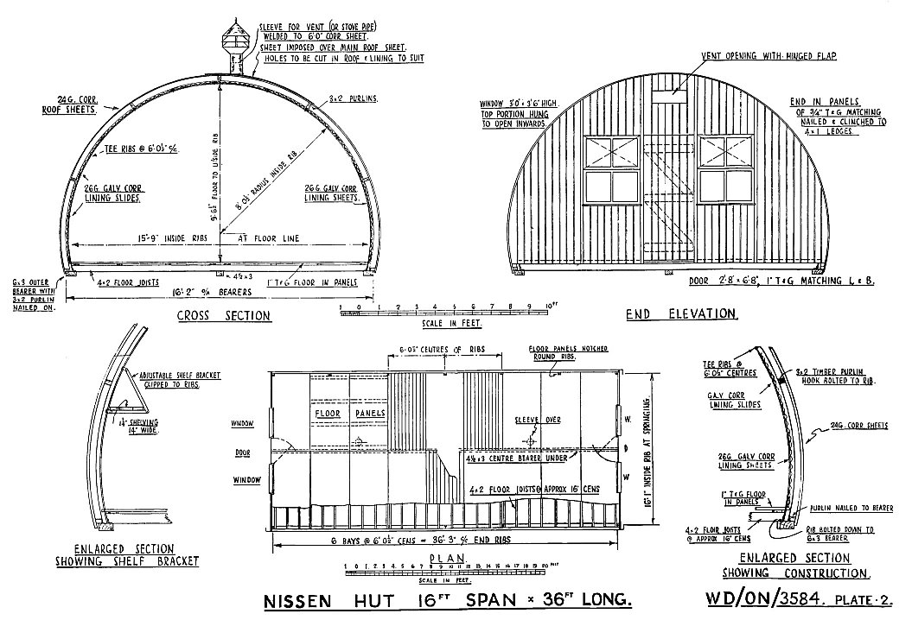

1916 Nissen hut design

Nissen patented the design and soon after the end of WW1 he established, ’Nissen Buildings Ltd.’ There were limited orders in the inter-war years. Peter Nissen died in 1930.

At the start of WW2, Nissen Buildings stepped up production and waived its royalty fees.

Parts of the huts were supplied by different manufacturing companies: John Summers & Sons Ltd and Brady and Co., manufactured corrugated iron sheets. Boulton & Paul Ltd, Norwich supplied corrugated iron sections, they also manufactured their own corrugated buildings. William Baird & Co Ltd, coal and iron masters of Coatbridge, produced steel frameworks. Thames Joinery Co. made wooden panels…..

The huts used for pow accommodation had a 16 feet span (4.8 metres) and were 8 feet high – with any lengths that were in multiples of 6 feet (1.8 metres), 30 and 36 feet being most frequent. Larger Nissen huts with spans of 24 and 30 feet were also available, but not used for accommodation.

|  |  |
| --- | --- |
| Several changes were made due to material shortages. Concrete floors, rather than timber, were used as portability was not a factor. Concrete or brick ends also replaced timber. Materials other than corrugated iron for the roofing were tested, but were not successful.  Most Nissen huts were built during the first few years of the war, until more economical and efficient buildings were designed. Although living in the huts was better than being accommodated in tents, most accounts recall them being cold and draughty in winter, and stuffy and humid in summer. |  |
| Brick ends to huts. © IWM D 26718 |

<http://www.nissenbuildings.com/> <https://nissens.co.uk/>

|  |  |
| --- | --- |
| **Spot the difference.**  Similar shaped and sized huts were developed by other companies – especially Quonset huts (16 ft x 36 ft) from the USA. Larger semi-circular huts such as Romney huts (35ft span) were sometimes used for dining halls and cinemas, (e.g. at Le Marchant Camp 23).  On the outside, Nissen huts had vertical corrugations, the inside had horizontal corrugations. Quonset huts were the opposite – horizontal outside, vertical inside (+ slight difference in curvature). |  |

**QUONSETT HUTS** were a re-design of the WW1 Nissen huts with better insulation. Manufactured in the USA and in the UK during WW2.

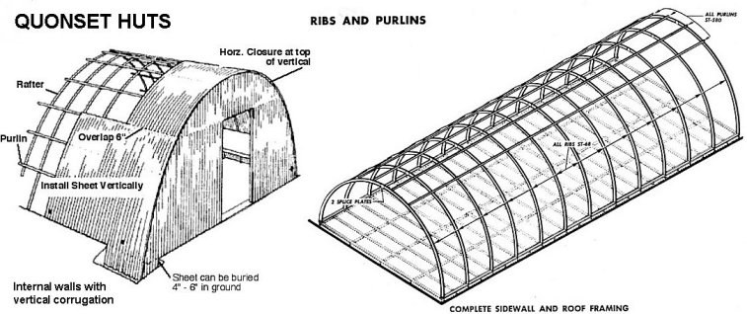

Excellent pdf on Quonset huts - <https://web.mst.edu/rogersda/umrcourses/ge342/quonset_huts-revised.pdf>

“Nissen and Quonset Huts” – J.David Rogers, Ph.D., P.E. – Missouri University of Science and Technology

|  |  |
| --- | --- |
| There were many variations of similar type buildings – e.g. “elephant huts” were simple iron structures in a semi-circle shape with thick corrugated steel roofing usually dug in to the earth. Described as being like a cross between a Nissen hut and an Anderson Shelter. They were used in WW1 in the trenches.  German Pows were held in 22 elephant huts at Johnston, Pembrokshire (Central Supply Department), a hostel for Henllan Camp 70. Presumably they were dug in to prevent bomb damage to whatever was stored. Colourized photo of WW1 elephant hut > |  |

**MoWP (Ministry of Works and Planning) HUTS**

During 1942, a ‘standard’ hut was designed that was efficient to construct and flexible and economic in the use of materials. A number of contractors were employed to produce the huts, and they soon outnumbered Nissen huts. The Parliamentary Secretary for the MoW, George Hicks, reported:

*“The number of Nissen huts erected since the beginning of the war is over 250,000. Those huts use a great deal of timber and steel. When those materials became short in supply it was necessary to change over to some form of hutting which did not use so much timber and steel, so six or seven types were chosen and proceeded with. Of these, 53,000 have been produced by my Ministry, and they are equivalent in accommodation to about 100,000 Nissen huts. Our standard hut is one that has been evolved by my Ministry and has now been found to be the most efficient and adaptable and enables a variety of building materials to be used—brick, concrete, asbestos cement sheets, plaster board or whatever may be necessary—for filling the sides.”* House of Commons debate 23 July 1943; Hansard, Volume 391, Col 1237.

Mr Hicks went on to state: “*We have an ample stock of standard huts to meet all foreseeable requirements*.”

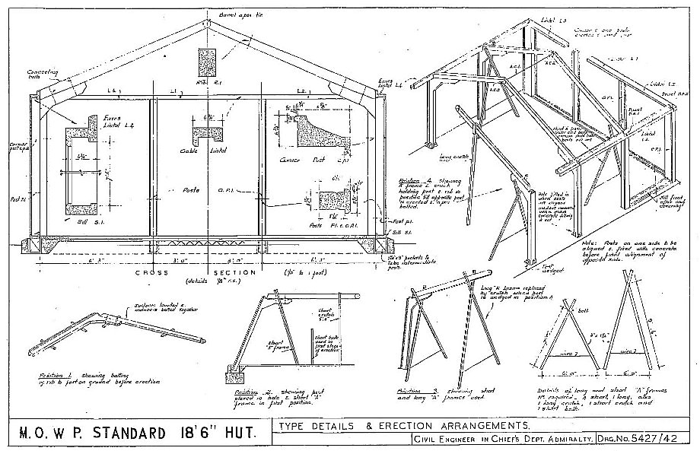

The most common size used was the 18ft.6inch x 60 ft hut, there was also a larger 24ft x 120ft.

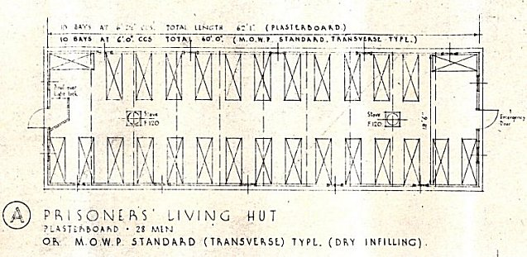

Killearn – a hostel for Castle Rankin Camp 64 - MOWP pow accommodation hut – plasterboard.

28 men.

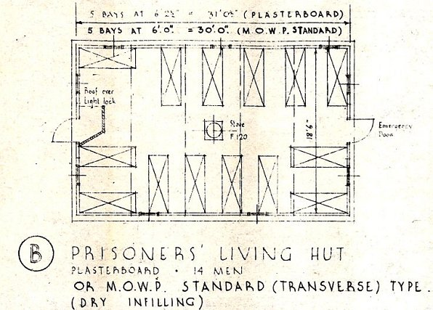

Killearn – MOWP pow accommodation hut – plasterboard. 30 foot length

14 men.

**MINISTRY OF SUPPLY LAING HUT**

|  |  |
| --- | --- |
| The Air Ministry acquired 12,540 Laing Huts in 1941/2 measuring 18 ft by 60 ft, made from felted plasterboard panels and corrugated asbestos for rooves.  Picture shows a Laing hut in use after being a pow camp as a Polish resettlement camp at Delamere, a hostel for Marbury Hall Camp 180.  A Revised Laing Hut was produced in 1942/3, covered with corrugated steel, lined hardboard or plyfelt, (plyfelt is believed to be bituminous-felted plywood panels). Built with ten x 6ft bays. Doors in gable walls. |  |
| <https://www.polishresettlementcampsintheuk.co.uk/delamere1.htm> |

**OTHER ‘MINISTRY’ BUILDINGS**



MoS Living Hut – Produced during 1941. 17ft 3in x 60ft. Timber framed with sloping walls, covered externally with felted plasterboard.

|  |  |
| --- | --- |
| **B.C.F. HUTS** (British Concrete Federation)  Two types were developed for the Ministry of Works by the BCF. Made from a frame of reinforced concrete posts into which panels of either pre cast concrete or corrugated asbestos could be slotted – the rooves differed. Used from 1942. | |
| 1. B.C.F. Clear Span Hut – flat roof of concrete slabs covered with felt.  2. B.C.F. Light Hut. – pitched roof, made with concrete slabs or corrugated asbestos cement sheets. |  |
| Example from Alton Lane ‘Drill Hall’ Hostel (cf Camp 61) / emergency housing in Ross on Wye. |

**AIR MINISTRY HUTS TYPE A AND B**

Many pows were moved into disused airbases and so were accommodated in huts acquired by the Air Ministry.

|  |  |
| --- | --- |
| Huts Type A and B were mainly made using timber with weatherboard, plasterboard and metal framed windows. They were constructed from sectional units so the length could be varied.  Type A was made of longer lasting materials and had a roof of corrugated asbestos sheeting.  Type B had a timber and felted roof.  The huts came in 4 sizes – 18 ft and 20 ft spans were used for accommodation, (small 10ft spans used for example as garages / wc blocks, larger 28ft spans as dining hall space). |  |

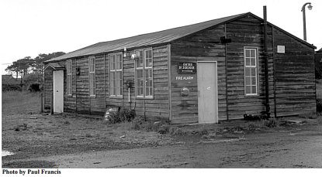

Type B Hut.

From ‘British Military Airfield Architecture’ by P Francis (Sparkford: Patrick Stephens, 1996).

|  |  |
| --- | --- |
| **Inside the huts –**  Furniture and fittings were often selected from catalogues supplied by the Ministry of Works. Some items were handmade either at the camps or nearby, (e.g. bunkbeds might be locally constructed).  Lighting – electric lighting if power supply available, or oil / hurricane lamps.  Furniture was very basic – beds or bunk beds – 2 or three tier. Benches and tables. Stove. It was rare that locker storage was made available. |  |
| © IWM H 41234 |
| Many other types of buildings were used for storage, ablutions, toilets, water towers, cookhouse, dining huts, drying room, stores, chapels, theatres, recreation rooms, exhibition rooms, workshops, services, medical centre (CRS – Camp reception station), prison…..  There were also separate guards’ barracks, administrative huts, reception building, gate hut…… |
| Glenmill |

|  |  |  |
| --- | --- | --- |
| Sometimes these other buildings were made from converted huts. The most famous example is probably the Italian Chapel at Camp 60 – but there were many more chapels at other sites, nearly all of which have been destroyed.  Water towers are usually the longest lasting camp structures, many still exist.  Chapel at Chingford > | |  |
|  |  |
| <Pow water tower converted to luxury home. | |

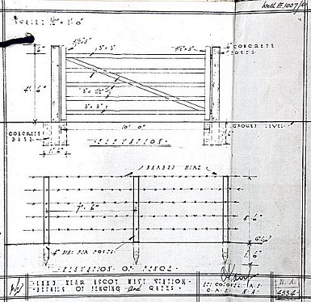**Perimeters**

Barbed wire fencing surrounded camps during the war years. Some camps had towers along the perimeter. Searchlights were sometimes made from car lights and batteries.

Barbed wire was removed from many camps during 1946 – and others reduced the height and/or number of strands. It was often said that the fences were there to keep local females out, rather than the prisoners in. During 1947 the majority of camps had some sort of minimal perimeter fencing which could be just 1 or 2 strands of wire between posts.

Details from Winter Quarters Camp 7. Fences to be 4’6” high – (137cm) and gates to be same height, 10 feet long (3.04m). >>>



The Ministry of Works provided specifications for contractors.

<<< Fences and gates 1942.

|  |  |
| --- | --- |
|  |  |
| Entrance gate to Boughton Camp 633. | Barrier gate at Weekley Camp 259 |

|  |  |
| --- | --- |
|  |  |
| Sentry towers –  Above – Grizedale Camp 1  Left Glenmill Camp 2. |

**Other features**



Many pows developed flower beds and vegetable gardens in the grounds of the camp. The very tidy looking Ledbury camp shown.

Lippits Hill, concrete statue at the camp gate. Many camps had concrete ornaments such as statues, lions, eagles, castles, model villages….



<<< Shrivenham model village.

The huge Marconi Monument at Wynolls Hill Camp 61 >>>