Camp 65 - Bank Hall, Bretherton, Preston, Lancashire

Prisoner of War Camps (1939 – 1948) - Project report by Roger J.C. Thomas - English Heritage 2003
OS NGR | Sheet | No. | Name & Location | County | Cond’n | Type 1945 | Comments
SD 463 202 | 102 | 65 | Bank Hall, Bretherton, Preston | Lancashire | 4 | German Working Camp | Huts scattered under trees to south east of hall

Location: The NGR above is for the Hall itself, about 12 km SW of Preston.  Lionel Taylor, Secretary and Archivist for The Friends of Bank Hall has told me that; “Bank Hall at Bretherton was a satellite station for monitoring Atlantic shipping and because of this there was some secrecy about the site which is probably the reason why you have not been able to find much information about the site during the war years.” From this information I wonder if the pow camp would have been based in the grounds immediately surrounding the Hall, or a bit further away. I have marked a possible site, SE of the Hall, at NGR SD 466 199.  Before the Camp: Part of Bank Hall estate.  Pow Camp: The Hall was used by the Royal Engineers and Auxiliary Territorial Service. The pow camp was in the grounds.  5 May 1944 - Hostels listed for Italian pows from this camp, (WO 32/10737): Haven Street, Todmorden, Lancashire  After the camp: The Hall fell into disrepair and was later restored.  https://repatriatedlandscape.org/england/pow-sites-in-the-north-west/pow-camp-65-bank-hall/  Haven Street, Todmorden SD 944 241 | 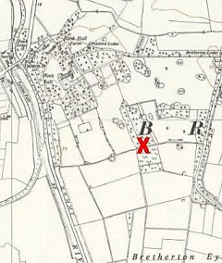
 | Ordnance Survey 1955

