Camp 55 - Shalstone Camp, Shalstone, Buckinghamshire

Included in the 1945 ICRC Camp list – Labour Camp. 55. Shalstone Camp, Shalstone, Buckingham

1947 Camp List
55(G.W.C.) | Shalstone Camp, Shalstone, Buckingham | E. | Priswar, Shalstone, Buckingham | Buckingham 3162 | Finmere | Lt.Col.C.P.Moore M.C. | v/1453/2

Prisoner of War Camps (1939 – 1948) - Project report by Roger J.C. Thomas - English Heritage 2003
OS NGR | Sheet | No. | Name & Location | County | Cond’n | Type 1945 | Comments
SP 657 356 | 152 | 55 | Shalstone Camp, Shalstone | Buckinghamshire | 3 | German Working Camp | STANDARD type.

Location: About 4km NW of Buckingham. The village of Shalstone is about 1.5km NW of the camp.  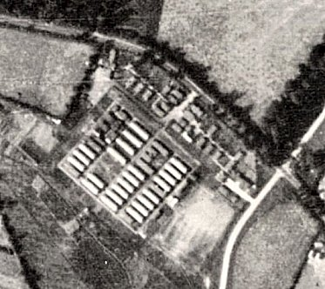  Before the camp: Farmland  Pow Camp: The site was accepted as a pow camp in December 1941. An Italian pow construction gang was allocated from Hartwell Dog Track Camp 36, to work with the Pioneer Corps. Standard type with a main pow compound and British / administrative huts at the ‘front.’ Mainly Nissen huts with concrete buildings for amenities; cookhouse, ablutions, showers, etc.  1942 - The camp opened for Italian pows.  One Italian pow’s account - Dante Cervi (1920-2015) – arriving at Shalstone mid-October 1942; “They were accommodated in heated huts, fed well and treated fairly. From that day on Dante and his comrades convinced themselves that their previous hardships were over. Although they always had the uncertainty as to what tomorrow might bring, their living conditions as pows never deteriorated.  The pows were formed into working teams and taken daily to different farms to carry out agricultural jobs such as potato picking, ditch cleaning and threshing. In order that the farmers did not have to go to the camp each day to collect their pow workers, in the spring of 1943 it was arranged that those pows who could be trusted would be allowed to go to live on the farms. Dante and six of his friends eventually went to live in an empty farmhouse at Gorrell Farm near Dadford. Dante found this initially to be a wrench as he had become accustomed to life in Shalstone Camp where in the evenings he could read, listen to Italian news broadcast from London, “Voce di Londra,” and attend the English school organised by the camp doctor. | 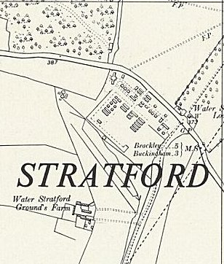
 | Photo 1947 – Map Ordnance Survey 1958

One of the seven friends became cook, three worked on Mr Colbert’s farm near Dadford, two on a neighbouring farm, while Dante cycled to Thatcham Ponds Farm a couple of miles up the road. This is where he first encountered the farmer, Mr Fred Tofield, who was to have an enormous influence on him for the rest of his life.

Dante and his friends found that life as a pow in England was initially relatively lax. In their free time they would go back to meet with other friends in Shalstone Camp, visit other farms, go to the cinema and attend Sunday Mass at Buckingham catholic church. The seven comrades all had bicycles and were allowed to travel within a five mile radius, but since there were seldom checks they would sometimes travel further to see if they could make better use of their wages (nine shillings per week plus overtime).
In the Autumn of 1943 following the partial capitulation of Italy, all the Italian pows were called together in Shalstone Camp and given an ultimatum. Either they could co-operate with the Allies or they would be imprisoned and be subjected to stricter and more severe discipline. Dante had no fascist sympathies but, since the war was still ongoing, did not wish to risk being branded a collaborator by his fellow countrymen. The farmers, with whom they worked, wanted them to stay with them on the farms and eventually Dante and his friends chose to cooperate. There was much hostility in the camp between the fascists, who suffered a strict regime, and the “collaborators” who now enjoyed more trust and freedom.”

Dante was repatriated in May 1946, he returned to settled in Britain in 1948. https://wingrave-rowsham-heritage.org.uk/articles/remembering-dante-cervi/ - has more details and pictures.

1943 – Hostels listed for Italian pows: Sulgrave - Haversham

May and November 1944 - The camp was listed in records as an Italian Labour Battalion under the Eastern Command area and then as an Italian POW Working Camp, (WO 32/10737).

Italian pows working on farms were increasingly billeted there. Reported that some worked in the brickworks at Bletchley. One local memory was of pows making baskets from willows growing along the local brooks – and another who made very good shoes.

1945 – Italian pows gradually placed in billets and hostels prior to repatriation. German pows arrive.

15 September 1945 - Hostels listed for pows from this camp, (WO 32/10737): Duns Tew, Oxford - Wakefield Lodge, Potterspury, Northamptonshire.

Oversight and development of re-education activities and English teaching for German pows was carried out by PID (Political Intelligence Department of the Foreign Office) / COGA (Control Office for Germany and Austria – UK). Visits and reports were made. The standard of the reports varied greatly. The visitors took little interest, if any, in activities other than re-education. They rarely mentioned welfare, sports, games, pastimes, crafts, etc of the pows.

Undated late 1945 / early 1946 – dates estimated according to details give in the report. English Education visit.

Commandant Lt Col H Wright – “not unfriendly.” 2 pow teachers of English – 136 pupils at main camp; 23 at Wolverton Hostel. There was a camp magazine – “Die Sense”

25/26 March 1946 – English Education Visit. Recorded that number of pows studying English was decreasing – this was true in all camps after an initial level of interest.

Captain R H F Allen was the interpreter at this camp – he was a cousin of Allen Lane, the owner of Penguin Books, and hoped that some special ‘concessions’ might be obtained for the pows, (presumably books, paper, ink…).

10 May 1946 - English Education Visit. Recorded that there were 122 billetees in 63 different locations, so English teaching was not possible for them, but they were probably learning more from working at the farms.

12/15 May 1946 – Routine visit from PID. Strength; 1 officer (the M.O.), 1147 Other Ranks. (Not including Italians in hostels).

Commandant: Lt Col Wright, TD. Camp leader: Geberzahn (A)
Interpreter: Capt Allen Deputy C/L: Graupner (A)
German M.O.: Dr Hesterberg (A+) *More below on Dr Hesterberg.
The Commandant was supportive of re-education, but was due to leave.

Camp leader – “innocuous but ineffective and owing to his entire lack of personality and intelligence I have arranged his transfer to 25 [Lodge Farm Camp] and Hilges (A) has been appointed in his place.” …… “his deputy is even more colourless if that were possible.”

Political screening: | A+ | A | A- | B+ | B | B- | C | Unscreened
 | 16 | 160 | 2 | 178 | 692 | 83 | 16 | 1

Morale overall was ‘fair.’ 150 pows had arrived from pow camps in the US – it was usually the case that their morale was very low as they had been misinformed in the States that they were being returned to Germany. Many of the pows were considered to be anti-British. The main negative factor was not having a date set for repatriation.

The standard list of re-education activities was given, (though no mention of a library):

Wochenpost and Ausblick – 300 / unknown, copies received respectively.

Newspapers – British papers purchased by the Welfare Fund (money raised from sale of goods in the canteen). Some foreign papers were received from PID.

Lectures - regular, but not very well received.

Discussion groups – 20/30 attending weekly.

Films – Popular.

Wireless – controlled from the camp leader’s office. No details as to how this was broadcast to the camp.

Camp magazine – in print for 9 months.

Press review – oral review given daily to 80/100 pows.

English instruction – 4 teachers to about 200 pows.

Other camp activities –

Religion – Protestant padre had a congregation of about 100. A catholic padre visited once a week.

Education – Small classes for French and Trades subjects.

Theatre – Quite active with fortnightly light entertainment.

Orchestra – small orchestra and a good choir.

31 July / 1 August 1946 – English Inspector’s Report. Strength 1449. 97 pupils in 5 classes in main camp. 0 pupils in hostels due to late harvest work with pows returning at 8.30 / 9.00 pm. All Italian pows had left by this time and hostels were used by Germans.

Commandant: Lt Col Moore Camp leader: Feld w. Klaus Hilgers (B+).

Billetees visited the main camp monthly to visit the canteen, change library books etc.

20-22 August 1946 – The new Commandant requested a visit and further political screening was carried out. Strength; 1 officer, 1405 OR. No details given of two hostels – Wolverton and Whittlebury. No reason for the Commandant’s request was given, but it was likely due to an increased number of C grade pows arriving in the camp.

The Commandant was said to be very interested in re-education. The new camp leader was proving effective – he had been hostel leader at Wolverton.

300 pows had by then arrived from camps in the US – many of these were regarded as grade C - Nazis. Despite this, morale and political outlook was recorded as improving – mainly as a result of the start of repatriations. It was recorded that a number of sick pows were still waiting for their repatriation. No communism was detected. There was an active Catholic Youth group of about 30-35 members.

The camp magazine had stopped due to lack of paper, and lecturers had not visited for some time.

27 August 1946 – A member of the Segregation Section of PID arrived to survey screening. Strength 1417.

Political screening: | A+ | A | A- | B+ | B | B- | C | C+
 | 14 | 202 | - | 271 | 742 | 117 | 70 | 1

Most of the ‘C’ category pows were new intakes from camps in the USA.

A RC padre, Bonenberg, was noted as being popular with 80-100 pows attending services.

5 6 7 November 1946 – Routine visit and screening. Strength; 1 officer, 876 OR.

Commandant: Lt Col Moore. Camp leader: Fw Hilgers (B+)
Interpreter: None Deputy C/L: None
2nd i/c: Major Attley German M.O.: Dr Hesterberg (A+)

Morale was good mainly owing to excellent treatment and repatriations. Negative aspects were; those still waiting for repatriation, non-fraternisation rules, lack of recreation and training.

The camp magazine had still not restarted.

21/22 November 1946 – English Inspector’s Report. Strength 1197. 91 pupils studying English at all sites.

* January 1946 – The M.O., Dr Georg Hesterberg, politically screened as (A+) – was arrested and sent to Wuppertal. He was tried in a British military court and found guilty of the murder in July 1944 of 3 wounded SAS men by lethal injection. The Commandant at Shalstone commented, “In my opinion he was a first class doctor and looked after the health of the camp very well… his behaviour was extremely correct.” Hesterberg was found guilty in April 1947 and sentenced to be hanged, but a further review found the case was not proven conclusively and he was to be set free. (See ‘SAS Operation Bulbasket’ – Paul McCue – Leo Cooper, 1996).

15/16 March 1947 - English Inspector’s Report. Strength 1041. 75 pupils studying English at all sites. Heavy snow and floods in UK.

Same Commandant and camp leader. A new S/Sgt interpreter had arrived a few days earlier.

5 May 1947 – Re-education survey and Re-screening of ‘C’s’. Strength; 1 officer, 1352 OR.

Commandant: Lt Col Moore. Camp leader: Fw Klaus Hilgers (B+)
Interpreter: S/Sgt Trevis Deputy C/L: Fw Hans Saalfrank (B) [Seilfrank?]
German M.O.: Stabsarzt Werner Molimous (B)

The interpreter was recorded as being; “a very weak spot in the picture…. a liability.” The Commandant wished for him to be removed.

The camp leader was recorded as; “not outstanding, but is the best available.” He had not been a Nazi Party member.

The Deputy C/L had been in place for 6 months. Aged 50, spoke perfect English, “a good man, politically safe.” He had not been a Nazi Party member.

The new M.O., aged 34, had been a member of the Nazi Party – “not, however, a dangerous influence.” He was treated with “decorum and fairness.”

Political screening: | A | B | C+ | PP | Crock | Vol.Defer | Frozen
 | 2 | 1302 | 2 | 16 | 13 | 1 | 17

PP = Protected personnel, e.g. medical staff; ‘Crock’ = medically unfit; Vol.Defer = Voluntarily deferred repatriation; Frozen in other cases, has meant under further investigation.

The number of C graded pows dropped from 70 to 2 after re-screening (another 3 were sent to a different camp). 75 appeals against grades had been made – 73 were allowed, this very high number was reflected in most camps, (the better the grade, the sooner repatriated, in theory). There were still 200 appeals pending. 430 pows repatriated to date.

Morale was only ‘fair.’ Most pows were politically apathetic.

About 400 of the pows were ‘youth’ (under 25). They were not seen to be a particular problem, though the 2 C+ pows were amongst them.

Despite the Commandant’s interest in re-education, activities were found to be ‘scrappy.’ The standard list was given:

Wochenpost and Ausblick – separate appendix.

Newspapers – Both British and foreign received. ‘Hansard’ and the ‘Military Government Gazette’ from Germany were regularly read.

Library – 1400 books, also circulated to the hostels and billetees. The M.O. wanted books on X-ray research.

Lectures – monthly.

Discussion group – Every Sunday evening.

Films – weekly

Wireless – adequate in main and hostels.

Camp newspaper – none; no paper or duplicator.

Press review – A daily news sheet was posted in the information room. A small weekly news sheet was sent to billetees.

Information room – displayed exhibition materials, text and pictures, sent by PID on subjects such as; ‘Political Parties in Germany.’

Other camp activities –

Religion – only 10% interest. Evangelical pastor, Karl Siegal (B), not a Nazi Party member, “his influence is good.” RC Priest from Buckingham visited.

Education – classes for French, Russian, shorthand and bookkeeping.

Entertainments – a small theatre group and an orchestra of 6. A well constructed theatre. Now that fraternisation rules had been relaxed, football was played against local teams.

6/7 August 1947 – English Inspector’s Report. Strength 1296. 88 pow pupils studying English at all sites.

New Commandant: Lt Col Faithfull. New Camp leader: Seilfrank (previously deputy).

“The general atmosphere of the camp is one of calm and contentment.”

1-4 October 1947 – Re-education survey. Strength; 1 officer, 955 OR.

Commandant: Lt Col A F Faithfull. Camp leader: Ofw Kurt Viehrig (B) [Fierig?]
Interpreter: None Deputy C/L: -
German M.O.: Stabsarzt Dr Werner Molinous (B)

The camp leader was, “rather grave but has a sound sincere attractive personality.” He was a teacher and previously the study leader and organiser of sport at the camp. Regarded as an excellent choice.

A less rosy picture of the camp was given than the previous English Inspector. The previous camp leader (Saalfrank) had been deposed by the Commandant on 2 October for losing his temper with a British S/Sgt. Some pows suffered from depression, exasperation and embitterment over their length of captivity. The local population in Buckingham was not very welcoming to the pows.

Simplified screening in use: A – 2, B - 953. 709 pows repatriated to date.

The standard list of re-education activities was given, similar to previous accounts. The Camp Magazine had restarted. Press reviews were broadcast over the camp speakers.

Religion – RC were more active and the RC Youth group continued. RC Chaplain, StFw August Muecke (A) had recently arrived – “A charming and reasonable man. He is a good influence.”

Protestant Chaplain, Karl Siegel (A), was also a good influence.

Education – psychology had been added to the list of classes.

Although many pows had informal contacts with families outside the camp, formal outside contacts were very poor. 6 men had attended a meeting of Brackley Town Council.

14 November 1947 - Camp number included in an ‘Urgent Memorandum’ (FO 939/270) regarding inspection of food parcels.

There were no more reports for the camp. It is likely to have closed by the end of the year – one of the hostels, Whittlebury, was listed with Camp 87 in December 1947.

Known Camp Commandants –
c. 1944 Major A J Ferguson
c. 1945 Lt Col H Wright, TD.
c. 1946/7 Lt Col Charles P Moore M.C. (I think he was with the King’s Regiment).
c. 1947 Lt Col A F Faithfull (I think he was with the King's Shropshire Light Infantry).

After the camp: The site was used for displaced people with many from Yugoslavia. Later mixed use including boarding kennels.

Further information:

National Archives FO 939/137 55 Working Camp, Shalstone Camp, Buckinghamshire. Dated 1946-1947. Used above.

Camp and hostels + number of pows where known:

 | Not open |  | Unknown |  | Open |  | With another camp

 | 1942 | 1943 | 9/45 | 45/46 | 5/46 | 1/8/46 | 22/8/46 | 11/46 | 3/47 | 5/47 | 8/47 | 10/47
Main |  |  |  |  | 878 | 926 | 1086 | 439 | 577 | 913 | 736 | 752
Haversham |  | With Italian pows |  |  |  |  | 60 German
Sulgrave |  |  | With C 87
Duns Tew |  | With C33 ⁽¹⁾ |  |  |  | 69 | 80 | 65 | 52
Wakefield L.
Sherington |  | With C35 |  |  |  | 67 | 60 | 65 | 125 | 150 | 199
Wolverton |  |  |  |  | 150 | 168 | ? | 145 | 118 | 130 | 138 | 171
Whittlebury |  |  |  |  |  | 49 | ? | 43 | 29 | 30 | 37 | 33
Billets |  |  |  | c.80 | 120 | 170 | 120 | 120 | 140 | 130 | 136 | ?
Total | ? | ? | ? | ? | 1148 | 1449 | 1406 | 877 | 1041 | 1353 | 1296 | 956

(1) 1944

Hostels

Duns Tew, Deddington, Oxon.  Duns Tew recorded as a hostel with Old Windmills Camp 33 in 1944  8/1946 – Hostel leader; Haensler (B)  11/1946 – Hostel leader; Wachtm Kohlhage (B), aged 28.  1942 1944 9/45 45/46 5/46 1/8/46 22/8/46 11/46 3/47 5/47 8/47 10/47  Duns Tew With C33 69 80 65 52 | 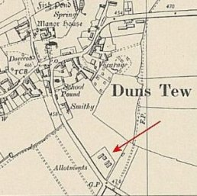
 | Ordnance Survey 1955

Haversham. Wooden huts – though the plan suggests there were also tents at some point.  NGR SP 818 427. Pows working on local farms and for the Ministry of Agriculture.  1943 – opened for Italian pows.  8/1946 – German pows. Hostel leader: Katarski (A)  After this the hostel must have been administered by a different main camp.  July 1947 - “POW were now allowed to ride on buses and to spend at local shops. On Saturday last many of the German POW stationed at Haversham Camp visited Wolverton and went to the ‘pictures’ and spent money in shops, and looked in at two dances. This added freedom to the relaxation recently announced Government restrictions.  Haversham is a White Camp and there are 141 POW housed there. A White Camp indicates that all the men there are anti-Nazi, and about a third of them speak English. They have between 4/- and 4/6 a week to spend outside the camp, and the maximum allowed in their possession is 30/- ordinary rank and £3 officers.  A Wolverton Express reporter spoke to a German interpreter at the Camp and said the men were pleased with the additional freedom. But they must be back in by 10pm or lighting-up time, whichever is earlier and they must remain within bounds. The only public resorts that the P.O.W. were not allowed to enter were those where intoxicants were sold. Cigarettes and newspapers were the most sought after items.” (Wolverton Express, 12 July 1947) | 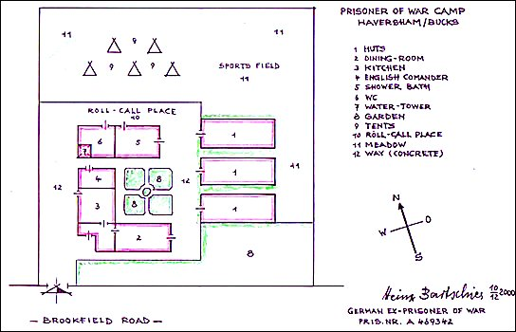
 | Plan of camp by German ex-pow – Heinz Bartschies
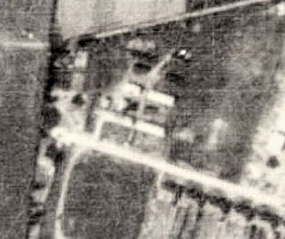
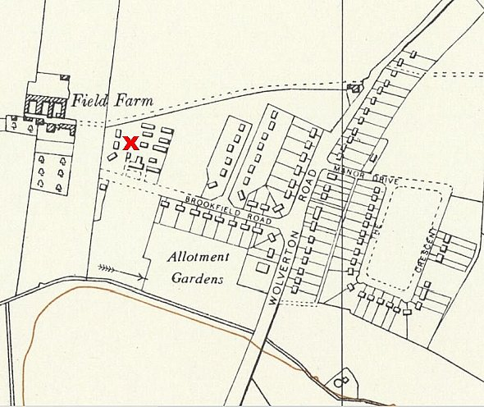
The pows built wooden toys to sell, and a model castle in the hostel. A 3-foot concrete star was at the entrance to the site.

Details from ‘Haversham Estate And the Parish I Grew Up In’ by David C Brightman, April 2000 –
www.mkheritage.co.uk/hav/docs/camp/camp.html

<, Ordnance Survey 1957, aerial photo 1948.

 | 1942 | 1943 | 9/45 | 45/46 | 5/46 | 1/8/46 | 22/8/46 | 11/46 | 3/47 | 5/47 | 8/47 | 10/47
Haversham |  | With Italian pows |  |  |  |  | 60 German

Sherington NGR SP 895 465 - Ordnance Survey 1958 >  Newport Pagnel District Council / War Agricultural Executive Committee (WAR-AG) directed this camp to be established.  1943 – Opened for Italian pows, listed with Boughton Park Camp 35. After the Italian Armistice, it was recorded as holding Italian ‘co-operator’ pows. | 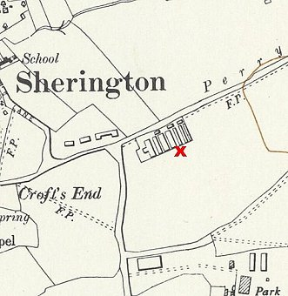
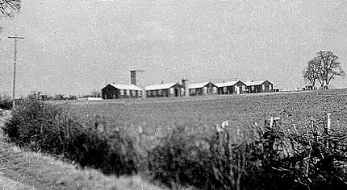
1946 - Held low risk Germans. Security was minimal.

S/Sgt Wilf Rollinson was in charge. He settled locally, married the farmer’s daughter and became a WAR-AG executive.

8/1946 – Hostel leader; Kurt Gehre (B), an I G Farben engineer.

1946/1947 – Two aerial photographs show that additional huts were built – this is born out by the rise in pow numbers below.

5/1947 – same leader.

10/1947 – noted as closed.

Picture with thanks to the Sherington Historical Society - they have an archive file on the camp - https://www.mkheritage.org.uk/sherington/places/general/prisoner-of-war-camp/

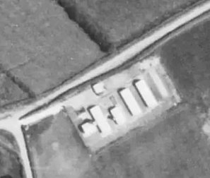 | 1946  1948 | 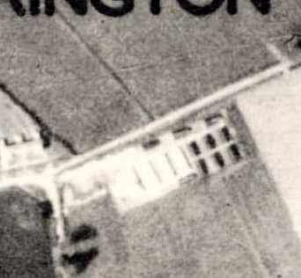 | The site is now a small residential estate.

 | 1942 | 1943 | 9/45 | 45/46 | 5/46 | 1/8/46 | 22/8/46 | 11/46 | 3/47 | 5/47 | 8/47 | 10/47
Sherington |  | With C35 |  |  |  | 67 | 60 | 65 | 125 | 150 | 199

Sulgrave SP 5612 4502 - see C87 for map and details.

1943 – Hostel listed for Italian pows.

1944 - Listed with Byfield Camp 87.

 | 1942 | 1943 | 9/45 | 45/46 | 5/46 | 1/8/46 | 22/8/46 | 11/46 | 3/47 | 5/47 | 8/47 | 10/47
Sulgrave |  |  | With C 87

Wakefield Lodge, Potterspury, Northamptonshire. SP 737 425.

Known to have continued as a pow hostel after this date with a different main camp.

 | 1942 | 1943 | 9/45 | 45/46 | 5/46 | 1/8/46 | 22/8/46 | 11/46 | 3/47 | 5/47 | 8/47 | 10/47
Wakefield L.

Whittlebury

Probably attached to a different main camp before these entries.

11/1946 – Hostel leader; Fw Henzler (A+). Recorded as being a small site – football pitches not available at the weekends.

5/1947 – Hostel leader; Gerhard Rebesky (B)

8/1947 – Groups of pows attended the local vicarage to take part in discussions on topical affairs – the vicar was an ex-education officer.

10/1947 – same hostel leader. 20 youth pows had joined the village youth club. They paid 6d a month to attend recreational meetings on Tuesday evenings.

12/ 1947 – Hostel listed with Camp 87.

 | 1942 | 1943 | 9/45 | 45/46 | 5/46 | 1/8/46 | 22/8/46 | 11/46 | 3/47 | 5/47 | 8/47 | 10/47
Whittlebury |  |  |  |  |  | 49 | ? | 43 | 29 | 30 | 37 | 33

Wolverton

5/1946 – Hostel leader; Fwl Hilgers (A)

8/1946 – Huts and tents.

11/1946 – Hostel leader; Fw Thier (B). Listed as just huts.

5/1947 – Hostel leader; Heinrich Maier (B) – “doing particularly good work.”

8/1947 – English speaking pows were able to attend the private house of the headmaster of Wolverton Grammar School to take part in discussions.

10/1947 – same hostel leader, but described as being “not very co-operative.”

 | 1942 | 1943 | 9/45 | 45/46 | 5/46 | 1/8/46 | 22/8/46 | 11/46 | 3/47 | 5/47 | 8/47 | 10/47
Wolverton |  |  |  |  | 150 | 168 | ? | 145 | 118 | 130 | 138 | 171

