Camp 64 (& 242) - Cowden Camp, Comrie, Perthshire

Prisoner of War Camps (1939 – 1948) - Project report by Roger J.C. Thomas - English Heritage 2003
OS NGR | Sheet | No. | Name & Location | County | Cond’n | Type 1945 | Comments
 |  | 242 | Cowden Camp, Comrie | Perthshire |  | German Working Camp | Scotland

To begin this site was Camp 21A, a hostel for Camp 21 Comrie / Cultybragan. Cowden Camp then became independent German Working Camp 242 in October 1945.

The 1947 Camp list shown, has the typewritten details for Castle Rankine Camp 64, later crossed out, and Cowden Camp details written on. This change of numbering occurred when the Commandant (Lt Col Fielding) and HQ was transferred from Castle Rankine to Cowden.

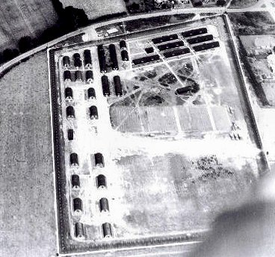 | Location: NGR NN 776 210. The site was on the bend of the Braco Road, where the word ‘CAMP’ happens to be, though that was a ‘site of antiquity.’ Cowden House / farm shown is just S of the camp.  Cultybraggan Camp 21 was 1.5 km to the SW.  Before the camp: Farmland.  Pow Camp: Nissen type huts can be seen in the compound area, there were also 14 huts for guards outside the compound on the E.  1945 – opened as an annexe for pows – attached to Comrie Camp 21.  18 & 19 August 1945 – Camp 21A - Mr James Grant (English Language Inspector), made a report on his visit to this site which he listed as a “subsidiary working camp”. He noted that the pows had been hand-picked from volunteers at Camp 16 [Gosford] but many were disappointed regarding the conditions they found at this camp.  22 October 1945 - Became independent German pow camp 242. | 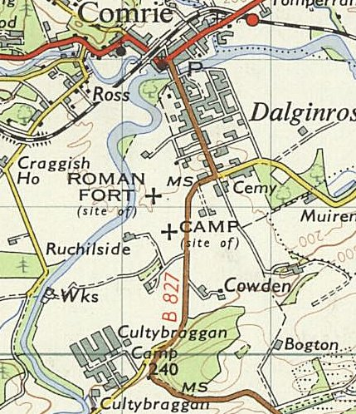
Aerial photograph, no credits given, c.1947 |  | Ordnance Survey 1961

22 November 1945 - The camp was inspected by the Red Cross:

Working Company 242.  Visited on November 22, 1945 by Mr. Bieri.  Address: 242 German POW Working Coy, Great Britain.  Commander: Major O' BRIEN.  Camp leader: RITSCHER Heinrich, "Hauptfeldwebel", 543289.  Assistant: GOERLITZ Josef, "Feldwebel", 746318.  Capacity: 500.  Strength: 489 German prisoners, including 108 warrant officers  Made up of:  414 army  35 navy  38 air force  2 civilians.  General information:  This camp, formerly an annex of camp 21A, became on October 22, 1945 the "242 German POW Working Coy". The huts remain the same, but paths and flower gardens have been developed. By establishing partitions in the huts, it has been possible to open two classrooms.  Each man has received bed linen and blankets.  Food  No complaints have been raised on this subject. The scale of rations for working prisoners is considered to be just sufficient. The menu on the day before our visit:  breakfast: tea, bread, marmalade  lunch (to take away): tea, bread, approximately 1 oz. of cheese  dinner: mashed potatoes, goulash with "corned beef" (approximately 0.8 oz, per man), carrots, and bread.  Medical services  This camp does not have an infirmary, but there is a first aid room with 3 responsible personnel. Treatments are given within camp 21 about 2 miles away. A German medical officer from Camp 21 comes every morning at 9.30 for medical visits.  No deaths have been recorded.  Clothing  The prisoners have all that is necessary, but they lack the material to repair their uniforms, their working clothes and underwear (except socks). The International |  | Committee of the Red Cross has sent German uniforms and approximately 75% of the men have complete uniforms, but the uniforms of those prisoners who have recently arrived are very worn out.  Work  Half of the prisoners are working in agriculture, the others in forestry. All earn on average 4/6 each week.  Canteen  The canteen is well provisioned. Welfare funds are not sufficient and it is possible that camp 21 will need to put some funds at the disposition of "Working Coy 242".  Religious services  The camp does not have its own chaplains and religious services are held by protestant and catholic chaplains at camp 21.  Protestant worship takes place every Sunday with 40 to 60 prisoners, and catholic services are held every Sunday afternoon for about sixty prisoners.  Leisure  The prisoners have a football pitch on which they play every Sunday afternoon with footballs, handballs and with "Faustball" [fist ball].  The prisoners have books from camp 21, that is:  approximately 180 German novels  80 German classics  Some manuals and some religious texts, etc.  The theatre group is composed of 5 to 8 actors, and the choir has 25 members. Up to now no cinema show has taken place. The camp orchestra has the following instruments: 3 violins, a clarinet, a guitar, a saxophone, a drum kit and one accordion.  The prisoners can also listen to the radio.  Classes  Director of studies: SOMMER Heinrich, "Gefreiter", B 60853.  Pupils  English............... 70  French.............. 40  Russian................. 20  German.............. 15  bee-keeping............ 40

About 200 men every week read the newspapers and 80 to 120 prisoners take part in debates and conferences on subjects of general interest.  Correspondence  On about 13 September 1945, 350 ‘cartes chamois’ have been dispatched:  approximately 200 to the British zone  100 to the American zone  50 to the French zone  Up until now nearly 200 replies have arrived from the British zone and one or two from the American and French zones.  Discipline  The discipline is good and no attempt has been made to escape.  Complaints  No complaints have been made about the conditions in this camp. |  | Requests  The camp leader asks for:  A soccer ball with bladder  Some books (novels and classics)  Some table tennis balls  Some manuals for the various commercial branches, including the system that unifies stenographic French and Russian  Some dictionaries (French-German and Russian-German or French-English and Russian-English)  Some sheet music for the camp orchestra, (especially classical music)  Some collections of popular songs  Some play scripts short and humorous, such as light comedies  Some novels in Swedish or Norwegian.  Conclusion  A very good camp.  (Translation from French by M Sanders 2010)

14 November 1947 - Camp number included in an ‘Urgent Memorandum’ (FO 939/270) regarding inspection of food parcels.

End 1947 / Beginning 1948 – Castle Rankine Camp 64 closed and staff transferred to Cowden, which then took the number 64.

4/7 February 1948 – English Inspector’s Report. Strength 1300 – 500 main; 426 Westerton hostel; 374 billets. 0 classes due to re-organisation.

Commandant: Lt Col D E M Fielding Camp leader: Paul Breyer (Both transferred from Castle Rankine).

Westerton hostel closed before April 1948.

31 March – 1 April 1948 – English Inspector’s Report. Strength 590. 0 classes.

Closed soon after.

Camp magazine for 242 – “Optimist”

Known commandants –
1945 - Major O'Brien
1947/8 - Lt Col Darcy Evelyn Mills Fielding OBE, of the York and Lancs Regiment.

After the camp: For a short time, it was a resettlement site for army units in the Polish Resettlement Corps, (Unit Kw.Gt.4 D.P.). Now a residential estate.

https://repatriatedlandscape.org/pow-sites-in-scotland/pow-camp-64-cowden/

Further information:

National Archives FO 939/145 - 64 Working Camp, Cowden camp, Comrie, Perthshire. Dated 1945-48. This file contained reports on Castle Rankine and just 2 English Inspector’s Reports for Cowden 1947/8 – used above.

Canmore http://canmore.org.uk/site/272695

