Camp 60 - Rockworks Camp, Lamb Holm, Orkney

I think there were four pow camps at Orkney:  Camp 34 - Warebanks on Burray - was the only one listed in the English Heritage pow camp list.  Camp 60 - ‘Rockworks’ on the island of Lamb Holm is the site of the famous Italian Chapel in Orkney.  Camp 165 – ‘Kirkwall’ was listed in a Pioneer Corps list of camps.  Camp 558 – Bruna (aka Bruno) was a small camp listed in the 1945 ICRC camp list.  The name ‘Tankerness’ (shown on map) is sometimes linked to Camp 34 – but I have not found out why.  Background  Scapa Flow was the northern naval base for the British fleet at the start of WW2. Although there were several sea routes into the harbour, many of these had been partly sealed with ‘blockships’ and other obstacles against submarine attacks. Unfortunately, many of these had not been maintained and had collapsed – and there were gaps. These faults had been recognised by the British, but efforts to reinforce the barriers came too late. |  | 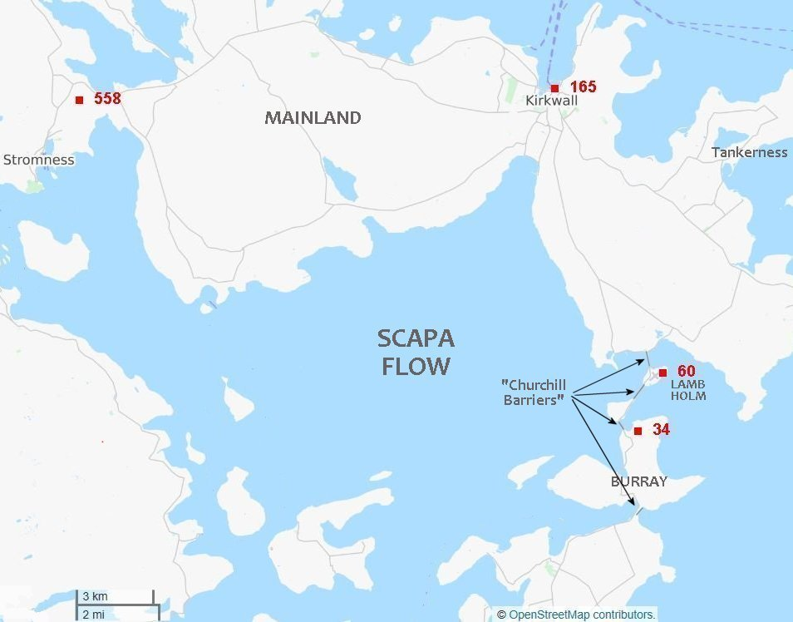
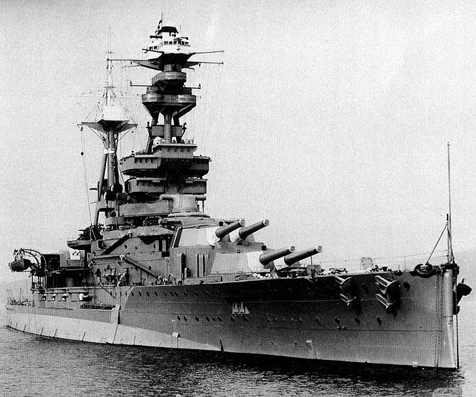 | HMS Royal Oak  The appalling loss of life shocked the nation.
The faults had also been recognised by the Germans. Just five weeks into the war, on 14 October 1939, the German U-47 managed to penetrate the defences and attacked HMS Royal Oak. 833 British sailors were killed and the harbour was out of use for many months while it was made safe.

To prevent further u-boat attacks, the sea defences were strengthened and Winston Churchill, as First Lord of the Admiralty, authorised the building of four ‘Great Barriers’ to block the eastern access routes to the harbour. Further air and sea defences were also built.

The contract to build the barriers was awarded to Balfour Beatty & Co Ltd who already had a large work campsite at Scapa Flow. From May 1940, construction workers and equipment started to arrive. Two more construction site camps were built at either end of the proposed barriers. (Note; the northern Balfour Beatty camp on the Eastern Mainland was also called ‘Rockworks’ – this was not the same site as the ‘Rockworks’ pow camp).

Man-power was a major problem due to conscription, conditions on Orkney, and workforce demands for other wartime projects. In 1941 a ‘Memorandum by the Lord President of the Council’ to the War Cabinet made a; “Proposal to bring 25,000 Italian Prisoners of War to this country” and that; “A number of Italians could also be used in the Orkneys, to free Irish labour”. (June 1941 WP (41) 120).

In late 1941, Balfour Beatty construction workers built two pow camps on the islands of Lamb Holm and Burray.  Lamb Holm is a small island in the Holm Sound, one of the eastern entries to Scapa Flow that needed to be closed. The island had no permanent residents. Details state there were 13 Nissen huts, a large mess hall with kitchen ranges, a canteen and a detention block. The camp was surrounded by a barbed-wire fence. As the island was uninhabited, water had to be piped in from the mainland. |  |  | 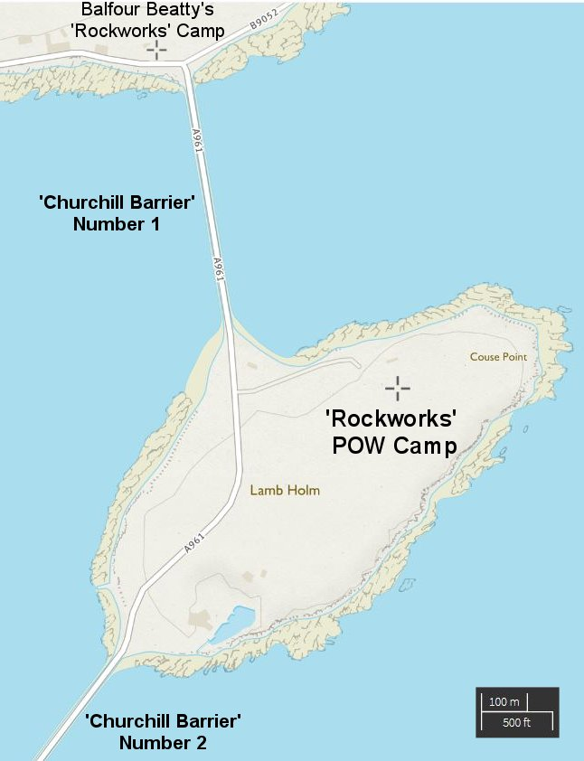
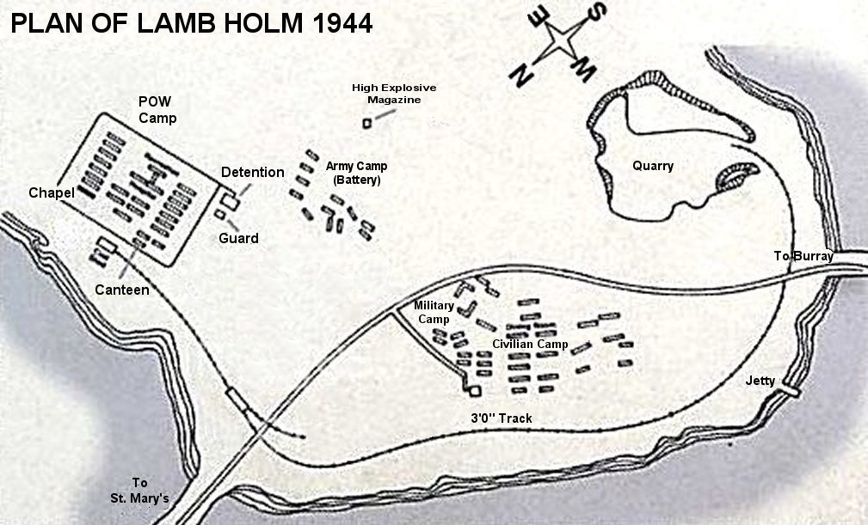
 |  |  | Rockworks Camp 60 - HY 488 005
1944 plan of Camp 60 – (I inserted the compass points).

Initial vetting of pows suitable to work in the UK occurred in Africa. From these a group of prisoners was selected to work in Orkney – they were mainly ex-members of the 6th Anti Aircraft Regiment of the Mantova Division and from the Italian Tank Corps. They were transported to Liverpool and then on to Edinburgh, (Donaldson’s School Camp 12). There were a few weeks delay for medical checks, documentation and uniforms to be issued before they could be sent to Aberdeen and then Orkney. They were guarded by men from the Pioneer Corps who remained with them on the islands.

The first group of 600 pows arrived at Scapa Flow in January 1942. They were based at the camp on Burray (Warebanks Camp 34) for a short time, then most were transferred to Lamb Holm.

The conditions for those arriving in winter were bleak. The location, weather and the length of daylight hours, came as a great shock. It was a place where neither the guards, nor the prisoners wished to be. Rockworks camp was described by Sergeant Fred Slater of the Pioneer Corps;

“Our camp was a cluster of Nissen huts which had to be secured against the gales by steel haywires fastened at the sides in concrete.” (‘Churchill’s Prisoners,’ p6).

If the 1944 plan below is accurate, it would appear that more Nissen huts were built. This is probably correct as numbers in both camps often exceeded their capacities – see ICRC table below.

The first Commandant of both camps was Major J.C. Yates with his HQ at Lamb Holm. (He was possibly there in 1941 to supervise the building of the camps). Visiting the other camp on Burray at this time required a boat trip.  Later, Rockworks Camp 60 was given a new Commandant; Italian speaking, Major Thomas Pyres Buckland, while Major Yates continued as Commandant at Warebanks. The Deputy was Major James Booth. The first Italian Camp Leader was Major G Fornasier of the Italian Tank Corps.  Administration, guard duties and some construction work was carried out by the Pioneer Corps.  Pows wore the standard uniform - chocolate-coloured battledress with 12-inch red disc on the back and two smaller red discs on the arm and leg. However, considering the nature of the work, many were also issued with wet weather clothing, oil-skins, overalls, boots and rubber gloves.  Apart from the medical officers and chaplain, the pows were NCOs or privates. They were organised into working-parties of up to forty depending on the task at hand, with Balfour Beatty men and usually an armed guard.  The camp routine was the same as for British army camps; Reveille was at 6 a.m. in the summer, and at sunrise in winter. Lights out was at 10 p.m. There were occasional searches throughout the camp, primarily looking for make-shift weapons and British currency.  Numbers in the camps varied throughout the war. From the initial 600 in January 1942, a further 600 arrived in July which led to tented accommodation for some. This was highly unsuitable for the conditions on the island. | 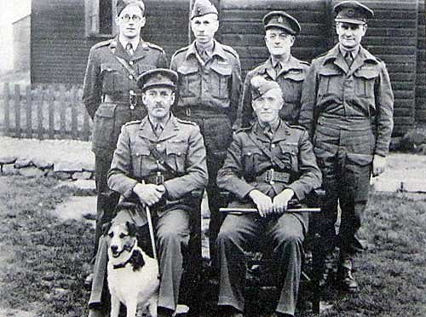
 | Major Buckland is seated on the right. The 2 men standing on the left also appear to be wearing Pioneer Corps uniform.

August 1942 - The International Committee of the Red Cross inspection report gave the following figures:

 | Burray: Camp 34 | Lamb Holm: Camp 60 | Total strength
Camp capacity | 400 | 460 | 860
Actual strength | 576 | 594 | 1,170
Excess strength | 44.0 % | 29.1 % | 36.5 %
Housed in barracks | 400 | 500 | 900
Housed in tents | 174 | 93 | 267
Medical officers | 1 | 1 | 2
Chaplains | 1 | 0 | 1
NCOs and privates | 574 | 593 | 1,167
In hospital | 7 | 8 | 15

(Camp 34 was inspected 24 August and Camp 60 on 30 August).

Many former prisoners have commented on the extreme cold and the thick mud throughout the camp for most of the year. There were many cases of illness – work related, psychological, and due to the cold. With just 1 medical officer at each camp, and infirmaries that did not have electrical lighting, medical facilities were basic – any pows needing more serious treatment were sent to the military hospital in Kirkwall.

The ICRC report noted the pows’ complaints of long working hours, crowded conditions, the quality of the food, a lack of soap, and water supplies to Camp 60.

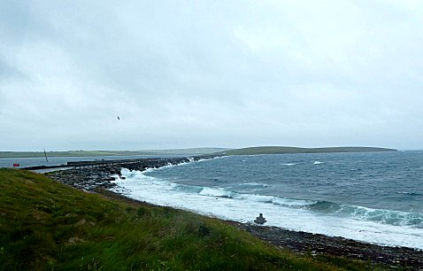 | < Mid-July 2019  A short while later, in September 1942, 255 pows were sent away from the islands due to lack of suitable accommodation, (or due to the ICRC report criticising this). Although the peak number of 1,200 pows (+520 British civilian workers) was reached again during 1943, at most times there were between 900 to 950 pows working with about 350 British civilians.  A good deal of the work was unskilled, heavy labour. It involved quarrying and transporting heavy stone to create the barriers, often in extremely poor weather. Casting concrete blocks and laying the asphalt road were other hard labour tasks. Some pows were employed performing work in the camp itself – food preparation, cleaning, some administration.  Skilled worker pows were paid 1/6 in camp money which were disc ‘coins’ or pow-notes. Unskilled manual workers earned 1/- (1 shilling = 5p – a British army private was paid 2/- at this time). Reward systems were also used in both camps at times to encourage productivity and reward ‘over-time’ – this was usually in the form of increased cigarette rations.
As in all pow camps, boredom was a negative factor in the pows lives. They organised their own entertainments, sports and games, (including a concrete bowling alley and billiard table), and many made small objects to sell. Educational classes were held, organised by the pows themselves, especially to assist the large number who were illiterate, (54% at Camp 60 according to the ICRC 1942 report). There was a camp newspaper called ‘Il Corriere delia Domenica,’ (The Sunday Chronicle).

February 1942 - not long after their arrival, the two Italian camp leaders gave one week’s notice to Major Yates that the pows were not prepared to continue working. They stated two main reasons; firstly, it aided the war effort; secondly, they had been placed in a war zone – both of these issues were against the Geneva Convention. The first reason was undoubtedly correct, the second more dubious as the whole of the UK could be considered a war zone at that time.

The British Inspector of POW Camps, (Colonel Lynch) arrived and stated that they had to continue to work while the matter was investigated by the Protecting Power. Both camps refused to work from 9 March, and they were put on a 14-day punishment diet of bread and water, with normal rations every fourth day.

A solution to this episode was found by assuring the pows that the barriers were not ‘Military Barriers,’ but were in fact ‘Civilian Causeways’ needed to link the islands for transportation and communication. Much of the credit for the peaceful end to the dispute is given to the new Commandant at Camp 60, Major Buckland, and the Kirkwall provost who spoke to the striking pows. It would seem that the majority of pows must have been apathetic towards continuing with the strike as they accepted this quite obvious deceptive use of words and resumed work.

The representatives for the ICRC in their visit to the camps in August went along with this new description of the work. It seems they had been informed that the work had been planned for some time before the war, which in relation to the actual work being carried out was not true. Nevertheless, the British got away with it. The argument that the camp was located within a war zone was also dismissed as there had not been an air raid for several months – which could not be said for many parts of mainland Britain. A short while later, the two Italian camp leaders with a ‘few’ others were transferred to other camps away from Orkney.

There were occasional other incidents of minor rebellion during the camps’ lifetime, including other strikes which lasted for up to a week. These were usually on account of conditions in the camp. One such incident involved a hut which refused to work. The British responded by frequent night time ‘inspections’ of that particular hut and that dispute quickly ended.

Two escape attempts were recorded. On an isolated beach, a pow from Lamb Holm camp found an old wooden dinghy which he was repairing with the intent to sail to Norway. He was discovered as guards became curious as to where he was disappearing to while fixing the boat. The other incident involved three pows making a raft from scrap wood and empty oil barrels who were found floating in Scapa Flow.

There were two pow deaths – 1 a fatal accident working on a diesel loco, the other from pneumonia. Considering the nature of the heavy construction work, and the nature of the location, this would seem to be a ‘good’ record – several Balfour Beatty workers were killed during the same time.

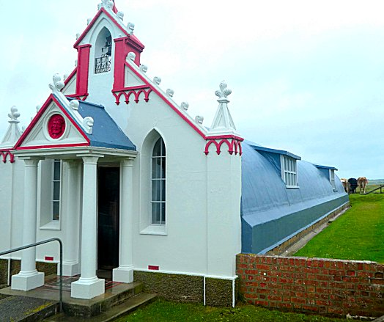 | September 1943 - Following the Italian surrender, regulations were eased. The pows were paid in British money rather than tokens, the red discs on their uniforms were no longer required, a radio was provided, and they were allowed to have bicycles.  It was at this time that the Italian Chapel was constructed. There is a considerable amount of detail available about the beautiful chapel at Camp 60. Camp 34 also had a chapel, (as did many other pow camps), but it was dismantled after the war.  In brief, during 1943 the chapel was suggested by the Camp’s priest, Father Giacobazzi, and the Camp commander, Major Buckland, accepted the proposal. Two Nissen huts were joined to form the shell which was lined with plasterwork. The front façade and altar were made from concrete. The principal pows creating the chapel were:  Domenico Chiocchetti – a skilled concrete worker and artist  Giuseppe Palumbi – a blacksmith and artisan who created the rood screen  Domenico Buttapasta – who created the outside façade. | 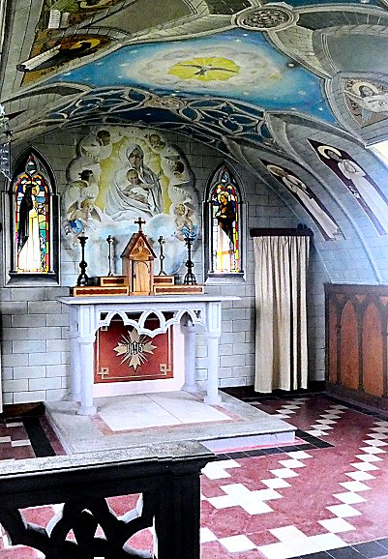

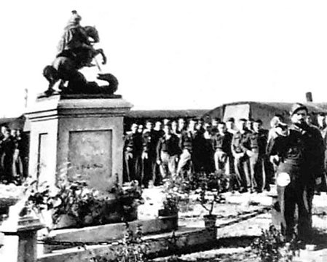 | < Domenico Chiocchetti also constructed the concrete statue of St George Slaying the Dragon which was placed in the camp square.  August 1943 - it was possible to walk across No1 causeway and gangs of pows from the island ‘were escorted across to Balfour Beatty’s Rockworks camp on the East Mainland to work.  May and November 1944 - The camp was listed as an Italian Labour Battalion under the Scottish Command area (WO 32/10737).  September 1944 - The work on the barriers was completed. It had taken 2 years and 9 months. A small group of pows stayed on at Camp 60 to clear the site, and some were allowed to complete the Italian chapel – nearly all the others were transferred to Overdale Camp, Skipton, (which then became Camp 60) as agricultural workers. All pows had left the two camps by 15 December 1945.  The roads across the barriers were officially opened on 12 May 1945 by the First Lord of the Admiralty, The Right Honourable, Albert Victor Alexander.

Sadly, in recent years, vandalism, theft and the damage caused by over 100,000 visitors a year has necessitated an increased security guard and cctv at the Italian Chapel.

Further information:

See in particular – ‘Churchill’s Prisoners: The Italians in Orkney 1942-1944’ – Compiled by James MacDonald – 1987 – published by the Orkney Wireless Museum.

For a detailed story of the Chapel and daily life in the camps see the excellent: ‘Orkney’s Italian Chapel’ – Philip Paris – 2010 – Black & White Publishing.

