Camp 54 - Hampton Lovett Camp, nr Droitwich, Worcestershire (aka Longbridge Camp)

Included in the 1945 ICRC Camp list – Labour Camp. 54. Hampton Lovett Camp, Droitwich, Worcs.

1947 Camp List
54(G.W.C.) | Hampton Lovett Camp, Droitwich, Worcs | W. | Priswar, Droitwich | Droitwich 2391 | Droitwich | Lt.Col.W.H.Green | v/1453/2

Prisoner of War Camps (1939 – 1948) - Project report by Roger J.C. Thomas - English Heritage 2003
OS NGR | Sheet | No. | Name & Location | County | Cond’n | Type 1945 | Comments
SO 888 652 | 150 | 54 | * Longbridge Camp, Hampton Lovett, Droitwich | Worcestershire | 4 | German  Working Camp | STANDARD type. Site occupied by residential caravans, hut footings used as hard-standings

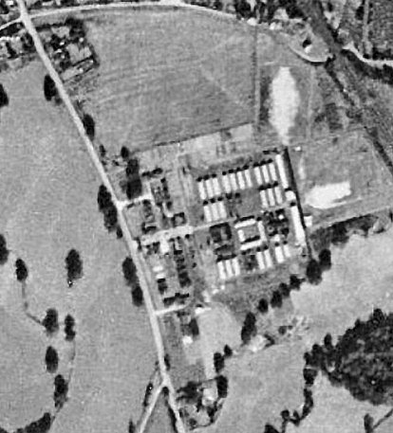 | Location: Hampton Lovett is a small village just to the N of Droitwich Spa. Site shown on 1954 map as Hampton Lovett Workers’ Hostel, just off Kidderminster Rd. *Longbridge name is incorrect – it was a hostel, not the main camp – reports / correspondence refer to Hampton Lovett Camp.  Before the camp: Farmland.  Pow Camp: The site was accepted as a pow camp in December 1941. An Italian pow construction gang was allocated from Camp 37 Sudeley to work with the Pioneer Corps.  The map and photograph show the standard layout with a main pow compound, and guard huts and offices at the ‘front’ of the camp.  1942 - The camp opened for Italian pows.  1943 – Hostels listed for Italian pows;  C.S.D. Kidderminster – Stoulton - Woods Lane - Moor Lane - Charlton Manor  9 March 1943 - International Red Cross (ICRC) inspection - Italian prisoners, capacity 800.  17 September 1943 – Death of Soldato Romeo Mendolicchio (b.2/4/1917) at Barnsley Hall | 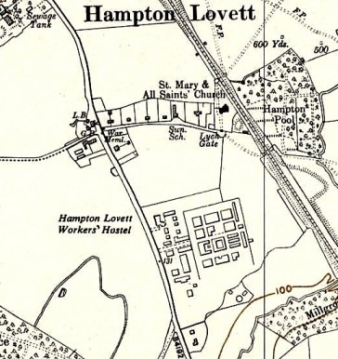
c.1946 aerial photograph |  | Ordnance Survey 1954
Hospital, Bromsgrove. Buried 21 September at Astwood Cemetery, Worcester.

5 May 1944 - Hostels listed for Italian pows, (WO 32/10737): Charlton, Pershore - Clifton, Rugby - Kidderminster - Moor Lane, Willoughby, Rugby - Pershore - Stoulton, Worcestershire - Woods Lane, Cradley Heath, Warley.

May and November 1944 - The camp was listed as an Italian Labour Battalion under the Western Command area, and then as an Italian Working Camp, (WO 32/10737).

Oversight and development of re-education activities and English teaching for German pows was carried out by PID (Political Intelligence Department of the Foreign Office) / COGA (Control Office for Germany and Austria – UK). Visits and reports were made. The standard of the reports varied greatly. The visitors took little interest, if any, in activities other than re-education. They rarely mentioned welfare, sports, games, pastimes, crafts, etc of the pows.

10 April 1945 – The site became a pow camp for Austrians, with Germans being placed in hostels. There were also Italians in hostels throughout 1945/early 1946, awaiting repatriation, but they were ignored in PID reports.

During 1945 (before September) - Hostels opened (FO939/383), all with 80 pows: Alvechurch - Harrington - Mustow Green.

17 October 1945 - Death of Austrian pow Georg Gausterer (b.21/2/1907) at the camp. Buried 20 October at Astwood Cemetery, Worcester.

7/8 November 1945 – English Education Report. 85 Austrian pupils in 4 classes – main camp. 127 German pupils in 8 classes in 7 hostels. Numbers would decrease steadily after an initial interest – this was the same in other camps.

Commandant: Lt Col A C F Foreman Camp Leader: Hfw Gustav Hladik
2nd i/c: Major A Phillips German Interpreter: Bremer
Interpreter: S/sgt Tuffill

The English classes were short of texts and room for teaching.  Austrian pows were noted as being discontent. They had been forbidden by the Commandant to make toys and other items, which they sold. He was determined to hold a hard line.  Like many others, the Commandant had no interest in re-education. He stated that; “if the War office was really inclined to support re-education, it was up to them to give him permission to erect a special hut.”  The Accounts Officer stated there was £240 in the Welfare Fund – but not available to use for books and instruments. As the visitor stated; “This seemed strange.”  Books and musical instruments were requested – as the Welfare Fund was not being released to purchase them.  29 July 1945 – ICRC camp inspection.  15 September 1945 - Hostels listed for pows from this camp, (WO 32/10737):  Ribbesford, Bewdley, Worcestershire; Sillins (Lane), Redditch, Worcestershire  2 October 1945 – The denial for funds to be released for books etc., continued. Extracts from a visiting lecturer’s report: | 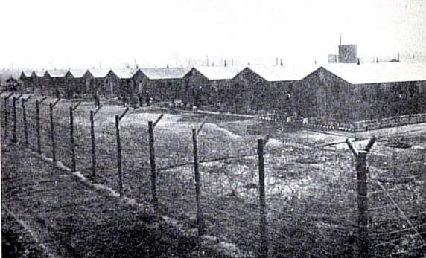
 | Photo by ICRC in a rather bleak looking Spring 1943
“Camp 54 (Austrian) The prisoners appealed to me for books and music. Austrian plays…Austrian music particularly Strauss waltzes… I understand that the prisoners would be in a position to buy a few books from their rather modest funds. The prisoners are fervent Austrian nationalists. The padre, a RC priest, has to read mass three times on Sunday… Many prisoners realise that they are still better off than their people at home and some have also written words to this effect in the first batch of letters they were able to write.”

23-29 March 1946 – PID Visit to camp for screening.

One change to senior personnel - there was a deputy camp leader: Fw Otto Muller

Political screening: | A+ | A | A- | B+ | B | B- | C | C+ | Unknown
 | 6 | 122 | 1 | 97 | 1139 | 100 | 220 | 5 | 180

Of the unknowns – 114 were from camps in Canada / 60 were awaiting screening results from previous camps.

Austrian pows were hoping for early repatriation.

6 April 1946 – English Inspector’s visit.

21 May 1946 – All Austrians had been removed from the camp prior to repatriation. It was now classed as a German Working Camp.

23 July 1946 – English Inspector’s Report. 69 pupils in 5 classes. 206 in 13 classes for hostels.

A new camp leader (Lagersprecher): G Braunsch.

Comment made that Longbridge hostel was ‘blackish,’ i.e. a high number of Nazi pows.

7/9 August 1946 – Objects of visit – 1. Screen hostel staff, 2. Re-education report, 3. Investigate trouble at Longbridge. Strength; 1 officer (the M.O.), 2520 Other Ranks.

Commandant: Lt Col A C Foreman Camp Leader: O/Fwl Braunsch (A)
2nd i/c: Major Letch Deputy C/L: Sta Gefr Adamski (A)
Interpreters: S/sgt Fry and S/Sgt Wulfson German M.O.: St.arzt Jansen (B-)

The 2nd i/c was regarded as a strict disciplinarian.

S/Sgt Fry was keen to promote re-education activities but was hampered by poor relationships and lack of support from the Commandant. S/Sgt Wulfson, despite being an interpreter, had; “a sketchy knowledge of German,” he was used primarily as a clerk.

Only a few of the newly arrived Germans had been screened, simplified numbers were given: A 48; B 200; C 92; Unknown 2181. Of the hostel leaders - 1 was A; 1 was B; 5 were C (!); 2 unscreened; it was agreed that several of these C grade leaders would be replaced.

Most of the Germans were from camps in the USA, they had been misinformed that they were to be sent back to Germany, consequently on finding themselves in a British pow camp, many had low morale. 900 pows were from Belgium where conditions in camps had been very poor; 113 were from camps in Canada.

The camp leader and deputy had been selected by S/Sgt Fry from the pows from Canada. The leader was stated to have a genuine democratic viewpoint and a strong character. He had a difficult time promoting activities due to the high level of discipline required. He did not receive support from the pows from Belgium who were mostly young, and many were Waffen SS – they were described by the visitor as “indisciplined and lazy.”

Low morale was recorded due to; 1. High standard of work demanded with no attempt to improve leisure facilities, 2. Young pows from Belgium; 280 pows had not received any mail. Morale was said to be higher in the hostels.

50% of pows were ‘Youth’ (under-25) and were regarded as a problem. It was suggested some should be sent to the special youth camp, and that a team be sent from Wilton Park to develop activities in this camp.

Re-education activities were slow to develop. Although the camp had 3 dining halls seating 250, they were also used as a theatre, cinema and for teaching. The standard list was given:

Wochenpost and Ausblick – 1300 / 165 copies respectively.

Newspapers – In the main camp, a good variety of British papers and journals were received. German and a few Swiss papers were also received. The large hostels had a regular supply of British papers. The smaller hostels relied on British staff brining in papers, this was not satisfactory.

Library – Insufficient, only 600 books in main camp and no arrangements to circulate books to the hostels. COGA asked to help out.

Lectures – Regular in main camp, but hostels often missing out.

Discussion groups – None in main camp.

Films – Fortnightly from COGA and YMCA, often on same day – it was requested to change this.

Wireless – Sets in all sites except Longbridge. Main camp had speakers in the dining halls.

Camp Magazine – The first editor was replaced as he was a Nazi. The new editor pow Gabriel was ready to produce the first issue, (Lagerecho) though interest was small and there was a shortage of paper.

Press reviews – A news review was given to about 20% of pows by a pow English teacher. Excerpts from British papers were translated and pinned on dining room walls.

English Instruction – separate reports.

Other activities -

Religion – Protestant padre, Boerner was based at Mustow Green and visited 4 other hostels on Sundays. He was regarded as a “healthy influence” and it was recommended he be brought to the main camp. No RC padre, RC pows could attend local churches.

Education – Main camp; English, French and stenography with small classes.

Entertainment – A theatre group had given one performance. They were disinclined to carry on as they received no support from the authorities and their materials had been confiscated. The Commandant stated he was not aware of this and promised he would allow costumes and props to be made. There were seven members of an orchestra which mainly supported the theatre group. A piano was to be purchased from welfare funds.

11/13 September 1946 – English Inspector’s Report. Strength 2994. Main - 85 pupils in 3 classes. Hostels – 275 pupils in 21 classes.

A new Commandant – Lt Col W H Green

19/22 December 1946 - English Inspector’s Report. Strength 2564. Main - 51 pupils in 3 classes. Hostels – 164 pupils in 16 classes.

A new camp leader – Richard Brinkmann, previously hostel leader at Impney.

25/29 March 1947 – Re-education survey. Strength 2 officers, 2189 OR.

Commandant: Lt Col Green Camp Leader: Hfw Richard Brinkmann (B-)
2nd i/c: Major Jarvis Deputy C/L: Ostm Buendgens (B)
Interpreter: S/Sgt B Weieman German M.O.: Oberarzt Dr Gress (B-)

Commandant Green was not interested in re-education, however he was due to leave and a new Commandant (Lt Col S W Jones) seemed to take an interest. The assistant commandant had some interest in re-education.

The S/Sgt interpreter was Ukrainian and had a poor command of German – he was recorded as unsuitable and cynical.

Camp leader Brinkmann was a book-keeper, joined the Nazi Party in 1936 but stated he had been forced to. “Trustworthy and professes interest for re-education, but lacks drive and initiative.” A replacement was being considered. Deputy leader was ex-navy, not a Party member, well-liked, but due to be repatriated.

Political screening: | A | B+ | B | B- | C
 | 23 | 249 | 1197 | 494 | 228

This was a high number of C grade pows. 230 appeals pending – the better the grade, the sooner the repatriation, in theory. Most appeals were usually successful. 996 pows repatriated to date.

Morale was mixed. Category C pows had low morale as their repatriation was uncertain – however many of them hoped for better grades after appeals / rescreening. Bad weather had meant that levels of work had been very low – the Welfare Fund had been used up. Political progress had been made and there were fewer problems arising.

Youth – approximately 40%. A Camp Committee were developing a range of indoor and outdoor sports to keep them active. Many of the younger pows from Belgian camps were still C graded.

The new Camp Committee had been formed to develop activities. It consisted of the Camp leader, deputy, leader of political discussions, and editor of the camp newspaper – it was hoped to include a few more active members. Space was still short, but it was hoped another hut would become available for use.

The standard list of re-education activities was given – there was only a slight overall improvement since August 1946:

Newspapers – adequate for British papers – but no German or Swiss papers.

Library – only 574 books, inadequate for over 2000 pows. A system to exchange books with the hostels had been developed.

Lectures – regular.

Discussion groups – weekly in main, Perdiswell, Longbridge and Alvechurch.

Films – fortnightly from YMCA and Gaumont British. Documentaries in German were requested.

Wireless – adequate.

Camp magazine – still suffering from lack of paper, and further supplies could not be bought as there was no Welfare Fund. COGA was asked to assist.

Press review – Weekly with discussions. About 50 pows attending.

English instruction – separate appendix.

Information Room – just press articles on display. No exhibition materials received from COGA.

Other activities –

Religion – Adequate facilities available. Weekly services and Bible hour held in camp church. Pows were able to visit local churches. Padre, Uffz Hoen (B-) did not have much influence, but was respected.

Education – very little, just English and Russian in the main camp. Small classes in some hostels.

Entertainment – Small shows put on by the theatre group. Despite promises made by the Commandant, costumes which were alleged to have been made from British Army blankets had been confiscated in a somewhat mean-spirited manner.

8 July 1947 – A case was raised in the House of Commons regarding fraternisation. Werner Wetter, aged 22, had been court martialled in Droitwich for association with a British ‘girl’ and sentenced to 12 months imprisonment. The young woman was pregnant and the pow wished to marry her. The issue received a good deal of public sympathy for the pow and was widely reported in the British and international press.

“Mr. Bellenger [Secretary of State for War] - My attention has been drawn to the case referred to. The proceedings of the Military Court have not yet been received at the War Office, but as soon as they have been received they will be carefully examined. I am, therefore, unable to make a statement at the moment.” He promised to raise the matter of marriage of pows to British women in general.

Mr Oliver, The Under-Secretary of State for the Home Department, gave a summary of the problems involved for pows to marry; “As the law stands, the woman, if British, would lose her nationality on marriage to a German. No provision could be made for her to live with her husband who, as a prisoner of war, would have to remain in a camp or hostel under military control; and there could be no relaxation in his favour of restrictions applicable to other prisoners of war. Moreover, no undertaking could be given that the husband would be allowed to remain in this country when he would in ordinary course be due for repatriation. If, therefore, a prisoner of war makes it known that he wishes to marry a woman who is resident here, steps will be taken to see that the considerations which I have mentioned are understood by both parties, and if, nevertheless, they determine to marry, no obstacle will be placed in their way.”

This general answer did not satisfy many MP’s with regard to the specific case;

“Mr. Sorensen - If a British girl marries a German prisoner of war who is subsequently repatriated to his own country, will she still be allowed to remain here if she wishes, in spite of the fact that as the result of the marriage she has become a German citizen?

Mr. Oliver - The answer is that as a British-born subject she would be allowed to remain.”

A question was then raised as to what the couple needed to do in order to marry. Mr Oliver was unable to answer and merely stated; “I have no doubt that the lady in question will take the earliest possible and the proper steps to find out the right mode of procedure.” He then went on to state that; “no obstacle would be placed in their way in regard to matrimony. So, therefore, all I can say is, in view of the statement which I have made, that steps will be taken.”

Mr Oliver failed to answer a question about the arrangements for a wedding, whether it would be inside or outside the prison where the pow was held. It was requested that the pow’s sentence be quashed in order to allow the marriage. Mr Bellenger only replied that the matter would be looked into. HC Deb 08 July 1947 vol 439 cc2013-92013.

The eventual result was a change to the regulations, allowing pows to marry British women – see 28 September, below.

11-16 August 1947 – Re-education survey. Strength; 1 officer, 2483 OR.

Changes to senior personnel since March - Commandant: Lt Col S W Jones - Deputy C/L: Uffz Klauschke (B). (Dr Gress had been upgraded from B- to B+).

The Commandant was reported to be well respected and promoted both the welfare and re-education of the pows, this would later be questioned.

The Ukrainian interpreter, S/Sgt B Weieman, was said to have improved his German, but done nothing positive to further re-education. It was recommended he be replaced.

The Commandant had kept the Camp Leader in place.

Deputy C/L; Uffz Klauschke had been hostel leader at Clent and was recommended to be removed. This had been done, “but somehow this opportunist had ingratiated himself into the position of Duputy Camp Leader in HQ. This will be rectified.” It was not rectified – Klauschke soon became Camp Leader.

Simplified screening figures in use – A 19; B 2465. Note all C grade pows have either been regraded or sent to a different camp.

Morale had improved, mainly due to the new Commandant. Negative factors mentioned were; restrictions on sending food items to Germany, and bad news from home. Most pows were politically apathetic. A small group were actively promoting re-education activities, but this was made more difficult with reduced restrictions and the preference for going out of the camp when possible.

The standard list of re-education activities was given, the variations on the previous report were:

Newspapers – Swiss and German papers received.

Library – 1700 books, up from 574. A better distribution of books had been set-up.

Discussion groups – suspended while good weather lasted.

Information room – had started to put on exhibitions of text and pictures.

Entertainments – the theatre group’s issues over costumes had been resolved. The small orchestra continued. There was an excellent choir.

Apart from informal contacts that pows developed with families, there was very little formal outside contacts being developed. The Society of Friends and Salvation Army were involved with some hostels. There were plans for further contacts.

28 September 1947 - Daily Express, reports of pow marriage to English girl.

“'Free to wed' P.o.W. is wed himself - Three meals, folk songs and a German band. [by] Express Staff Reporter: Hampton Lovett (Worcs), Sunday.

Werner Vetter, the 22-year-old German prisoner of war whose story and detention gave freedom to all German prisoners to marry English girls, was married himself today.

His English girl is Olive Reynolds, also 22, from Chingford, Essex. They met when he was working on a farm and it was last June that he was sentenced to 12 months' detention by an Army court martial for ‘consorting’ with her. He asked then: "Why do you wish to punish me for something that, in the months to come, will be permissible?"

Next month the law was changed. Prisoners got the right to wed and other freedoms. Vetter was released after serving a few weeks of his sentence. And today he stood with Olive in Hampton Lovett church, 100 yards from Vetter's camp, in front of 150 German prisoners, Olive's family, and a few villagers.”

After the marriage the reception was held in the local Girl Guides hut with Olive’s family and friends and pows. “They ate three meals, cooked by prisoners with food saved from their rations, including a wedding breakfast of soup, roast beef, potatoes and carrots, and fruit dessert…. They saw two wedding cakes cut. They heard speeches in German and English. Then came German folk songs, dancing, and games, to the music of a prison camp orchestra. It all ended at ten tonight and everyone went home: Vetter to his camp in Hampton Lovett, and Olive to Droitwich, one and a half miles away.”

7-11 October 1947 – Re-education survey. Strength; 1 officer, 2112 OR.

No change to senior staff. The interpreter S/Sgt Weieman was still in place despite the recommendation to remove him, however it was stated that he was unhappy in the camp and had applied for a transfer.

Simplified screening in use: A 1, B 2112. 1977 pows repatriated to date.

Morale was recorded as ‘fair.’ There was political apathy in general. Youth pows (35%) were no longer seen as a problem – “their main interests are sport and their evening liberty rather than intellectual pursuits.”

Main changes to re-education activities – no lecturers had visited since the last report, no explanation for this as they were continuing to visit other camps – discussion groups were dwindling through lack of interest. Classes, theatre group and orchestra were beginning to have difficulties as pows were repatriated. Formal outside contacts were still trying to be created.

24/28 October 1947 – English Inspector’s Report. Strength; 2004. 9 classes with 94 pupils for the whole camp.

14 November 1947 - Camp number included in an ‘Urgent Memorandum’ (FO 939/270) regarding inspection of food parcels.

6/9 January 1948 - English Inspector’s Report. Strength; 1428. 4 classes with 55 pupils for the whole camp.

The previous Deputy, Uffz Klauschke, had taken the role of Camp Leader despite recommendations made by PID visitors.

3/4 March 1948 – A visit was made to; 1. arrange for 3 pows to attend a conference, and 2. conduct a re-education survey. Strength; 1 officer, 1671 OR.

Commandant: Lt Col S W Jones Camp Leader: O/Fw Wilhelm Baranek [previously hostel leader at Assarts Common.]
Interpreter: S/Sgt Popper Deputy C/L: Fw Kurt Boehnert
German M.O.: Oberarzt Dr Fredjof Gress

Purpose 1 was a waste of time. The Commandant refused to release the 3 pows to a Workers’ Education Alliance weekend conference without War Office authority. Perhaps a ‘phone call could have found this out?

In many camps that were still open at this time, ‘surveys’ of pow attitudes towards Britain were conducted. It was another waste of time. There was no set method for the survey; in some camps it was held with whatever pows were around when the visitor arrived, in others it was with a group selected by the Commandant and/or the Camp Leader. In this camp the survey was conducted with 120 pows assembled by the Camp Leader, with discussions on the questions raised and an open show of hands. The results were meaningless – and so late as to be pointless.

For what it is worth, it was recorded that in this camp; the pows were “reasonably friendly” towards British people, but hostile to the authorities. “The majority of Ps/W state that they have derived no benefit whatsoever from their enforced stay in England, there is little or nothing in the English way of life which they would like to see in Germany and they are really quite indifferent in their feelings about England.” A series of complaints were made regarding rations, unfair treatment, camp rules, Britain’s authority in Germany, and being treated as slave labour.

A group of pows about to be repatriated had been issued with patched battle-dress and told to repair them – not surprisingly this caused bitterness.

The pows found the citizens of Droitwich to be unfriendly, while they were welcomed in Worcester.

Re-settlement officers were touring to talk to pows about repatriation – they had not been to this camp, (they visited very few).

Two lucky pows were invited on a sight-seeing tour of London and visit to the House of Commons and Lords, (invited by MP for ‘Cardiff’ who visited the camp – probably Cardiff South, James Callaghan.)

Overall, this report revealed some unsettling aspects of this camp. The Commandant, previously praised as being well respected and promoting welfare and re-education was described differently – “despite his friendliness, must be classed as un-cooperative in view of his strict adherence to Administrative instructions; and his generally very military attitude towards Ps/W.”

3/5 May 1948 – Visit to survey re-education and take a group of pows to Pershore Rural District Council Meeting. Strength; 6 officers, 1221 OR. This report was misfiled under FO 939-140 at the National Archive.

No changes to senior personnel.

The Commandant and British staff were summed up as, “Friendly but disinterested.” The camp was due to close between the end of May, up to 18 June.

Attitudes from the March survey were repeated – why?

The resettlement team had still not visited. The very limited formal local contacts had all ended.

Known Camp Commandants:
1945. Lt Col A C F Foreman. Later Commandant at Royston Heath Camp 29.
1946. Lt Col W H Green MC - William Howard Green of the King’s Own Royal Regiment. Recorded at Harcourt Hill Camp for a short time in 1947.
1947. Lt Col S W Jones

After the camp: A workers’ hostel. Now a site for prefabricated houses.

Further information:

National Archives – FO 939/136 54 Working Camp, Hampton Lovett Camp, Droitwich, Worcestershire. Dated 1945-1948. Used above.

Camp and hostels + number of pows where known:

 | Not open |  | Unknown |  | Open |  | With another camp

 | 1942 | 1943 | 5/44 | 11/45 | 3/46 | 7/46 | 8/46 | 9/46 | 12/46 | 3/47 | 8/47 | 10/47 | 1/48 | 3/48 | 5/48
Main | ? |  |  | 1424 A |  | 978 ⁽²⁾ | 1024 | 970 | 952 ⁽³⁾ | 731 | 893 | 876 | 556 ⁽²⁾ | 593 ⁽⁴⁾ | 940 ⁽⁵⁾
Kidderminster
Stoulton |  |  |  | G
Woods Lane |  |  |  |  |  |  |  |  |  |  |  |  |  | 45
Moor Lane
Charlton M. |  |  |  | G
Clifton
Pershore
Alvechurch |  |  |  | G |  | 127 | 124 | 108 | 69 | 74 | 77 | 57
Harrington |  |  |  | G | With C49 / 87 / 259
Mustow Gr. |  |  |  | G |  | 82 | 80 | 78 | 75 | 72
Ribbesford |  |  |  | (1)
Sillins |  |  |  | (1) |  | 124 | 142 | 130
Pitchill |  |  |  | G | With C? |  |  |  |  | With C31
Perdiswell Sat |  |  |  | G | Camp 287 |  |  | 412 | 413 | 355 | 398 | 346 | 334 | 257
Impney Court |  |  |  |  |  | 297 | 292 | 274
Longbridge |  |  |  |  |  | 344 | 352 | 348 | 384 | 354 | 285 | 169 | 181 | 182 | 60
Clent |  |  |  |  |  | 125 | 155 | 141 | 71 | 68
St Margarets |  |  |  |  |  | 92 | 77 | 73
Stourbank |  |  |  |  |  | 83 | 82 | 78 | 194 | 181 | 129 | 105 | 123 | 72
Inkberrow |  |  |  |  |  | 38 | 67 | 69
Wheatfields |  |  |  |  |  |  |  | 103 | 79 | 85 | 85 | 68 | 72
Stourport |  |  |  |  |  |  |  | 15
Bentley M |  |  |  |  |  |  |  |  | 105 | 125 | 140 | 78 | 102 | 79 | 4
Summerfield |  |  |  |  |  |  |  |  | 61 | 14 | 62 | 20
Assarts C |  |  |  |  |  | With C 27 |  |  |  |  | 176 | 160 | 60 | 60
Wordsley |  |  |  |  |  |  |  |  |  |  |  |  |  | 211 | 139
Halesowen |  |  |  |  |  |  |  |  |  |  |  |  |  | 112 | 4
Billets |  |  |  |  |  | ? | 126 | 175 | 128 | 132 | 239 | 234 | ? | 59 | 23
Total | ? | Cap800 | ? | ? | 1870 | 2417 | 2521 | 2994 | 2564 | 2191 | 2484 | 2113 | 1428 | 1672 | 1227

(1) Possibly Italians. (2) Including billetees. (3) + 33 sick. (4) + 2 in prison. (5) + 53 as rear party at Ledbury Camp 27, 2 in prison, and 2 escapees.

Satellite Camp - Perdiswell (Hall), Worcester. SO 853 576, Map etc., see Perdiswell Camp 287.

1945 – Listed as a hostel for Camp 54 with German pows.

1946 – Became independent Camp 287

9/1946 – Became a satellite camp for Camp 54.

3/1947 – Camp leader; Hfw Hofmeister (B+)

8/1947 – same leader, described as one of the camp’s “outstanding personalities.”

10/1947 – same leader.

 | 1942 | 1943 | 5/44 | 11/45 | 3/46 | 7/46 | 8/46 | 9/46 | 12/46 | 3/47 | 8/47 | 10/47 | 1/48 | 3/48 | 5/48
Perdiswell Sat |  |  |  | G | Camp 287 |  |  | 412 | 413 | 355 | 398 | 346 | 334 | 257

Hostels

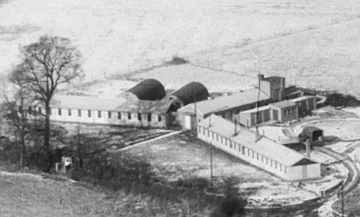  Alvechurch. Huts. Tanyard Lane, Alvechurch - SP 026 727, shown as ‘hostel’ on map.  11/45 – Listed as a hostel with German pows – may have held Italian pows before this.  8/1946 – Hostel leader; Ofwl Zapf (C)  3/1947 – Hostel leader; Uffz Moersdorf (B)  8/1947 – same leader.  10/1947 – Hostel leader; O/Fhr Nehte (B-) – “willing and capable.”  Photo 1948.  1942 1943 5/44 11/45 3/46 7/46 8/46 9/46 12/46 3/47 8/47 10/47 1/48 3/48 5/48  Alvechurch G 127 124 108 69 74 77 57 | 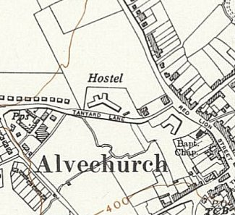
 | Ordnance Survey 1956

Assarts Common. SO 779 408, for map etc see Ledbury Camp 27

8/1947 – Hostel leader; Uffz Tohtz (B-), Nazi Party member from 1933, which he claimed to be “purely nominal” – he had been a joiner, “solid and uninspiring.”

10/1947 – Hostel leader; O/Fw Baraneck (B) – “Rather a colourless individual with little initiative.”

 | 1942 | 1943 | 5/44 | 11/45 | 3/46 | 7/46 | 8/46 | 9/46 | 12/46 | 3/47 | 8/47 | 10/47 | 1/48 | 3/48 | 5/48
Assarts C |  |  |  |  |  | With C 27 |  |  |  |  | 176 | 160 | 60 | 60

Bentley Manor. (W of Redditch). SO 998 652.  Certainly, linked to a different main camp before this. Wikipedia states requisitioned by War Office in 1942.  3/1947 – Hostel leader; Strom Raudzus (B-)  8/1947 – Hostel leader; Uffz Klippel (B), aged 31, no Party record, unpolitical “nondescript engineer.”  10/1947 – Hostel leader; Uffz Pable – “quite a good man but is rather overshadowed by his interpreter.”  1942 1943 5/44 11/45 3/46 7/46 8/46 9/46 12/46 3/47 8/47 10/47 1/48 3/48 5/48  Bentley 105 125 140 78 102 79 4 | 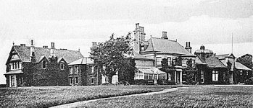

Charlton (Manor), Pershore, Worcestershire. Charlton House was located at SP 009 457.

1943 / 1944 - listed as a hostel for Italian pows.

1945 – a hostel for German pows.

Most likely attached to another main camp after this.

 | 1942 | 1943 | 5/44 | 11/45 | 3/46 | 7/46 | 8/46 | 9/46 | 12/46 | 3/47 | 8/47 | 10/47 | 1/48 | 3/48 | 5/48
Charlton M. |  |  |  | G

Clent (SSE of Stourbridge).

Most likely attached to an different main camp before this.

7/1946 – huts and tents.

8/1946 – Hostel leader; Ufwl Lichtenhagen (C)

9/1946 – still huts and tents.

3/1947 – Hostel leader; Uffz Klauschke (B), described as a; “very poor, untrustworthy specimen who pays lip-service only to re-education.” The Commandant promised to replace him – he was eventually promoted to be camp leader!

 | 1942 | 1943 | 5/44 | 11/45 | 3/46 | 7/46 | 8/46 | 9/46 | 12/46 | 3/47 | 8/47 | 10/47 | 1/48 | 3/48 | 5/48
Clent |  |  |  |  |  | 125 | 155 | 141 | 71 | 68

Clifton (Upon Dunsmore), Rugby, Warwickshire

May 1944 – listed as a hostel for Italian pows.

Probably attached to a different man camp after this.

 | 1942 | 1943 | 5/44 | 11/45 | 3/46 | 7/46 | 8/46 | 9/46 | 12/46 | 3/47 | 8/47 | 10/47 | 1/48 | 3/48 | 5/48
Clifton

Halesowen.

Appears to have been taken over after a different main camp closed.

 | 1942 | 1943 | 5/44 | 11/45 | 3/46 | 7/46 | 8/46 | 9/46 | 12/46 | 3/47 | 8/47 | 10/47 | 1/48 | 3/48 | 5/48
Halesowen |  |  |  |  |  |  |  |  |  |  |  |  |  | 112 | 4

Harrington, Northamptonshire. SP 765 793.

1945 – Listed as a pow hostel attached to Hampton Lovett Camp 54 (FO 939/383) with capacity for 80 German pows.

July 1946 – Listed as a satellite camp attached to Farndon Road Camp 49 (FO 939/131) and later Byfield Camp 87 (FO 939/167), then Weekley Camp 259 (FO 939/314).

 | 1942 | 1943 | 5/44 | 11/45 | 3/46 | 7/46 | 8/46 | 9/46 | 12/46 | 3/47 | 8/47 | 10/47 | 1/48 | 3/48 | 5/48
Harrington |  |  |  | G | With C49 / 87 / 259

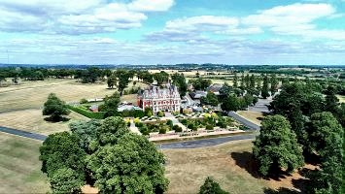

Impney Court, Droitwich. (Chateau Impney). SO 912 639.

Pows were accommodated in the house and the parklands. Reported to have held Italian pows before the entries below, so would have been attached to a different main camp.

8/1946 – Hostel leader; Hfwl Brinkmann (C). Regarded as a ‘black’ hostel with a high number of Nazi pows.

9/1946 – Protestant pows attended a Baptist chapel in Droitwich. RC pows were looked after by a missionary college in Hadzor.

 | 1942 | 1943 | 5/44 | 11/45 | 3/46 | 7/46 | 8/46 | 9/46 | 12/46 | 3/47 | 8/47 | 10/47 | 1/48 | 3/48 | 5/48
Impney Court |  |  |  |  |  | 297 | 292 | 274

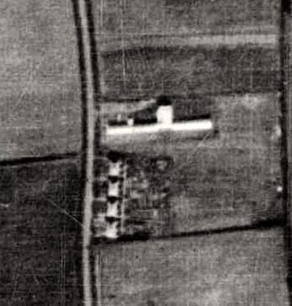  Inkberrow. Huts. SP 015 582. Previous use for Women’s land Army.  Probably attached to a different main camp before and after these entries. Part sticking out near middle was the kitchen.  8/1946 – Hostel leader; Fwl Tietze (-)  1942 1943 5/44 11/45 3/46 7/46 8/46 9/46 12/46 3/47 8/47 10/47 1/48 3/48 5/48  Inkberrow 38 67 69 | 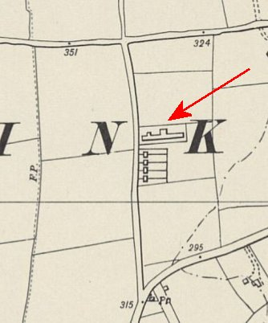
 | Ordnance Survey 1955
Kidderminster (C.S.D.) – Command Supply Depot. I do not think this is the site of the US Hospital / pow camp at Wolverley.

1943 / 1944 – Listed as a hostel for Italian pows.

Probably attached to a different main camp after this.

 | 1942 | 1943 | 5/44 | 11/45 | 3/46 | 7/46 | 8/46 | 9/46 | 12/46 | 3/47 | 8/47 | 10/47 | 1/48 | 3/48 | 5/48
Kidderminster

Longbridge. Huts. Groveley Lane.

8/1946 – Hostel leader; Ofwl Brockmeyer (C). The Commandant had requested the hostel be investigated regarding Nazi influences.

One pow ‘Klette’ had given a lecture on democracy which had been fiercely opposed with shouts such as; “All Germans who line up with democracy are swine.” He also stated that other lectures had been given which were anti-democracy and supported Hitler. He requested to be transferred to the main camp for his safety.

Another pow stated that the atmosphere was like the “Nazi-run camps he knew in the USA” where he had once been placed in protective custody. A small group of pows backed up the opinion that there was a Nazi atmosphere and that it was dangerous to express any other opinion. In some huts Nazi songs were sung in the evenings and there were even some Nazi books brought back from the US.

At least 5 pows were considered to be actively promoting Nazism, including the hostel leader, (“an unpleasant type of opportunist”). The hostel leader was to be replaced and sent to the main camp. The four other active Nazis were sent to Watten Camp 165. A further list of possible trouble-makers was given to the Commandant to keep under supervision. Staff were told to watch for victimisation and Nazi songs. If these measures were not sufficient, it was recommended that further screening be carried out.

3/1947 – Hostel leader; Fw Reis (B). Tensions at Longbridge had eased with the new leader.

8/1947 – Hostel leader; Fw Rolfes (B-), aged 35, RC, was a member of SA and Nazi Party, he stated this was necessary for his job – but admitted a sense of guilt. Significant political progress was noted.

10/1947 – same leader.

5/1948 – Hostel leader; Uffz Oswald Rakete.

 | 1942 | 1943 | 5/44 | 11/45 | 3/46 | 7/46 | 8/46 | 9/46 | 12/46 | 3/47 | 8/47 | 10/47 | 1/48 | 3/48 | 5/48
Longbridge |  |  |  |  |  | 344 | 352 | 348 | 384 | 354 | 285 | 169 | 181 | 182 | 60
Moor Lane, Willoughby, Rugby, Warwickshire

1943 / 1944 – Recorded as a hostel for Italian pows.

 | 1942 | 1943 | 5/44 | 11/45 | 3/46 | 7/46 | 8/46 | 9/46 | 12/46 | 3/47 | 8/47 | 10/47 | 1/48 | 3/48 | 5/48
Moor Lane

Mustow Green, Kidderminster. Huts

8/1946 – Hostel leader; Uffz Roscher (B)

3/1947 – Hostel leader; Obfhr Nethe (B-)

 | 1942 | 1943 | 5/44 | 11/45 | 3/46 | 7/46 | 8/46 | 9/46 | 12/46 | 3/47 | 8/47 | 10/47 | 1/48 | 3/48 | 5/48
Mustow Gr. |  |  |  | G |  | 82 | 80 | 78 | 75 | 72

Pershore, Worcestershire

5/1944 – Hostel recorded for Italian pows.

 | 1942 | 1943 | 5/44 | 11/45 | 3/46 | 7/46 | 8/46 | 9/46 | 12/46 | 3/47 | 8/47 | 10/47 | 1/48 | 3/48 | 5/48
Pershore

Pitchill. SP 051 516 – See Ettington Camp 31 for map and details.

 | 1942 | 1943 | 5/44 | 11/45 | 3/46 | 7/46 | 8/46 | 9/46 | 12/46 | 3/47 | 8/47 | 10/47 | 1/48 | 3/48 | 5/48
Pitchill |  |  |  | G | With C ? |  |  |  |  | With C31

Ribbesford, Bewdley, Worcestershire. Possibly Ribbesford House SO 786 738 – after being used by Free French, British and US Forces, recorded as holding Italian pows.

 | 1942 | 1943 | 5/44 | 11/45 | 3/46 | 7/46 | 8/46 | 9/46 | 12/46 | 3/47 | 8/47 | 10/47 | 1/48 | 3/48 | 5/48
Ribbesford |  |  |  | (1)

(1) Possibly Italians.

Sillins (Lane), Redditch, Worcestershire. Sillins Hall – SP 013 646. Listed as a building.  8/1946 – Hostel leader; Stfwl Raudzus (C)  9/1946 – Record that this hostel did not have a wireless. Overall, the site made a poor impression on the PID visitor.  1942 1943 5/44 11/45 3/46 7/46 8/46 9/46 12/46 3/47 8/47 10/47 1/48 3/48 5/48  Sillins (1) 124 142 130  (1) Possibly Italians. | 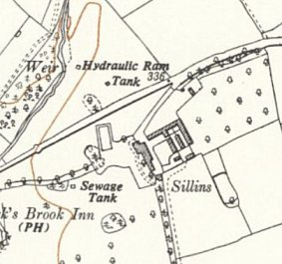
 | Ordnance Survey 1955
St Margarets. Huts. 7 miles from main camp. No clue at all as to which St Margaret’s.

8/1946 – Hostel leader; Uffz Fleischmann (-). Discussion groups held, but not well attended or organised.

 | 1942 | 1943 | 5/44 | 11/45 | 3/46 | 7/46 | 8/46 | 9/46 | 12/46 | 3/47 | 8/47 | 10/47 | 1/48 | 3/48 | 5/48
St Margarets |  |  |  |  |  | 92 | 77 | 73

Stoulton. SO 918 496  1942 1943 5/44 11/45 3/46 7/46 8/46 9/46 12/46 3/47 8/47 10/47 1/48 3/48 5/48  Stoulton G | 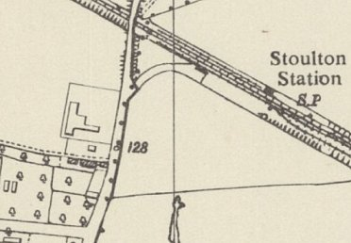
 | Ordnance Survey 1955
Stourbank, Stourport. Huts.

8/1946 – Hostel leader; Ogefr Hubert (A). 50 pows attended a weekly discussion group evening.

3/1947 – Hostel leader; Obfw Polaschke (B+)

10/1947 – same leader.

 | 1942 | 1943 | 5/44 | 11/45 | 3/46 | 7/46 | 8/46 | 9/46 | 12/46 | 3/47 | 8/47 | 10/47 | 1/48 | 3/48 | 5/48
Stourbank |  |  |  |  |  | 83 | 82 | 78 | 194 | 181 | 129 | 105 | 123 | 72

Stourport. (Listed separately from Stourbank, Stourport.). Listed as stables.

 | 1942 | 1943 | 5/44 | 11/45 | 3/46 | 7/46 | 8/46 | 9/46 | 12/46 | 3/47 | 8/47 | 10/47 | 1/48 | 3/48 | 5/48
Stourport |  |  |  |  |  |  |  | 15

Summerfield, (Droitwich/Kidderminster). Possibly the site at Summerfield SO 840 734.

3/1947 – Hostel leader; Obfw Fahrner (B-) [Fahner?]

10/1947 – same leader

 | 1942 | 1943 | 5/44 | 11/45 | 3/46 | 7/46 | 8/46 | 9/46 | 12/46 | 3/47 | 8/47 | 10/47 | 1/48 | 3/48 | 5/48
Summerfield |  |  |  |  |  |  |  |  | 61 | 14 | 62 | 20

Wheatfields, Worcester. Listed as stables. SO 835 503  3/1947 – Hostel leader; Fw Poelkmann (B) [Pelkemann?]  10/1947 – same leader.  1942 1943 5/44 11/45 3/46 7/46 8/46 9/46 12/46 3/47 8/47 10/47 1/48 3/48 5/48  Wheatfields 103 79 85 85 68 72 | 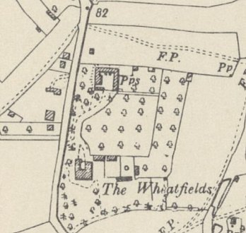
 | Ordnance Survey 1955
Woods Lane, Cradley Heath, Warley, Worcestershire. Area shows on 1955 map as a heavy industrial area.

Between 1945 to 1948 – probably attached to a different main camp.

 | 1942 | 1943 | 5/44 | 11/45 | 3/46 | 7/46 | 8/46 | 9/46 | 12/46 | 3/47 | 8/47 | 10/47 | 1/48 | 3/48 | 5/48
Woods Lane |  |  |  |  |  |  |  |  |  |  |  |  |  | 45

Wordsley. Bromley Lane, Wordsley.  5/1948 – Hostel leader; S/Gefr Friedrich Fuss.  1942 1943 5/44 11/45 3/46 7/46 8/46 9/46 12/46 3/47 8/47 10/47 1/48 3/48 5/48  Wordsley 211 139 | 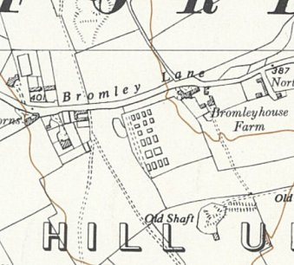
 | Ordnance Survey 1955

