Camp 52 - Nether Headon Camp, Ladywell Rise, East Retford, Lincolnshire

Included in the 1945 ICRC Camp list – Labour Camp. 52. Nether Headon Camp, Retford, Notts.

1947 Camp list
52(G.W.C.) | Nether Headen Camp, Retford, Notts | N. | Priswar, Retford | Rampton 229 | Retford (L.N.E.R.) | Lt.Col.C.D.Bowdery, M.C. | v/1453/2

Prisoner of War Camps (1939 – 1948) - Project report by Roger J.C. Thomas - English Heritage 2003
OS NGR | Sheet | No. | Name & Location | County | Cond’n | Type 1945 | Comments
SK 7506 7810 | 120 | 52 | Nether Headon Camp, Ladywell Rise, East Retford | Lincolnshire | 2 | German  Working Camp | STANDARD type. Light industrial estate occupied by Paperwaste and Crown Engineering

Location: About 5.5 km SE of Retford..  Before the camp: Farmland  Pow camp: The site was accepted as a pow camp in December 1941. An Italian pow construction gang was allocated from Camp 17 Lodge Moor to work with the Pioneer Corps. The standard type camp had a large pow compound, with a separate British / administration section at the ‘front’ by Lady Well Lane.  1942 – The camp opened for Italian pows.  1943 – Hostels listed for Italian pows; Misson / Potter Hanworth / Nether Langwith.  22 October 1943 – Caporale Maggiore Guido Cavazza, aged 33, was found drowned in a land drain. He was a cook at Nether Headon and worked as a farm hand near Misterton. An open verdict was made as there was, “no evidence to show how he got in the water.” He was later re-interred at Brookwood Military Cemetery.  May and November 1944 - The camp was listed as an Italian Labour Battalion under the Northern Command area and then as an Italian POW Working Camp, (+Pioneer Corps Groups), (WO 32/10737).  5 May 1944 - Hostels listed for Italian pows from this camp on, (WO 32/10737): Misson, Bawtry, Nottinghamshire / Nether Langwith, Derbyshire / Treeton, Rotherham, Yorkshire.  13 October 1944 – 845 German pows arrive. Italians repatriated or waiting in hostels.  24 October 1944 – A report made by a visiting lecturer. “Physical conditions and discipline in this camp seem to be very good, but the mood of the men is not too happy and their intellectual standard rather low.” Mail had not been received. | 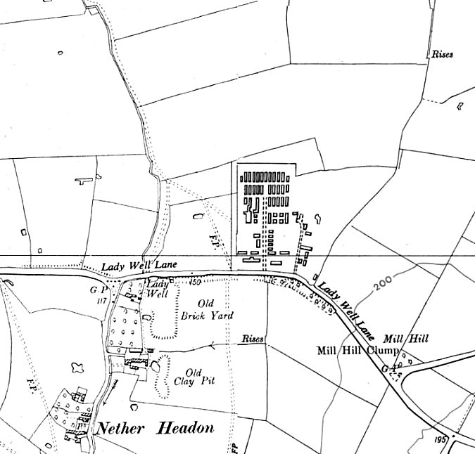
 | Ordnance Survey 1956

16 March 1945 - Obergefreiter Otto Hanisch, aged 44, from Lubbenau : German army, died from heart failure. Buried at East Retford Cemetery, later re-interred at the Cannock Chase Germany Military Cemetery.

Oversight and development of re-education activities and English teaching for German pows was carried out by PID (Political Intelligence Department of the Foreign Office) / COGA (Control Office for Germany and Austria – UK). Visits and reports were made. The standard of the reports varied greatly. The visitors took little interest, if any, in activities other than re-education. They rarely mentioned welfare, sports, games, pastimes, crafts, etc of the pows.

16-18 May 1945 – Re-education visit. Strength not recorded.

Commandant: Lt Col Powell Camp Leader: ‘Paul’
Interpreter: S/Sgt Ellwood Deputy C/L: ‘Figger’
German M.O.: Dr Neuefeind (Steuefeind in next report) / Dr Bedarwe

Considered to be 95% white (category A) camp. Pows were working in small parties on farms, many without overseers. Farmers were very pleased with the work and were willing to have pows billeted with them.

Some pows had formed a ‘United Anti-Fascist Front’ holding meetings and lectures – it lasted for a few months before being disbanded..

Religion – a new Protestant paster, Flechsenhaar. 100-150 pows attended services.

Education - Classes were being held for geography, English, German literature and French. English classes had 150 beginners and 30 advanced – though this number would soon decrease.

Two allegations of crimes committed in France and Russia were raised with the visitor. No details of follow-up.

1/2 June 1945 – English Inspector’s Report by Mr W Dadley-Potter.

The Inspector stated that the Commandant, Lt Col Powell, was very enthusiastic about the work of PID, and that; “he had no sympathy with those fellow-Commandants who were hostile to visitors, and who did not realise how important PID work was. He praised his prisoners, their good conduct and work, and said, ‘Germans have been badly led; given good leadership they would turn out good men.’”

Mr Potter gave a lecture-lesson about the English language to an audience of 600 pows – more than half the camp, including the Commandant.

26-28 June 1945 – General survey.

Commandant Powell was praised for his work in developing re-education and extremely good relations with the pows. He sympathised with the idea of abolishing militarism as far as possible. It was regretted that he was soon to leave. The German guards were supplied with batons, but these were restricted to only being carried at night.

Camp leader Paul, was described as a young man with a pleasant calm manner. He had been a barber and tramway man. Highly praised for his re-education work and leadership of the anti-fascist group.

The film about concentration camps had been shown, there was a; “striking reception given here to the atrocity film. After a bunch of orders, insignia and decorations were thrown into a box for destruction.”

Complaints had again been raised about lack of mail from Germany. This occurred in many camps – but considering the disruption across Europe was understandable.

13 miners had been repatriated to Germany as they were regarded as priority.

There had been 150 new arrivals from Merevale Camp 195.

16/17 July 1945 – Mr Dadley-Potter carried out another English Inspection and received a hearty welcome. He found that English standards had risen. 250 pows attended his lecture. This was probably the peak of interest from the pows in learning English, in this and other camps there was a steady decline.

August 1945 – Correspondence shows that the new Commandant, Lt Col C D Bowdery, had joined the camp.

13-14 January 1946 – Mr Dadley-Potter returned.

The Commandant, Lt Col Bowdery, was stricter than his predecessor, but took a keen interest in the welfare of the pows. The Commandant believed that restlessness amongst the pows arose from:

- Receiving mail led to a stronger desire for repatriation.
- Discontented pows arriving from other camps.
- Cold weather.
- Repatriation of Italians, not Germans.
- Reduction of NAAFI rations, no cake and only 15 cigarettes a week.
- Idleness, in part caused by the weather.

He thought that this restlessness would decrease as time went by. He also found that the pows were apathetic towards camp activities.

The interpreter, S/Sgt Ellwood, stated that some letters from Germany mentioned the return of pows from Russian camps. This was partly true – but Russia also held on to many pows until the mid-1950’s. This news made some pows look on communism more favourably.

Mr Dadley-Potter gave two lectures with attendance down to 150/60.

12 February 1946 - Exchange in Parliament – “Lieut.-Commander Gurney Braithswaite asked the Secretary of State for War whether he is satisfied that Northern Command Order No. 97 of 1946 is being sympathetically administered as regards other ranks at prisoner of war camp, Nether Headon.

Mr.Lawson - My information is that this is a very well run camp and that the order in question has been administered as sympathetically as the manpower situation and the requirements of security have permitted. The hon. and gallant Member will appreciate. that it is essential to have a proportion of officers and other ranks on duty at all times in a prisoner of war camp.” (This matter had been resolved – House of Commons, 12 February 1946, Vol 419, Cols 167-8).

17 May 1946 – Report on re-education, select German staff, and political screening of pows. Strength; 1 officer, (the M.O.), 1706 Other Ranks.

Commandant: Lt Col Bowdery, MC, DLI Camp Leader: Gefr Dr Weck (A)
Interpreter: S/Sgt Ellwood Deputy C/L: O/Gefr Fulde (A)
German M.O.: O/Arzt Dr Henselmanns (est B+)

The Commandant was stated to be keen on re-education; this would later be contradicted when a new commandant started – see June 1947. He had organised the camp to allow some extent of democratic self-rule.

The camp leader, Dr Weck, aged 42, “typical German civil servant. Weck is not a great personality and lacks the necessary drive.” He taught English, and gave lectures. He was replaced not long after this report.

The interpreter was described as: “a quiet, efficient man whose personality is nil.” He inevitably got a negative comment from the visitor as he took no part in re-education activities. He was due to be demobilized.

Screening: | A+ | A | A- | B+ | B | B- | C | Unscreened
 | 7 | 118 | 4 | 126 | 557 | 46 | 23 | 826

The camp was hutted with 56 men in each barrack. Hostels for Germans were started at the end of April 1946. 1 pow was Austrian, the rest German.

During Spring 1946 the camp received pows who had been previously held in camps in the USA, Canada and Belgium. Each of these groups had issues. Pows from the USA had been mis-informed in the States that they were going back to Germany, only to find themselves in pow camps in Britain, morale was often very low. Pows from Canada had been captured early in the war, many still retained Nazi attitudes. The camps in Belgium had been very badly run, many pows were malnourished.

Morale overall declined, especially from the effect of the pows from USA. Only 200 pows were employed due to lack of agricultural work, so the rest were not able to earn wages. A further negative issue arose as guards were searching pows on return from work and any cigarettes, money etc., given to them by farmers was impounded. Morale in the hostels was seen to be better.

30% of the pows were ‘youth’ (under-25). The majority were uncooperative and not interested in re-education. The padre started a weekly RC youth group with 50 members. There were also five ‘sports-clubs’ whose members were mainly youth.

Attempts to develop activities in the camp went through various phases – this was unusual. A group calling themselves the “Anti-fascist Front,” tried to promote re-education in 1945, but this was dissolved a couple of months later as it was unable to work effectively and had communist tendencies. Camp Leader (O/Gefr Paul) was found to be incapable of the task, so plans were drawn up for a committee of 8 pows, this did not get off the ground. In March 1946, two pows took control of re-education – the Camp Leader and O/Maat Radeloff (A+). Radeloff was repatriated and his place taken by Gefr. Sailer (A). Eventually a group of three pows led the development of re-education activities. The British staff took no interest I re-education.

There was a shortage of accommodation for re-education activities. The standard list was given:

Wochenpost and Ausblick – more needed.

Newspapers – 10 daily British papers, and 3 weeklies. Irregular supplies of German and Swiss papers. French newspapers requested.

Library – 945 books, including 189 sent to Wigsley and 100 to Little Carlton. More requested.

Lectures – regular, but only at the main camp.

Discussion groups – 1 started during this visit.

Films – sent by PID and the YMCA, but only to the main camp.

Wireless – 2 sets and 5 loudspeakers. 1 set in the canteen used for music and entertainment. 1 set in the education room used for news, lectures and political programmes.

Camp magazine – one had started, but ceased due to shortage of paper. Supplies were requested from PID.

Press review – started, but did not continue as the leader was involved in other activities.

Other activities –

Religion – 45% RC, 45% Protestant, 10% Other. 30% of pows attended services.

RC Padre; San/Uffz Dr Wengel (A) – “the most popular man among all PW at this camp. A typical Bavarian, he has an almost aggressively straight-forward manner…. Bitterly anti-Nazi.” Also taught philosophy in the camp. Held services every evening and Sunday mornings, he also visited the hostels.

A protestant padre came from Norton Park Camp 174 every Sunday, but only to the main camp.

Education – small classes of between 8 to 20 pupils were held for; French, architecture, building, carpentry, shorthand, philosophical history, drawing, biological chemistry. There was also a general study group led by Dr Lenz – he had a Nazi record, but was not considered to be a risk.

Theatre – There was a good stage. A theatre group gave various performances; classical, variety and musical (with the orchestra). They had so far only visited the hostels once. Texts were requested.

Orchestra – 6 violins, 1 set of drums, 1 piano, 1 cello, 1 accordion. Performed weekly and very popular. They had so far only visited the hostels once. Music scores requested. There was also a Schrammelmusik (Viennese folk music) band consisting of 1 guitar, 1 accordion, 1 banjo and 1 zither who gave small performances at special events such as parties.

20-21 June 1946 – English Inspector’s Report. Strength 2032. 97 pupils in 4 classes in the main camp.

Recorded that Blyth, Carlton In Lindrick, Lea Hall and Misson were all taken over from Camp 143

19/25 October 1946 – 2 members of the Segregation Section carried out political screening. Strength; 2 officers, 1953 OR.

New Camp Leader: O/Fw Scheibbs (A), had been in post since May. Previously a leader in USA, then at Wigsley hostel. “A well known athlete. A particularly pleasant and friendly type.”

Deputy C/L: O/Gefr Fulde, “A thoroughly reliable type, speaks good English.”

New Interpreter: S/Sgt E Garfield, from Vienna, had lived in Australia and Canada – “young and energetic.”

Screening: | A+ | A | A- | B+ | B | B- | C | C+ | Not known
 | 2 | 262 * | - | 492 | 1043 | 89 | 62 | 4 | 1

* Original entry was incorrect, stating 162.
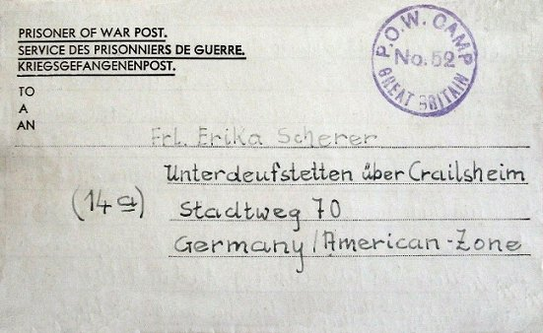
Although the overall political views of the pows was seen to be improving, there were two groups singled out as not making any progress; 90 ex-Rumanian pows; “who are not likely to change their views,” and all pows who had been in captivity for three years or more.

The pows were working long hours at farms for the harvest.

27-30 November 1946 – English Inspector’s Report. Strength 2122. 49 pupils in 3 classes.

1 January 1947 - Maat Friedrich Wilhelm Willer, German Navy, from Osterwick-Danzig was killed in a road traffic accident. Buried at East Retford Cemetery, later re-interred at the Cannock Chase Germany Military Cemetery.

< Letter sheet, January 1947.

21 January 1947 – Re-education visit. Strength; 0 officers, 1888 OR.

Changes to the German staff: Camp leader – O/Gefr Fulde (A-), previously deputy / Deputy C/L - Gefr Dr Weck (A), previously leader up to May 1946. No German officer M.O.

Screening: | A | B | C | C+ | Unscreened
 | 34 | 1352 | 75 | 4 | 423

Morale was considered to be good – due to repatriations, and sports / entertainments at this camp.

The standard list of re-education activities was given, with little change from previous reports. The hostels were included in films and lectures when transport was available. Films were supplied by YMCA and Gaumont British. The discussion group was short lived.

Religion – A protestant padre Uffz Warko (A) held weekly services and visited the hostels.

The RC padre, Uffz Wengel, was praised as a good influence and visited other camps.

Education – all classes had ended due to repatriations.

Entertainments – 15 member theatre group performed sketches. 10 member orchestra was popular and also gave performances at the hostels.

2/5 March 1947 – English Inspector’s Report by Commander A Crawfurd. Strength; 1800. 45 pupils in 2 classes – believed to be another 150 studying privately.

The visitor stated it was not a successful visit as transport had broken down. Only incomplete and rounded numbers were given.

7 March 1947 – Commander Crawfurd raised a formal complaint to COGA over his visit to the camp. He stated that neither the Commandant or British officers had any interest in English teaching, and that the S/Sgt Interpreter was not just busy, but went out of his way to avoid contact. In general, he felt he had been treated with disrespect. There are no follow-up notes in the file. This was the first report that there were major issues arising in the camp.

7 May 1947 - Oberfaehnrich Albert Stuempel from Buren/Westf, died from heart failure. Buried at East Retford Cemetery, later re-interred at the Cannock Chase Germany Military Cemetery.

23-26 June 1947 – Re-education report. Strength; 0 officers, 2210 OR. The M.O. was ‘Unterarzt,’ this was not considered to be an officer rank.

This report was very much at odds with those previous, which had been largely positive.

Commandant: Lt Col McBarnett Camp Leader: OGefr Johannes Franke (B)
Interpreter: S/Sgt Garfield Deputy C/L: Uffz Helmut Hinke (B+)
German M.O.: U/Arzt Dr Widuking Lenz (B-)

The Commandant had started a few weeks earlier, described as, “an experienced interrogator.” The previous Commandant, was not criticised in reports before, however, this visitor stated that; “The change of Commandant had a beneficial influence on morale.” This was reinforced with another comment that, “The attitude of the previous Commandant and the Interpreter have handicapped political progress.”

The Adjutant (unnamed) was on leave, but, “alleged to be obstructive and his unfriendly attitude is confirmed by the Commandant.”

The S/Sgt Interpreter, 21 years old, - “having caused irreparable damage to re-education, is now under arrest awaiting court-martial.” Frustratingly, no further details were given.

The new camp leader and deputy were described as, “highly suitable.”

Simplified screening figures were used: A 6 : B+ 588 : B 1381 : B- 235. There were 30 appeals against the political grades pending – the better the grade, the sooner the repatriation, in theory. 849 pows repatriated to date.

For the first time, morale was declared to be ‘low.’ This was put down to depressing news from Germany, length of captivity, apathy, and delays to repatriations. Many pows were anti-British and identified democracy as the system that prevented them from going home and preventing Germany from recovery.

About 40% of the pows were ‘youth’ – the RC youth group continued.

Re-education was described as, “not satisfactory.” The standard list;

Newspapers – Adequate, but supply for hostels re-arranged.

Library – 1076 books, “but hardly any political works. Hostels badly supplied. This ‘library’ is utterly inadequate.” The visitor wanted more political books – I doubt if many of the pows would have agreed.

Lectures – twice a month. Hostels visited if time and transport allowed.

Discussion groups – none, and little interest.

Films – adequate.

Wireless – a new amplifier needed. The wireless worked, but was not very loud for the speakers.

Camp magazine – none.

News review – daily, and in the hostels.

Information room – none.

Other activities – there were lessons for shorthand and draughtsmanship. The theatre group and orchestra continued. There was a choir. Sport played an important part in camp life.

The RC priest, Wengel was described as “very active and has a beneficial influence on the camp” – but see note in August report.

Outside contacts – Some pows attended lectures at Newark Technical College. Other contacts were being pursued, but had not started.

13-16 August 1947 – Report on Re-education. Strength; 0 officers, 1964 OR.

The Commandant was stated to have, “done excellent work.” Though he was sceptical towards re-education, he was co-operative.

A new interpreter: 2nd Lt. C.O.L. Juulman, started a few days earlier. “Young and a little shy, but has proved his worth in his last camp.”

1068 pows repatriated to date.

Morale was recorded as still below average, but rising. Efforts of the Commandant were helping to develop morale. Intakes from pows held in RAF units were a bad influence, the report did not state why, but in other camps it was because RAF camps tended to be more lax in regulations. Morale in the hostels was said to be higher as they had been less under the influence of the previous Commandant and Interpreter, and their local populations were more friendly.

Most prisoners were not interested in politics. There was a mention of the attitude of the previous interpreter reviving some antisemitic feelings.

The local population of Retford and Gainsborough was stated to be hostile towards pows from the main camp. To make matters worse, some pows distributed leaflets saying that German pows were being used as slave labourers. There was a general mistrust of the British amongst the pows.

The number of ‘youth’ pows had risen to about 50% - no provision for them was mentioned.

The standard list of activities was given with little change from before. Changes were noted for the library where a few “excellent” books had been received, bringing the total to 1144. “More light books are wanted.” A rather strange remark – “25 books are torn beyond repair and could be sent to the ward for infectious diseases of PW hospital.”

The RC priest, Wengel, who had been highly praised in previous reports, had been posted away from this camp as he had instigated the distribution of the leaflets mentioned above.

Outside contacts – though most pows maintained their own informal contacts, there were no formal outside contacts listed.

2 / 3 October 1947 – Dr Klein, a visiting lecturer submitted a report on his visit:

“2nd October, 2000h. Main Camp. Present 60 / 7%. They are in an unpleasant mood. I noticed already during the lecture ironical smiles / meaning: this is all propaganda and lies…

3rd October… The majority of the men were very young and did not take part in the discussion. Those few who did were thoroughly cynical and disillusioned. I had to break off after 20 minutes as I was to speak at another hostel….”

The lecture was on, ‘World Food Problems,’ but the camp report stated that he was not well received as a mass of figures was given and he did not focus on Germany.

10 November 1947 - South Yorkshire Times: “Road Accident to Popular Mexborough Teenager - Twelve German prisoners-of-war from No. 52 Prisoner-of-War camp at Nether Headon, near Retford, where Private Lawrence Arthur Batty, 8 Tennyson Avenue Mexborough, 19 years-old soldier, was pay clerk, attended his funeral at Mexborough on Wednesday. At the request of his parents some of them acted as bearers.

Pte. Batty was found lying Injured shortly after 5 a.m. on Saturday on the footpath near the junction of Clayfield Road and Doncaster Road, Mexborough. His cycle was nearby. There was a dense fog at the time. [From his position it looked as though he had fallen from his bike and his head hit an electric switch box]

Mr. and, Mrs. Batty told a “South Yorkshire Times” reporter yesterday that their son loved the Germans and had “converted four of them.” Three of his converts had returned to Germany, but the fourth, Hans, attended the funeral and brought with him a bunch of flowers. After greeting Mrs. Batty before the funeral, the 12 Germans lined up on each side of the coffin and said the Lord’s Prayer in German. “The German boys were heartbroken when they knew they had lost Lawrence, ‘ Mrs. Batty said. “He used to read the Gospel in French and German for them.” Pte, Batty, who had been to many other prisoner-of-war camps with Pastor W. L. Richards, of Worksop Assembly of God, was a Sunday School teacher at Rotherham Assemblies of God.“

14 November 1947 - Camp number included in an ‘Urgent Memorandum’ (FO 939/270) regarding inspection of food parcels.

17-21 November 1947 – Re-education survey. Strength; 0 officers, 1918 OR

No change to senior personnel. 1399 pows repatriated to date.

The I.O. did not live up to expectations and his interest in re-education was limited. The rest of the British staff was completely un-interested and rigidly interpretated orders.

Relations with the civilian population continued to be good in hostels, but were “practically non-existent in the Main Camp, as the attitude of the population of Retford varies from indifference to hostility. In spite of the efforts of the Commandant and District HQ cinemas are still closed to PsW.” There had also been difficulties with the local bus company. The main reason for this was believed to be, “a great number of the local boys were taken prisoners with the 46th Division in Norway and were badly treated by the Germans.”

Changes to re-education activities:

Library – 100 books received from the IRCC

Information room – had been started with wall displays of newspapers, but no exhibition materials had been sent by COGA.

Other camp activities -

A RC padre from Norton Park Camp 174 visited the camp and hostels fortnightly.

Entertainment – The orchestra and theatre group had disbanded owing to repatriations. Football, basketball and table tennis were popular.

24/26 November 1947 – English Inspector’s Report. Strength 1896. 16 pupils in 3 classes.

22 January 1948 – Lecturer’s report. Lectures were disrupted as the camp was due to close.

This was the last report in the file.

Known Camp Commandants –
c.1944 Major E J Johnson (Camp we v/1264/2)
c.1945 Lt Col Powell
c.1946/7 Lt Col C D Bowdery, M.C. Formerly with Durham Light Infantry. His diary includes his time at Nether Headon and is held by the Imperial War Museum, Cat No. nts.3558
c.1947 Lieutenant Colonel A A E McBarnett (Royal Regiment of Artillery)

Camp and hostels + number of pows where known:

 | Not open |  | Unknown |  | Open |  | With another camp

 | 1942 | 1943 | 1944 | 5/1946 | 6/1946 | 11/1946 | 1/1947 | 6/1947 | 8/1947 | 11/1947
Main |  |  |  | 1051 ⁽¹⁾ | 1000 | 1039 | 955 | 1058 | 930 ⁽³⁾ | 931 ⁽⁴⁾
Misson |  |  |  | With C143 | 75 | 71 | 66
Potter Hanworth
Nether Langwith
Treeton |  | With C17
Caunton |  | With C51 |  | 69 | 67 | 53 | 52
Little Carlton |  |  |  | 124 | 232 | 342 | 286 | 401 | 335 | 242
Wigsley |  |  |  | 300 | 295
Blyth |  |  | Was C143 * |  | 164 | 188 | 132 | 184 | 183 | 198
Carlton I L |  |  |  | With C143 | 89
Lea Hall |  |  |  | With C143 | 110 | 177 | 151 | 118 | 118 | 90
Thorney |  |  |  |  |  | 63 | 58
Sconce Hill |  |  |  |  |  |  | 188 | 264 | 195 | 264
Billets |  |  |  | 161 | ? ⁽²⁾ | 189 | ? ⁽²⁾ | 185 | 193 | 169
Total | ? | ? | ? | 1707 | 2032 | 2122 | 1888 | 2210 | 1964 | 1918

(1) + 3 Others in hospital or attached elsewhere. (2) included in main camp figure (3) + 6 detached and 4 in hospital. (4) + 21 detached, 3 in hospital.

After the camp: Light industry. Site called Headon Camp Industrial Estate.

The site as it is now - https://repatriatedlandscape.org/england/pow-sites-in-the-east-midlands/pow-camp-52-nether-headon/

Further information:

National Archives – FO 939/134 and 301 - 52 Working Camp, Nether Headon Camp, East Retford, Nottinghamshire and 92 Working Camp, Bampton Road Camp, Tiverton, Devon. Dated 1945-1948 – used above.

Hostels

Blyth. c.17miles from main camp. See Serlby C143 for map. Huts. Previously Serlby Camp 143 * (taken over with 3 hostels).

October 1946 – Hostel leader; Uffz Georg Heinze, a reproduction technician, aged 37. “Politically sincere SPD adherent, wife and child killed.” Upgraded from B to A.

January 1947 – Hostel leader; O/Gef Lang (B)

June 1947 – Hostel leader; Fw Helmut Goetsch

November 1947 – same leader. 2 bus trips to London had taken place. There were good relations with the local Salvation Army.

 | 1942 | 1943 | 1944 | 5/1946 | 6/1946 | 11/1946 | 1/1947 | 6/1947 | 8/1947 | 11/1947
Blyth |  |  | Was C143 * |  | 164 | 188 | 132 | 184 | 183 | 198

NB * I am basing this on different comments made in reports – BUT, I have not found direct evidence that Blyth hostel was Serlby Camp 143.

Carlton In Lindrick. See Carlton C143 for map. (Carlton Hall) C.20 miles from main camp. Previously independent camp 143, then as a satellite to Serlby Camp 143.

June 1946 – when taken over it was stated that this was a satellite camp and was attached to Camp 143. It was to be a hostel, rather than satellite status.

October 1946 – Hostel leader; Bootsman Hans Klamt (A). Had been in the Hitler Youth for just 3 months. “Quite a suitable appointment.”

 | 1942 | 1943 | 1944 | 5/1946 | 6/1946 | 11/1946 | 1/1947 | 6/1947 | 8/1947 | 11/1947
Carlton I L |  |  |  | With C143 | 89

Caunton. Huts. See C51 for map.

Memories of this site when it had just been taken over for displaced persons – “A central hut adjoined the cookhouse and dining hall and offered two bedrooms and a bathroom. Apart from these central buildings I believe there were three long huts at each side, but the three on the Bathley side had disappeared by the time we moved in. The three on the Caunton side comprised an ablution block, a recreation hall and the hut closest to the Norwell Road was a "posh" hut finished in fine weatherboarding with a good dance floor inside and a small stage….

The Camp also had its own sewage treatment plant and a couple of car garages and cycle sheds (next to the road) and a parade ground… anyone could have stepped over the fence and there was no accommodation for guards, fancy gates or towers to be seen….”

May 1946 – Hostel leader; S/Gefr Paul (A). Was camp leader, but removed from that post – “he comes into his own when leading a small group of men, which he does very efficiently.” No newspapers received. Had its own wireless set. No education classes.

January 1947 – Hostel leader; O/Gef Gerlach (B+)

 | 1942 | 1943 | 1944 | 5/1946 | 6/1946 | 11/1946 | 1/1947 | 6/1947 | 8/1947 | 11/1947
Caunton |  | With C51 |  | 69 | 67 | 53 | 52

Lea Hall. (Gainsborough) C.24 miles from main camp. Huts.  Lea Hall NGR SK 828 864 – possible; square marked area at N of grounds.  October 1946 – Hostel leader; O/Wm Johannes Kolhe (B+). Captured in 1942, had been a camp leader in USA. “A typical NCO, very anti-communist.”  January 1947 – Hostel leader; O/Gef Ralf (B)  June 1947 – same leader.  August 1947 – Hostel leader; Sold Kuno Ahrens.  November 1947 – same leader.  1942 1943 1944 5/1946 6/1946 11/1946 1/1947 6/1947 8/1947 11/1947  Lea Hall With C143 110 177 151 118 118 90 | 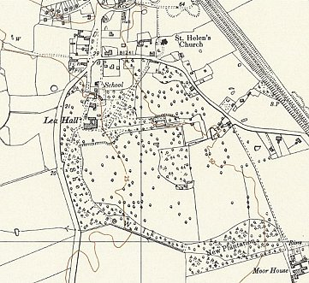
 | Ordnance Survey 1956

Little Carlton. Based at an old farm, no barbed wire enclosure, huts.  Bathley Lane, NGR SK 779 574  May 1946 – Hostel leader; Fw Esch (B), “a reliable intelligent Silesian who runs a good show.” No newspapers received. Had its own wireless set. No education classes.  October 1946 – Hostel leader Esch, aged 40, married with 5 children, was upgraded from B to A. “Very well reported on by British camp staff. A very definite anti-militarist.”  27 January 1947 - A visiting lecturer, Dr K Rawitzki, met open hostility. At the start, one pow demanded the lecturer should speak on; “the British policy of starving the German people.” This was rejected, but later the same pow led a walk-out by nearly all attending. The camp issued report played the incident down stating that in part it was caused by the lecturer’s delivery – but that does not explain the question raised at the very start. On the other hand, no similar incident was recorded. | 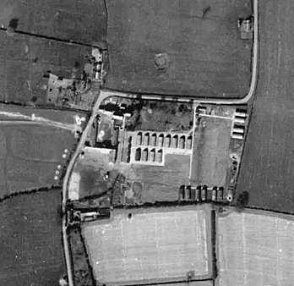 | 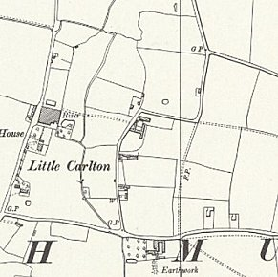
 | 1945 | Ordnance Survey 1956

January 1947 – Hostel leader; Tangelmann (B). Had its own active theatre group.

June 1947 – Hostel leader; Uffz Gerhard Leopold. Held its own debating group. A Nottingham University lecturer to give lectures.

November 1947 – same leader. Little Carlton used battery wireless sets, as electricity was supplied by a generator.

 | 1942 | 1943 | 1944 | 5/1946 | 6/1946 | 11/1946 | 1/1947 | 6/1947 | 8/1947 | 11/1947
Little Carlton |  |  |  | 124 | 232 | 342 | 286 | 401 | 335 | 242

Misson, Bawtry, Nottinghamshire. C.21 miles from the main camp. Huts.  At site of present Misson Mill – NGR SK 685 949  January 1947 – Hostel leader; Gef Stuempel (B)  15 March 1947 - Obergefreiter Georg Stuermer, from Rothenburg : 70 Div 170 Rgt 3 K.p, died from heart failure. Address at Misson. Later re-interred at the Cannock Chase Germany Military Cemetery.  1942 1943 1944 5/1946 6/1946 11/1946 1/1947 6/1947 8/1947 11/1947  Misson With C143 75 71 66 | 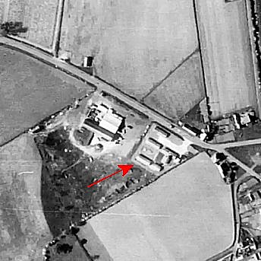
 | 1948

Nether Langwith, Derbyshire  NGR SK 526 701  1943 / 44 – Italian hostel. Probably attached to a different main camp after this.  1942 1943 1944 5/1946 6/1946 11/1946 1/1947 6/1947 8/1947 11/1947  Nether Langwith | 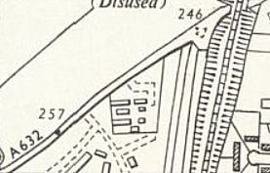
 | Ordnance Survey 1955

Potter Hanworth (Potterhanworth).  NGR TF 063 674  1943 – Italian hostel. Probably attached to a different main camp after this.  1942 1943 1944 5/1946 6/1946 11/1946 1/1947 6/1947 8/1947 11/1947  Potter Hanworth | 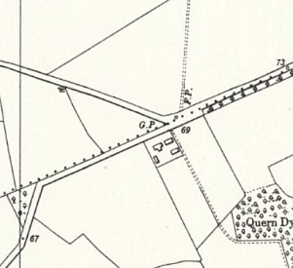
 | Ordnance Survey 1956

Sconce Hill, Newark  NGR SK 792 533  Almost certainly attached to a different main camp before these entries.  January 1947 – Hostel leader; Gef Wilhelm Manteufel (B+)  November 1947 – same leader. 10-12 men visited meetings of the Newark Discussion Society, and 5 men attended evening classes at Newark Technical College.  1942 1943 1944 5/1946 6/1946 11/1946 1/1947 6/1947 8/1947 11/1947  Sconce Hill 188 264 195 264 | 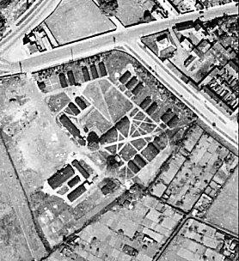 | 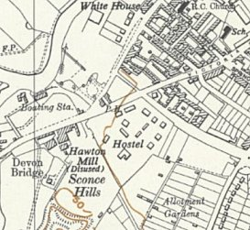
 | 1948 | Ordnance Survey 1955

Thorney.

Reported to be at Thorney Manor – NGR SK 860 728.

October 1946 – Hostel leader; O.Fw Rudolf Busche (A), aged 38, leader since May. He had been held for a short time in Heuberg concentration camp. SPD supporter.

January 1947 – same leader.

 | 1942 | 1943 | 1944 | 5/1946 | 6/1946 | 11/1946 | 1/1947 | 6/1947 | 8/1947 | 11/1947
Thorney |  |  |  |  |  | 63 | 58

Treeton, Rotherham, Yorkshire.

Probably administered by another main camp after 1944

 | 1942 | 1943 | 1944 | 5/1946 | 6/1946 | 11/1946 | 1/1947 | 6/1947 | 8/1947 | 11/1947
Treeton |  | With C17

Wigsley. C12 miles from the main camp. Huts.

Italians recorded in this hostel before 1946.

May 1946 – “Very well run.” Hostel leader; O/Fw Scheibbs (est B) – had been a leader in a US camp – “quiet, efficient, regular soldier.”

There was an irregular supply of newspapers. Wireless did not work. Daily news reviews of British papers was issued.

Gefr Buettner formed a RC youth group with 30 members. He also held 2 services a week.

Classes were held for French, technical drawing and graphic art, and electro technique.

June 1946 – Anger expressed by pows that only 80 were employed and they had been taken off farm work and put onto the lowest paid work at just ¾d (three-farthings) per hour.

 | 1942 | 1943 | 1944 | 5/1946 | 6/1946 | 11/1946 | 1/1947 | 6/1947 | 8/1947 | 11/1947
Wigsley |  |  |  | 300 | 295

