Camp 58 & 248 - Nether Heage Camp, Belper, Derbyshire (aka Firs camp / Belper)

Included in the 1945 ICRC Camp list – Labour Camp. Belper Camp, Belper, Derby.

1947 Camp List
58(G.W.C.) | Nether Heage Camp, Nr Belper, Derbyshire | N. | Priswar, Belper | Ambergate 156 & 41 | Butterley | Lt.Col.W.A.Dickens M.C. | v/1453/2

Prisoner of War Camps (1939 – 1948) - Project report by Roger J.C. Thomas - English Heritage 2003
OS NGR | Sheet | No. | Name & Location | County | Cond’n | Type 1945 | Comments
SK 36 50 | 119 | 58 | Nether Heage Camp, Belper | Derbyshire | 5

Location: NGR SK 357 506. About 3 km N of Belper.  Before the camp: Farmland  Pow camp: Names seen – Nether Heage / Belper / Firs (from Heage Firs shown on map).  The site was accepted as a pow camp in December 1941. An Italian pow construction gang was allocated from Garenden Park Camp 28 to work with the Pioneer Corps.  1942 - The camp opened for Italian pows.  March 1942 – British staff of 4 Officers and 77 OR attached to The Hayes Camp 13 for training.  1943 – Hostels for Italian pows; Huthwaite; Biggin  May and November 1944 - The camp was listed as an Italian Labour Battalion under the Northern Command area, (WO 32/10737). The Italians were recorded as co-operators.  Italian pows up until at least 1945, then German pows.  1 August 1945 - an urgent memorandum was sent to this camp, and others, about maintaining records of Italians who were classed as ‘co-operators’. At this point many, sometimes all, of the Italian pows were in hostels / billets.  September 1947 - Hostel at Derby Old Race course was transferred to Knighthorpe Camp 28. Report that pows worked on local farms and a nearby flax factory. (British Hemp and Flax Development Company Ltd, Heage Road, Ripley).  Camp Number changed from 58 to 248: C248 was Drill Hall, Derbyshire up to at least September 1946 - and then Norton, Yorkshire (there was a Red Cross visit there in Feb 1947 using this number). | 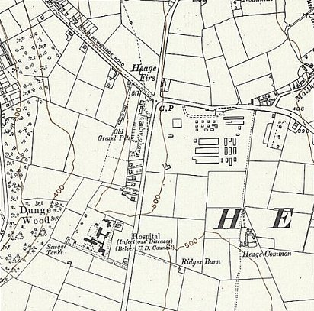
 | Ordnance Survey 1955

November 1947 – The IWM hold a copy of a camp magazine - Blinkfeuer (Signal Fire?) – described as published by PWW Camp 248, Nether Heage, Derbyshire. Dated November 1947. https://www.iwm.org.uk/collections/item/object/1506002420 An earlier camp magazine for Camp 58 was called, Aufbau Nether Heage Camp (Construction).

18 December 1947 – Letter.  Many families hosted German pows during Christmas 1947. The letter also confirms the use of the number 248.  Camp commandant c.1947 Lieutenant Colonel W A Dickens M.C.  After the camp: Site developed into light industrial area called the Firs Works.  The site as it is now - https://repatriatedlandscape.org/england/pow-sites-in-the-east-midlands/pow-camp-58-nether-heage/  Further information:  The Imperial War Museum has a copy of the magazine Aufbau. Dated 24 December 1946, Ref LBY E.J. 335 – Blinkfeuer is Ref LBY E.J. 337. | 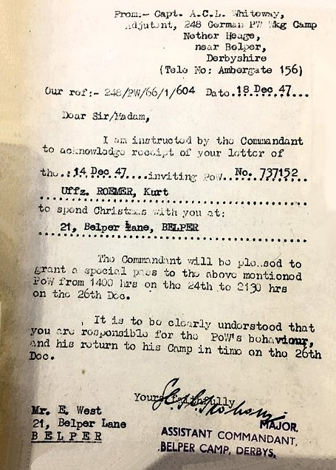

Hostels

Biggin. NGR SK 160 592  “5 or 6 Ministry of Supply huts for PoWs used as farm labour with Italians from 1943 and Germans by 1945.”  1943 - Listed with C58 holding Italian pows. | 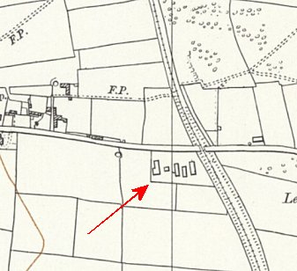
 | Ordnance Survey 1955
Derby Old Race Course

 | Unknown |  |  |  |  |  | With Nether Heage |  | With Camp 28
 | -/43 | 4/46 | 7/46 | 9/46 | 10/46 | 12/46 | 4/47 | 7/47 | 9/47 | 11/47 | 12/47 | 3/48
Derby ORC |  |  |  |  |  |  | With Camp 58 |  | 150 | 236 | 222

Huthwaite

Location: around SK 4683 5842 - on the B6027 (Common Road). It is about 6 miles NE of Swanwick.

1943 - Listed with C58 holding Italian pows. Wooden huts (possibly 6, including 1 used for cooking / eating). Area enclosed by barbed wire fencing with an entrance gate almost opposite Pit Road. Transferred to The Hayes (see camp 5).

