Camp 56 - Botesdale, Suffolk

Included in the 1945 ICRC camp list – Labour Camp. 56. Botesdale Camp, Diss, Norfolk.

1947 Pow Camp List
56(G.W.C.) | Botesdale Camp, Botesdale, Diss, Norfolk | E. | Priswar, Botesdale | Botesdale 31 | Diss | Lt.Col.J.S.D. Lloyd | v/1453/2

Prisoner of War Camps (1939 – 1948) - Project report by Roger J.C. Thomas - English Heritage 2003
OS NGR | Sheet | No. | Name & Location | County | Cond’n | Type 1945 | Comments
TM 056 764 | 144 | 56 | Botesdale, Diss | Suffolk | 4 | German Working Camp | STANDARD type. Demolished apart from water tower

Location: The camp was about 1 km NE of Botesdale, and 7 km SW of Diss. On the map in an area known as ‘The Warren.’ Also shown above is Redgrave Park Military Hospital – Camp 231 for pows.  Before the camp: Part of Redgrave Park estate. In December 1941 the site was originally intended to be located at ‘Bury St Edmunds – Ixworth.’ The location was changed and an Italian pow construction group from Camp 26 Ely were sent to build the site with the Pioneer Corps.  Pow camp: 1942 – opened for Italian pows.  1943 – Hostels listed for Italian pows; Deerbolt Hall; Bungay; Long Stratton; Mousehold.  5 May 1944 - Hostels listed for Italian pows from this camp, (WO 32/10737): Bungay; Deerbolt Hall; Long Stratton.  May and November 1944 - The camp was listed in records as an Italian Labour Battalion under the Eastern Command area and then as an Italian POW Working Camp, (WO 32/10737).  1944 – the first German pows started to arrive.  15 September 1945 - Hostel listed for pows from this camp, (WO 32/10737): Thornham Park.  September 1945 – Although Germans were replacing the Italians, I have seen a letter-sheet from an Italian pow dated September – they were probably held in one of more of the hostels.  Oversight and development of re-education activities and English teaching for German pows was carried out by PID (Political Intelligence Department of the Foreign Office) / COGA (Control Office for Germany and Austria – UK). Visits and reports were made. The standard of the reports varied greatly. The visitors took little interest, if any, in activities other than re-education. They rarely mentioned welfare, sports, games, pastimes, crafts, etc of the pows.  22 – 27 May 1946 – Re-education survey. This was the 4th visit, but the previous reports are not in the file. Strength; 2 officers, 1302 Other Ranks - German. | 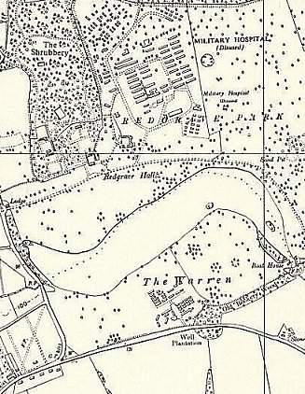
 | Ordnance Survey 1958
Commandant: Lt Col J Lloyd Camp leader: Fw S Gorsten (A)
Interpreter: S/Sgt D A Olikier Deputy C/L: O.Fw Klein (A)
German MO: M.S.Arzt Reimann (A) / O/Arzt Schmidt.

Political screening: | A | B | C | Unscreened
 | 338 | 583 | 36 | 413
The Commandant started 2 months earlier – he was ‘co-operating’ with re-education. As in most camps, the Commandant accepted re-education activities, but did not actively promote them.

The interpreter was considered to have; “neither the age, education, experience nor interest to be of any use in matters of re-education.”

The camp leader was described as; “a man of education and initiative and allows nothing to discourage him or his staff.”

No breakdown of numbers was given in main camp, hostels or billets – there was only a mention of one hostel at Thornham.

The German staff were considered to be ‘very good.’ 300 pows had arrived from camps in the USA. They had been mistakenly informed in the US that they were being returned to Germany, consequently their morale was low when they found themselves in a British working camp. It was considered that they were “settling in.”

Over 200 of the pows were ‘youth’ (under-25). There was a youth group attended by 20-30 men – the visitor from PID stated that more should be encouraged.

The camp appeared to be more active than many others. The standard list of re-education activities was given:

Wochenpost / Ausblick – 200 / 100 copies.

Newspapers – Only 5 papers received and passed on to the hostel the next day. 2 dozen ordered for near future.

Library – 500 books, insufficient.

Lectures – Regular, with high attendance and discussions. Some pows also gave lectures which could be broadcast to the dining halls.

Discussion groups – 3 small groups meeting at different evenings. Political group – 25 pows / Cultural issues – 40 pows / Social issues – no number given.

Films – Regular from PID and YMCA.

Radio – good set, good reception.

Camp magazine – Weekly, nine editions so far. ‘Die Flamme der Freiheit und des Rechts – Wochenzeitung des POW Camps 56’ – The flame of freedom and justice – Weekly news for Pow Camps 56. A copy is held by the Imperial War Museum – Ref LBY E.J. 356.

Press review – 300 attending on Monday evenings.

English teaching – separate appendix.

Other activities –

Religion – Army RC padre visited with 150-200 attending Mass. A new unnamed protestant padre had recently arrived – “very young and quite inexperienced.” Also, Bible classes and discussions.

Education – Classes for French, Latin, commerce, shorthand, commercial arithmetic, mathematics and agriculture. About 50% of pows attended at least one of the classes.

Theatre – 30 members produced a show every 6-8 weeks. They needed play scripts. The camp had a theatre that could hold up to 400.

Orchestra – 7 members played light music, often in support of the theatre group.

Choir – 45 members, singing classical works. Music received from YMCA.

16/17 December 1946 – Major R l S Raffles submitted an English Inspector’s Report. Strength 1134. 62 pupils in 3 classes.

New ‘Lagersprecher’ (Camp leader); Jetter.

The local clergyman was in touch with the camp and pows were allowed to visit the local Anglican church.

Handwritten notes on the report made it clear that PID were not at all pleased that major Raffles spent 2 days at the main camp and failed to visit the two hostels.

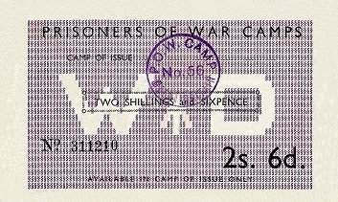 | Until the relaxation of rules in 1947, pows could only use ‘Camp Money.’  The paper money had to be used in the camp of issue and was date stamped on the back after each use. | 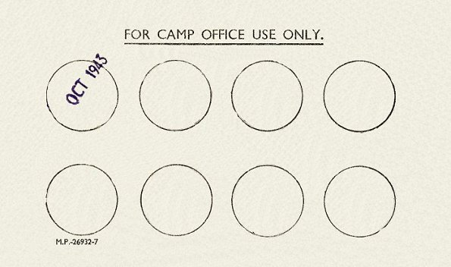

16/17 June 1947 – Re-educational survey. Strength; 1 officer, 414 OR.

Commandant: Major T A Halset Camp leader: Ofw. Otto Hingst (B) (but based n the hostel).
Interpreter: S/Sgt D A Olikier Deputy C/L: Ofw. H Ehrlich (B)
German MO: O/Arzt Schmidt (A)

The new commandant supported re-education more actively than his predecessors, however changes in the camp meant there were many obstructions to developing activities.

The camp leader was aged 44 . He had been a member of the Stahlhelm, SA and Nazi Party – described as, “opportunist with a clean nationalistic past, claims ‘change of heart,’” – with a warning that he should be watched.

Political screening: | A | B+ | B | B- | C+
 | 5 | 27 | 352 | 30 | 1

23 appeals against political gradings were pending – the better the grade, the sooner repatriated, in theory.

Between January and June 1947, 220 pows had been repatriated.

The intention to use the main camp to hold Ukrainians had been announced and German pows were being transferred to Thornham hostel. The local public near the hostel were said to be, “not too friendly.” A shortage of clothing was noted. The Germans appeared restive and made complaints of a “trivial and frivolous character.”

The C+ grade pow, Gefr W Niederhausen, was described as, “an ardent Nazi, a vicious type who might increase the difficulties in this camp.” It was suggested that he be transferred to Watten Camp 165 in Scotland.

Youth pows were described as no special problem and no provision was listed for them.

Re-education activities were affected by the move to the hostel – some activities continued. A new Information Room had been opened which showed exhibitions of materials sent by COGA.

Attendance at religious services had rapidly declined and was now descrbed as ‘poor.’

Entertainment – had all been disrupted by the move to the hostel.

1947 - Ukrainian pows were held at Botesdale. They were some of the members of the Waffen-SS Division Galizien. The division was accused of major war crimes against civilians.

19-20 August 1947 – Re-educational survey. Strength; 1 officer, 352 OR – NOTE This is German POWS only – the Ukrainians were not counted.

Changes to senior staff – there was no camp leader or deputy as the main camp held mainly Ukrainians. Otto Hingst was recorded as hostel leader at Thornham Park.

54 German pows were retained in the main camp as administrative staff, all other pows were Ukrainian. Further notes – see Thornham Hostel below.  14 November 1947 - Camp number included in an ‘Urgent Memorandum’ (FO 939/270) regarding inspection of food parcels.  There are no further reports in the National Archive file.  Known Camp commandants –  c.1944 Major J H Jacques MC  c.1946 Lieutenant Colonel J S D Lloyd, the Suffolk Regiment.  c.1947 Major T A Halset | 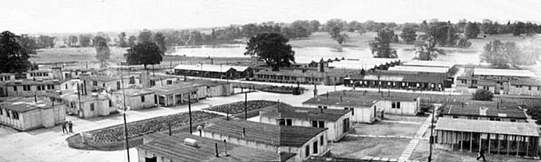
 | Panorama created by Jim Healey from assembled photographs taken from the water tower. From the ‘Parish Magazine – Redgrave cum Botesdale with the Rickinghalls’ March 2015.

Camp and hostels + number of pows where known:

 | Not open |  | Unknown |  | Open |  | With another camp

 | 1942 | 1943 | 5/1944 | 9/1945 | 5/46 | 12/46 | 6/47 | 8/47
Main |  |  |  |  |  | 815 | 69 | 54
Deerbolt Hall
Bungay
Long Stratton |  |  |  |  |  | 52
Mouselhold |  |  | With C82
Thornham Park |  |  |  |  |  | 267 | 295 | 299
Starston
Billets |  |  |  |  |  | (1) | 51 | ?
Total | ? | ? | ? | ? | 1304 | 1134 | 415 | 353 (2)

(1) Probably included in the main camp number. (2) German pows only – see note above.

After the camp: 1948 held 1,264 Ukrainians, mentioned above, whose status had been changed allowing them to stay in the UK under the ‘European Volunteer Workers Scheme’.

The site as it is now - https://repatriatedlandscape.org/england/pow-sites-in-eastern-england/pow-camp-56-botesdale/

Further information:

National Archives: FO 939/138 56 Working Camp, Botesdale Camp, Diss, Norfolk. Dated 1946-1947. Used above.
Hostels

Bungay, Suffolk. NGR TM 344 890  (Nearby there was also Bungay Base Camp 171, and Flixton Airfield Camp 273).  1943 and 1944 – listed for Italian pows. | 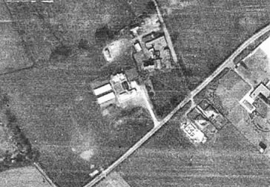 | 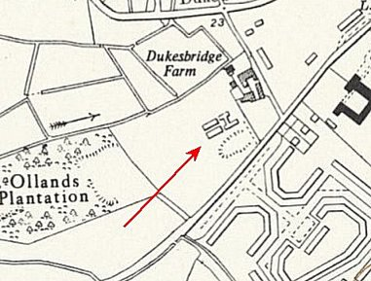
 | 1946 | Ordnance Survey 1957

 | 1942 | 1943 | 5/1944 | 9/1945 | 5/46 | 12/46 | 6/47 | 8/47
Bungay

Deerbolt Hall, Earl Stoneham, Towmarket, Suffolk. Probably in the grounds – TM 111 584

1943 and 1944 – listed for Italian pows.

 | 1942 | 1943 | 5/1944 | 9/1945 | 5/46 | 12/46 | 6/47 | 8/47
Deerbolt Hall

Long Stratton, Norwich. Huts 13 miles from the main camp.

Memories – “German and Italian prisoners of war came from a POW camp at Long Stratton to work on the farm [at Hethersett]. A lorryload would be driven out — about thirty men I suppose — and they’d work on the farm all day and be driven back to camp at night.

They wore overalls. They were supervised by someone from the camp. They had breaks for tea and lunch. We gave them tea from the farmhouse, and they brought their own packed lunches from the camp.

I think some of them might have made friends with the local girls.” https://www.bbc.co.uk/history/ww2peopleswar/stories/09/a3803609.shtml

1943 and 1944 – listed for Italian pows.

It may have held Italian pows from 1944 to 1946 – the reports did not record them.

December 1946 – German pows.

 | 1942 | 1943 | 5/1944 | 9/1945 | 5/46 | 12/46 | 6/47 | 8/47
Long Stratton |  |  |  |  |  | 52
Mousehold. Mousehold Farm is located at TG 292 129. There was also Mousehold Heath Camp 253, Norwich about 6km away at TG 245 105.

1943 – listed with Italian pows.

May 1944 - Mousehold Farm hostel with Hempton Green Camp 82

 | 1942 | 1943 | 5/1944 | 9/1945 | 5/46 | 12/46 | 6/47 | 8/47
Mouselhold |  |  | With C82

Starston

May 1946 - Only record for this hostel – “in March the hostel at Starston was given up.”

 | 1942 | 1943 | 5/1944 | 9/1945 | 5/46 | 12/46 | 6/47 | 8/47
Starston

Thornham Park, Kings Lynn, Norfolk. Huts. 6 miles from the main camp. NGR TM 102 718.

May 1946 – unnamed hostel leader was said to be excellent in matters of re-education.

June 1947 – Germans were moved from the main camp to this hostel and numbers greatly reduced.

August 1947 - The move to the smaller hostel created some resentment. The imposition of the new hostel leader, Hingst, was resented by many of the pows who had been at the hostel prior to the move. The isolated position of the hostel meant there was little chance to develop outside contacts – many pows stated that the local population was ‘hostile.’

There was a new padre in the camp, Gefr W Hang (A) – aged 43, “cheerful and conscientious type.” Only 10% attended services.

Entertainments – Sports were popular, with a good football team and table tennis. The choir continued and gave performances in local churches.

Visits had been made to:

22 pows performed as a choir at Wickham Skeith Church.

50 attended a social event in Thornham Parish Hall.

‘Some’ pows attended a concert at the church of Beddingfield.

 | 1942 | 1943 | 5/1944 | 9/1945 | 5/46 | 12/46 | 6/47 | 8/47
Thornham Park |  |  |  |  |  | 267 | 295 | 299

