Camp 51 - Allington, Grantham, Lincolnshire

Included in the 1945 ICRC camp list – Labour Camp. 51. Allington Camp, Grantham, Lincs.

1947 Camp list
51(G.W.C.) | Allington Camp, Allington, Grantham, Lincs | N. | Priswar, Allington | Long Bennington 271/2 | Segebrook | Lt.Col.O.Price | v/1453/2

Prisoner of War Camps (1939 – 1948) - Project report by Roger J.C. Thomas - English Heritage 2003
OS NGR | Sheet | No. | Name & Location | County | Cond’n | Type 1945 | Comments
SK 8604 3972 | 130 | 51 | Allington, Grantham | Lincolnshire | 4 | German Working Camp | STANDARD type. Site occupied by housing

Location: SW edge of Allington, below sewage works on map. Allington is 3 miles (5 km) north-west of Grantham.  Note – The site proposed in December 1941 was: 51. Brant Broughton, Lincs – Leadenham Village at Leadenham House Park.  Before the camp: Farmland  Pow camp: Believed to have opened late 1942. Listed as Italian working camp / labour battalion to 1945, then German pows.  18 February 1943 - There was an International Red Cross inspection; Italian prisoners, capacity 750.  1943 - Hostels were listed for Italian pows at Saxondale, Caunton and Buckminster.  May and November 1944 - The camp was listed as an Italian Labour Battalion under the Northern Command area, (+Pioneer Corps Groups), (WO 32/10737). The Italians were recorded as co-operators.  9/10 July 1945 – Mr James Grant carried out an English Instruction review. The pows were German. He found that the pow English teachers had been transferred and there | 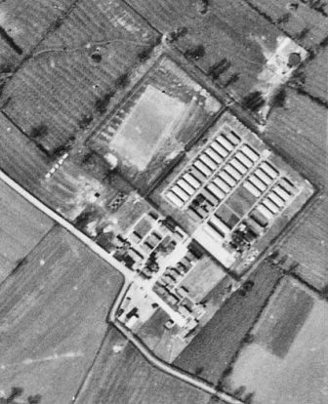 | 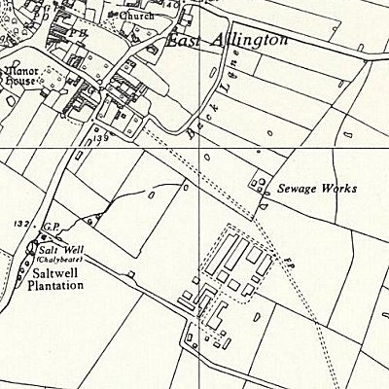
 | 1944 | Ordnance Survey 1956
was no one else suitable to replace them. He recommended that new teachers be sent. He mentioned that a new commandant had just arrived.

14/15 August 1945 – Mr Dadley Potter gave a report on the camp. He was from the Political Intelligence Department, (P.I.D.) London which was responsible for overseeing re-education activities.

Commandant: Lt Col A E Goodwin Camp leader; Kurballer
2nd i/c: Major Waring
Adjutant: Captain Coward
Interpreter Officer: Lt Lyster.
Although Mr Potter was made welcome in the camp there was hostility towards P.I.D.; “P.I.D. is anathema in this camp. There is a strong undercurrent of hostility among the officers to PID activities on account of the valuable Ps/W who have been moved, i.e. the Camp Leader and four teachers…. “The best Ps/W are Nazis” remarked the Commandant. “Why can’t we be allowed to run the camp on our own without outside interference?” I heard in a stage whisper in the Mess…”

This view was shared by British staff in many camps. They saw little value in re-educational activities and did not welcome the additional work required. It was largely a matter for the Commandant to decide whether activities were promoted or not.

The loss of teachers resulted in the number studying English falling from 200 to 25. Mr Potter was trying to recruit seven more teachers from amongst the pows.

28/29 November 1945 – Mr James Grant visited the camp for an English Education Report.

Despite previous hopes, classes had dwindled further – again it was hoped that new classes would start soon.

Mr Grant noted that Commandants only had short stays at this camp, but the I.O. was still in place and showed great interest in educational courses.

29/30 June & 1 July 1946 – English Inspector’s Report by Mr W Dadley Potter. Total strength 2545. There were 6 classes with 90 pupils in the main camp.

Commandant; Lt Col O Price Lagersprecher; Krug
Interpreter: S.Sgt Gruenbaum
Adjutant: Capt. Coward.

Many of the pows had been held in camps in the USA. Their morale was low as they had been misinformed in the States that they were to be returned to Germany.

24 August 1946 – English Inspector’s Report on Woolfox Lodge, see hostels below.

17/20 September 1946 – Mr W Dadley Potter carried out another English Inspector’s Report. Total strength 2570 in main + 4 hostels.

No change to senior staff noted.

30 December 1946 / 1 January 1947 – Major R l S Raffles gave an English Inspector’s Report. Total strength 2650 in main + 1 satellite and 3 hostels. All in huts.

Commandant; Lt Col O Price Lagersprecher; Ludwig

There were 4 classes for English in the main camp. There was a theatre which could hold 220.

9/11 April 1947 – W G W Aston carried out a survey of grade C pows, and a re-educational survey. Total strength 2 officers, 2317 OR.

Commandant; Lt Col O Price Camp leader; Fw Ludwig Werner (A)
Interpreter: Capt I Agoston [due to be demobilized] Deputy C/L: Uffz Schiffels Walter (B+)
German M.O. Stabsarzt Dr Stutz (B) and Soldat Dr Helma (B)
German dentist Fw Dr Meyer (B)

The camp leader, aged 30, had been in place since December 1946. Previously a clerk in civil life. Described as; “..rather a weak type…” a later report described him as “phlegmatic”, but the British staff found him to be a satisfactory camp leader. He was due for repatriation, but still in place in June.

The deputy C/L, aged 36, had also been in place since December 1946. Previously a teacher in a Volkschule. “…although a good type has not the personality to make much impression of the PsW”

Political screening: | A | B+ | B | B- | C | C+
 | 102 | 287 | 1468 | 455 | 1 | 6

310 pows had been repatriated to date.
Morale was generally good except at Harrowby hostel. The visitor was impressed by the interest shown by the British staff in re-education. Mr Aston estimated that 25% of the pows still showed Nazi ‘symptoms’, but that re-education activities were having a positive effect.

30% of the pows were ‘youth’ (under-25). There were no special arrangements for them and they were not considered to be a problem.

There was a shortage of space for classrooms and other activities. The standard list of re-education activities was given;

Wochenpost and Ausblick – 250 / 180 copies of each.

Newspapers – A wide range of British newspapers + copies of Picture Post and the Sphere. 6/8 German papers were sent by COGA, (part of PID, Control Office for Germany and Austria) – additional papers were sent by repatriated pows. Some Swiss newspapers were also received.

Library – 800 volumes including 600 fiction. More were requested.

Lectures – regular, but attendance varied. Not surprisingly there was a keener interest on subjects related to German current affairs.

Discussion groups – fortnightly meetings of a ‘cultural union’.

Films – Gaumont British fortnightly and YMCA every three weeks. The Gaumont films were not very popular here, or in other camps, as they were often old films.

Wireless – in Camp Leaders office with 6 loudspeakers.

Camp magazine – Fortnightly ‘Lagerpost’ of 4 pages – 2500 copies were printed by Grantham Publications Ltd. It included articles about the life of the pows – and posed questions such as; “Warum englische Mädchen heiraten?” (Why do English girls marry?) – an article which discussed whether it was right for an English girl to marry a German pow. (The full article written by Manfred Knodt is included in - ’Improperly and amorously consorting’ - Doctoral thesis by Mary Ingham, 2019, Goldsmiths, University of London).  Edition shown is from November 1947 – front page articles cover; ‘Great Fun At Saltby’, where two concerts had been held – Allington pows setting a good example for tending war graves at Grantham – and, ‘Not a word about turnips’ concerning a recent lecture about agriculture.  Press review – selected news was translated and posted on a noticeboard. Some news was relayed over the wireless system. There were no discussion groups, but this was under review.  English instruction – For the camp and hostels there were 115 pupils with 8 teachers. Many also studied privately. ‘English For All’ was popular and more copies were requested.  Information room – no space available.  Other activities –  Religion – Protestant padre Hpt Rudolf Maurer (B-), aged 42. “..complacent in religion as well as politics, has applied to his bishop to clear him of Nazi stigma. He joined the Wehrmacht as an infantry officer. His room was most untidy and stuffy, the crucifix seemed out of place | 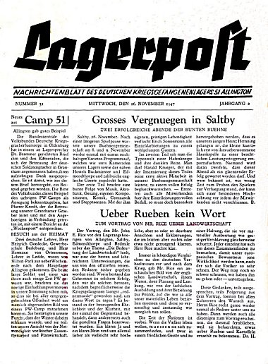
in the unholy atmosphere.” Only 10% of the pows attended services. There was no RC padre, but prayer and bible study groups met, and the RC priest from Horbling Camp 80 visited occasionally. Some pows attended church services in neighbouring villages and the Grantham Methodist Church.

Education – There were few classes as most pows were more interested in going out of the camp. Small groups studied craftsmanship, draughtsmanship, history of music and agriculture.

Entertainments – 15 members of a theatre group produced various shows. 10 members of an orchestra played mostly light music. 35 members in a choir. The chief recreations were football, boxing and table tennis.

29 Apr / 1 May 1947 – Mr P Donovan gave an English Inspector’s Report. Total strength 2454.

Three English classes for 34 pupils in the main camp.

24/26 June 1947 – a further re-education survey by W G W Aston. Total strength, 2 officers, 2608 OR.

Commandant; Lt Col L B Shepherd-Folker MBE [new] Camp leader; Fw Ludwig Werner (A) [same]
Interpreter: S/Sgt G Spier [new] Deputy C/L: Uffz Neumann Erhard (B) [new]
German M.O. Ass.Arzt Dr Ringel Gerhard (B) [new], and SS-Mann Dr Helma Walter (B) [new]
German dentist Fw Dr Meyer Kurt (B) [same]

The commandant had been in post for three weeks. The interpreter was only 18 years old, “but intelligent”. An interest in re-education was shown by the British staff.

The new deputy C/L was 36 years old. Previously a bank official. Described as; “..unimpressive personality” by the visitor, (his personal comments about German staff are all negative). It was noted that the British staff were satisfied with him.

Political screening: | A | B+ | B | B- | C | C+
 | 13 | 374 | 1682 | 536 | 2 | 1

105 pows had appealed against their grading – the better the grading, the sooner the repatriation, in theory. 1207 pows had been repatriated to date. Many of the A grade pows had already left and the visitor noted there were still some Nazi sentiments.

The leading pows stated that morale was fairly high in the camp, but the visitor thought that various factors were having a negative influence – bad news from home – no football field at Woolfox – lack of facilities for re-education – and, lack of “enlightened and organising” pows. There were recommendations that some changes to German staff should be made (see July).

Well over 1000 pows were ‘youth’, with 598 being under 21 – a very high number in comparison to most camps. Their main interest was in sport and going out. There was no separate provision for them, but this was recommended.

The standard list of re-education activities was given – there was little change from the last report. Some activities were affected due to repatriations. The library had double the number of books. Discussion groups were sporadic. ‘Travelling Films’ had replaced Gaumont British. The number of loudspeakers had doubled – all hostels had a wireless.

Religion – there was a camp chapel. A new Evangelical padre, Leut Knodt Manfred (B+), aged 27, had transferred from Horbling Camp 80. He had been ordained during the war and most of his vocational experience was gained in the army. There was also a RC padre, Uffz Gruenewald (A) who was regarded as being more successful, but most pows were apathetic towards religion.

Education – no classes. Some pows were studying privately.

Entertainments – the theatre group had ended due to repatriations. The orchestra of 12 members continued. The main sports were football, handball, boxing, table tennis and skittles.

7/8 July 1947 – Mr Aston returned to ‘Implement changes in P/W staff.’ Total strength - 2 0fficers, 2606 OR.

A suitable candidate to lead Woolfox Satellite camp was brought in. Two other pows were transferred to the camp and recommended as Camp Leader and a Hostel leader to the Commandant. A new study leader was also appointed in the main camp.

One of the M.O.’s, Dr Ringel, was being repatriated on medical grounds and was replaced by Ass.Arzt Hermann Woebecke (B) from Llanmartin Camp 184.

The youth pows were to be balloted to elect leaders for a committee. It was hoped that a programme of activities would then be developed, “to dispel the present fatalistic tendency.” The visitor spoke to the camp and hostel leaders to tell them it was their duty to encourage the youth pows – “to seek their salvation in personal freedom by right and objective thinking”.

There were a number of other changes to try to improve facilities for re-education activities – all a bit late really.

16/17 September 1947 – English Inspector’s Report. Total strength 2199. In the main camp there were three classes with just 22 pupils.

There was a new lagersprecher: Dr Eduard Brammer. [Appointed July].

1-3 October 1947 – C J St.J Chappell visited to carry out a re-educational survey. Total strength 3 officers, 2317 OR.

No changes to senior personnel, two new German M.O.’s. The new Camp Leader, Fahnenj.Ofw.Dr Eduard Brammer (B-) had been a lawyer; “extremely certain of himself and a little intolerant of men of lesser education and intelligence.” He was very interested in re-education.

Simplified political screening was listed; A – 1 / B – 2319. 1947 pows had been repatriated to date. Morale was generally regarded as good. The visitor stated that it was very hard to stimulate interest in politics as the majority of pows were either farm labourers or very young (50% youth pows).

Despite attempts to create activities for the youth pows, very little – if anything – had occurred.

The standard list of re-education activities was given. There was little change other than:

Discussion groups – There was a successful Politische Arbeitsgemeinschaft (Political Committee) in the main camp. A similar group ran at Harlaxton hostel.

Information room – space had been found for this. The Visual Education Section (of COGA) sent display materials about ‘Deutsche Jugend’, but the pows found it to be poor.

Other activities –

Religion – Regular Catholic and Protestant services were held in all camps. Some pows attended services in Grantham.

Education – in the main camp there were no classes recorded, some pows were conducting private studies.

Entertainment – 14-man orchestra in main camp. Excellent football team which was unbeaten in matches against army and local teams.

1947 - Ukrainian pows were held at Allington. They were some of the members of the Waffen-SS Division Galizien. The division was accused of major war crimes against civilians. They were not reported on by COGA.

4/6 November 1947 – English Inspector’s Report by Maj R L S Raffles. Total strength 1948. Just 2 English classes, but a large number of pows studied privately.

14 November 1947 - Camp number included in an ‘Urgent Memorandum’ (FO 939/270) regarding inspection of food parcels.

31 March – 2 April 1948 – English Inspector’s Report by Maj R L S Raffles. Total strength 1120. There were no English classes. There was a new interpreter – S/Sgt Hallet.

The camp is practically a transit camp - of the 668 pows in the main camp, 400 were new arrivals.

July 1948 – the German pows had been repatriated or were in transit. 1401 Ukrainian pows were still located here. Their status as pows soon changed and by Autumn they were recorded as members of the European Voluntary Workers scheme. The site was no longer listed as a camp, but as a hostel for the EVW.

Known Camp Commandants;
c.1945 Lt Col A E Goodwin
c.1946-1947 Lieutenant Colonel O Price (I think he was with Duke of Wellington’s Regiment (West Riding)
c. 1947 Lt Col L B Shepherd-Folker OBE (from the Royal Lincs Regiment)

Camp numbers:

 | Open |  |  | With other camps |  |  | Unknown |  |  | Not listed / not open

 | 1943 | 6/46 | 9/46 | 1/47 | 4/47 | 5/47 | 6/47 | 9/47 | 10/47 | 11/47 | 4/48
Main | ? | 975 | 1060 | 1000 | 996 | 1080 | 1003 | 799 | 907 | 861 | 688
Allington hostel |  | 60
Buckminster | ? | With Camp 262 |  |  |  |  |  | 103 | 105 | 92 | 24
Caunton | ? | With C52
Saxondale | ?
Woolfox Lodge Sat |  | Not given | 540 | 823 | 615 | 865 | 805 | With Stamford Camp 10 (106)
Honington hostel |  | 60 | 50 | 55
Harlaxton |  | 290 | 300 | 273 | 219 | 209 | 282 | 179 | 189 | 149 | 148
Harrowby |  | 297 | 300 | 282 | 275 | 300 | 277 | 194 | 231 | 211
Saltby Satellite |  | See notes below |  |  |  |  |  | 509 | 500 | 336
Redmile |  | With Camp 262 |  |  |  |  |  | 93 | 89 | 785 | 34
Edmondthorpe |  | With Camp 262 |  |  |  |  |  | 82 | 85 | 80
Stamford | Previously Camp 10 / 106 |  |  |  |  |  |  |  |  |  | 181
Billetees |  | Not given | 320 | 250 | 214 | Not given | 241 | 240 | 214 | 144 | 45
Total | 750 cap | 2545 | 2570 | 2650* | 2319 | 2454 | 2608 | 2199 | 2320 | 1948 | 1120
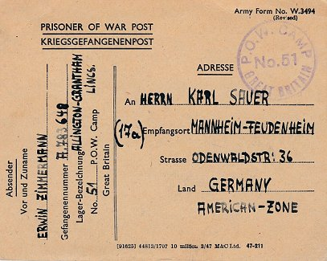
*2683 listed.
Pow postcard February 1948.
After the camp: 1948, Ukrainians under the ‘European Volunteer Workers Scheme’. The site later became a caravan park and then an estate for prefabricated houses. The borders of the site seem to be the same as that used by the pow camp.
The camp as it is today - https://repatriatedlandscape.org/england/pow-sites-in-yorks-humber-and-lincs/pow-camp-51-allington/
Further information:

National Archives – FO 939/133 51 Working Camp, Allington Camp, Grantham, Lincolnshire. Dated 1945-1948 (Used above)

The German Federal Archives has a copy of the camp magazine.

Hostels and Satellites

In a report from June 1946, a hostel was listed – ‘Syston Park’ – with the note; “not as yet settled. Camp in a state of flux.” No pows were recorded there. The site did not appear in any future report for Camp 51.

Saltby Satellite.

Previously Camp 183. It would seem the camp was independently administered for just a short while as it was listed as a satellite camp for Langar Camp 262 and then, from 13 September 1947 it was administered by Allington Camp 51.
October 1947 – Camp leader – Uffz H Kalina (B+) – “An energetic and intelligent man, he is proud of his camp and takes an interest in all matters affecting it.”
Art and handicrafts were a popular activity in the camp. There was an 8-man orchestra.

November 1947 – Officer i/c Captain T J Morgan MC.

 | 1943 | 6/46 | 9/46 | 1/47 | 4/47 | 5/47 | 6/47 | 9/47 | 10/47 | 11/47 | 4/48
Saltby Satellite |  | See above and separate details |  |  |  |  |  | 509 | 500 | 336

Woolfox Lodge Satellite – Stretton / Stamford (near Oakham). 20 miles from main camp. Hutted. Most likely ex-RAF accommodation huts at the Woolfox Lodge airfield

24 August 1946 – English Inspector’s Report by J E Jackson for this camp – recorded as a ‘hostel’. Strength 467.

Commandant; C.S.M. Currie Lagersprecher; Eulich, H

Separate reports were rarely made on satellite camps / hostels – no reasons were given for this one. There were three English classes. A shortage of newspapers and no radio was noted. There was a cinema.

April 1947 – Camp leader Fw Meier (A). No ground available for sports. “…re-education was hindered by day and night shifts stemming the floods, for which the Ps/W showed a good spirit.”

June 1947 – Commandant Capt Gould. Camp leader; Ofw. Kruesel Oskar (B-)

The new leader was 32-years-old, he had been in the army since 1934. “Little personality and organising powers,” the commandant was not sure of his ability, but the visitor thought there was no suitable replacement.

July 1947 – A new camp leader was proposed - Fahnenj.Ofw Eduard Brammer (B), aged 47 – “tall, self-assured, ‘a doctor of law and graduated economist’ but politically untutored.” He had previously been camp leader at one of the many RAF hostels attached to King’s Cliffe Camp 702. The deputy leader at this camp was not thought to be suitable as leader being described as, “an ordinary type of person.” [When the administration of the camp was transferred to Stamford Camp 10 – Oskar Kruesel was still listed as leader}.

 | 1943 | 6/46 | 8/46 | 9/46 | 1/47 | 4/47 | 5/47 | 6/47 | 9/47 | 10/47 | 11/47 | 4/48
Woolfox Lodge Sat |  | Not given | 467 | 540 | 823 | 615 | 865 | 805 | With Stamford Camp 10

Allington hostel ½ mile from main camp.

Just one mention. Very near to the main camp. Probably a temporary overflow site.

 | 1943 | 6/46 | 9/46 | 1/47 | 4/47 | 5/47 | 6/47 | 9/47 | 10/47 | 11/47 | 4/48
Allington hostel |  | 60

Buckminster hostel (Melton) 11 miles from main camp. Location – local information: The Old Stable Block... It then became a hostel for displaced person, a men’s hall of residence for a college at Stoke Rochford - now houses rented out by the Buckminster Estate.

1943 – recorded as a hostel for Italians.

There was a period of time when the hostel was attached to Langar Camp 262.

September 1947 – again re-listed with Allington, with German pows.

October 1947 – Hostel leader; Uffz W Wieditz (B+) – “Adequate and quite interested in re-education, but by no means an outstanding man.”

“A large number of Rumanian ‘Volksdeutsche’ who are depressed by either bad news or absence of news from the Eastern Zone.”

 | 1943 | 6/46 | 9/46 | 1/47 | 4/47 | 5/47 | 6/47 | 9/47 | 10/47 | 11/47 | 4/48
Buckminster | ? | With Camp 262 |  |  |  |  |  | 103 | 105 | 92 | 24

Caunton hostel. Location – on the Norwell Road to Bathley. NGR SK 753 601 shown as hostel on 1955 map.  1943 – recorded as a hostel for Italians.  Recollections by a resident after the camp – “…central hut adjoined the cookhouse and dining hall and offered two bedrooms and a bathroom. Apart from these central buildings I believe there were three long huts at each side but the three on the Bathley side had disappeared by the time we moved in.  The three on the Caunton side comprised an ablution block, a recreation hall and the hut closest to the Norwell Road was a "posh" hut finished in fine weatherboarding with a good dance floor inside and a small stage….  The Camp also had its own sewage treatment plant and a couple of car garages and cycle sheds (next to the road) and a parade ground. While it was known as a prisoner-of-war camp, it was actually for Italian prisoners and [later for] displaced persons.”  Vernon Taylor: http://www.ournottinghamshire.org.uk/page/pow_camp_in_caunton | 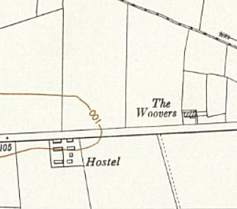
 | OS Map 1955

 | 1943 | 6/46 | 9/46 | 1/47 | 4/47 | 5/47 | 6/47 | 9/47 | 10/47 | 11/47 | 4/48
Caunton | ? | With C52

Edmondthorpe hostel (Melton) 13 miles from the main camp. Location – reported to be in the stable block and out-buildings for the hall. NGR SK 8605 1750

Previously attached to Langar Camp 262.

Problem with dates. Langar was on an ex-RAF base and reported to have opened at the end of the war – however, Edmondthorpe hostel is recorded on various websites as having Italian pows from 1942 or 1943. If this is the case then the hostel must have been attached to a different main camp.

Stories relate Edmondthorpe Hall being burnt down with the presence of Italian pows – but there is another problem with dates. Some sites record the Hall being destroyed by fire in 1942, (Wikipedia stating 10 February 1942), this was before pows were held here. Other sites state it was burnt down in 1943 and associate this event with pows, for example;

“Time passed, and Edmondthorpe Hall became a Prison of War camp during World War Two. A fire destroyed the Hall and the story goes that the camp cook threw a rolling pin, which upset a candle into a pot of fat, starting a destructive blaze that could be seen for miles around. Why did the cook throw the rolling pin? Because of a cat that kept coming into the kitchens, looking for food. Many people had seen it around, and after the fire, it disappeared!” https://www.travelintime.uk/2022/01/06/edmondthorpe/

October 1947 – Hostel leader; Ofw O Keller (B) – “A keen and intelligent man very interested in promoting study of current events. He runs a local press review.”

 | 1943 | 6/46 | 9/46 | 1/47 | 4/47 | 5/47 | 6/47 | 9/47 | 10/47 | 11/47 | 4/48
Edmondthorpe |  | With Camp 262 |  |  |  |  |  | 82 | 85 | 80

The site as it is now - https://repatriatedlandscape.org/england/pow-sites-in-yorks-humber-and-lincs/pow-hostel-51-edmondthorpe-hall/

Harlaxton hostel (Grantham) – 7 miles from the main camp. Hutted. Probable site: SK 896 320 – NOT confirmed, but local memories place hostel on Gorse Lane + many pow sites became ‘Agricultural Hostels’, often with European Volunteer Workers.  Probably attached to another camp before June 1946.  Winter 1946 / 1947 – memories of pows clearing snowdrifts along the road in severe weather.  April 1947 – hostel leader Fw Rumetsch (B)  June 1947 – Hostel leader Ogefr Haushahn Heinrich (B), 41 years old, a master painter. Regarded as having a strong personality which had raised morale in the hostel.  Some pows attended meetings of Grantham Council.  October 1947 – Hostel leader; Ogefr. M Haushahn (B) – “Very keen on promoting the welfare of men at his hostel and is the leader of intellectual activity there.” | 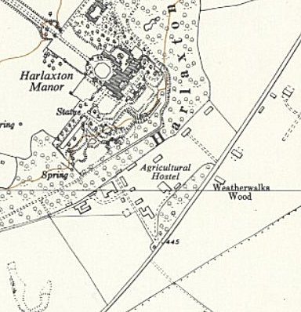
 | Ordnance Survey 1959

 | 1943 | 6/46 | 9/46 | 1/47 | 4/47 | 5/47 | 6/47 | 9/47 | 10/47 | 11/47 | 4/48
Harlaxton |  | 290 | 300 | 273 | 219 | 209 | 282 | 179 | 189 | 149 | 148

Harrowby hostel (Grantham) – 6 miles from the main camp. Hutted. Location – Map undated, but probably immediately post-war. On Harrowby Lane, NGR SK 9427 3611  Probably attached to another main camp before June 1946.  January 1947 – “Ps/W at this hostel are employed in the construction of drains, water mains, etc. for a new suburb of Grantham. The site at present bears the appearance of a snipe-bog and conditions of work are unpleasant.” Recorded that English teaching books were needed.  April 1947 – hostel leader Owm Huth Max (B+), aged 32, a butcher by trade. “…is a depressed-looking person. He has not a strong personality with the result that discipline at this hostel is somewhat lax, and he resented P/W camp police coming from main camp to implant what he termed militarism.” His future as hostel leader was being considered.  June 1947 – same hostel leader. Some pows attended meetings of Grantham Council.  July 1947 – a bullying S/Sgt was removed from the camp. | 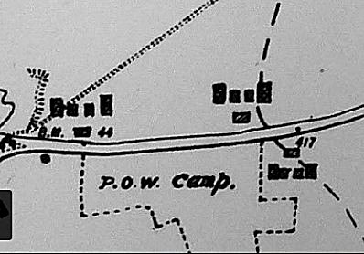
 | https://sites.google.com/view/rafregimentbeltonpark/maps

October 1947 – Hostel leader; O/Faehnrich H Lux (B-) – “A professional teacher, he is capable but cannot be described as a ‘leading spirit’.”

 | 1943 | 6/46 | 9/46 | 1/47 | 4/47 | 5/47 | 6/47 | 9/47 | 10/47 | 11/47 | 4/48
Harrowby |  | 297 | 300 | 282 | 275 | 300 | 277 | 194 | 231 | 211

Honington hostel – 7 miles from main camp. Hutted.  Location – “..to the north of Honington Station and level crossing,” (Lincolnshire Past & Present, No. 59 Spring 2005).  Possibly attached to another camp prior to June 1946.  January 1947 – “..an unattractive little camp, originally intended for land army girls…” Lack of English books noted.  1943 6/46 9/46 1/47 4/47 5/47 6/47 9/47 10/47 11/47 4/48  Honington hostel 60 50 55  http://www.slha.org.uk/photogallery/?thislocation=Honington – a picture of some of the buildings that may have been part of the site. | 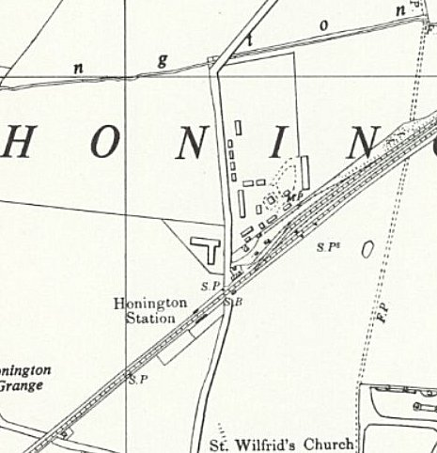
 | Ordnance Survey 1956

Redmile (Bingham) - 7 miles from the main camp.

Previously attached to Langar Camp 262.

October 1947 – Hostel leader; Schulze (A)

 | 1943 | 6/46 | 9/46 | 1/47 | 4/47 | 5/47 | 6/47 | 9/47 | 10/47 | 11/47 | 4/48
Redmile |  | With Camp 262 |  |  |  |  |  | 93 | 89 | 785 | 34

Saxondale

1943 – recorded as a hostel for Italians.

Use after this date - ?

 | 1943 | 6/46 | 9/46 | 1/47 | 4/47 | 5/47 | 6/47 | 9/47 | 10/47 | 11/47 | 4/48
Saxondale | ?

Stamford – Previously camp 106.

Administered by Allington for just a short time as it was being closed down.

 | 1943 | 6/46 | 9/46 | 1/47 | 4/47 | 5/47 | 6/47 | 9/47 | 10/47 | 11/47 | 4/48
Stamford | Previously Camp 10 / 106 |  |  |  |  |  |  |  |  |  | 181

