Camp 49 - Farndon Road Camp, Farndon Fields Farm, Market Harborough, Leicestershire

Included in the 1945 ICRC camp list – Labour Camp. 49. Farndon Road Camp, Market Harborough, Leics.

1947 Camp List
49(G.W.C.) | Farndon Road Camp, Market Harborough, Leics | E. | Priswar, Market Harborough | Market Harborough 421 | Market Harborough | Lt.Col.J.J.Jolliffe, M.B.E. M.C. M.M. | v/1453/2

Prisoner of War Camps (1939 – 1948) - Project report by Roger J.C. Thomas - English Heritage 2003
OS NGR | Sheet | No. | Name & Location | County | Cond’n | Type 1945 | Comments
SP 725 864 | 141 | 49 | Farndon Road Camp (Harrington Camp), Farndon Fields Farm, Market Harborough | Leicestershire | 3 | German Working Camp | STANDARD type. Caravan site

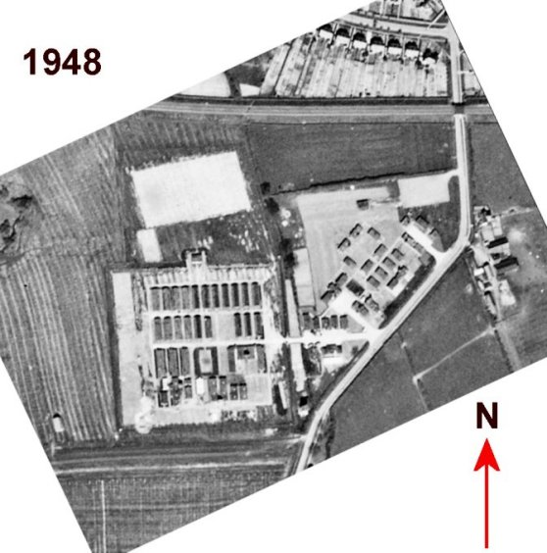  Location: On the SW edge of Market Harborough – marked on the map as an ‘Agricultural Hostel.’ The boundary line on the map shows that it was half-half in the counties of Leicestershire / Northamptonshire. The little village of Harrington is about 8km SE of the camp. Harrington Camp was a satellite camp for the Farndon Road Main Camp.  Before the camp: Farmland.  Pow Camp: The site was accepted as a pow camp in December 1941. An Italian pow construction gang was allocated from Camp 35 Boughton Park to work with the Pioneer Corps.  Standard type with a main pow compound and a British / administration area at the ‘front’ of the camp. Italian camp to 1945, then a German working camp.  1942 - The camp opened for Italian pows..  1943 – Hostels listed for Italian pows; Dunton Bassett, Corby | 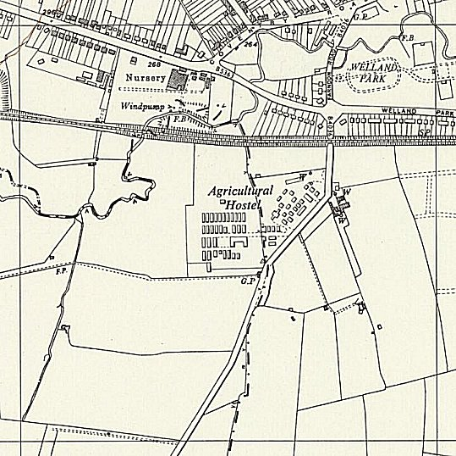
 | Ordnance Survey 1958
May 1944 and November 1944 - The camp was listed in records as an Italian Labour Battalion under the Eastern Command area, (WO 32/10737). The Italians were recorded as co-operators.

1 August 1945 - an urgent memorandum was sent to this camp, and others, about maintaining records of Italians who were classed as ‘co-operators’.

Oversight and development of re-education activities and English teaching for German pows was carried out by PID (Political Intelligence Department of the Foreign Office) / COGA (Control Office for Germany and Austria – UK). Visits and reports were made. The standard of the reports varied greatly. The visitors took little interest, if any, in activities other than re-education. They rarely mentioned welfare, sports, games, pastimes, crafts, etc of the pows.

6/7 June 1946 – First visit for re-education. The camp was still listed as an Italian Labour Battalion – but there are no references to the Italians in the report. The report was based only on the two German hostels. Strength; 0 Officers, 123 OR (Germans ONLY).

Commandant: Lt Col J J Joliffe, MBE. MC, MM Camp leader: Italian, not listed
Interpreter Officer: S/Sgt L Gersten

The visitor met the British officers and outlined PID re-educational policy.

Morale was “reasonably high.” Bad mail service from the Russian zone caused concerns. The visitor described the pows as “of low mental grade.” No communism reported.

Youth pows (under-25) were not regarded as a problem.

Re-education activities were just starting. The standard list was given:

Wochenpost / Ausblick – 10 / 0 copies respectively.

Newspapers – A couple of papers were passed to the pows by the British. 8 German newspapers received each week.

Library – “excellent.” books just received from PID.

Lectures – just one so far.

Radio – news broadcast on extension loudspeakers at 21.00 and 22.00 from British section.

Discussion groups / Films / Camp magazine / Press reviews– none

English teaching – only individual study, mainly using ‘English For All.’

No other activities were listed other than RC pows able to attend a local church.

5/6 July 1946 – English Inspector’s Report. Strength 1877. 0 classes.

6 September 1946 – the Harborough Advertiser and Mail, told how up to 100 pows attended some services at St John the Baptist at East Farndon. “For the sermon the Rector says a sentence, it is repeated to the Germans by an interpreter, and so on. The lessons are given in English and then translated by the interpreter. “There has been no complaint at all from my congregation,” the Rector told the “Advertiser.”

“I am not at all pro-German, but there is an opportunity of letting them become normal German Christians and they seem very anxious to play their part. I try to make them feel they are wanted and they are responding most nobly. The Colonel in charge of the camp asked me if I would allow them to come to my evensong if they had requested permission to attend and I agreed. They follow the service most attentively.” https://eastfarndon.org/wp-content/uploads/2023/02/Prisoner-of-War-Camp-on-Farndon-Road.pdf

28 September 1946 – Very brief report with few details. Now listed as a German Working Camp.

Like most others, the Commandant showed little interest in re-education, but he did not stop activities.

A different interpreter – S/Sgt Carp, was reported as unsatisfactory, but leaving in a few days.

A camp magazine had started – Wir gehen mit. (Loose translation – We are with you).

6 – 9 November 1946 - a German theatre group journal held by the Deutsches Historisches Museum, recorded a visit to Harrington Camp 49, giving 2 performances.

12-13 November 1946 - General survey. Strength; 1 Officer, (the M.O.), 1446 OR.

Commandant: Lt Col J J Joliffe, MBE. MC, MM Camp leader: Fdwl Wilhelm Mueller
Interpreter Officer: None Deputy C/L: None
German M.O.: Oberarzt Dr. Lobel

Political screening was being carried out.

Morale was recorded as ‘good,’ owing to excellent supervision by the British staff and the development of recreation activities, (rather than re-education activities).

A negative aspect arose as the weather was rainy and pows were being sent home early; this resulted in a cut in pay and talk by some pows of being exploited.

Very few re-education activities were occurring. The camp library previously described as ‘excellent,’ in fact contained just 166 reading books

30 January / 1 February 1947 – Re-educational survey. Strength; 1 officer, 878 O.R.

Camp leader, Gefr Wilhelm Mueller (B+), aged 35, master painter (art), “a sympathetic type… maintains cordial relations which ensures the smooth running of camp activities.”

Only change to senior personnel – Deputy C/L; W/M Willy Schaake (B+), “exhibits a democratic attitude.”

Screening; A – 20, B – 755, C – 104. This was a high number of C grade pows in comparison to most camps.

Morale was described as; “not high.” Reasons given for this fall since the last report were; length of captivity, many pows from Russian zone, bad news from home.

Only vague statements about the 104 C grade pows were given. “No leading pow would admit that there are still many Nazi-tainted comrades.” Though screening was often very inaccurate, it had been carried out recently (December 1946) and was unlikely to be 100% inaccurate.

Re-education was being largely met with apathy. Many of the A class pows who may have been leaders of activities had been repatriated. The British staff were not interested and there was no interpreter. The standard list was given:

Wochenpost and Ausblick – 460 / 130 copies.

Newspapers – 4 copies of 4 daily British papers, 2 magazines, 6/8 German papers fortnightly, some pows received Swiss papers.

Library – 750 books. – the attitude of the PID visitor shows – “PsW requirements place emphasis on criminal, love and detective stories thereby indicating their frame of mind and trend of thought,” he wanted them to read political and historical texts.

Lectures – regular, but given in cold rooms and attended by the same pows.

Discussion groups – none in the main camp.

Films – supplied by YMCA and Gaumont British fortnightly in main and hostels. GB films charged 12 shillings per show, and 6d (6 pence) per pow – like most camps this was resented, especially as many of the films were in English without subtitles.

Wireless – the set was in the ‘haircutting saloon’ with 4 loudspeakers around the camp. The hostels had their own sets. Reception was often not good.

Camp magazine – the visitor commented that it was entirely free from politics.

Press review – translations of articles were pinned to a board.

English Instruction – 50 pupils in 3 grades with 3 teachers.

Information room – “the only bright room… comfortably installed and heated.” No exhibition materials for display from PID were recorded. Also used as a reading and writing room.

Other activities –

Religion – there was a camp chapel, but pows preferred to attend the church in Market Harborough with a pow Evangelical padre. Some attended methodist services. 25% of pows were RC and a priest from Market Harborough visited the camp.

Education – just 10 pupils studying book-keeping.

Entertainment – a new 8 member theatre group giving cabaret shows. A choir of 20. A trio playing light music. Main physical activities were football and table tennis.

10/11 March 1947 – English Inspector’s Report. Strength; 821. 41 pupils in 3 classes.

No teaching was taking place due to lack of fuel for heating. The two hostels were not visited as the roads were blocked with snow.

28 April – 2 May 1947 – Re-educational survey and Re-screening ‘C’s. Strength; 1 officer, 901 OR.

Commandant: Lt Col J J Joliffe, MBE. MC, MM Camp leader: Gefr Wilhelm Mueller (B+) (previously listed as Fdwl)
Interpreter Officer: S/Sgt Kubermann Deputy C/L: Fw Anton Tinnerfeld (B)
German M.O.: Oberarzt Dr. Loebell (spelling?)

The administration was recorded as ‘fair and tolerant’ and the pows had a high level of respect for the British officers.

The camp leader was upgraded to ‘A’ and was due to be repatriated. The deputy would take his place.

Deputy C/L – Anton Tinnerfeld, aged 32, no Nazi Party history, a professional soldier.

The IO was new and had no experience of working with pows.

Political screening: | A | B+ | B | B- | C+
 | 7 | 163 | 258 | 473 | 1

The higher the grading the sooner the repatriation, in theory. 113 ‘C grade’ pows appealed against their grades – 112 were accepted. This high number of successful appeals was reflected in many camps at this time. For the one rejected appeal, the pow was regarded as; “pro-Nazi, active and dangerous” – he was moved from this camp shortly after. 60 B grade pows were pending appeal. 525 pows had been repatriated to date.

Once again, morale was recorded as “good.” This was partly due to the regrading of the C’s. One pow receiving bad news from the Russian zone had attempted suicide. The visitor believed that most pows had made political progress, though many remained confused over the transition from Nazi Germany to a democratic country.

30% were ‘youth’ pows. 20 of these had been nominated for the ‘Youth Camp.’

Re-education activities were seen to be “plodding on.” The Study Leader, Hermann Sauer, aged 37, a civil servant, had been a member of the S.A., but was regarded a “quite safe politically.” The standard list was given:

Wochenpost and Ausblick – separate appendix.

Newspapers – Good supply including foreign newspapers, except from the Russian zone.

Library – 2000 books. System to change books at hostels in place.

Lectures – regular, with up to 100 pows attending.

Discussion groups – being re-organised.

Films – regular. Stated to be “twice a week,” – but I think this should have been fortnightly.

Wireless – well equipped. Not popular as the pows preferred to walk out of the camp in the evenings.

Camp magazine – 250 copies of 20 pages, monthly.

Press review – Compiled daily and distributed to main and hostels.

Information room – None. Now just a reading room.

Other activities –

Religion – 10% interest in religion. Regular services and the chapel was well furnished.

“Pastor Eisele (B+) has recently been posted from 106 Camp [Stamford] where he was the centre of trouble in the Democratic Study Group. He has already realised that he was imprudent and here in 49 Camp he is confining his activities to his religious duties.” He was not expected to cause any further trouble, but a watch was kept on his activities.

Education – “various subjects, scientific and cultural.”

Entertainments – Sports section was flourishing. A good football team which beat the team from Market Harborough. A good football ground. Small theatre and orchestra groups continued, but were affected by repatriations.

No formal outside contacts were listed. The pows had good relationships with most of the local population.

Overall, the camp was seen to be ‘friendly and with good spirit.’

14 July 1947 - the camp became a satellite camp to Camp 94, Gaulby Road, Billesdon.

Known Camp Commandants:
Lieutenant Colonel John James Jolliffe, M.B.E. M.C. M.M. from the Manchester Regiment.

Camp and hostels + number of pows where known:

 | Not open |  | Unknown |  | Open |  | With another camp

 | 1942 | 1943 | 6/46 | 7/46 | 11/46 G | 2/47 G | 3/47 G | 5/47 | After 7/47
Main | It | It | It | 900 It | 671 | 451 | 420 | 568 | Sat to C94
Corby |  | It |  | With Camp 259
Dunton Bassett |  | It | 72 G | 75 G
Drayton |  |  | 40 G | 45 G | With C94
Harrington |  |  | With C54 | 750 G ⁽¹⁾ | 642 | 322 | 299 | 254 | With 87 / 259
Naseby |  |  |  | 45 G ⁽¹⁾ | 30 | 25 | 24 | 30 | With C87
Yelvertoft |  |  |  | 50 | 52 | 39 | 38 | 50 | With C87
Billets |  |  | 11 G | 12 | 46 | 42 | 40 | 0
Total | ? | ? | 123 G + ?It | 1877 | 1447 | 879 | 821 | 902 | /

G(ermans) It(alians) (1) These hostels had not yet been attached, but were expected to be.

After the camp: The camp was used for European Volunteer workers. Now part residential / industrial area.

The site as it is now - https://repatriatedlandscape.org/england/pow-sites-in-the-east-midlands/pow-camp-49-farandon/

Further information:

National Archives FO 939/131 49 Working Camp, Farm Road camp, Market Harborough, Leicestershire. Dated 1946-1947. Used above.

National Archives - FO 1120/214 – ‘Re-educational survey visit reports for camps 47 to 49’. Duplicates of some of the reports above.

Satellite camp

Harrington Aerodrome. Northamptonshire. 6 miles SE of the main camp. RAF Huts. Previously listed with C54.

11/1947 – Camp leader; Uffz Koehneke

2/1947 – Camp leader; Uscha. Adolf Leuschner (B-), aged 25, “despite his youth is a capable youngster who has shown signs of mending his ideas and political outlook. He is the ‘teachable’ type.” The hostel held its own discussion groups.

5/1947 – same camp leader.

Transferred to Camp 87 and then 259 – Adolf Leuschner remained as leader.

 | 1942 | 1943 | 6/46 | 7/46 | 11/46 G | 2/47 G | 3/47 G | 5/47 | After 7/47
Harrington |  |  | With C54 | 750 G ⁽¹⁾ | 642 | 322 | 299 | 254 | With 87 / 259

Further details see Camp 54.

The site as it is today - https://repatriatedlandscape.org/england/pow-sites-in-the-east-midlands/pow-hostel-259-harrington/

Hostels –

Corby

Location – there was a site at Stanion Lane, Corby – not confirmed this is the same site.

1943 - Just the one entry as a hostel for Italians.

From 7/1946 - listed with Weekley camp 259

 | 1942 | 1943 | 6/46 | 7/46 | 11/46 G | 2/47 G | 3/47 G | 5/47 | After 7/47
Corby |  | It |  | With Camp 259

Drayton. 10 miles NE of main camp. Listed 1946 as a house.

1943 – Italian hostel

23 February 1946 – Became German hostel with pows from Shady Lane Camp 167.

6/1946 – Hostel leader; O/Fw Hermann Koenig (est B) – dismissed off-hand by the visitor as; “of no re-educational significance.” Political screening; A – 0; B – 38; Unknown – 2.

8/1946 - listed with Gaulby Camp 94 to 7/47

 | 1942 | 1943 | 6/46 | 7/46 | 11/46 G | 2/47 G | 3/47 G | 5/47 | After 7/47
Drayton |  | I | 40 G | 45 G | With C94

Dunton Bassett. 18 miles NW of the main camp. Huts.  Location NGR SP 548 909 – shown as ‘Agricultural Hostel’ on 1955 map.  1943 – listed as a hostel with Italian pows.  23 February 1946 – Became German hostel with pows from Shady Lane Camp 167.  6/1946 – Hostel leader; O/Fw Franz Kupszyck (est B-) – dismissed off-hand by the visitor as; “of no re-educational significance.” Political screening; A – 1; B – 68; C – 1; Unknown – 2.  1942 1943 6/46 7/46 11/46 2/47 3/47 5/47 After 7/47  Dunton Bassett It 72 G 75 G | 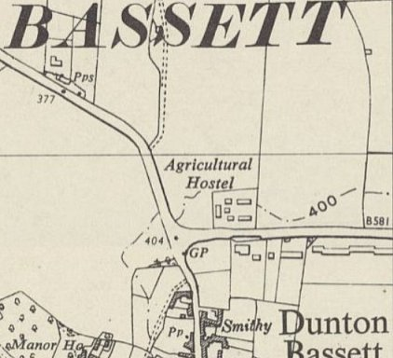
 | Ordnance Survey 1955

Naseby – 8 miles S of the main camp. Was a Women’s Land Army brick built hostel. Was probably attached to a different camp before 7/46.

Location – The WLA hostel was located where Hall Close now stands – NGR SP 688 782

11/1946 – Hostel leader; Feld Ernst Ziemier (B+)

5/1947 – same leader, spelling Zimmer

11/1947 - attached to Byfield Camp 87.

 | 1942 | 1943 | 6/46 | 7/46 | 11/46 G | 2/47 G | 3/47 G | 5/47 | After 7/47
Naseby |  |  |  | 45 G ⁽¹⁾ | 30 | 25 | 24 | 30 | With C87

Yelvertoft. 20 miles SW of the main camp.  Local memories of Italians at this site, so opened well before 11/1946 – “There was a P.O.W. camp at Yelvertoft. The van would come through the village and they would stop to buy their cigarettes. They couldn’t speak English, but you got to know what they wanted. The Italians were very polite and would give a little bow to you.”  Location – “The original Village Hall was built in the early 1950s alongside the existing refurbished single storey brick buildings which were used by the Land Army, for housing WW2 prisoners of war and afterwards support facilities to serve the Hall.” NGR SP 594 758  11/1946 – Hostel leader; Obfeld Abeler.  2/1947 – Hostel leader; Uffz Herbert Heymann (B+)  5/1947 – same leader  10/1947 - with Camp 87 | 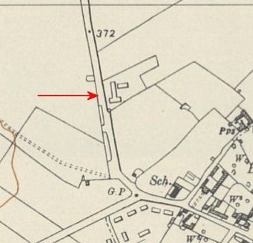
 | Ordnance Survey 1955

 | 1942 | 1943 | 6/46 | 7/46 | 11/46 G | 2/47 G | 3/47 G | 5/47 | After 7/47
Yelvertoft |  |  |  | 50 | 52 | 39 | 38 | 50 | With C87

