Camp 39 - Maxstoke Castle Camp, Coleshill, Warwickshire

Included in the 1945 ICRC camp list – Labour Camp. 39. Castle camp, Maxstoke, Coleshill, B’ham.

1947 Camp List
39(G.W.C.) | Castle Camp, Maxstoke, Coleshill, Warwickshire | N. | Priswar, Shustoke Green. | Coleshill 2184/5 | Whitacre Junction | Lt.Col.F.G.N.Alexander | v/1453/2

Prisoner of War Camps (1939 – 1948) - Project report by Roger J.C. Thomas - English Heritage 2003
OS NGR | Sheet | No. | Name & Location | County | Cond’n | Type 1945 | Comments
SP 228 889 | 139 | 39 | Castle Camp, Maxstoke, Coleshill | Warwickshire | 4 | German Working Camp | STANDARD type. Golfcourse

In all of the reports I have seen, the camp was called “Castle Camp” – I have used Maxstoke Castle to help people find the information.  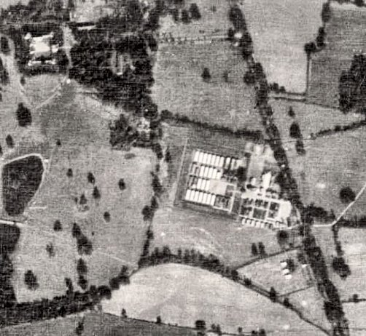  Location: The camp was in the grounds of Maxstoke Castle park. 0.5 km from the village of Maxstoke.  The aerial photo (1947) shows the standard layout of the camp with a main compound, and at the ‘front’, alongside the road, huts for British staff and administration.  Before the camp: The Castle and grounds were being rented out to a Country Club from 1934 to 1939. The War Office used the castle and buildings to accommodate an army unit. From 1940 to 1946 the Ministry of Aircraft Production used the castle for storing aircraft components.  Pow Camp: The site was accepted as a pow camp in December 1941. An Italian pow construction gang was allocated from Ettington Camp 31 to work with the Pioneer Corps. The camp opened in 1942. | 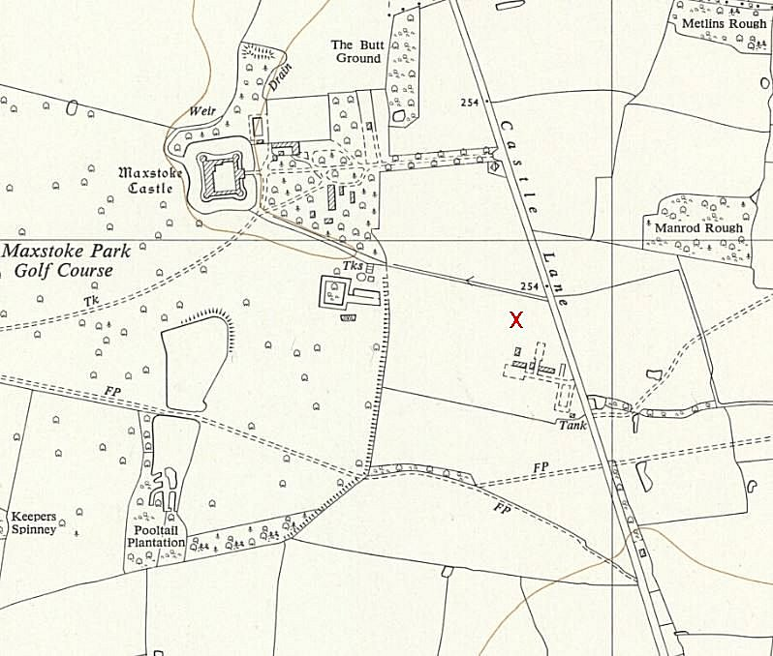
 | Ordnance Survey 1955
1943 – Hostels listed for Italian pows: Lapworth; Polesworth; Solihull C.S.D.

31 December 1943 - International Red Cross visit - Italian prisoners, capacity 840.

5 May 1944 - Hostels listed for Italian pows from this camp, (WO 32/10737): Moseley, Birmingham - Central Supply Depot, Solihull, Warwickshire.

May 1944 and November 1944 - The camp was listed as an Italian Labour Battalion under the Western Command area, (WO 32/10737).

1945 – became a German pow camp.

Oversight and development of re-education activities and English teaching for German pows was carried out by PID (Political Intelligence Department of the Foreign Office) / COGA (Control Office for Germany and Austria – UK). Visits and reports were made. The standard of the reports varied greatly. The visitors took little interest, if any, in activities other than re-education. They rarely mentioned welfare, sports, games, pastimes, crafts, etc of the pows.

19-21 November 1946 – English Inspector’s Report. Total strength 1561.

Commandant: Lt Col Alexander Lagersprecher: H Rick.
Asst Commandant: Major Lynch, (formerly Commandant at Warwick Racecourse Camp 140).

47 pupils in 3 classes in the main camp, held in the theatre.

A range of English newspapers were being received. There was 1 radio. Only a small library.

The protestant chaplain, Frederich Schmidt, also taught English. RC chaplain visited monthly. “The privilege of attending outside places of worship has been withdrawn from all hostels on account of misdemeanours committed by P/W ostensibly attending divine service.”

14 January 1947 – Report on re-education. Strength; 2 officers, 1566 O.R.

Commandant: Lt Col Alexander Camp leader: O/Maat Hans Rick (A)
Interpreter: S/Sgt W G Meyer R.A.C. Deputy C/L: Uffz G Schneider (B+)
German M.O.: O/Arzt Schaefer (B).

The commandant was ‘co-operative.’ The interpreter, “knows his job, speaks excellent German and is keen.”

Simplified political screening figures were given: A 25; B1378; C 163; 2 unscreened pows were in hospital. Despite there being 10% C grades (Nazi), the visitor believed that only 2% were still politically Nazi, (5% anti-Nazi, 93% no political view). The report does not state this, but this was often the case when a large number of young, Waffen-SS troops were held. There were 200 ‘youth’ pows (under-25), but they were not seen as a problem and the majority participated in camp activities. 100 pows expected to be repatriated in early February.

Morale was regarded as good, now that repatriations were due to start. The British and German staff worked well together.

The standard list of re-education activities was given:

Wochenpost & Ausblick – separate report.

Newspapers – A range of British newspapers. Weltwoche Zűricherzeitung, a Swiss weekly magazine, was also received.

Library – 1280 books.

Lectures – Regular and well received.

Discussion group – weekly and well attended.

Films – Monthly YMCA and fortnightly Gaumont British films. Gaumont was seen as unreliable and did not visit the hostels.

Wireless – a good set located in the camp leader’s office, (presumably with loudspeakers elsewhere).

Magazine - Das freie Wort; Wocenzeitung Des Lagers 39 – (The Free Word – weekly newspaper for camp 39). Had problems with paper supplies.

English Instruction – Beginners and advanced classes with 40 pupils altogether. Classes were also held in the hostels.

Other activities –

Religion – Weekly services in the camp chapel by protestant Pfarrer Friedrich Schmidt (C). The RC padre from Arbury Hall camp 196 visited weekly and Catholics visited the church in Coleshill.

Theatre – 12 pows in the theatre group giving small sketches.

Orchestra – Very good, playing both classical and light music – 2 violins, 2 pianos, 1 bass viol, 2 saxophones, 1 guitar, 1 clarinet and 2 accordions.

16/18 April 1947 – Survey of re-education. Strength; 2 officers, 1240 OR + 43 attached, not on strength.

Commandant: Lt Col D E Bathgate Camp leader: Ofw A Kuffer (B)
Interpreter: 2/Lieut W G Meyer R.A.C. (was s/sgt). Deputy C/L: Uffz G Schneider (B+)
German M.O.: O/Arzt H Schaefer (B).

The new commandant started a week earlier on his first command of a pow camp. He had no interest in re-education activities.

The new interpreter had started a few days earlier. He had started work on developing re-education activities, he had his own ideas which was not liked by the visitor as they were, “not always in agreement with PID/COGA policy. Also, he does not like to accept suggestions.” Tensions such as these often arose – camps were under the responsibility of the War Office – while re-education was the remit of the Foreign Office. In general, it was what the officers in the camp wanted that won out.

The new camp leader did not take a “great part” in re-education. Activities were mainly under the control of the deputy C/L.

Morale was regarded as good in a, “pleasant, well kept camp and hostels.” New privileges for leaving the camp and fraternisation were a positive factor – however, they also affected re-education as the pows preferred to walk out when possible, rather than attend meetings. Repatriation was the main interest of all the pows. They were treated fairly by the British staff and good relationships with the local population were developing. One third of the pows were ‘youth,’ but this was not seen as a problem.

Screening: A 4; B+ 74; B 840; B- 216; C 151. 161 appeals against their political grading had been made – the better the grade, the sooner repatriated, in theory. 1 appeal had been granted so far. 387 pows repatriated to date.

The standard list of re-education activities was given. There were few changes: more German newspapers received; an Information Room developed which showed ‘exhibitions’ from materials sent by COGA. An exhibition on ‘Housing Problems in Germany’ had been shown and was circulating the hostels.

Other activities –

Religion – the protestant chaplain was active and popular. Pfarrer Kuepper from Camp 196 continued to visit.

Education – Classes in English, Spanish, Shorthand and Book-keeping; only about 10% of the pows attended.

Recreation – “Ample.” 10 piece orchestra, 15 member theatre group, football teams, boxing, ping pong, athletics, and gramophone concerts. Small parties of pows visited Warwick Castle.

28-29 July 1947 – Re-education survey. Strength; 1 officer, 2017 OR. No reason was given for the very large increase in numbers – or why Penns Lane hostel was not recorded.

1 change to senior personnel; a new Deputy camp leader, Uffz. H Geicke (B)

The commandant remained sceptical about the value of re-education activities and the British staff showed no interest, apart from the interpreter. The interpreter (Meyer/Meier) expressed anti-German sentiments to the visitor, but his views were not, “virulent enough to alienate the prisoners from him, being tempered by a sense of fairness and correctness.”

Camp leader Ofw Kuffer – regular soldier since 1934, aged 34 – “Efficient, but rather colourless from political and re-education standpoint.”

Deputy C/L Uffz Geicke – also the study leader and magazine editor, worked in father’s jam factory in Hamburg, aged 28, had been in Hitler Youth, but no “marked political tendencies.” Called up in 1936 – “Energetic and intelligent.”

Simplified screening: A 1; B 2017. 11 recent appeals had been made against grading, but only 1 was successful. There was no mention of the previous 161 appeals. 700 pows had been repatriated since January.

Morale was still good. Positive influences were the treatment received at the hands of British authorities and the public. However, the visitor had some doubts about political progress away from nationalistic and militaristic viewpoints. He gave an example when several pows had expressed views that Britain had declared war on Germany out of jealousy at the growth of her power and wealth.

The interpreter officer was praised for his work developing re-education activities. The standard list was very similar to previous reports – there was an addition for ‘Press reviews’ where a wall newspaper had been developed to give a summary of the news.

Other activities – technical classes were held for; electricity, photography, and Building Construction and Excavation Work.

Entertainment – the orchestra had given some public concerts. One member, C Tegtmeier composed light music and jazz. There was also a choir.

Formal outside contacts were being developed. The Lord Mayor of Birmingham and a local MP visited. Pows had been present at a recent court martial and at an inquest for a pow suicide.

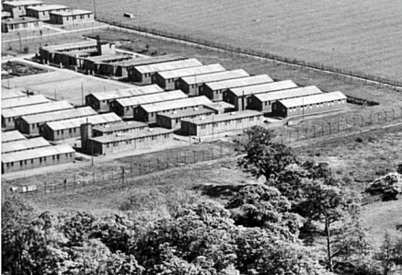 | 30 September – 3 October 1947 – Re-education survey. Strength; 1 officer, 1646 OR.  1 change to senior personnel – a new camp leader; Hwm Busch (B) – a grocer’s traveller, aged 38 - “intelligent with a pleasing personality, and carries out his work efficiently.” He had not been a member of the Nazi party.  The report was largely pointless being a repetition of previous remarks.  1-3 October 1947 – English Inspector’s Report - at the same time as the re-education survey.  In the main camp - 25 pupils in 2 classes. 150 pows “studying privately.” All the hostels had an English teacher. Unusually, teachers in this camp were paid an extra 1 shilling a week from the welfare fund.  The Inspector took a swipe at the Birmingham accent – “the proximity of Birmingham and the fact that many prisoners work in local industries has given them quite exceptional opportunities to make English friends. This accounts for the high standard of English speaking, except, of course, in the matter of pronunciation.”  14 November 1947 - Camp number included in an ‘Urgent Memorandum’ (FO 939/270) regarding inspection of food parcels.  17-22 November 1947 – Re-education survey. Strength; 1 officer, 1701 OR.
Top corner of aerial photograph 1947 showing type of huts in use. EAW006938 - Aerial Photo | Historic England

No changes to senior personnel.

Another repetitive report by the same visitor. It stated again that the commandant was new to pow work – he had been there for 7 months. The theatre group had collapsed due to repatriations.

15/18 December 1947 – English Inspector’s Report. Strength 1985.

A new camp leader noted – ‘Preuss.’

In the main camp - 2 classes with just 20 pupils. 80 studying privately.

12-17 January 1948 – Re-education survey. Strength; 1 officer, 1772 OR.

Commandant: Lt Col D E Bathgate Camp leader: Hans Preuss (B)
Interpreter: 2/Lieut W G Meyer Deputy C/L: Friedrich Evers (B)
German M.O.: O/Arzt Dr Friedrich Dobler (B-)

All senior German personnel were new. The Camp leader started on 9 December – aged 35, railway head clerk. Was not a Nazi Party member – “pleasant, efficient and carries out his duties satisfactorily.”

Deputy C/L started 27 December – aged 24, a student before being called up in 1942 – “a pleasing personality and is very intelligent.” He had also taken over as editor for the camp magazine, as study leader, and leading re-education activities.

The M.O. – aged 33, attended Heidelberg University, called up in 1940. Had been a member of the S.A. As a pow he was held at Watten Camp 165. There was a comment which could apply to his time at Watten or at this camp. A report had been made that he was spreading subversive propaganda, but it was not supported by evidence; “He is young and very full of himself and may be rather tactless in his approach to Ps/w. A watching brief will be held..”

All activities within the camp were affected by repatriations, but they still continued.

Religion – the padre had been repatriated, there was no replacement. Many pows attended local churches.

Formal outside contacts had been made with pows visiting council meetings, magistrates court and assizes. Warwick Library supplied 60 German books for a 6 months loan.

25/27 February 1948 – English Inspector’s Report. Strength 1096. Main camp - 1 small class of 5 pupils + a class of 6 at Penns Lane.

24 and 25 April 1948 – Belatedly, small teams of ‘Resettlement Officers’ toured some of the camps to talk about conditions in Germany and returning home. Many camps did not get any visit at all. 3 officers attended Camp 39 and gave a talk about issues to 80 pows.

27/29 April 1948 – Visit for ‘Final Impressions’ and re-education survey. Strength; 1 officer, 386 OR.

Due to repatriations, all German senior personnel had been replaced again; Camp leader Werner Hentschel (B); Deputy Fritz Hamdorf (B); M.O. A/Arzt Dr Brauneck.

The remaining pows expected to be repatriated soon. Relationships between pows and British staff regarded as excellent.

Surveys of pow attitudes towards the British were carried out in camps that were still open. They were carried out in ad hoc ways, often with just a group of pows and a show of hands. The results were pointless. For what they are worth, in this camp:

Hate – “No evidence.”
Dislike – 5%. Complaints made about; firm discipline in the camp, dismantling of German factories, lack of coal and bad news from Germany.
Distrust – 15%. Complaints over lecturers, screening, pow camps in Belgium, poor conditions of British farms.
Indifference – 50%. Pows more concerned with buying gifts to take home and personal problems. They all agreed they had been treated fairly.
Benefit of the doubt – 30%. Most positive factor was good relationships with local civilians.

Known Camp Commandants:
c.1946 - 1947 Lieutenant Colonel F G N Alexander
1947 - Lt Col D E Bathgate from the Queen’s Regiment.

Further information:

National Archives FO 939/121 39 Working Camp, Castle Camp, Maxstoke, Coleshill, Warwickshire. Dated 1946-1948. Used above.

The Imperial War Museum have copies of the magazine, dated 1947 (editions 65, 68, 70, 74-75, 95 and December + January 1948 (front page only, edition 100). Ref LBY E.J. 358. The German Federal Archives also have a copy, unknown date.
Camp and hostels + number of pows where known:

 | Not open |  | Unknown |  | Open |  | With another camp

 | 1942 | 1943 | 1944 | 11/46 | 1/47 | 4/47 | 7/47 | 10/47 | 11/47 | 12/47 | 1/48 | 2/48 | 4/48
Main |  |  |  | 475 | 491 ⁽¹⁾ | 357 | 774 | 665 | 683 ⁽³⁾ | 615 | 563 | 410 ⁽¹⁾ | 204
Lapworth |  |  |  | With C 31
Polesworth
Solihull CSD
Moseley |  |  |  | 115 | 122 | 97 | 94 | 88 | 79 | 90 | 83
Lea Hall |  |  |  | 79 | 79 | 66
Minworth |  |  |  | 177 | 175 | 161 | 109 | 57 | 109 | 131 | 116 | 29
Penns Lane |  |  |  | 167 | 181 | 158 |  | 317 | 329 | 462 | 403 | 297
Shustoke |  |  |  | 97 | 92 | 80 | 120 | 71 | 52 | 101 | 87 | 59
Uplands |  |  |  | 122 | 119 | 88 | 486 | 93 | 95 | 153 | 137 | 82
Walmley Ash |  |  |  | 305 | 274 | 209 | 379 | 303 | 109 | 381 | 344 | 194 | 183
Bomb Disposal ⁽²⁾ |  |  |  |  | 35 | (43 not inc)
Billets |  |  |  | 24 | ? | 26 | 56 | 53 | 53 | 49 | 40 | ?
Total | ? | 840 | ? | 1561 | 1568 | 1242 | 2018 | 1647 | 1702 | 1985 | 1773 | 1096 | 387

1 Including billetees. 2 there was a small detachment of German pows located at Welsh House Farm hostel, administered by Maxstoke Camp 39, who worked with No.1 Bomb Disposal Squadron. The main HQ for pows with 1 BDS was at Bunny Camp, a hostel for Langar Camp 262. (Ref FO 939/83). 3 + 3 in hospital.

After the camp: The park became a golf club and the site of the pow camp is the practice area. The family owners returned to the castle.

Hostels

Lapworth. By Rising Lane, NGR SP 189 722.  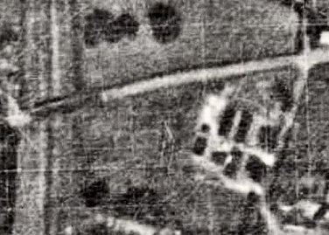  1943 – Hostel listed for Italian pows with Camp 39.  Not listed with C39 in 1944 – probably attached to another main camp until September 1946, when it was recorded as attached to Ettington Park Camp 31.  Memories – “….when out that way we used to chat to them a lot and if we had any cash we would buy the typical P.O.W. knick-knacks from them. This was mostly treen (wooden artefacts) and I remember the most popular was an eagle carved out of a single piece of wood, about a foot long and with fully spread wings. I wish I had a few of these things now! Some fraternisation occurred and I believe a lot of these P.O.W.'s stayed behind after the war…”  https://www.solihull.gov.uk/sites/default/files/migrated/libraries_wartimebooklet.pdf  Aerial photo – 1948. | 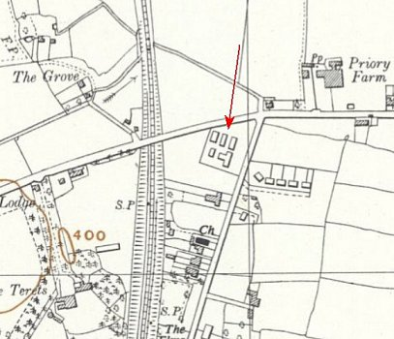
 | Ordnance Survey 1954

 | 1942 | 1943 | 1944 | 11/46 | 1/47 | 4/47 | 7/47 | 10/47 | 11/47 | 12/47 | 1/48 | 2/48 | 4/48
Lapworth |  |  |  | With C 31

Lea Hall. 5 miles N of the main camp. Huts. (In the 11/46 report it was listed as – ‘Lea Hall. Hams Hall.’

April 1947 – Hostel leader; Uffz B Hoelscher (B)

 | 1942 | 1943 | 1944 | 11/46 | 1/47 | 4/47 | 7/47 | 10/47 | 11/47 | 12/47 | 1/48 | 2/48 | 4/48
Lea Hall |  |  |  | 79 | 79 | 66

Minworth. 7 miles NW of the main camp. Huts. Two similar memories place it at back of school / alongside Kingsbury Road. SP 156 922  April 1947 – Hostel leader; O.Fr H Kissling (B-)  42 43 44 11/46 1/47 4/47 7/47 10/47 11/47 12/47 1/48 2/48 4/48  177 175 161 109 57 109 131 116 29 | 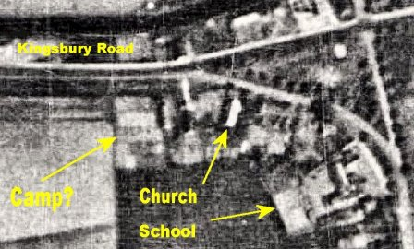 | 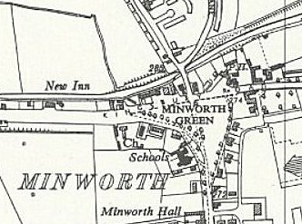
 | 1948 – possible location. | Ordnance Survey 1955

Moseley. 16 miles W of the main camp. Huts.

One memory for location – “I used to see Italian PoWs in a huge house …on the corner of Oxford Road and School Road. They sold wicker baskets.” There is a school on one corner now, but it was not there in the 1940’s – NGR SP 080 827

5 May 1944 - Hostel listed for Italian pow

November 1946 – “At Moseley there is no radio, it having been withdrawn by the parent camp at Wolverhampton, to which Moseley (formerly Swanshurst Park) belonged.”

April 1947 – Hostel leader; Hwm F Busch (B)

August 1947 – there was a small musical circle and 10 strong drama group. Outside contacts developed with local Baptists, Church of England, a social club and the ‘Fellowship of Reconciliation.’

 | 1942 | 1943 | 1944 | 11/46 | 1/47 | 4/47 | 7/47 | 10/47 | 11/47 | 12/47 | 1/48 | 2/48 | 4/48
Moseley |  |  |  | 115 | 122 | 97 | 94 | 88 | 79 | 90 | 83

Penns Lane. 10 miles NW of the main camp. Huts. (A note stated Penns Lane, ‘Ardington’ - this was supposed to be Erdington).

April 1947 – Hostel leader; Ofw P Wachholz (B)

 |  | 1942 | 1943 | 1944 | 11/46 | 1/47 | 4/47 | 7/47 | 10/47 | 11/47 |  | 12/47 | 1/48 | 2/48 | 4/48
Penns Lane |  |  |  |  | 167 | 181 | 158 |  | 317 | 329 |  | 462 | 403 | 297
 |  |  |  |  |  |  |  |  |  |  | Ordnance Survey 1955
 | Polesworth. NGR SK 265 019  1943 – Hostel listed for Italian pows attached to Camp 39. Attached to a different main camp after this date.  Later housed German pows.  Edited notes from memories of the hostel –  “The camp was built in the early 1940s and consisted of two bunk houses, a guard hut, bicycle shed and kitchen, dining area and ablutions. There was a very deep ditch along the perimeter between 4 and 5 feet deep. The entrance to the camp was where 104 Grendon road stands and the bike sheds and guard house where near 108 Grendon Road.  The Italians were given bicycles to travel to work on local farms.. but, [many of] the Germans [also] worked on the roads in gangs and were closely supervised….  The Italians used to sing in the camp after work and would speak to anyone who passed along St. Helena Road and they also played football in the next field. Each Sunday prisoners were marched down to the Cinema on Market Street – now the site of apartments and houses by the canal side – for a private film viewing. The Italians loved children and if given a sixpenny piece they would make a bracelet or a ring. Some went to the osier beds by the church and made baskets too.  The only serious trouble at the camp was an attempted murder of one Italian prisoner and one of the pioneer corps guarding the camp. The perpetrator was a local Dordon youth who was annoyed that he hadn’t been called up and |  |  |  |  |  |  |  |  |  | 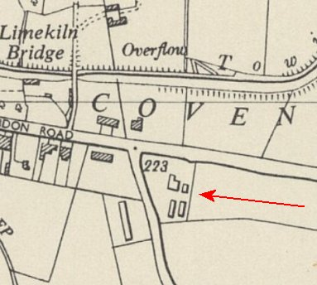
decided to take matters into his own hands. He was given three years hard labour. The site of the crime is in the back garden of 106 Grendon Road. The guards did not carry guns or rifles when the Italians were at the camp.

After the war had finished it was used as a displaced persons camp.”

By Margaret Henley; Chair, Polesworth History Project Group - https://www.visitpolesworth.co.uk/polesworth-prisoner-of-war-camp/ [NOTE - I changed some of the chronology as it is known that Italians were there first].

 | 1942 | 1943 | 1944 | 11/46 | 1/47 | 4/47 | 7/47 | 10/47 | 11/47 | 12/47 | 1/48 | 2/48 | 4/48
Polesworth

Shustoke. 2½ miles NE of the main camp. Described as a ‘House’ rather than huts.

Location – most likely Shustoke Hall. This site was identified as a possible site for a main pow camp in 1941, but that did not happen – instead, I think the site became a hostel a little later.

April 1947 – Hostel leader; Uffz E M Liess (B-)

 | 1942 | 1943 | 1944 | 11/46 | 1/47 | 4/47 | 7/47 | 10/47 | 11/47 | 12/47 | 1/48 | 2/48 | 4/48
Shustoke |  |  |  | 97 | 92 | 80 | 120 | 71 | 52 | 101 | 87 | 59

Solihull C.S.D. (Central Supply Depot).  “There was an Army supply depot situated in Beechwood Park Road behind Streetsbrook Road. Italian prisoners of war were there for a time. German prisoners were also in Solihull and put to work in the fields by local farmers.” Probably where the Council Yard was later, shown on the map SP 134 804.  1943 – Hostel listed for Italian pows with Camp 39.  5 May 1944 - Hostel listed for Italian pows with Camp 39  [Possibly another Italian hostel at Faulkner Road SP 147 823] | 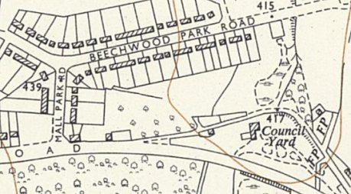
 | Ordnance Survey 1956

 | 1942 | 1943 | 1944 | 11/46 | 1/47 | 4/47 | 7/47 | 10/47 | 11/47 | 12/47 | 1/48 | 2/48 | 4/48
Solihull CSD

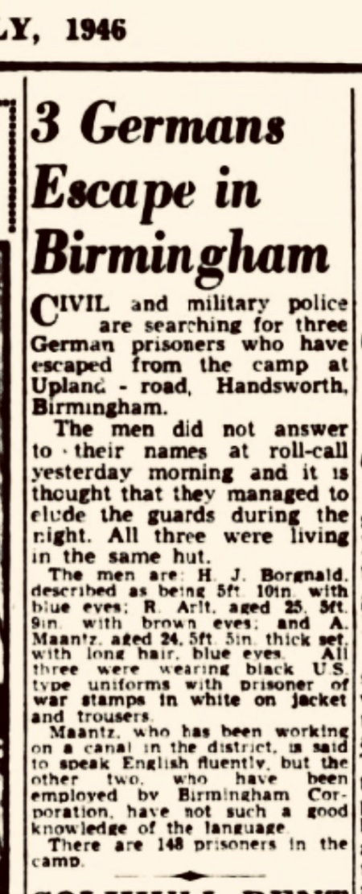 | Uplands. Handsworth, Birmingham. 16 miles W of the main camp. Huts.  Location – ‘The Uplands’ was a farm shown on the 1948 map – the 1955 map shows a ‘Hostel’ nearby. I believe this was the pow hostel, though by 1955 it would have been used for agricultural workers. NGR SP 035 914  < July 1946 - 3 escaped pows from Uplands, Handsworth.  The last sentence states “There are 148 prisoners in the camp.”  November 1946 – note that it was previously attached to a camp in Wolverhampton.  April 1947 – Hostel leader; Fw K Schneider (B) | 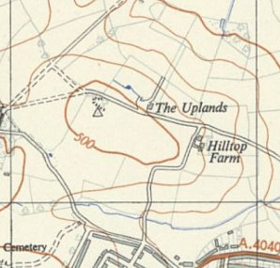 | 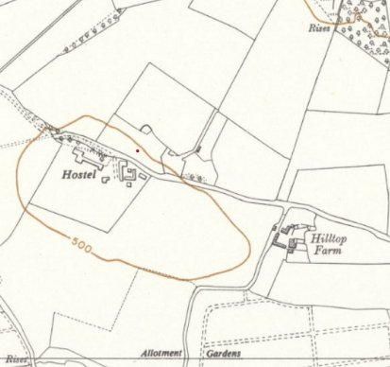
 |  | Ordnance Survey 1947 | Ordnance Survey 1955
December 1947 – noted that electricity was generated by a plant at this hostel and the lighting was poor.

 | 1942 | 1943 | 1944 | 11/46 | 1/47 | 4/47 | 7/47 |  | 10/47 | 11/47 | 12/47 |  | 1/48 | 2/48 | 4/48
Uplands |  |  |  | 122 | 119 | 88 | 486 |  | 93 | 95 | 153 |  | 137 | 82

Walmley Ash. 9 miles NW of the main camp. Huts. Location – “near Jones Wood.” (SP 138 937).

April 1947 – Hostel leader; Hwm Karl Lommel (B)

April 1948 – same hostel leader.

 | 1942 | 1943 | 1944 | 11/46 | 1/47 | 4/47 | 7/47 | 10/47 | 11/47 | 12/47 | 1/48 | 2/48 | 4/48
Walmley Ash |  |  |  | 305 | 274 | 209 | 379 | 303 | 109 | 381 | 344 | 194 | 183

This was not a hostel for Maxstoke, but a small detachment was located here:

Welsh House Farm. Tennal Road, Quinton, Birmingham. (tel. Harborne 30202).  The junction of Welsh House Farm Road and Tennal Road is NGR SP 022 842. There is a golf course along WHF Road - a possible site. The Farm is shown further long the road.  1947 - there was a small detachment of 31 German pows located at Welsh House Farm who worked with No.1 Bomb Disposal Squadron. | 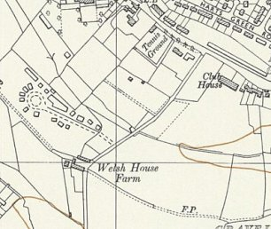
 | Ordnance Survey 1955

