Camp 44 - Goathurst Camp, Goathurst, Bridgewater, Somerset

Included in the 1945 ICRC camp list – Labour Camp. 44. Goathurst Camp, Bridgwater, Somerset.

1947 Camp List
44(G.W.C.) | Goathurst Camp, Goathurst, Bridgwater, Somerset | S. | Priswar, Goathurst | North Petherton 311 | Bridgwater | Lt.Col.R.C.C.Joy, D.S.C. | v/1453/2

Prisoner of War Camps (1939 – 1948) - Project report by Roger J.C. Thomas - English Heritage 2003
OS NGR | Sheet | No. | Name & Location | County | Cond’n | Type 1945 | Comments
ST 259 337 | 182 | 44 | Goathurst Camp, Goathurst, Bridgewater | Somerset | 4 | German Working Camp | STANDARD type

Location: Goathurst village is about 5 km from Bridgwater. The plan of the camp below, shows the site to be a little further north of the NGR indicated, just above where it says Park Lane Cottage.  Before the camp: Part of the Halswell Park estate.  Pow Camp:  December 1941 - The site was accepted as a pow camp. It opened in 1942. Initially a small camp for up to 300 Italian pows.  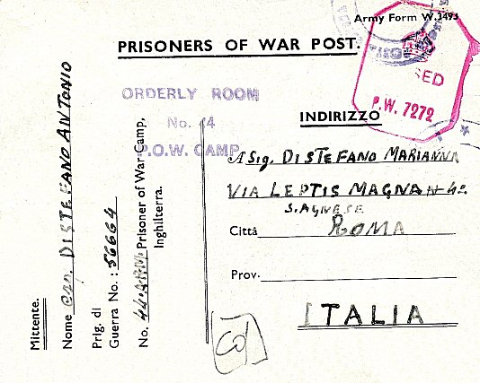  < Pow postcard December 1942.  1943 – The camp held c.500 Italian pows, and a further c.200 were in billets.⁽¹⁾  1943 – Hostel for Italian pows listed at West Lambrook  May 1944 - The camp was listed as an Italian Labour Battalion under the Southern Command area, and in November 1944 as an Italian POW Working Camp, (WO 32/10737).  July 1944 – Italians were being transferred to another camp at Cannington over several months. ⁽¹⁾ Replaced by German pows.  (1 Information from; Somerset at War 1939-1945, Mac Hawkins, Dovecote Press, 1988). | 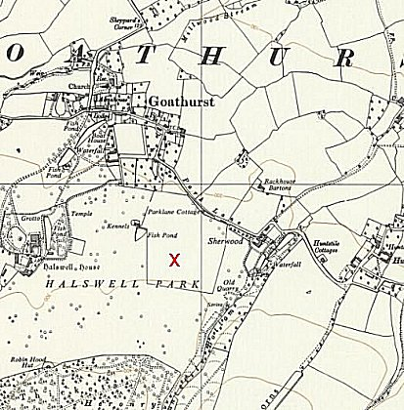
 | Ordnance Survey 1962
Memories of an Italian pow, John Salvatore Zuncheddu. He had been captured in 1941 at Tobruk: “Eventually he arrived at a PoW camp just outside the village of Goathurst, near Bridgwater, in Somerset; at the time he thought that the camp held a couple of hundred prisoners, men from all different parts of Italy.

The prisoners were housed in “this great big round thing,” a Nissen hut. [Most were housed in wooden huts.] They were asked if they were willing to go and work on the farms in the area. Less than a half of the PoWs agreed to work, and those who volunteered were called ‘co-operators,’ and they were considered to be traitors by the other prisoners. Those who would not co-operate, some believing that Mussolini would triumph, and would have them shot when they eventually returned home, were still put to work, in gangs.

The ‘co-operators’ were taken, in groups of twenty, by lorry each day to various places in the area to work, to places fairly near the camp, e.g., Langport, a town fourteen or fifteen miles away, or further afield, on occasions, to the other side of Bristol some forty miles away. The prisoners were given a ration of one packet of cigarettes a week and paid 5d [2p] a day if they stayed in camp. Those that chose to work outside could earn more, and spend the money in a mobile shop that came into the camp, to buy extra cigarettes or other goods. In camp plastic circular shaped tokens were used as currency, those marked No 1 were worth a 1d, those marked 5 were worth 5d, and those marked 10 were worth 10d.

The PoWs could write home to their families, leaving the envelopes unsealed so that they could be read and censored. There were no restrictions on the number of letters sent [there were to begin with] or received, but it sometimes took nearly a month for a letter to get home and for a reply to be received back. After about six months John left the camp each day to work, carrying out general labouring jobs, which included hedging and ditching. One-time, at Martock, a village in South Somerset, he helped to construct a building. Later, he and another Sardinian, Nino, went to work at Washford, in West Somerset, where a Miss Thorner who ran White Farm employed them. Miss Thorner, who spoke Italian, had often travelled in Italy before the war. The two men were fed and slept on the farm, sleeping in part of the granary. After returning to Goathurst for a while John moved out to another farm at Luccombe, near the coastal town of Minehead. Here he carried out general farming duties: cutting with a scythe and baling grass, and feeding the cows. The farm was isolated, and it was a long way to walk to the nearest Catholic Church in Minehead, and he became lonely. The PoWs were not allowed to
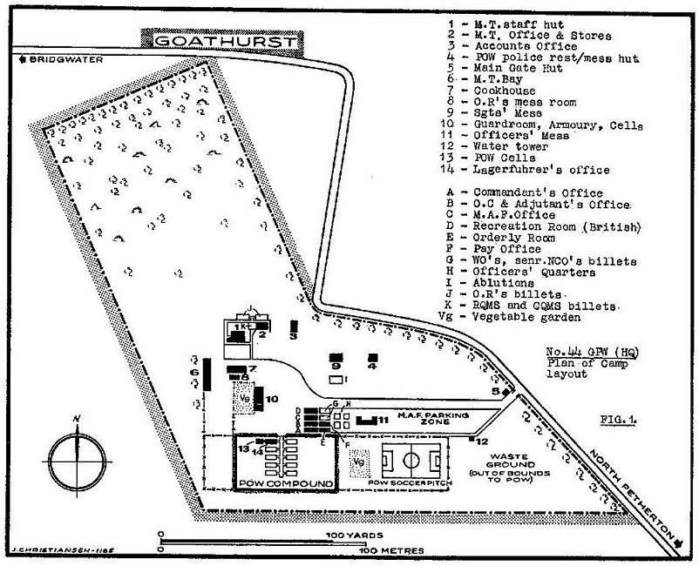 | make contact with anyone, and were restricted to a five-mile radius from their workplace. In their distinctive brown uniform with yellow flashes the police easily spotted them if they wandered too far.  John did not stay long at Luccombe, and after returning to camp for a time; he took another job at Burtle, a village on the Somerset Levels, at Lower [Watt] Farm working for Mr Ted Moxey. After a year: feeding the cows, milking them by hand, and cleaning the milking stalls, in 1945, with the war over, he was to be repatriated.  The PoWs were assembled at a camp at Wookey Hole, near the City of Wells, and prepared for their journey home. The authorities then decided that those who wished it could stay in England and be released, or they could travel home. John was shipped, via London, to Naples, and then, after a week sailed on to Sardinia. Just before he left Mr Moxey’s farm he was asked, “Would you like to come back and work for me?” and John replied, “If you get a permit I come back,” and said he would write to Mr Moxey if he was unhappy after returning home. He had taught himself English using a book named The English in Three Months.  After a time working on the construction of a dam in Sardinia, mixing cement and collecting sand from a riverbed; he wrote to Mr Moxey and agreed to return to England if he organised and sent him a permit. After eighteen months at home, in 1947, he returned to Burtle. In the spring of 1950, he made another trip to Sardinia, this time to get married. On the 15th April 1950 he married Rosetta, the daughter of a contractor he once worked for, and he and his new wife returned to England to live and work; after a couple of years a baby was born.”  (From - bbc.co.uk/ww2peopleswar - Contributed by Somerset County Museum Team. Article ID: A3936602).
From; ‘Die deutschen Kriegsgefangenen in britischer Hand’ by Helmut Wolff, (Munich, 1974).

Notes from another Italian pow’s memories of Goathurst ⁽¹⁾;

There was high fencing around the camp, but no watchtowers. There was a brick built prison block outside of the pow compound.

British Officers were housed in Halswell House, Other Ranks (mainly Pioneer Corps) were in a barrack hut outside the pow compound. The commandant (not named) had lost an arm at Tobruk – he was well respected.

The buildings were mostly wooden, with a few built from corrugated iron. The huts had electric lighting and a ‘tortoise’ stove (sometimes 2) for heating, though they still got cold in winter. The huts were 20 yards long, housing 64 pows with bunks spaced every 4 feet. Pows were supplied with 1 bolster and 1 or 2 blankets. If it was cold they slept in their underwear as pyjamas were not supplied, they often placed their overcoats on top.

With 700 pows, baths/showers with hot water and hard soap were often less than once a week.

Food was short, but sufficient. The Italians preferred bread to potatoes and were able to get some pasta, a little meat and some cheese. They had their own kitchen.

Italian pows wore a dark brown uniform with diamond or circular patches on the right leg and on the back, (this was changed after the Italian armistice).

At first, work gangs with one armed guard, were taken by bus to sites for loading coal, drainage work and clearing beaches. Pows working on farms were collected and returned by the farmers – from 1943 some pows were billeted at the farms.

There was a chapel with an Italian padre. An Italian doctor visited daily. As freedom to walk out of camp increased, pows could visit cinemas and shops, but not pubs. The pow here supplemented his wages by hunting rabbits with a shotgun and selling them. Other pows made jewellery or toys from any scrap material they could find.

There is a report that two Italian pows escaped from the camp and got as far as Southampton.

From July 1944, the Italians were sent out to live at farms or hostels and German pows were moved in.

Wooden huts and Nissen type hut in background >  Oversight and development of re-education activities and English teaching for German pows was carried out by PID (Political Intelligence Department of the Foreign Office) / COGA (Control Office for Germany and Austria – UK). Visits and reports were made. The standard of the reports varied greatly. The visitors took little interest, if any, in activities other than re-education. They rarely mention welfare, sports, games, pastimes, crafts, etc of the pows.  June 1945 – In a report for Exhibition Camp 42, reference was made to Goathurst – “It was noted that the pows had made a collection of money for the victims of concentration camps, but that the War Office refused to send this on. This made an unfortunate impression on the pows.” | 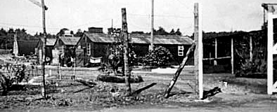

30 June 1945 – English Education visit. Commandant: Lt Col G L S Smith. Interpreter Officer Lt Silver.

The visitor met the pow teachers and left various information leaflets. He gave a lecture to 250 pows. There was a brief note that the unnamed camp leader and deputy were being transferred to Springhill Lodge Camp 185 in the near future, but no reasons were given.

September 1945 - Appendix to HQ Southern Command War Diary; Goathurst, Bridgwater – German labour camp – capacity 1000 – 120/694550

Italian hostels – West Lambrook, Walford Cross, Merriott, Load Farm – total cap 380

German hostels – Houndstone (Yeovil), Crowcombe, Wellington – total cap 380

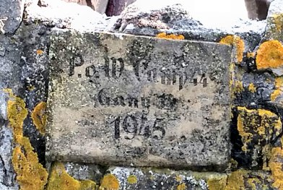 | < A plaque on the river bridge at Biddisham that was found during the repairs at the end of Biddisham Lane. The inscription reads – ‘P.o.W Camp 44, Gang 14, 1945’. The bridge and drain had been built by Italian and German pows from Goathurst.  8-15 July 1946 – 4 members of the ‘Segregation Section’ reviewed political gradings. 1 officer (the M.O.), 2267 OR.  Commandant: Lt Col Smith Camp Leader: Ofw Lambert Lohne (B)  Interpreter: S/Sgt Lester Deputy C/L: -  The commandant was soon to leave and would be greatly missed – the pows often referred to him as ‘grandpa.’  Camp leader review; “…is making great efforts to create a good impression… does his best to encourage re-education and he is wholeheartedly supported by Col Smith.”  German M.O. – O/Arzt Dr Hubert Schober (A); “Whilst he wants to give the impression that he supports us in his way, he does exactly the opposite. As Oberarzt he commands the respect of the youths in the camp, who are impressed by his condescending manner. He uses his position to propogate old Nazi ideas. This man should be carefully watched by T.A’s and if any subversive infleunce is in evidence he should be removed.” (youth = under-25; TA = Training Assistant).
‘POW Plaque found on River Bridge’ - posted on www.blogger.com by Alexandra King

Political screening: | A+ | A | A- | B+ | B | B- | C | C+ | Unknown
 | 8 | 117 | 0 | 203 | 1180 | 322 | 343 | 68 | 27

A very mixed range of political categories. Some of the pows had themselves been held in concentration camps – it was recommended they be repatriated as soon as possible.

17/23 December 1946 – Re-education survey. Strength; 1 officer, 1940 OR.

Commandant: Lt Col Joy Camp Leader: Fahnenjunker F/w Nitschke (B+)
2nd i/c: Major L G Covenly MBE. Deputy C/L: Gefr Roth (B)
Interpreter: S/Sgt Lester German M.O.: Oberarzt Schober (A) (or Schauber)

The Camp Leader made a very good impression – a former Trade Union member, he had attended the special training course at Wilton Park. He did not wish to be repatriated at that time because, “he has no place to which to go.”

Deputy C/L – “good and reliable.”

The German M.O. was still in place.

Political screening: | A+ | A | B+ | B | B- | C | C+ | Unknown
 | 1 | 2 | 185 | 1121 | 273 | 290 | 4 | 65

286 pows appealed against their political screening grade – the better the grade, the sooner repatriated, in theory. In most camps the majority of appeals were upheld. 375 pows had been repatriated to date, including 191 sick.

Morale was reported as declining. The main reasons were Christmas away from home and the small number of repatriations. National Socialism was rejected by most pows, and an interest in democracy was shown.

About 25% of the pows were ‘youth.’ A committee had been created to develop activities and discussions, but interest in the group was declining. Many of the C grade pows were youth pows as they had been drafted in to the Waffen SS.

No interest was shown in re-education from the British staff other than S/Sgt Lester. There was a shortage of space in the main camp for activities. The standard list was given:

Wochenpost and Ausblick – separate appendix.

Newspapers – no British papers received from PWD/COGA. A few were obtained locally. Only 3 or 4 German papers received weekly.  Library – 815 books. An exchange system every 2-3 months with the hostels had been established.  Lectures – some, but not as frequent as they should be.  Discussion groups – weekly with 150-200 pows attending.  Films – Every three weeks from YMCA. Gaumont British also visited, but the charge of 6d (2½p) was considered to be too high.  Wireless – adequate except at Heathfield.  Camp magazine - ‘Das Leuchtfeuer Kriegsgefangenenzeitung Fűr Das Goathurst Camp 44’ – (The Beacon - POW Newspaper for Goathurst Camp 44). 85 copies produced. Few contributors.  Press review – a short daily review without comment of the British papers. A weekly review of British and German papers was read out at meetings. A noticeboard with news reviews pinned up.  English instruction – separate appendix. | 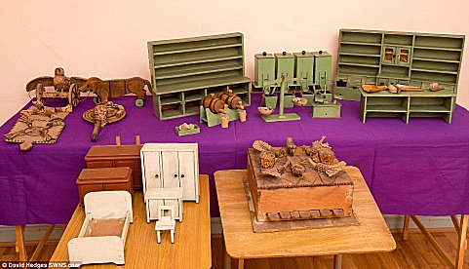
Toys carved for a little girl by a German pow – (see further below). © David Hedges SWNS.com
Such activities were rarely mentioned in reports.
Information room – An exhibition (title unknown) was put on by the pows.

Other activities –

Religion – 70% protestant, 30% R.C. 50-80 protestant pows attended services at the local church and received help from the parson. Pow chaplian – St.Gefr Buerger - “a decent man of the village parson type.” RC’s visited by Kreis, who attended other camps in Somerset – “he is considered to be more difficult to approach.”

Education – classes for English, German, elementary electricity, book-keeping and shorthand.

Entertainments – 10 pows had formed a stage group with monthly shows. They were unable to perform at the hostels due to transport difficulties. A 9 man orchestra gave monthly concerts and for special occasions. The orchestra had visited some hostels where there was a piano, (no explanation as to why the orchestra could visit, but the actors could not). A string quartet played at Goathurst Church.

19 January 1947 – English Inspector’s Report. Total strength 1716 German pows. 1 advanced English class of 9 in the main camp. Some pows studying privately.

28 March 1947 – Re-education survey. Strength; 1 officer, 1687 OR.

No change to senior personnel. Morale was regarded as good.

The only noteworthy change to re-education activities; Lectures – now once a month.

The theatre group and orchestra visited the hostels. 20 members were in the theatre group with a good stage and adequate accommodation. The orchestra played mainly opera and dance music.

20-23 / 25,26 August 1947 – Re-education Survey. Strength; 2 officers, 1996 OR.

Commandant: Lt Col Joy Camp Leader: Fahnenjunker F/w Nitschke (A+)
2nd i/c: Major Littleboy Deputy C/L: Boensch (B)
Interpreter: S/Sgt Edwards German M.O.: St/Arzt Dr Buerger (B)

The commandant had no interest in re-education activities, he was however, “much respected for a fair and just man.” The new S/sgt interpreter was, “very good in all respects.” The new 2 i/c was, “a strong believer in re-education and will prove a power for good in the camp.” A less positive picture of British staff was given 6 months later.

The camp leader had deferred his repatriation indefinitely. He was regarded as, “a little aloof from his fellow Ps/W, though he nevertheless backs their interests in a firm way.”

The new German M.O. was stated to be, “a big improvement on the old one.”

Simplified screening was used: A+ 1 / A 3 / B 1994. C grades had either been upgraded or moved to other camps. 990 pows repatriated to date.

Morale was good and improving – mainly because repatriations were well underway. A monthly meeting of the hostel leaders was held with the commandant – “a useful instrument for voicing grievances, making suggestions and the like.”

Late nights working on the harvest and increased opportunities to leave the camp affected re-education activities. Noteworthy changes:

Library – ample supply of German literature, many Swiss books had arrived (from the ICRC). “Demand is for sensational novels.”

Discussion groups - held infrequently at the main camp and at Wells, rarely at other hostels.

Films – continued to arrive from the YMCA and pows were able to attend cinemas.

Press reviews – these had largely lapsed.

Other activities –

Religion – weekly services in camp, and many local churches welcomed pows.

Entertainments – The theatre group put on a new high standard performance every 8 weeks. The orchestra / band were popular. A choir of 20 members had formed and sung at a concert in Bridgewater. Sport of all kinds – including football, ping-pong, chess tournaments, handball, and swimming.

Education – there were small classes for book-keeping, shorthand, English, French and arithmetic.

Outside contacts – of all activities this had the most influence on the attitudes of pows. Formal contacts had been made with Bridgewater Arts Council, “excellent” – Toc H, YMCA, Salvation Army, Christian Socialists. Most pows had developed informal contacts and friendships with local citizens.

26 / 29 September 1947 – English Inspector’s Report. Strength 1800. Only 1 English class at Wells.

30 September - 3 October 1947 – Re-education survey and “Investigation of Application for Compassionate Release.” Strength 2 officers, 1804 OR.

No change to senior personnel. There were tensions between the S/Sgt and the Commandant and Camp Leader. The S/sgt was regarded as intelligent and promoting re-education. He found the C/L to be deceitful and unpopular with many of the pows. However the Commandant found the C/L to be reliable and efficient.

Simplified screening was used: A+ 1 / A 2 / B 1803. 1331 pows repatriated to date – including 42 compasionate cases in September. This number of cases seems remarkably high, but no reason was given. Unfortunatley no details were given regarding the application for compassionate release.

Many of the re-education activities had ended in the main camp, though still continued at Wells.

Further formal outside contacts had been established with Brigewater Town Council, County Court and Conservative Association; Rotary Club; Wells Society of Arts; Wells Council and Conservative Association; Wellington Council; and Taunton Corporation.

14 November 1947 - Camp number included in an ‘Urgent Memorandum’ (FO 939/270) regarding inspection of food parcels.

9-11 December 1947 – Re-education survey. Strength; 2 Officers, 1430 OR.

No change to senior personnel. The tensions between the S/Sgt and the C/L were noted again.

A new adjutant was listed – Captain Bryant, previously at Newlands House camp 125 – “less severe than the previous one, and more popular with the prisoners.”

Simplified screening: A 4 / B 1428. 163 pows repatriated since start of October, including another 34 compassionate.

‘Fairly good’ morale. Positive factors were repatriations, good local contacts except at Cannington, a sympathetic British staff. Some pows had requested to defer their repatriations until December 1948, especially at Wells – many of these were from the Russian zone.

Noteworthy changes to re-education activities;

Films – The camp had a film projector on loan from the YMCA. Pows from Brampton Road Camp 92 and Nisson Creek Camp 276 came to see films here. Films were sent fortnightly by the YMCA and occasionally the COI and Foreign Office, (German Section).

An excellent range of outside contacts was maintained.

Religion – A new padre, Adolf Tadge, arrived from Exhibition Field Camp 42.

Entertainments – Theatre group continued to perform. The choir and orchestra performed with a smaller number of members.

30/31 December 1947 – 1/2 January 1948 – English Inspector’s Report. Strength 1445

Inspectors reviewed classes, gave occasional lessons and sometimes held exams. Considering there had been no classes at this camp for some time, it is hard to see what this inspector did / achieved in 4 days.

24 – 27 February 1948 – Re-education survey. Strength; 1 officer, 923 OR. (Pointless screening figure: B 924).

Commandant: Lt Col R C G Joy D.S.O. Camp Leader: Alfred Werner (B)
Interpreter Officer: Capt F S Kingston Deputy C/L: Franz Vasters (B)
German M.O.: St/Arzt Dr Buerger (B)

The new IO had recently arrived from Quorn Camp 9. The new Camp Leader had been hostel leader at Wellington.

Concerns were raised about the camp. Some issues may have arisen as the camp was aware it would soon close down, but some appear to be longer term. The atmosphere within a camp was largely under the control of the commandant. Goathurst appears to be an unhappy camp at this time with comments such as; “Camp discipline is severe” and, “Constant inspections, fire alarm and orders are treated as a joke….”

Previous comments about good contacts were amended. Formal outside contacts had ceased. The orchestra had been disbanded and no further concerts given. The main camp was 5 miles from Bridgewater with no bus connection; “Contact with the local population is therefore rather limited.” Contacts with families were maintained by individual pows.

Re-education activities were reduced to receiving newspapers and films, lectures, the camp magazine, wireless and the library. There were no discussion groups, press reviews, meetings or exhibitions.

A new padre had arrived from Camp 40; Otto Sattig – he had been unpopular with the British and Germans in his previous camp. “He is very passive, and while admitting that interest in religion is very poor, he does not seem disposed to do much about it.”

It seems only the nearness of repatriation kept things in order. “There is no entertainment or education carried on in the camp where the main activity is the packing and repacking of kit.”

This was the last re-education report. There was a further pointless English Inspector’s Report which was dated; “22nd 1948”, no month given.

The camp most likely closed during March 1948.

Known camp commandants –

c.1944 Major S W Thomas

c.1945 Lt Col G L S Smith

c.1947 Lt Col R C G Joy, D.S.C. Previously at The Hayes Camp 5 and then Camp 124. Ronald Cecil Graham Joy from the Royal Dragoons, (also English cricketer playing for Essex 1922 to 1928).

Camp and hostels + number of pows where known:

 | Not open |  | Unknown |  | Open |  | With another camp

 | 1942 | 1943a | 1943b | 9/45 | 7/46 | 12/46 | 1/47 | 3/47 | 8/47 | 9/47 | 10/47 | 12/47 | 1/48 | 2/48
Main | Cap 300 | Cap 500 |  | Cap 1000 | 1136* | 821 | 807* | 779* | 677 | 603 | 610 | 593 | 778 | 641
West Lambrook |  |  |  | Cap 380  Italian | 68 | 66 | 66 | 58
Walford Cross
Merriott |  |  |  |  | 69
Load Farm
Houndstone |  |  |  | Cap 380  German | 97 | 88 | 84 | 69 | ? | 54 | 54 | 62 | 69 | 77
Crowcombe H. |  |  |  |  | 241 | 137 | 137 | 119 | 96 | 84 | 84 | 68 | 64
Wellington |  |  |  |  | 495 | 439 | 405 | 489 | 232 | 152 | 151 | 77 | 102
Cannington |  |  |  | With C107 | 162 | 106 | 104 | 92 | 80 | ? | 61 | 58 | 109 | 35
Merryfield |  |  |  |  |  | 78 | 63 | 40 | 80 | 80 | 76
Wiveliscombe |  |  |  |  |  | 50 | 50 | 42
Wells |  | Camp 107 |  |  |  |  |  |  | 590 (a) | 577 | 436 | 307
Taunton |  |  |  |  |  |  |  |  | 40 | ? | 19 | 10 | 10 | 8
Billets |  | c.200 |  |  |  | 156 |  |  | 203 | 250 | 315 | 257 | 313 | 163
Total | Cap 300 | c.700 | ? | Cap 1760 | 2268 | 1941 | 1716 | 1688 | 1998 | 1800 | 1806 | 1432 | 1445 | 924
* including billetees (a) including 120 billetees

After the camp: Reverted to parkland.

The site as it is now: https://repatriatedlandscape.org/england/pow-sites-in-the-south-west/pow-camp-44-goathurst/

Further information:

(1) Somerset At War – Mac Hawkins – Dovecote Press, 1988.

National Archives: FO 939/126 44 Working camp, Goathurst camp, Goathurst, Somerset. Dated 1945-1948. Used above.

Aerial photographs: RAF CPE/UK/1944 4423-5 and RAF CPE/UK/1944 2034-5. (23/1/1947).

Another recorded memory of the camp came from a guard from about 1946 to 1948, included in; ‘The Germans We Trusted’ – Pamela Howe Taylor – 2003 - Lutterworth Press.

Recording of Italian pow John Salvatore Zuncheddu is available from ‘Somerset Voices – Oral History Archive.’ http://www.somersetvoices.org.uk/people/?entryid4=625&cid=25492

A video showing the wooden toys carved by Lance Corporal Franz Schmidt for Patricia Herring on YouTube: www.youtube.com/watch?v=Bfdyfanq9AQ – see also MailOnline, 8 January 2016.

The Imperial War Museum holds a copy of the camp newspaper; dated April 1947. (Catalogue LBY E.J.387)

Hostels

Cannington. 3 miles from the main camp.

Location – believed to have been in the grounds of Brymore House – ST 246 395 – now Brymore Academy.

1945 – a hostel for Penleigh (Wells) Camp 107 with Italian pows up to at least September.

July 1946 – Descibed as a ‘black’ hostel – i.e Category C. Many pows had been held in camps in the USA where they had been incorrectly informed they were to be returned to Germany – consequently morale was low.

December 1946 – Hostel leader; O/maat Gertzmann (B+)

March 1947 – same leader, but regraded as (A).

August 1947 – Hostel leader; Franz Hasse (B)- “shows promise.” Recorded that the commandant replaced a leader called Glockmann who was, “not pulling his weight” with Hasse.

February 1948 – same leader.

 | 1942 | 1943a | 1943b | 9/45 | 7/46 | 12/46 | 1/47 | 3/47 | 8/47 | 9/47 | 10/47 | 12/47 | 1/48 | 2/48
Cannington |  |  |  | With C107 | 162 | 106 | 104 | 92 | 80 | ? | 61 | 58 | 109 | 35

Crowcombe Heathfield. 15 miles from the main camp.

Location – possibly at nearby Rexton Gorse ST 129 342.

1945 – Hostel for German pows.

December 1946 – Hostel leader; Wm Wieck (B). No electric power supply. Accummulator batteries had to be sent away to be recharged affecting wirelss reception. No films.

March 1947 – Hostel leader; Fw Stoetzel (A)

August 1947 – Hostel leader; Burghardt – “understanding and capable.”

December 1947 – same. Still no electric supply.

 | 1942 | 1943a | 1943b | 9/45 | 7/46 | 12/46 | 1/47 | 3/47 | 8/47 | 9/47 | 10/47 | 12/47 | 1/48 | 2/48
Crowcombe H. |  |  |  |  | 241 | 137 | 137 | 119 | 96 | 84 | 84 | 68 | 64

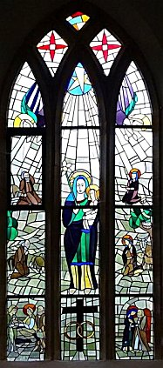 | Houndstone (Yeovil). 26 miles from the main camp.  Probably in the large army camp. One memory places it at ST 524 166.  1945 – Hostel for German pows.  July 1946 – Hostel leader; O/Fw Hans Tiedjen (A). No party record other than 1 year in Hitler Youth - “Positive and co-operative.” At the hostel for 2 months, but had already started a small active political club and he hoped to start a hostel paper.  Mixed political views at the hostel – “The reality of KZ [concentration camp] horrors is doubted, also the total number of victims. One P/W (Helmut Bootz) Rottenfuehrer [section leader of paramilitary SS] in the allgemeine SS from 1933/39 was sent to Oranienburg for refusing to ill treat P/W in a KZ when he himself was employed as a guard. The C/L was asked to let this man give an account of his experiences in order to break down the notion that KZ horrors are not as bad as they are painted.”  December 1946 – Hostel leader; Hfw Schramm  March 1947 – Hostel leader; Fw Bescht (B)  October 1947 – Hostel leader Bruehl (B). A comment in the report sounds like the hostel was closed for a short time between March / September.  December 1947 – Hostel leader W Schlottmann (B+) had previously been leader at West Lambrook then Merryfield. Pows could see film shows at the local RASC Depot.  February 1948 – Hostel leader Albert Auge (B)  After the camp – All but one of the stained glass windows at St. Mary the Virgin, East Chinnock were made and installed between 1962 and 1988 by Herr Gunther Anton, Master Glazier of Leonberg, Stuttgart. Gunther had been a rear gunner in the German Luftwaffe who was shot down over Southampton in 1944 and sent to the pow hostel at Houndstone. He was billeted at a farm near East Chinnock and would come into the church to pray and find comfort and help.

Returning to West Germany in 1948, Gunther built up a business with his father making stained glass windows. In 1962 he returned to bring his first gift of a beautiful window for the south wall of the nave. He provided more windows up to 1988. http://eastchinnock.net/Home/Church/History-of-St-Marys-Church//The-Stained-Glass-Windows

 | 1942 | 1943a | 1943b |  | 9/45 | 7/46 | 12/46 | 1/47 | 3/47 | 8/47 | 9/47 | 10/47 | 12/47 | 1/48 | 2/48
Houndstone |  |  |  |  | ? | 97 | 88 | 84 | 69 | ? | 54 | 54 | 62 | 69 | 77

Load Farm, Long Load, Somerset

1945 – Hostel for Italian pows.

 | 1942 | 1943a | 1943b | 9/45 | 7/46 | 12/46 | 1/47 | 3/47 | 8/47 | 9/47 | 10/47 | 12/47 | 1/48 | 2/48
Load Farm

Merriott

Location - POW camp, previously an American army camp, at the recreation ground. ST 438 124.

1945 – Hostel for Italian pows.

July 1946 – Hostel leader; Fw Max Braun (A), aged 45, “sociable and competent.”

German pows - many had been held in camps in the USA. They had been incorrectly informed they were to be returned to Germany – consequently morale was low.

 | 1942 | 1943a | 1943b | 9/45 | 7/46 | 12/46 | 1/47 | 3/47 | 8/47 | 9/47 | 10/47 | 12/47 | 1/48 | 2/48
Merriott |  |  |  |  | 69

Merryfield (Ilton). 15 miles from the main camp.

December 1946 – Hostel leader; O/Fw Amann (B)

March 1947 – Hostel leader; Fw Schlottmann (B), regular German navy – “very commendable work…. Shows tact and judgment.” Previously leader at West Lambrook.

October 1947 – same leader.

 | 1942 | 1943a | 1943b | 9/45 | 7/46 | 12/46 | 1/47 | 3/47 | 8/47 | 9/47 | 10/47 | 12/47 | 1/48 | 2/48
Merryfield |  |  |  |  |  | 78 | 63 | 40 | 80 | 80 | 76

Taunton (Officers’ Mess).

October 1947 – Hostel leader; Mueller (B)

December 1947 – same leader.

 | 1942 | 1943a | 1943b | 9/45 | 7/46 | 12/46 | 1/47 | 3/47 | 8/47 | 9/47 | 10/47 | 12/47 | 1/48 | 2/48
Taunton |  |  |  |  |  |  |  |  | 40 | ? | 19 | 10 | 10 | 8

Walford Cross

1945 – Hostel for Italian pows.

 | 1942 | 1943a | 1943b | 9/45 | 7/46 | 12/46 | 1/47 | 3/47 | 8/47 | 9/47 | 10/47 | 12/47 | 1/48 | 2/48
Walford Cross

Wellington. 16 miles from the main camp.

Part of Somerset HER – “36024: Second World War army and POW camp, Pyles Thorne Close, Wellington. Grid Reference ST 144 201 (314491,120107).

There is mention in an article about Prisoners of War in Wellington of a camp in the area of Pyles Thorne Close. Originally an army camp it became a POW camp following the Normandy landings in 1944. There were 18 Nissen huts each housing 40 prisoners. The camp closed in 1948 and the site is visible on aerial photos of about that date, partly dismantled. [Email: Murless, Brian, Somerset Industrial Archaeological Society, to HER (28/4/2016) not retained.]

…The camp occupies an area of approximately 5.4 hectares… The camp is dominated by a number of Nissen huts and other smaller structures which are concentrated within the northwest portion of the site, as well as along the line of the field boundaries to the northeast and east. Interspersed with these Nissen huts and also within the central eastern section and along the southern edge of the camp are an arrangement of regularly spaced square bases for possible former hut-like structures, measuring approximately 4.5m square. Pale linear cropmarks forming a rectilinear area within the northeast area of the camp may be tentative evidence of a sports pitch… By 1989, aerial photographs show that the former camp has been completely cleared and the site developed into residential housing.”

3 aerial photographs held in Historic England Archives, Swindon.

1945 – Hostel for German pows.

July 1946 – Hostel leader; S/Wm Toni Walch (B) – “A very sensible and willing man, a professional soldier… unpolitical… quite efficient and right for his job.”

December 1946 – Hostel leader; O/Fw Werner (B), medical student – later comment; “A sound man doing a good job.”

December 1947 – same leader. Had its own theatre group.

 | 1942 | 1943a | 1943b | 9/45 | 7/46 | 12/46 | 1/47 | 3/47 | 8/47 | 9/47 | 10/47 | 12/47 | 1/48 | 2/48
Wellington |  |  |  |  | 495 | 439 | 405 | 489 | 232 | 152 | 151 | 77 | 102

Wells (Penleigh). Previously Camp 107. In all but one report, it is listed as a hostel, in the other it was called a Satellite Camp which considering its size and previous status is more likely to be correct.

August 1947 – Hostel leader; Werner Hennig (B) – “an idealist who is at present much under the influence of Christian Science – this colours many of his actions” – as a leader; “good and reliable.” He had been Camp leader when this site was Camp 107.

Had its own German M.O. – Oberarzt Dr Korn – “made a pleasant impression.”

October 1947 – Officer i/c Captain Shepherd.

December 1947 – same camp leader. Wells had its own choir which gave performances in local churches.

30 December 1947 – camp closed.

 | 1942 | 1943a | 1943b | 9/45 | 7/46 | 12/46 | 1/47 | 3/47 | 8/47 | 9/47 | 10/47 | 12/47 | 1/48 | 2/48
Wells |  | Camp 107 |  |  |  |  |  |  | 590 (a) | 577 | 436 | 307

West Lambrook. 20 miles from the main camp.  Location ST 413 185  1943 – Hostel for Italian pows.  1945 – Still in use holding Italians.  December 1946 – German pows. Hostel leader; Hfw Schlottmann (B)  March 1947 – Hostel leader; Gefr Roth (B)  Part of picture of West Lambrook; hostel in the background. From:  https://www.kingsburytimetravellers.org.uk/ww2/prisoners-of-war-at-west-lambrook/  Other pictures show a water tower, just off left of this photo and Italian pows. | 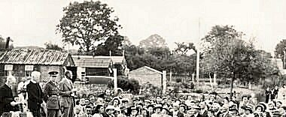

 | 1942 | 1943a | 1943b | 9/45 | 7/46 | 12/46 | 1/47 | 3/47 | 8/47 | 9/47 | 10/47 | 12/47 | 1/48 | 2/48
West Lambrook |  |  |  |  | 68 | 66 | 66 | 58

Wiveliscombe. 20 miles from the main camp.

Location – local memories place it near to Culverhead House – ST 075 276

December 1946 – Hostel leader; Uffz Nagel (B)

March 1947 – same leader.

 | 1942 | 1943a | 1943b | 9/45 | 7/46 | 12/46 | 1/47 | 3/47 | 8/47 | 9/47 | 10/47 | 12/47 | 1/48 | 2/48
Wiveliscombe |  |  |  |  |  | 50 | 50 | 42

DAS LEUCHTFEUER KRIEGSGEFANGENENZEITUNG FUR DAS GOATHURST CAMP 44

DAS LEUCHTFEUER KRIEGSGEFANGENENZEITUNG FUR DAS GOATHURST CAMP 44

OBJECT DETAILS

